Free Web space and hosting from 1hwy.com

  
  
 |  | Top of Form  Bottom of Form |  | Popular Searches: vacation airfare concert ticket

Music of Bethel

If you would like to order our music, please make Checks or Money orders payable to:
Brenda Hutton
347 7th. Avenue
Dayton, TN 37321

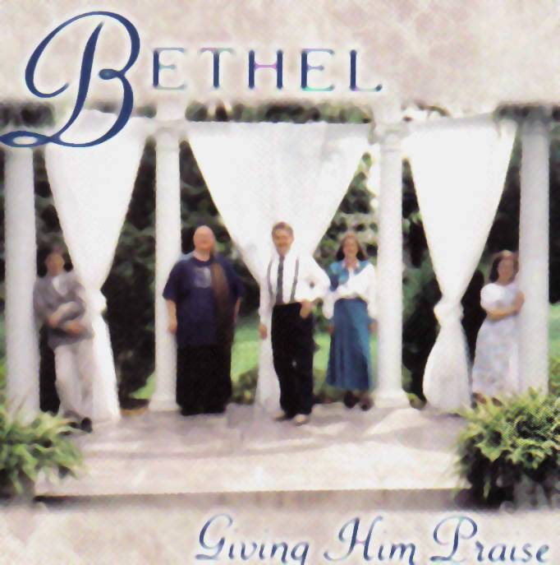
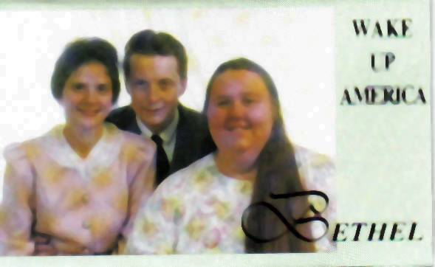
Giving Him Praise (Bethel)
T R A C K S - I N C L U D E S:
01. Nothing But Love
02. Second Birth
03. Trail of Tears
04. He Ain't Ever Done Me Nothing But Good
05. Covered in Red
06. After All
07. God Is Faithful
08. Came Here to Praise the Lord
09. Little Girl
10. I'm Bound for a City
CD: $13.00 plus $2.35 S.H. / TAPE: $10.00 plus $2.12 S.H.
Wake Up America (Bethel)
TRACKS INCLUDES:
01. Wake Up
02. Songs Holy Angels Cannot Sing
03. I Just Start Living
04. Soul Filling Station
05. Let's Have a Revival
06. I think I'll go back to the Table
07. Driving Nails
08. Little David
TAPE: $10.00 plus $2.12 S.H. / CD Unavailable

