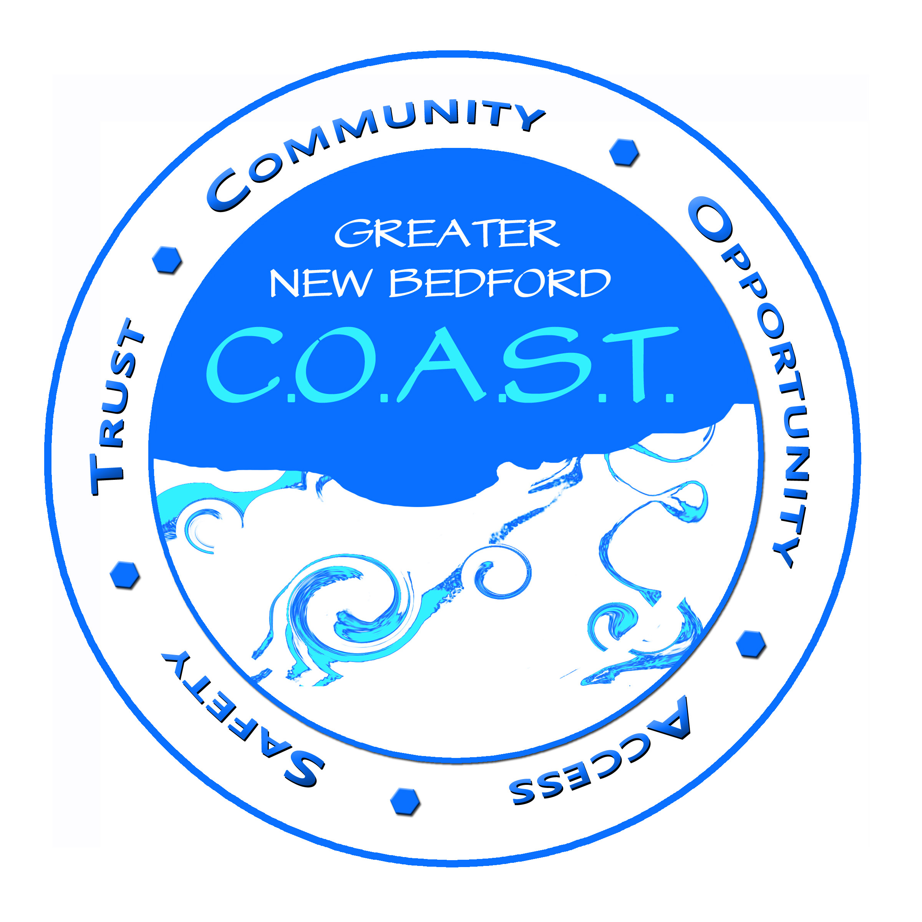
C.O.A.S.T.* Connections
The Newsletter of Greater New Bedford C.O.A.S.T. (AKA The Greater New Bedford Health & Human Service Coalition) www.geocities.com/gnbhhsc
Serving Acushnet, Dartmouth, Fairhaven, Freetown, Marion, Mattapoisett, New Bedford, Rochester and Wareham
Volume 2, No. 5, 6 May/June 2007

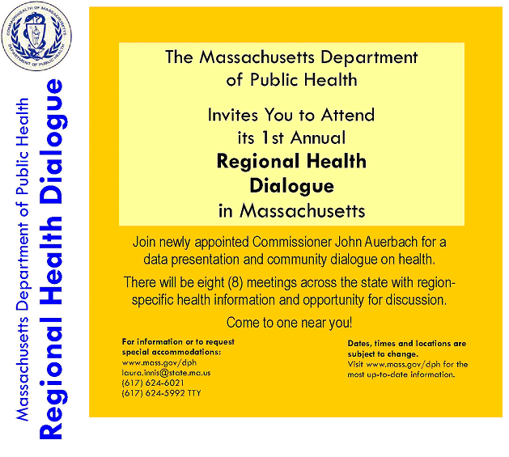

In Lieu of the GNB COAST Monthly Networking Meeting,
Please attend the SOUTHEAST Regional Dialogue
Thursday, June 7, 2007, 9:00 to 11:00 AM
Bristol Community College, Fine Arts Building, Room H209, 777 Elsbree St., Fall River


Did You Know That…?

Greater New Bedford Community Health Center Extends Urgent Care Hours - Urgent Care Department opens at 7:30 to accommodate patients and walk-ins whose work schedules would otherwise prevent them from getting immediate care. No appointment is needed. The Urgent Care Department is staffed by physicians who are board certified in Emergency Medicine and Internal Medicine. On-site laboratory and radiology services are available. The Urgent Care Department hours are 7:30 am to 6 pm Monday through Thursday, 7:30 am to 5 pm on Friday, and 9:00 am to 5 pm on Saturday. Contact Lois Curley for information at 508-984-8401, x182.

Underage Drinking Attitudes Survey will determine the attitudes in our community regarding underage drinking. A media campaign is being launched, and survey will be used to evaluate whether messages have made a difference in the attitudes of the community. This survey is part of the evaluation measurement. The survey is completely anonymous so more people may feel comfortable sharing their opinions. Please share this information with your respective listserves. Contact Jocelyn Andrade, 508-990-8280, x210, or jocelynandrade@aol.com. Survey is found at http://www.surveymonkey.com/s.asp?u=920053884091

MA DPH 1st Annual Regional Health Dialogue with Commissioner John Auerbach - In lieu of the GNB COAST Networking Meeting, please attend the MA DPH 1st Annual Regional Health Dialogue, 6/7/07 9:00-11:00am, at the Bristol Community College, Fine Arts Building, Rm H209, 777 Elsbree St., Fall River.
Cards, Words of Encouragement, Donations for Brad Sell may be sent to the Bradley L. Sell Family Fund, Citizens Bank, 4 Plaza Way – 660, Fairhaven, MA 02719.

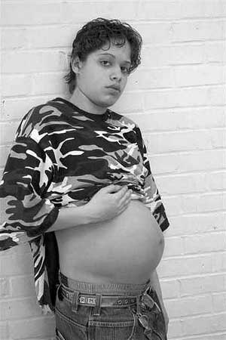
Faces of Teen Pregnancy opening reception invites you to the multimedia exhibit of the RAPPP Program of Southcoast Hospitals Group. It personalizes the issue of teen pregnancy with evoking black and white images accompanied by moving audio narratives. Gallery X, 169 William St., New Bedford. Exhibit runs May 2 - June 1, 2007, Wednesday through Sunday, 11am-3pm and Thursday May 10, 11:am-9pm. Call 508-994-0548.

Walk on AIDS is a rain or shine event. Pledge sheets may be obtained at many local AIDS service organizations beginning 4/30, or call 508-995-0793. 100% of funds goes to participating, local organizations that provide assistance to individuals with HIV/AIDS. 6/2/07, 9:30 registration, 10:00 walk begins. For pledge sheets or information, call 508-995-0793.

Connecting for Change! Youth Summit 2007 - The MA Department of Public Health's Office of Adolescent Health and Youth Development is sponsoring a statewide youth development event bringing together teams of youth and adults from across MA to network, share strategies, and create opportunities for young people to use their talents, voices and collective strength to positively impact their communities. The event will feature interactive presentations and displays of effective youth leadership initiatives covering a range of public health issues. It will be held 6/2/07, 9:30-3:30, Best Western Royal Plaza Hotel, Marlborough. Please contact Itege for forms and information at 617-624-6058.

Public Hearing on Women’s Issues will be held 6/6/07, 5:30pm-7:00pm at UMD Woodland Commons. MA Co-sponsored by the Commission on the Status of Women and the UMD Women’s Resource Center. Free. Written testimony accepted, translators available upon request. RSVP intent to attend and/or testify to mcsw@state.ma.us, or telephone 617-626-6520.

Understanding the Challenges...Meeting the Needs of Adolescents in the 21st Century - Developed and sponsored by the RAPPP program of Southcoast Hospitals Group. Adolescent At-Risk Conference for providers and youth. 6/7/07, Taunton Holiday Inn and Conference Center. Registration at www.southcoast.org/rappp

The Office of Juvenile Justice and Delinquency Prevention (OJJDP) invites applicants for its Prevention and Intervention Programs solicitation, which is intended to demonstrate the practical implications for policy and practice of programs that enhance juvenile justice, child protection, and delinquency prevention. Deadline 6/8/07. Must register with Grants.Gov ASAP. For information, contact angela.parker@usdoj.gov or 202-353-9252, or lou.ann.holland@usdoj.gov or 202-305-2742. See http://ojjdp.ncjrs.gov/grants/solicitations/FY2007/intervention.pdf.


COALITION/COMMITTEE
MINUTES & REPORTS

GNB COAST General Meeting. 5/3/07, 9:00, Coastline Elderly Carriage House.

Luncheon Debriefing – 150 attended the April 5th GNB COAST meeting at the Century House. Peter Lee was the speaker. Purpose was to mobilize people and follow up with attendees to encourage and increase relationships. Evaluations and comments from attendees were shared. Suggestions for improvement for the next event were shared:
- Just one speaker and subcommittee reports
- Engage the audience more
- Follow the agenda
- There was concern that CHNA meetings might not have a lot of engagement
- Focus on promoting GNB COAST
- History was too long; need more of what’s happening now
- Hard to see the power point
- Screen was inadequate
- Public health video too long
- It was mission focused, informative and brought new members
- Networking afterwards was great
- Sarah did a great job with the cake
- Different room for the meal

Coalition Quarters – GNB COAST needs a permanent place for a base for operations and meeting space for general and subcommittee meetings. Membership is asked for suggestions for donated space. Wish list includes space, internet, desk, phone lines, ease of parking, low on distractions. Can involve partners in decision making, and provide an opportunity for them to support the CHNA. Suggestions include Welby Park, Community Foundation, NB Rehab Hospital, Coastline, Howland Place, Health Department, Southcoast Hospitals, Fort Tabor and any others. This needs to happen fast.

GNB COAST Website – The Coalition is still using the www.geocities.com/gnbhhsc site for announcements and updates, and waiting for passwords, user names and a user guide from the website company.

Staffing – New Staff are needed to replace Lorraine, who will be leaving in June. She will continue to do some work from a distance.

Summer Meetings
- Regular General meetings are not usually held in the summer.
- A Taking Care of Ourselves usually replaces one of the meetings.
- Last year a strategic planning retreat was held. Projects and directions from that meeting can be chosen.
- Members are asked to attend the Regional Health Dialogue on 6/7/07, 9:00-11:00, in place of the monthly general meeting (See page 1)
Budget – A comprehensive budget plan needs to be done. Craig will do a snapshot report of previous spending at the next general meeting. A comprehensive audit print out is needed to move forward in making a budget. Audra is doing a vendor list to get reductions or free items from sponsorships. Savings can be passed on to the community through minigrants.

Next Steps:
Locate donated space to serve as headquarters for GNB COAST (Membership)
Subcommittees are asked to finalize a regular time of the month and date for monthly meetings, and forward the information to Lorraine, Sarah and Audra. (Chairpersons)
Pursue the necessary information from M&I to work on the new website. (Dan)
Continue to recruit new membership (Members)

Next Meeting: In Lieu of the GNB COAST Monthly Networking Meeting, please attend the SOUTHEAST Regional Dialogue on Thursday, June 7, 2007, 9:00 to 11:00 AM, at Bristol Community College, Fine Arts Bldg, Rm H209, 777 Elsbree St., Fall River.

Contact Persons: Dan Riding, 508-994-0885, x3157, Tim Velho, 508-994-0548

GNB C.O.A.S.T. Calendar of Events:
June/July 2007

June 7, 9:00-11:00am | MA DPH 1st Annual Regional Health Dialogue, with Commissioner John Auerbach. For information or special accommodations, please call 617-624-6021. | Bristol Community College, Fine Arts Building, Rm H209, 777 Elsbree St., Fall River
June 8, 10:00-Noon | South Coast HIV/AIDS SSC Quarterly Meeting. RSVP to Steve Baker at 508-583-2250 or email sbaker@hcsm.org. | STARR, Fall River. Directions at www.sstar.org/pf_directions&maps.htm
June 8, 12:30 | GNB C.O.A.S.T. Domestic Violence Committee. RSVP to Camille at canderson@ci.new-bedford.ma.us. | South Coastal Counties Legal Services,  21 South Sixth St., New Bedford, MA
June 12, 9:00 | Youth Empowerment Advocates Committee. Chairperson: Jocelyn Andrade, 508-990-8280, x219. | 589 First St., New Bedford, MA
June 14, 8:30am | GNB C.O.A.S.T. Health Access Meeting. | Greater NB Community Health Center  874 Purchase St., New Bedford.
June 15, 2:00 | GNB C.O.A.S.T. Steering Committee. | Location TBA
July 6, 12:30 | GNB C.O.A.S.T. Domestic Violence Committee. RSVP to Camille at canderson@ci.new-bedford.ma.us. | South Coastal Counties Legal Services,  21 South Sixth St., New Bedford, MA

GNBHHSC (GNB C.O.A.S.T.)

P.O. Box 7567
New Bedford, MA 02742-7567

To submit an article, announcement or other information to C.O.A.S.T. Connections, please email Lorraine Rosa at mcaprosa@yahoo.com or Skype Lorraine Rosa by 6/15/07. You may also access copies of this newsletter at www.geocities.com/gnbhhsc.

