UNIVERSITI TUNKU ABDUL RAHMAN

FACULTY OF INFORMATION AND COMMUNICATIONS TECHNOLOGY

UICS2113 DATA COMMUNICATIONS AND NETWORKING

YEAR 1 SEMESTER 1

TITLE: IPV6

MEMBERS | ID. NO | TUTORIAL GROUP
CHUA LEE SAN | 04UAB01908 | 1
CHUA YI LING | 04UAB01628 | 1
GOH SIEW LIM (Leader) | 04UAB01906 | 1
LIM YEN NEE | 04UAB02234 | 2
WEE SIAO HUI | 04UAB01627 | 1

COURSE : BUSINESS INFORMATION SYSTEMS
LECTURER : MR. CHENG SOON GIAP
DATE OF SUBMISSION : 6th AUGUST 2004
TABLE OF CONTENT

CONTENT | PAGE
Introduction | 1
New Changer in IPv6 | 2 - 3
Transition From IPv4 and IPv6 | 3 - 5
The Main IPv6 Header | 5 - 11
ICMPv6 | 11 - 12
IPv6 Addressing | 12 - 15
Conclusion | 16
Learning Outcome | 17
Reference | 18

INTRODUCTION

Internet Protocol version 6 (IPv6), also known as Internetworking Protocol, next generation (IPng) is a new version of the Internet Protocol (IP), designed to support the continued growth of the Internet, while enabling a wider range of Internet-connected devices, and to replace the IPv4 data transport protocol that has been used as the basis for the Internet to date as the standard protocol for networking for the Internet and other WAN networks.

IPv6 is designed by the IETF IPv6 was recommended by the IPng Area Directors of the Internet Engineering Task Force at the Toronto IETF meeting on July 25, 1994 in RFC 1752. This recommendation was approved by the Internet Engineering Steering Group and made a Proposed Standard on November 17, 1994. The core set of IPv6 protocols was made an IETF Draft Standards on August 10, 1998.

IPv6 was adopted because:
- IPv4 has two-level address structure (netid and hosted) categorized into five classes (A, B, C, D, and E). The use of address space is inefficient.
- The Internet must accommodate real-time audio and video transmission. This type of transmission requires minimum delay strategies and reservation of resources not provided in the IPv4 design.
- The Internet must accommodate encryption and authentication of data for some applications. Originally, IPv4 provided no security mechanism.

IPv6 also offers automatic addressing which would eliminate the manual setting of IP or by some other DHCP service. Another improvement of IPv6 is its three types of addresses: unicast addressing, multicast addressing and anycast addressing.

Included in the IPv6 header are several additional fields. In particular, a priority field and a flow field. These additional fields can provide important added security for the rapid growth in e-commerce IPv6 could great benefit the only community in may ways other than just more address space. E-commerce, on-line bank, multimedia broadcasts, video conferencing, and voice over IP.

IPv6 is a typical attempt on the part of equipment vendors and service providers to differentiate themselves from each other. IPv6 helps them stand apart a bit.

IPv6 is a natural increment to IPv4. It can be installed as a normal software upgrade in Internet devices and is interoperable with the current IPv4. Its deployment strategy is designed to not have any flag days or other dependencies. IPv6 is designed to run well on high performance networks and at the same time still be efficient for low bandwidth networks. It is also provides a platform for new Internet functionality that will be required in the near future.

New changes in IPv6
There have some changes from IPv4 to IPv6:
i )Simplified header format: The IPv6 header format is simpler than IPv4.
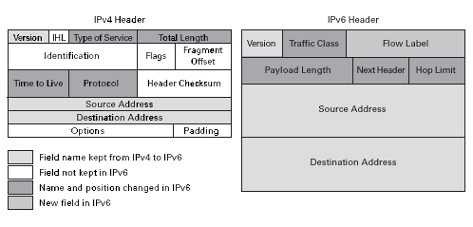
The header format has been greatly simplified for IPv6. Some of the header fields have been removed and others have been moved to the optional IPv6 Extension Header. The IPv6 header is only twice the size of the IPv4 header.

IPv6 header options are encoded differently. Options are now carried in a separate IPv6 extension header that travels between the normal IPv6 header and the transport-layer header in a packet. Also, the options length is no longer limited to 40 bytes. The IPv6 Extension Header facilitates routing by allowing routers to quickly identify whether an option should be processed or ignored.
ii) Longer address fields: The length of address field is extended the bits. The address structure also provides more levers of hierarchy.
There is the increased address size from 32 bits to 128 bits. The larger address size supports a larger internet base, a flexible and different internet structure, and auto-configuration. The IPv6 address is four times the size of the IPv4 address. This allows for 3.40 x 10³⁸ addresses. It would be impossible to construct an internet that could take advantage of all of the address space; yet, even the lowest estimates predict over 1.99 x 10³³ addresses. The world is expected to have eleven billion people in the year 2150. With proper management, IPv6 could enjoy a longer life than IPv4. Most likely, future needs for a new protocol will be driven by new technological advancements and not by a lack of address space.
iii) Flexible support for option: The options in appear in optional extension headers that are encoded in more efficient and flexible fashion than they were in IPv4.
iv) Flow label capability: Packets may be labeled according to the type of traffic they contain, such as real-time service for video-conference links.
v) Security: IPv6 supports built-in authentication and confidentiality
Privacy and Security support is also included in IPv6. IPv6 Extension Headers may now better carry authentication options that were not practical for use in IPv4. The authentication options only need to be processed by specific routers along the path, instead of forcing every router to process all of the options for every packet that it receives. Internet Protocol Security (IPSEC) works below the application level.
vi) Large packets: IPv6 supports payloads that are longer than 64 kilo bytes, call jumbo payloads.
vii) Fragmentation at source only: Routers are not allowed to fragment packets. If a packet needs to be fragmented, it must be done at the source.
viii) No checksum field: The checksum field has been removed to reduce packet processing time in a router. Packets carried by the physical network such as Ethernet, ATM are typically already checked.
Transition from IPv4 to IPv6
Transition from IPv4 and IPv6 is a process to change and migration IPv4 and IPv6. Migration is the changes of the operating system and also software development environment version.
It is because of the huge of systems on the internet, there is impossible to transition directly from IPv4 to IPv6. It will take much time to change completely from IPv4 to IPv6. The transition should be smooth to prevent any problems between IPv4 and IPv6.
There are three general strategies to deal with transitioning to IPv6. They can be used independently of each other, or in combination.
- Dual-Stack Strategies, which allow IPv4 and IPv6 to communicate in the same devices and networks.
- Tunneling Techniques, to avoid order dependencies when upgrading hosts, routers or regions.
- Translation Techniques, to allow IPv6 only devices to communicate with IPv4-only devices.
Dual-Stack
When adding IPv6 to a system, do not delete IPv4. This multi-protocol is well understood and applications or libraries choose the IP version to use based on a DNS response or the version of the beginning packet.
This technique allows indefinite co-existence of IPv4 and IPv6, and a gradual, app-by-app upgrade to IPv6 usage.

Figure 1.0 Dual Stack

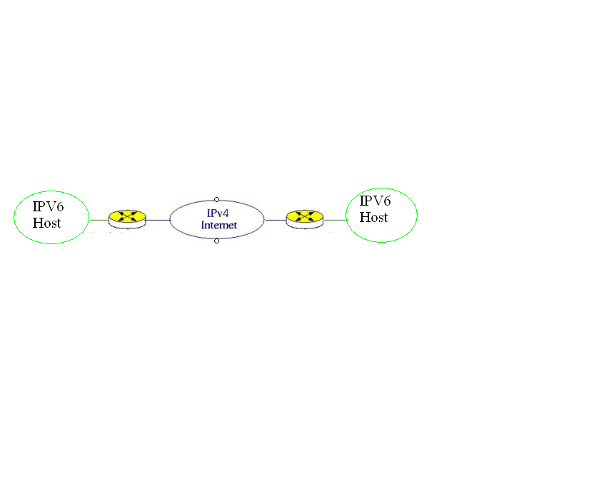
Tunneling
Tunnels allow you to get packets through IPv6 ignorant Routers and Switches by encapsulating IPv6 packets inside of IPv4 packets.
Tunneling is a strategy used when two computers using IPv6 want to communicate with each other when the packet must pass though a region that used IPv4. To pass though this region, the packet must have an IPv4 address. So the IPv6 packet is encapsulated in an IPv4 packet when it enters the region, and the IPv6 packet leaves its capsule when it exist the region. It seems as if the IPv6 packet enters a tunnel at one end and emerges at the other end. To make it clear that the IPv4 packet is carrying an IPv6 packet as data.

IPV6 Header

Payload
IPV6 Header

Payload
IPv4 header

IPv6 header

payload

Figure 2.0: Tunneling

Header Translation
Translation is for use for those who may prefer to use IPv6-IPv4 protocol translation for new kinds of internet devices such as cell phones, cars, appliances, or for those who need to entirely shed the IPv4 stack on their LANS.
Header translation is necessary when the majority if the internet has move to IPv6 but some system still use IPv4. The sender wants to use IPv6, but the receiver does not understand IPv6. Tunneling does not work in this situation because the packet must be in the IPv4 format to be understood by the receiver. In this case, the header format must be changed totally though header translation. The header of the IPv6 packet is converted to an IPv4 header.

IPV4 Header

Payload

IPV6 Header

Payload

IPV6 Header

Payload

Figure 3.0: Header translation

The Main IPv6 Header
Introduction
The IPv6 header is simpler and more efficient than the IPv4 header. The simplified IPv6 header helps to reduce processing costs. This topic discusses how the IPv6 header has been simplified. The base header and extension header are covered in this topic.

Base Header
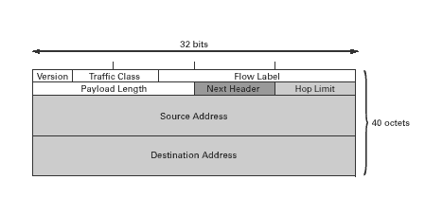
Figure 1 The format of an IPv6 base header.
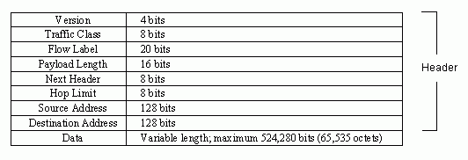
Figure 2 IPv6 datagram fields and field sizes

Version: The version field specifies the version number of the protocol. The version field is always 6 for IPv6 (and 4 for IPv4). This is also the first field examined by a router and has the same number of bits (4-bit) as in IPv4.

Priority: The 4-bit priority field defines the priority of the packet with respect to traffic congestion. The 16 values of the 4-bit field divide traffic into two priority groups: congestion-controlled and noncongestion-controlled. Values 0 through 7 are for transmissions that are capable of slowing down in the event of congestion, and values 8 through 15 are for real-time traffic whose sending rate is constant, even if all the packets are being lost. If one of two consecutive datagrams must be discarded due to congestion, the datagrams with the lower priority will be discarded.

Traffic Class: The traffic class field can be used to indicate the class of service desired for the datagram. The bits in this field allow a given datagram to have a higher precedence than others have when a router handles it.

Flow Label: The flow label is a 3-byte (24-bit) field that is designed to provide special handling for a particular flow of data. Flow labeling makes it possible to group and identify a series of datagrams that originate from a common application.

Payload Length: The payload length field (2-byte) indicates the length of the data field (excluding the base header) in the datagram. The payload length is limited to 65,535 bytes.
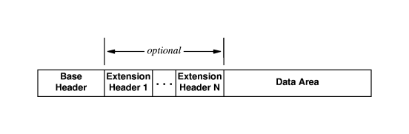
Figure 3 The general form of an IPv6 datagram. Extension headers are optional -- the minimum datagram has a base header followed by data.

Next Header: The next header is an 8-bit field defining the header that follows the base header in datagram. There are six optional header extensions: Hop-by-hop, source routing, fragmentation, destination support, authentication, and security encapsulation.

Code | Next Header
0 | Hop-by-Hop Options Header
6 | TCP
17 | UDP
41 | Encapsulated IPv6 Header
43 | Routing Header
44 | Fragment Header
46 | Resource ReSerVation Protocol
50 | Encapsulating Security Payload
51 | Authentication Header
58 | ICMPv6
59 | No next header
60 | Destination Options Header
Table 1 Next header codes

Hop Limit: This 8-bit hop limit fields serves the same purpose as the TTL field in IPv4. This field specifies the maximum number of hops a packet may travel before reaching the destination. Because there is no checksum in the IPv6 header, the router can decrement the value without needing to recalculate the checksum, which saves processing resources.

Source Address: The source address field is a 16-byte (128-bit) Internet address that identifies the original source of the datagram.

Destination Address: The destination address field is a 16-byte (128-bit) Internet address that usually identifies the final destination of the datagram.

IPv6 Extension Header
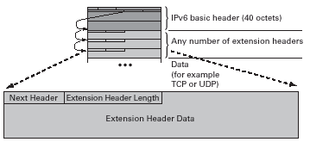

Figure 1 : IPv6 Extension Header

IPv6 options are placed in separate Extension Headers to facilitate routing and to provide a practical means to implement additional options. The Extension Headers are placed between the Transport Layer Header and the IPv6 Header. Several types of Extension Headers are defined for IPv6, a value in the Next Header Field identifies the type of Extension Header that follows. Every header contains its own Next Header Field to identify subsequent headers.
The Extension Headers are placed in order so that a router can stop reading the Next Header field once it reaches the last value or Extension Header that may pertain to it. In this fashion, all of the extension options do not have to be processed by each router that the packet traverses along its way to the destination. In fact, many IPv6 Extension Headers are not processed until they arrive at the destination.
The variable length Extension Header may extend beyond the 40 byte limit in IPv4 options. This flexibility allows for the practical use of security options in the Extension Headers. For example, the Authentication Extension Header may contain Algorithmic information to assure the secure IPv6 packet transfer.
Many options have already been defined for use in IPv6 Extension Headers. These options are grouped in integer multiples of 8 octets. This grouping format is used to retain alignment for the Transport Protocol Headers that follow. Some of the currently assigned options and the assigned values that identify them in the Next Header Field are:

- Hop-by-Hop Options header (header code: 0): Special options which require hop-by-hop processing.
- Routing header (header code: 43): Provides extended routing, similar to IPV4 source routing and full of partial route to follow.
- Fragment header (header code: 44): Contains fragmentation and Re-assembly information.
- Authentication header (header code: 51): Provides packet integrity and Authentication Security.
- Encapsulating Security Payload header (header code: 52): Confidentiality and provide privacy.
- Destination Options header (header code: 60): Optional information to be examined by the destination node.

a. Hop-by-Hop Options Header
It defines special options that require hop-by-hop processing. IPv6 implements an efficient method to alert routers of a packet that requires special processing. Packets that do not contain the IPv6 Hop-by-Hop Option Header are not fully processed by each router, instead they are allowed to quickly continue on their way to their destination. This method allows routers to quickly identify and fully process packets that require special route handling. Routers that recognize this Option Header examine the packets accordingly, routers that do not recognize this option ignore it.
This header consists of the following:
- Next Header (8 bits): Identifies the type of header immediately following this header.
- Header Extension Length (8 bits): Length of this header in 64-bit units, not including the first 64 bits.
- Option: A variable-length field consisting of one or more option definitions. Each definition is in the form of three subfield: Option Type (8 bits), which identifies the option; Length (8 bits), which specifies the length of the Option data field in octets; and Option Data, which is a variable-length specification of the option.

b. Routing Header
Routing Extension Headers are used by the source to control the routing of a packet. In this fashion, the Routing header may explicitly dictate the route from the source to the destination. The IPv6 address of each of the nodes along the path is included, and the destination then uses the reverse path for communication as well.

The routing header contains a list of one or more intermediate nodes to be visited on the way to a packet’s destination. All routing headers start with a 32-bit block consisting of four 8-bit fields, followed by routing data specific to a given routing type. The four 8 – bit fields are as follows:
- Next header: Identifies the type of header immediately following this header.
- Header Extension Length: Length of this header in 64-bit units, not including the first 64 bits.
- Routing Type: Identifies a particular Routing header variant. If a router does not recognize the Routing Type value, it must discard the packet.
- Segments Left: Number of route segments remaining; that is, the number of explicitly listed intermediate nodes still to be visited before reaching the final destination.
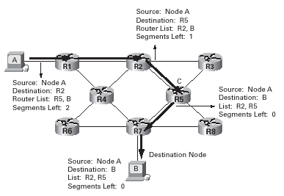
Figure 2 : IPv6 Routing Header
c. Fragment Header
Although the IPv6 effort aims to prevent subsequent fragmentation, the Fragmentation Header allows fragmented packets to traverse the IPv6 network. In IPV6, fragmentation may only be performing by source nodes, not by routers along a packet’s delivery path. Although this change is a major philosophical break with the past, it simplifies the routers’ work and makes routing go faster. A disadvantage is that the path between a source and a destination must remain reasonably static so that the path MTU discovery does not give outdated information.
If a router is confronted with a packet that is too big, it discards the packet and sends an ICMP packet back to the source. The source must use a path MTU discovery technique to find the smallest MTU supported by any network on the path. The source then fragments, using this knowledge. Otherwise the source must limit all packets to 1280 octets, which is the minimum MTU that must be supported by each network. The fragment header consists of the following:
- Next header (8 bits): Identifies the type of header immediately following the header.
- Reserved (8 bits): For future use.
- Fragment Offset (13 bits): Indicates where in the original packet the payload of this fragment belongs. It is measured in 64-bits units. This implies that fragments (other than the last fragment) must contain a data field that is a multiple of 64 bits long.
- Res (2 bits): Reserved for future use.
- M Flag (1 bit): 1 = more fragments; 0= last fragment.
- Identifications (32 bits): Intended to uniquely identify the original packet. The identifier must be unique for the packet’s source address and destination address for the time during which the packet will remain in the Internet. All fragments with the same identifiers, source address, and destination address are reassembled to form the original packet.
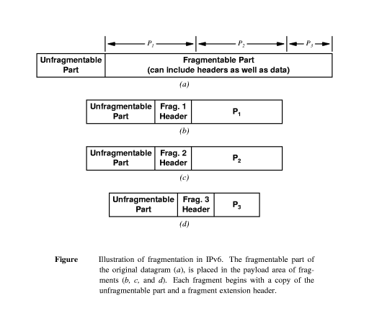
d. Authentication Header
The Authentication Header uses an algorithm to ensure that the IPv6 packet has not been altered along its path. The header also ensures that the IPv6 packet has arrived from the source listed in the IP Header. The authentication header provides a mechanism by which the receiver of a packet can be sure of who sent it. With IPV4, no such guarantee is present. The encrypted security payload makes it possible to encrypt the contents of a packet so that only the intended recipient can read it. These headers use cryptographic techniques to accomplish their missions.

e. Encapsulating Security Payload header
For packets that must be sent secretly, the encrypted security payload extension header is used. It starts out with a 32-bit key number, followed by the encrypted payload. The encryption algorithm is up to the sender and receiver, but DES in cipher block chaining mode is the default. When DES-CBS is used, the payload field starts out with the initialization vector (a multiple of 4 bytes), then the payload, then padding out to multiple of 8 bytes. If both encryption and authentication are desired, both headers are needed.

f. Destination Option Header
The destination Options header caries optional information that, if present, is examined only by the packet’s destination node. It is not used during routing. The format of this header is the same as that of the Hop-by Hop Options header.

ICMPv6 Header

Another protocol that has been modified in version 6 of the TCP/IP protocol siute is ICMP (ICMPv6). Internet Control Message Protocol version 6 defines IPv6 node to node messaging techniques. Nodes use ICMPv6 to communicate errors and to perform diagnostic functions. ICMPv6 has many changes from ICMPv4. The ARP and IGMP protocols in version 4 are combined in ICMPv6. The RAMP protocol is dropped from the suite because it is not used often.
ICMPv6 messages always follow an IPv6 Header and any IPv6 Extension Headers that may exist. A Next Header Field value of 58 identifies that the next header is an ICMPv6 Header. This header format is shown in Figure 1.2.
Type | Code | Checksum
Message Body
Figure1.2 ICMPv6 Header Format

The Type field is 8 bits long. This field defines the ICMPv6 Message as either an error message or an informational message. A zero in the high order bit of this field indicates that the message is an error message. A one in the high order bit indicates that the message is an informational message. In this fashion, type field decimal values from 0-127 are error messages, and values from 128-255 are informational messages.
The Internet Draft titled "Internet control Message Protocol (ICMPv6) for the Internet Protocol Version 6 (IPv6) Specification" discusses the message formats for the following ICMPv6 messages:
Error Messages |  | Informational Messages
1 | Destination Unreachable | 128 | Echo Request
2 | Packet too big | 129 | Echo Reply
3 | Time Exceeded
4 | Parameter Problem

The 8 bit Code Field depends on the message type. For an Error Message, the Code Field might give more specific information about the type of error encountered. The 16 bit Checksum is used to detect errors inside of the ICMPv6 message.
The Message Field may be used to contain part of the packet that an Error Message relates to. Note, the ICMPv6 packet may not exceed 576 octets. For Informational Messages the Message Field contains three separate fields; the Identifier Field, the Sequence Number Field, and the Data Field. The Identifier and Sequence Fields are used to invoke Echo Requests or match Echo Replies to their corresponding Echo Requests. The Data Field carries the information from the reply or arbitrary data for an Echo Request.

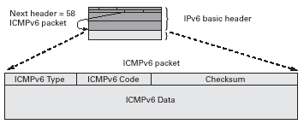
Figure 1 : IPv6 ICMP Packet

IPv6 ADDRESSING

IPv6 provides a 128-bit address space, as opposed to the 32 bits of version 4. Thus, in theory this allows for 2¹²⁸ ≅ 10⁴⁰ different addresses. Besides, IPv6 can address 3.4 x 10³⁸ nodes if address assignment efficiency is 100%.

There are three basic types of IPv6 address:
- Unicast - The address corresponds to a single computer. A packet sent to the
unicast address must be delivered to that specific computer. Example of unicast address format:

010 | Registry | Provider | Subscriber | Subnet | interface

- Anycast - It is also known as cluster addressing. The address corresponds to a
set of computers that share a common address prefix. A packet sent
to the address is routed along a shortest path and then delivered to
exactly one of the computers. Example for anycast address format:

Subnet prefix | 00000000000000

- Multicast - It defines a group of computers that may or may not share the
same prefix and may not be connected to the same physical network. A packet sent to a multicast address must be delivered to each member of the set. Example of multicast address format:

11111111 | Flags | Scope | Group ID

In IPv6, all zeros and all ones are legal values for any field, unless specifically excluded. Specifically, prefixes may contain, or end with, zero-valued fileds.

Address Notation
Although an address that occupies 128 bits can accommodate Internet growth, writing such numbers can unwieldy. For example, a 128-bit number written in dotted decimal notation:
105.220.136.100.255.255.255.255.0.0.18.128.140.10.255.255

To reduce the number of characters used to write an address, a more compact syntactic form - Colon Hexadecimal notation, had been recommend. In this form, each group of 16 bits is written in hexadecimal with a colon separating groups. Besides, it requires fewer characters to express an address. For example, the above example will become:
69DC:8864: FFFF: FFFF: 0:1280:8C0A: FFFF

Zero Compression, an additional optimization further reduces the size. It replaces sequences of zeros with double semicolons. Note that this form of address can only once per address. If there are two runs of zero sections, only one of them can be abbreviated. Reexpansion of the abbreviated address is very simple: Align the unabbreviated portions and insert zeros to get the original expanded address. For example:
FDEC: 0:0:0:0: BBFF: 0: FFFF

can be written as
FDEC:: BBFF:0:FFFF

In cases where the 0 string begins the address, the notation starts with the double colon. Example:
0000:0000:0000:0000:0AFF:1BDF:000F:0077

can be written as
:: 0AFF:1BDF:F:0077

This address can be further simplified with leading 0s within a four-digit group need not be listed. Example:
:: AFF: 1BDF: F: 77

Another type of IPv6 address is CIDR Notation. The example below show how can we define a prefix of 60 bits using CIDR.
FDEC: 0:0:0:0: BBFF: 0: FFFF/60

In particular, to help ease the transition to the new protocol, the designers mapped existing IPv4 addresses into the IPv6 address space. Any IPv6 address that begins with 96 zero bits contains an IPv4 address in the low-order 32 bits. The format is

80 bits | 16 | 32 bits
0000…………………………………………..0000 | FFFF | IPv4 address

Unicast Addresses
IPv6 unicast addresses are aggregable with prefixes of arbitrary bit-length similar to IPv4 addresses under Classless Interdomain Routing.

There are several types of unicast addresses in IPv6:
- Global unicast - the general format is

n bits | m bits | 128 - n - m - bits
Global routing prefix | Subnet ID | Interface ID
Where the global routing prefix is a value assigned to a site, the subnet ID is an identifier of a link within the site, and the interface ID is used to identify the interfaces on the link.
- Site-local unicast - it is designed to used for addressing inside of a site without
the need for a glocal prefix. The format is

10 bits | 54bits | 64 bits
1111111011 | Subnet ID | Interface ID

- Link-local unicast - it is used on a single link. The addresses are designed on a
single link for purposes such as automatic address configuration, neighbor discovery, or when no routers are present. The format is
10 bits | 54 bits | 64 bits
1111111010 | 0 | Interface ID
Anycast Addresses
An IPv6 anycast address is an address that is assigned to more than one interface, with the property that a packet sent to an anycast address is routed to the “nearest” interface having that address, according to the routing protocols’ measurement.

Anycast addresses are allocated from the unicast address space by using any of the defined unicast address formats. Thus, anycast addresses are syntactically indistinguishabl from unicast addresses.

For any assigned anycast address, there is a longest prefix P of that address that identifies the topological region in which all interfaces belonging to that anycast address reside. Within the region identified by P, the anycast address must be maintained as a separate entry in the routing system; outside the region identified by P, the anycast address may be aggregated into the routing entry for prefix P.

Multicast Addresses
Pre-defined Multicast addresses
The group ID’s defined in this section are defined for explicit scope values. Use of these group IDs for any other scope values, with the T flag equal to 0, is not allowed. Below is the reserved Multicast Addresses
FF00:0:0:0:0:0:0:0
FF01:0:0:0:0:0:0:0
FF02:0:0:0:0:0:0:0
FF03:0:0:0:0:0:0:0
FF04:0:0:0:0:0:0:0
FF05:0:0:0:0:0:0:0
FF06:0:0:0:0:0:0:0
FF07:0:0:0:0:0:0:0
FF08:0:0:0:0:0:0:0
FF09:0:0:0:0:0:0:0
FF0A:0:0:0:0:0:0:0
FF0B:0:0:0:0:0:0:0
FF0C:0:0:0:0:0:0:0
FF0D:0:0:0:0:0:0:0
FF0E:0:0:0:0:0:0:0
FF0F:0:0:0:0:0:0:0
The above multicast addresses are reserved and shall never be assigned to any multicast group.
All nodes addresses : FF01:0:0:0:0:0:0:1
FF02:0:0:0:0:0:0:1
The above multicast addresses identify the group of all IPv6 nodes within 1 scope 1 (interface-local) or 2 (link-local).

All routers addresses: FF01:0:0:0:0:0:0:2
FF02:0:0:0:0:0:0:2
FF05:0:0:0:0:0:0:2
The above multicast addresses identify the group of all IPv6 routers within scope 1 (interface-local), 2 (link-local), or 5 (site-local).

Solicited-Nodes Address: FF02:0:0:0:0:1:FFXX:XXXX
Solicited-node multicast addresses are computed as a function of a node’s unicast and anycast addresses. A solicited-node multicast address is formed by taking the low-order 24 bits of an address (unicast or anycast) and appending those bits to the prefix FF02:0:0:0:0:1:FF00::/104 resulting in a multicast address in the range FF02:0:0:0:0:1:FF00:0000 to FF02:0:0:0:0:1:FFFF:FFFF.

Conclusion
IPv6 is now a reality IPv6 and has come at the right time, as we are getting closer to running out of IPv4 addresses due to the Internet growing so rapidly. IPv6 also is the solution of the new disruptive applications that need more Internet Protocol features. All IP networks will have to move and the new IPv6 infrastructure allows the deployment of new applications based on peer- to- peer and the push models. With IPv6, the use of the network becomes simpler
Although the transition from IPv4 to IPv6 will be a larger task for some company or industry but the rate of IPv4 address consumption is rapidly increasing. Simplicity of deployment will be the key to rapid adoption. Internet service providers may wait until there are enough IPv6 applications to deploy IPv6 networks, and application developers may wait for the IPv6 network to be deployed first. They should not wait for others to be the firsts. So it is depends to the ISPs and application developers to take more and more IPv6 into consideration, and also all the business sectors to consider migrating to IPv6. Of course, if everyone waits until the last minute, it could end up costing much more, not just to engineer the transition, but in the cost of the disruption to what has become a crucial part of our economic and social infrastructure.
At last, IPv6 has a bright future. IPv6 will allow us to build a more robust and reliable Internet. IPv6 will also simplify the implementation and deployment of emergency response networks, making our lives safer and more secure.

LEARNING OUTCOME

We learnt a lot of new knowledge by doing this assignment. The following is the learning outcome from each member:

Goh Siew Lim:
“After doing this assignment, I have more understanding about IPv6, especially IPv6 packet structure. In my point of view, we have chosen the right topic because I get to know that IPv6 has become more important in the Information Technology environment. Therefore, as an IT student, it is necessary for us to have the basic understanding of the IPv6.”

Chua Lee San:
“As an IT student, knowing the development of Internet Protocol is very important. After doing the part of IPv6 addressing, I had learnt to differentiate addresses between IPv4 and IPv6. It is very useful for me when I involved my self in IT field in future.”

Chua Yi Ling:
“I have learnt more detail in IPv6 especially in part of Base Header. While doing this assignment, I had found much useful information about the components in Base Header and their function. Besides, I also get to know the differences between the base header in IPv4 and IPv6 and also the development of IPv6. Through this assignment, I had learnt new knowledge.”

Wee Siao Hui:
“I had gain new knowledge about the IPv4 and IPv6 after doing this assignment. I get to know more about the transition from IPv4 to IPv6 and the differences between them. In conclusion, I gain many benefits in IPv4 and IPv6.”

Lim Yen Nee:
“After doing this assignment, I learn more about the IPv6 and know more why IPv6 become adopted. I also get to know how to different IPv4 and the IPv6. I feel that IPv6 is important for networking and can overtake the task IPv4 and the use of IPv6 will be wider because it is better than IPv4.”

The most important thing that we learnt is the teamwork. Teamwork is very important in a group work. A good assignment only can produce with the cooperation from each member. Thus, teamwork that we learnt now will guide us to do well in future.

References

1. Widjaja, G. Communication networks: Fundamental Concepts and Key Architectures.
McGraw - hill

2. STALLINGS, W. Data & Computer Communication, 6th edition. Prentice Hall
International, Inc.

3. Forouzan, B.A., Data Communications and Networking (3rd edition), Singapore:
McGraw - Hill

4. Mark, J. W., and Weihua, Z. Wireless Communications and Networking. Prentice
Hall)

5. HaoJin, W., Packet Broadband Network Handbook. Prentice Hall

6. Comer, D.E., Computer Networks and Internets with Internet Application, 3rd edition.
Prentice Hall

7. BICSI, Network Design Basics for Cabling Professionals. McGraw - Hill

8. http://www.marsfind.com/search.html?keywords-IPv6

9. http://www.garykessler.net

10. http://www.zvon.org/tmRFC.RFC2460/output/chapter4.html

11. http://www.faqs.org/rfcs/rfc2553.html

12. http://www.geocities.com/SiliconValley/Foothills/7626/defin.html

13. http://www.ietf.org/html.charters/ipv6-charter.html

14. http://www.ripe.net/ripe/wg/ipv6/

15. http://www.ripe.net/comparison between IPv4 &IPv6 - Q&A.htm

