YuYuHakusho
Okay, so I know it's a little old and all,
but that doesn't mean I don't like it anymore.

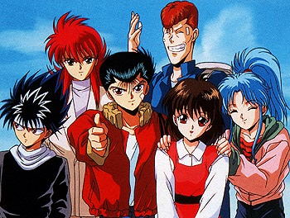
YuYuHakusho is an anime about a high school student named Yusuke (Eugene). He's very good at fighting which is why all the bullys in their neighborhood are, if not afraid of him, challenging him to fight. Although, even if he usually picks fights and cuts classes, he still had a pure heart. He one day goes home from school and rescues a little boy from getting hit by a car. By saving the little boy's life, he loses his. He turns into a ghost and is met by Botan (Charlene), a being from another world. She explains to him that he died early and that she can give him another chance to live if he goes with her to Koenma (Jericho), the ruler of the world she was from. At first, Yusuke didn't believe her, but then he figured, 'what the hell? he was dead anyway', so he goes with her and meets with Koenma. Koenma tells him that in order to be able to live again, he had to take care of an egg, and he would also have to get help from the people who're alive and care about him. He was able to successfully ask help from his girlfriend Keiko (Jenny), and so after a few days of floating around as a ghost, he came back to life and was back on his feet. That's not where the story ends, though. The day he comes back to life is also the day he saves the cat of his friend Kuwabara (Alfred), from this evil being he's never seen before. And that's when Botan tells him that he automatically became the detective of the world she was from and that his mission was to put an end to all the evil beings who want to destroy Earth and its people. He is given special powers and missions he had to accomplish. He meets Kurama (Dennis) and Hiei (Vincent), fellow fighters with supernatural powers, in one of his missions and they eventually become his friends. The three of them, along with Kuwabara who is also given special powers, fight with evil spirits and monsters throughout the series.

