Bilibin
Items: None
Djinn: Gust (Wind)
Enemies: None
Screens: 12
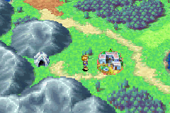From Goma Cave simply walk east to get to Bilibin.
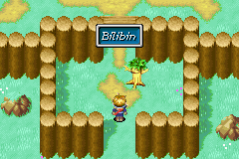The first thing you notice when you enter Bilibin it the strange tree standing by the gate. If you use mind read on it, it says “Help me somebody” because it use to be a man and he was turned into a tree by a Holy Tree.
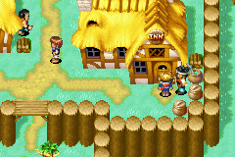The first thing you should do when you enter Bilibin is go to the Inn to heal yourself; the Inn is just to your right when you enter the town.
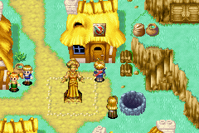You should then go to the weapons shop to buy some more powerful weapons. I suggest buying a broad sword for Isaac and Garet and a witch’s wand for Ivan. Now you need armour for Isaac and Garet you should get Leather Armour, Bronze Shield and a Wooden Cap. For Ivan you should get a Travel Robe, a Wooden Cap and Leather Gloves.
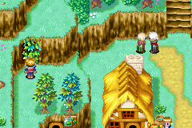Now head up the stairs next to the weapons shop and walk all the way around the town on the fence until you come to a cave mouth with Ivy covering the entrance. Use whirlwind and enter the cave.
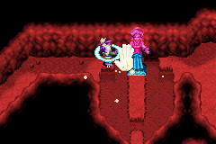Climb down the ladder and walk over to the statue. Use move to slide the Statue down so you can get past.
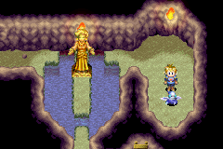Jump over to the other side where you will see a wind Djinni, don’t worry you don’t have to fight this one.
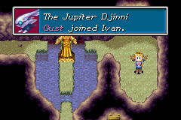Just press A on it and it will join Ivan. You can now leave this cave and walk all the way back on the fence.
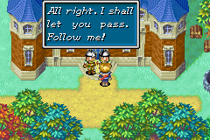Now head to the northern end of town go up the stairs and you will se a palace talk to the guard on the right and he will let you in.
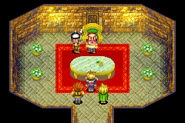Head straight up past the stairs and through the door at the end of the corridor. In this room a man talks to you he says he will give you the key to the barricade but he changes his mind because he thinks you are just wee Children.
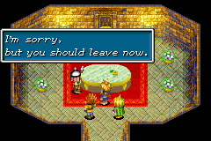The Guard then tells you that you should leave, he then talks to you out side he says that you might not need a key to the barricade to get to Kolima.
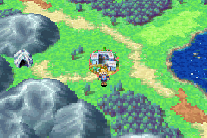There is noting else to do in Bilibin so head back out to the world map.

Next part Kolima/Forest

