Goma Cave
Items: Lucky Medal
Djinn: Forge (Fire)
Enemies: Zombie, Bat, Will Head, Ghost, Skeleton, Forge (Djinni)
Screens: 31

Getting to Vault:
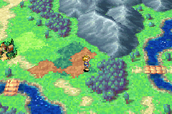To get to Goma Cave first head east across a bridge.
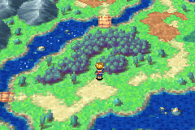Then head northeast past the first bridge you see and up to the next.
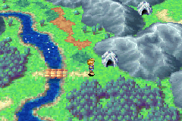You can see Goma cave when you get over the Bridge so just walk into it.
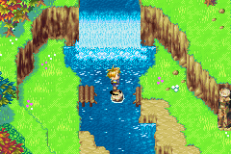You are now at the entrance to Goma cave head north then jump across the river by the bridge.
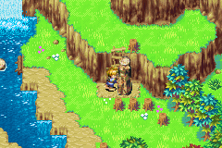There is a pillar blocking your way up the ladder you don’t need to use move just push it out of your way.
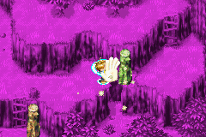Now you will see a pillar blocking your way across a small gap use move and pull it toward you so it drops into the gap and you can walk over.
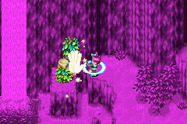Climb up the next ladder and walk across you will see a stump trapped in the ivy try to use move on it but you can’t move it.
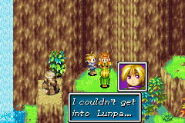Once you have tried to move it Ivan will come to help you, he use whirlwind to rip the ivy off the stump so you can move it.
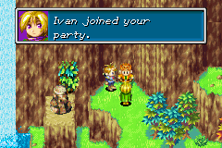Ivan tells you that he can’t get onto Lunpa so he has decided to help you on your quest.
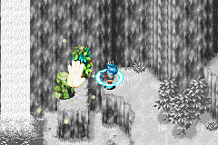You can now use move on the stump so push it into the river.
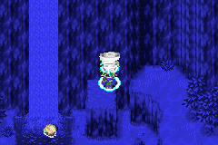You now need to use Ivan’s whirlwind to open the cave mouth. You can now finally enter Goma Cave.

Goma Cave:
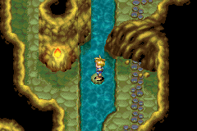Head north until you can’t go any further then jump across the water by jumping on the rock in the middle of it.
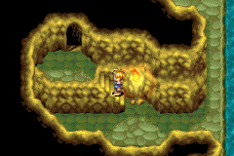Head south along the stream and up the stairs to your left then through the door.
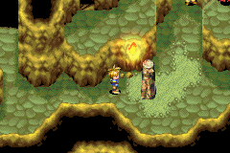Head down the stairs and then east till you get to the other end of the room.
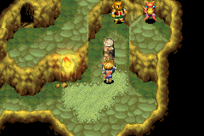Push the pillar across and then up as far as it will go so you can jump from ledge to ledge when you get up there.
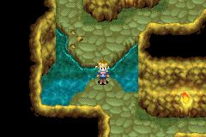Head back west and down where you can jump across a small stream of water. Then head east and through the door.
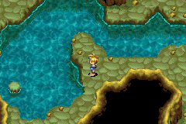Head north and then across at the waters edge and then jump onto the rock in the water and then onto the other side.
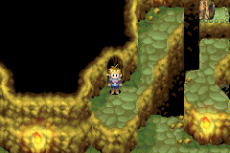Head north and up the stairs in this room you will see a pillar blocking your way across a gap.
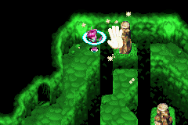Use move and push it away from you so you can jump across.
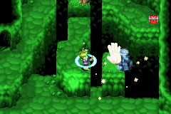Jump across and use move to push the stump off the ledge it’s sitting on.
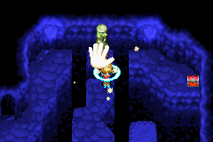Head back up and use move to push the pillar to your left so you can gets what’s in the treasure chest.
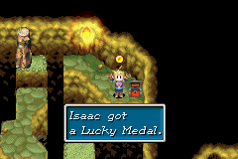Jump up and across to checks what’s in the chest it’s a Lucky Medal don’t throw it away you use them later on in the game.
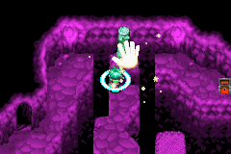Walk back across and use move to move the pillar out of your way so you can go back down the stairs you came up.
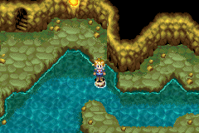When you go down the stairs you will notice that the stump you pushed up in the other room has fallen into the water making a stepping-stone for you to get across the water.
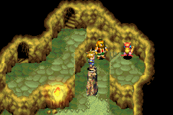Walk across and up the stairs then jump onto the pillar you move a while ago and jump onto the ledge with the first fire Djinni on it the prepare to fight it, I suggest setting Flint and healing any of your wounded characters the Djinn is not very hard to beat but it sometimes runs away and you have to leave the room and come back to fight it again.
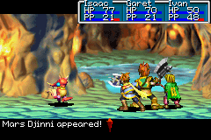With Isaac first unleash Flint then summon Venus.
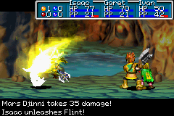
With Garet just keep attacking it normally because fire psyenergy isn’t very effective on it and with Ivan keep using Ray and you will probably beat it within two turns.
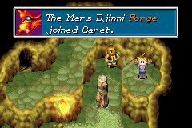
When you beat it, it will join with Garet you can now jump back across and through the door to the north.
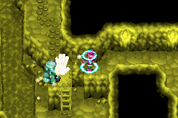Head straight up and across you will see a stump use move on it and push it into the water the jump across.
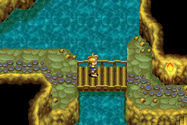Head up through the door then east across a bridge, down the stairs and down to the exit of Goma Cave.
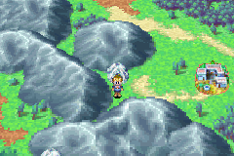You have now exited Goma Cave and your next stop is Bilibin Which you can see on your map.

Next Part Bilibin

