Vale Part One
Items: None
Djinn: None here
Enemies: Bat, Vermin, Wild Mushroom, Mystery Man (Saturos) and Mystery Woman (Menardi).
Screens: 19

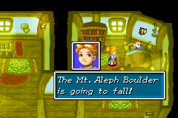You begin the game with Isaac, the main character being awoken by his mother Dora. She gives you your tunic and tells you to proceed south to the plaza. From the house head north, up the stairs and around the house until you meet a guy (Garret) trying to pull a chest full of his stuff to safety.
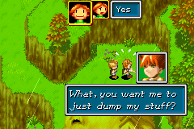Talk to him twice and tell him to dump his stuff and he will join your party. Continue on north and across the bridge to your left. Head down and you will see a cut scene of four people trying to stop a boulder from crushing Vale.
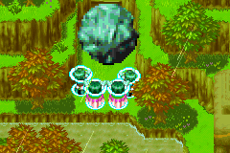After walking down the steps head left. Continue on, speak to the man lying on the ground who thinks he’s dying. He will tell you that a boulder has broken the fence and there are monsters everywhere. Then he will ask you if you think he is going to die if you say yes he will die and if you say no he won’t it doesn’t really matter though.
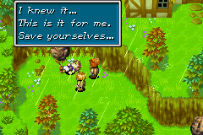Start heading south there you will encounter you first monster battle but it is nothing to worry about.
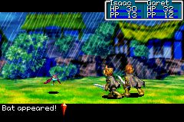Head east till the next screen, from here head south and you will encounter an awkward situation. A guy named Felix is in the river holding on to a piece of wood but no one has any psyenergy left to save him.
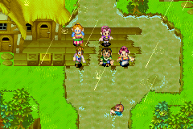They will talk for a while then Jenna and your mother will go to get help. Your mother will come up to you and ask if you could help Jenna find someone with some psyenergy left. Head south and across the bridge to the east till the next screen. Continue east and go do the steps then head south till you see a Jenna and a group of other people, walk up to them and they will talk for a while then a man will come who has enough psyenergy to save Felix.
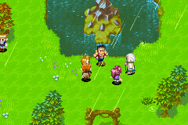 Head back up north the way you came to the bridge there you will stop and Dora will ask if you found anyone to save Felix. Then you will go down to Felix but just before you can save him the Mount Aleph Boulder start to fall.
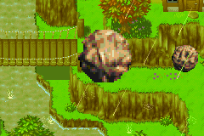Everyone runs to safety before it lands.

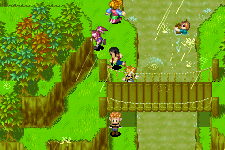But Jenna’s parents, Isaac’s father are on the wharf and Felix is in the water and they can’t get away in time and the boulder lands right on top of them.
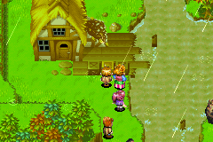You get control of Isaac again, head back to the plaza where you found the man to help Felix but when you get to the next screen you will see a man and woman on the cliff above you.
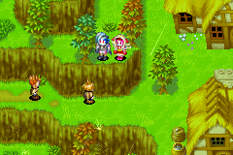
They will talk about the Sol Sanctum them Garret will come running up behind you a yell your name, the man and woman notice you and come to the edge of the cliff and ask if you were eavesdropping. It doesn’t matter what you say they will fight you and win there is no point trying here because you are meant to lose.
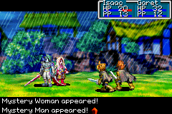Once you are defeated you will see yourselves lying on the ground unconscious.
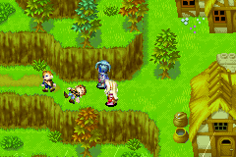 It is three years later and Isaac is on the roof of his house Jenna walks up past you to Garret who is training his psyenergy. They will talk for a while then walk to Isaac who is repairing the roof using his psyenergy.
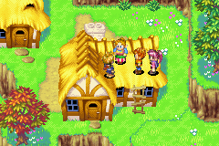Dora, Jenna and Garret climb onto the roof with Isaac and talk for quite a long time, eventually Garret and Jenna join you party and you get off the roof.
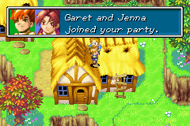 Head north up to the bridge to the west, cross it and head west where you did at the beginning of the game. You will meet Saturos and Menardi they were talking to Kraden about the Sol Sanctum they will let you go.
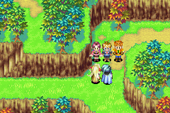
Head east a bit more and up the stairs to Kraden’s house he is talking to himself about Saturos and Menardi and how they know so much about the Sol Sanctum.
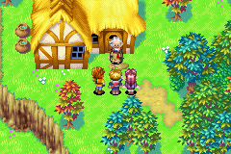
He then notices you and talks to you about them he thinks they might be robbers stealing from the Sol Sanctum, but he thinks that you should check if what they said about the Sol Sanctum was true so they know if they have actually been in there. He then goes into his house and gets four mythril bags then he comes back out and join your party but no as a playable character. Head back from where you came over the bridge and up the stairs to the north, and up to your left. A elder will jump out from behind a tree and chase you back to the stairs and ask you if you were trying to sneak up mount Aleph.
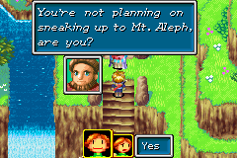
Once he has gone to the other side of the building run back up before he sees you to the entrance of the Sol Sanctum.
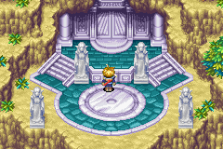

Next Part Two Sol Sanctum

