Kolima/Forest
Items:
Djinn: Granite (earth)
Enemies: Bat, Ghost, Zombie, Troll, Skeleton,
Screens: 25

Getting to Kolima:
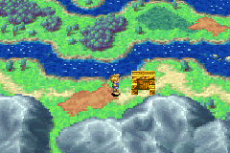From Bilibin had southeast in-between the mountain Range and a river until you get to the Bilibin Barricade.
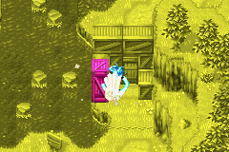Walk up to the barricade and use move on the box on the left hand side to side it down and let you past. Walk through the gap you have just made and leave Bilibin Barricade.
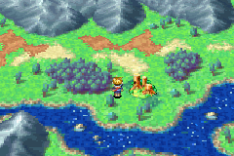Head east across the bridge and then keep going further east till you get to Kolima.
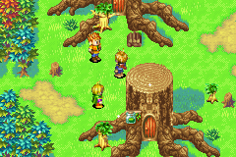When you enter Kolima you find that everyone has been turned into trees.
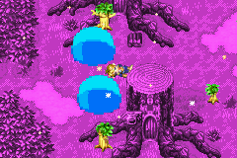Then the Holy tree that turned them into trees tries to turn you into a tree but your Psyenergy saves you.
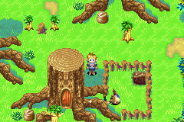When you get control of Isaac again head across to your right where you will see a fenced off area next to a building with an Earth djinni inside. There is a non-visible door at the back off the house next to the fenced off area that leads to a cave.
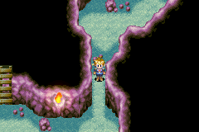Climb down the ladder into the cave from their head left then up and around following the cave until you reach another ladder.
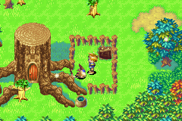Climb the ladder up and you are in the fenced off area with the earth Djinni don’t worry you don’t have to fight this one either.
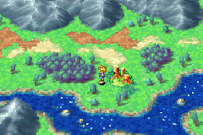You can now exit through the cave and leave Kolima. You are now going to Kolima Forest.
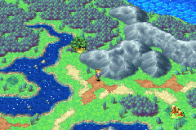Head northwest from Kolima and you will see the entrance to Kolima Forest.
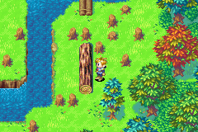One in Kolima Forest head straight up and to the left you will see a log push it into the water. Then walk up and over the bridge there you will see another log push this one backwards and walk past it to the next screen.
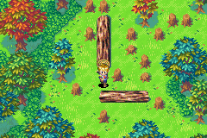Their will be another log in front of you just ignore it and walk down then left and push the horizontal log down. Now head up as far as you can go then west and up to the next screen.
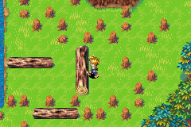Walk to the left and up and push the vertical log to the left.
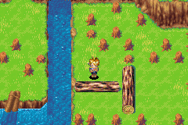Now walk up through the gap in the stumps and push the horizontal log down. Then push the vertical log back where it came from and the other horizontal log down.
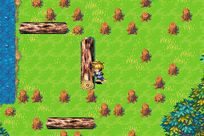Push the first horizontal log back up then walk around all the stumps and push the vertical log into the water.
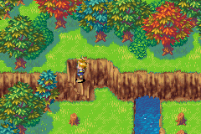Jump across the water and walk up the stairs and then all the way along to the right.
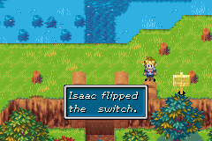In this screen head down and to the right and flip the switch next to the dam that holds the water in, the water drain out so you can move the logs.
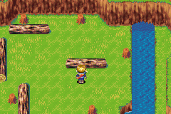Walk back to your left and down the stairs, now push the two horizontal logs up.
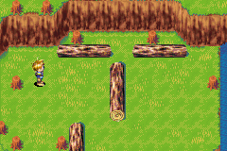Then push the vertical log next to them across to the right. Then push the lowest vertical log to the right then push the two horizontal logs back to where they came from.
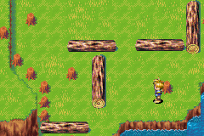Then push the lower vertical log back to where it came from.
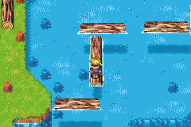Now go back up and flip the switch by the dam so the logs float giving you a path to the item on the other side.
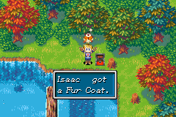The item in the chest is a fur coat you can equip this to any one of you characters.
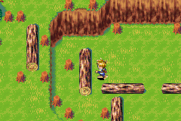Now leave this screen and come straight back to reset the puzzle, which makes things a lot easier. Flip the switch and go back down the stairs then push the vertical log up the top to the left.
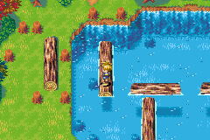Now go back up and flip the switch then jump from log to log to reach the other side.
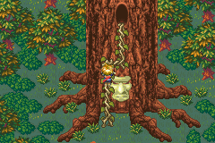
Walk straight up to the next screen their you will see the two tree’s that spoke to you earlier. You don’t need to talk to them just head east and climb up the vines on the tret.

Next Part Tret Tree

