Sol Sanctum
Items: Small jewel x2, Herb
Djinn: None here
Enemies: Vermin, Wild Mushroom, Bat, Slime, Amaze
Screens: 37
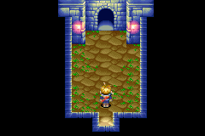Head straight up to the next screen where you will find a pool of water with stepping-stones in it.
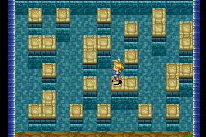Jump onto the one furthest to the right and make your way to the other side and head straight through the door. You are now in a long corridor just follow it to the next door you may encounter some monster battles on the way.
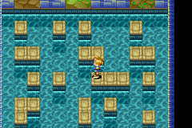Now you will find another pool with stepping-stones, jump onto the one in the middle first and straight up to the middle door where you will find a chest with a small jewel in it.
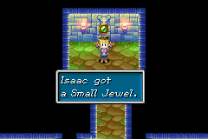Head back down to the pool and walk half way down the stepping-stones in the middle then cross over to the right and up to the door on the far right. Follow the path and you will see a relief of a minotaur with one of tis eyes missing put the small jewel into the eye socket and you will hear the sound of shifting stones.
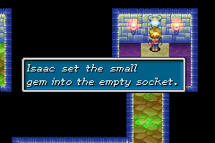Walk back to the pool and across to the other side then walk to the far left and onto the stepping-stones, head straight up to the other side and follow the path to the next door. There you will find what the elders think is the Sol Sanctum but Kraden thinks it looks strange because the Sol Sanctum is built in honour of the sun and yet there is nothing there to reflect that. Walk to the right of the room and push the statue with dots around it across to the right.
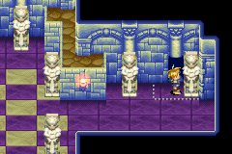 Walk through the door and up the stair to the next room, head to the right and straight up until you see an intersection.
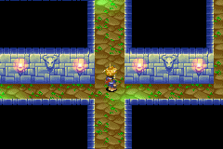
Walk to the left and follow the path until you find a chest open it and you will find another small jewel. Head back to the intersection, then go straight up and then left at the first corner. Follow the path to the next door.
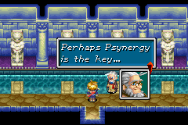You will be in a room with lots of statues, walk to the statue furthest to the left and use move to slide the statue across to reveal another minotaur with an eye missing, put the small jewel in the socket and you will hear the sound of stones shifting again.
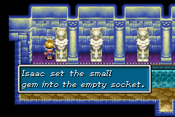 Then walk to the statue on the far right and use move to slide that across revealing a door. Walk through the door to the next room.
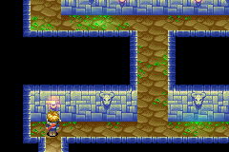Head across to your right and up then left to find a chest with a herb in it. Then head back down, across and to your right and up to the real Sol Sanctum.
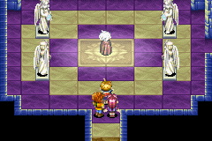 You will talk for a while with Kraden, say that you will go further with him and continue. Head across to the left and you will talk to Kraden a bit more, he will stay in that room and tell you to continue on.
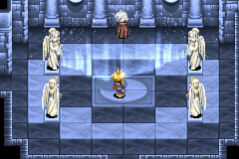Walk down and up the stairs, if you want to hear yourself you can head down from where you are now into another room and use Isaac’s heal to restore you health and then pick up the purple psyenergy stone in front of you to restore you psyenergy.
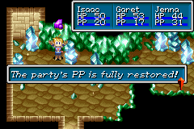Then head back out of this room and up to the next room with a picture of the sun in the middle of it.
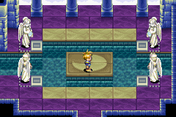Head over to the other room on you left, it has a picture of the moon in it.
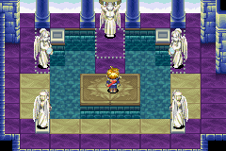Move the statues on the right and left of this room into the grey things.
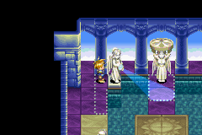Once you have moved both of them a hole will appear in the floor in front of the statue in the middle of the room. Walk onto the platform in front of the hole and use move to slide the big statue into the hole and you will hear something click.
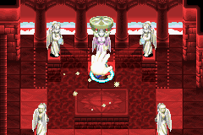 Then head over to the room with the moon in the middle of it and slide all of the statues into the grey things turning the moon into the sun.
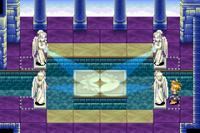Then go back down to where Kraden is and he will talk to you, now head over to the other room to left and you will see that the picture of the sun has turned into the moon. There is also light coming from the centre of the moon and hitting the wall
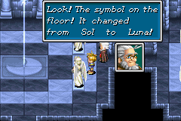Walk to where the light hits the wall and press A to look at it and a portal will open up.
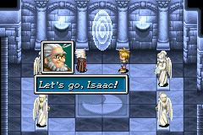You will find yourself in the middle of a room with stone pillars sticking out of the water all around you and at each corner of the room the elemental stars are in the hands of statues.
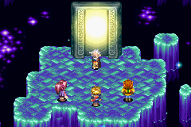
You talk to Kraden for a while, then he tries to get the elemental stars put the pillars are to slippery, so he gives you the four Mythril bag he got from his cottage and tells you to go and get them for him.
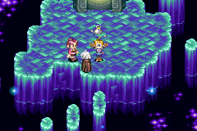
When you get control of Isaac again head to the top right of the stone you are standing on and jump onto the pillar closest to you then go as far right as you can then down to get the first elemental star Venus (earth). When you get it more stone pillars will pop out of the water giving you access to the next star.
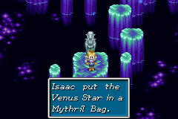Had back up and to your left then up until you can see the next elemental star then jump across to it and get the second elemental star Mercury (water), more pillar will pop up again giving you access to the third star.
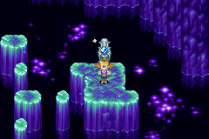Head back to where Kraden and Jenna are, then jump onto the pillar at the bottom of the screen and jump from pillar to pillar to get the next star Jupiter (wind).
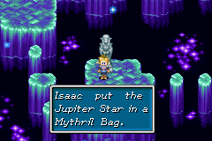Then you will notice that Saturos and Menardi are with Kraden and Jenna and they want you to give them the elemental stars. They talk for a while then another guy comes through the portal he is wearing a blue and green mask. They talk again for a while then the guy wearing the mask takes it off and it’s Felix Jenna’s brother who everyone thought had died three years ago. They talk for a while again then Garret goes to give them the Elemental Stars and another guy called Alex, Garret gives him the Elemental Stars and they ask you to go and get the remaining one.
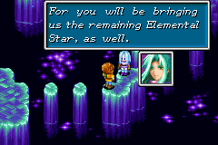
When you get control of Isaac again head back up to where you got the Mercury Elemental Star. Then head up as far as you can go then go left until you see a place where you can go down, keep going that way until you get to the Mars Elemental Star.
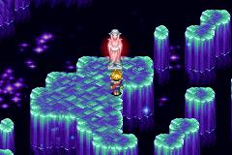When you get the Mars star the earth begins to shake, the water disappears and lava starts appearing in cracks in the ground.
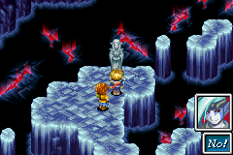Saturos, Menardi, Alex and Felix start talking about what they are going to do then the wise one appears it looks around at everyone.
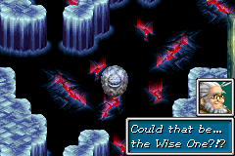 Saturos, Menardi, Alex, Felix, Jenna and Kraden leave through the Portal leaving Isaac and Garret alone with the wise one.
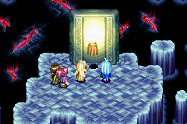Isaac and Garret talk for a while then the wise one appears next to them.
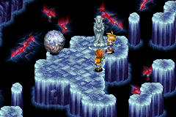Lava starts coming out of one of the cracks in he ground the wise one stops it from flowing then the elemental Djinn come out of the statues.
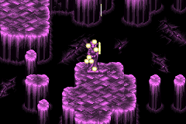
The wise one talk to Isaac and Garret about what is happening then the lava stars coming out another crack and the wise one stops this as well.
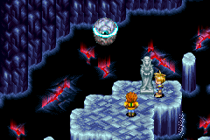Then he tells them to go but they don’t know how so the wise on transports them back into the room with a picture of the moon on the floor.
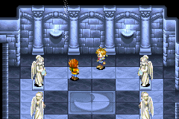When you finally get control of Isaac again you have to run out the way you came in. Just keep heading down through all of the rooms and just follow all the corridors and eventually you will make your way out side.
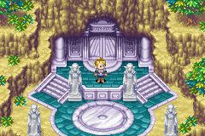Once out side run down to the village, there everyone is waiting. When you get down to them they want to know what happened, you go into the Sanctum where you explain what happened. During their explanation the wise one spoke to the great healer and explained what happened. The wise one then tell the great healer what will happen if no one stops Saturos, Menardi and the others. Then the great healer says that saving the world is Isaac and Garrets fate alone, and then the wise one appears and tells you that you are brave and that you need to find the lighthouses and the elemental Djinn. Then the wise on and the elders leave and Dora and the Mayor decide that they should go tomorrow.
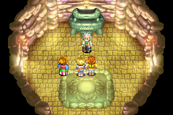The next day everyone is gather around the gate leading out of vale, bidding farewell to Isaac and Garret you talk for a while and get a herb and catch beads, then they say one final farewell and you leave vale.
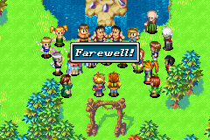
Next Part Three Vault

.

