My thoughts and Philosophies on things.

For one thing, I would like to tell you about my self. I have way too many thoughts to tell you, it would take a while.

Things that might happen if I tell all of them to you.

- Your brain would explode and therefore be in a billion itsybitsy pieces.
- You would die.
- You would never think again.
- I would be a human and you would be a pile of crap.
- If my thoughts were formed into a ball of energy, It would probably destroy everything, even other universes.
One thing that I have observed is that people have butts. If you look back in the middle ages, people had butts then too. IT’S SIMPLY AMAZING!!!! Nowadays people say that butts are for turning guys on, sitting, and excreting fesses. But upon further investigation and inspection, I have come to another conclusion.
  - I have decided that butts hold the key to universe travel. By looking at a piece of grass with human crap on it, I see that in the crap live other things. If I arrange those living things DNA in a manner, they look like little humans. This means that they produce the link to other universes that exist in past times because my brain knows.  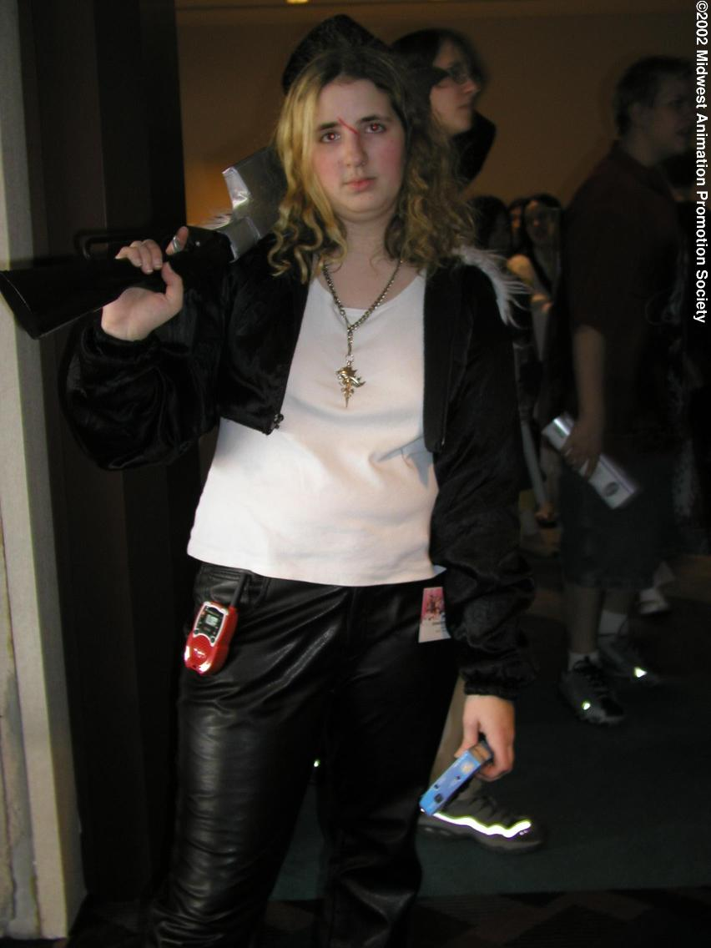
  - Also, back in the days, butts were used as transportation. Butts used to be black holes until it was time to crap. People would jump in a butt crack and swallowed up. People had to wait till that person had to crap, once they did, they would crap for about an hour straight. They did this because it took that long to crap out the whole body. Some times people were stuck inside a person’s body. When people were stuck inside a person’s body they would….
  - Walk around. If a guy was stuck in a girl
, sometimes that girl would be pregnated. One time a girl became Pregnated but the guy was stuck inside the baby. So the baby had a guy for an eyeball.
One time a girl even turned into a katana. I believe we should reconnect with these powers to better society.

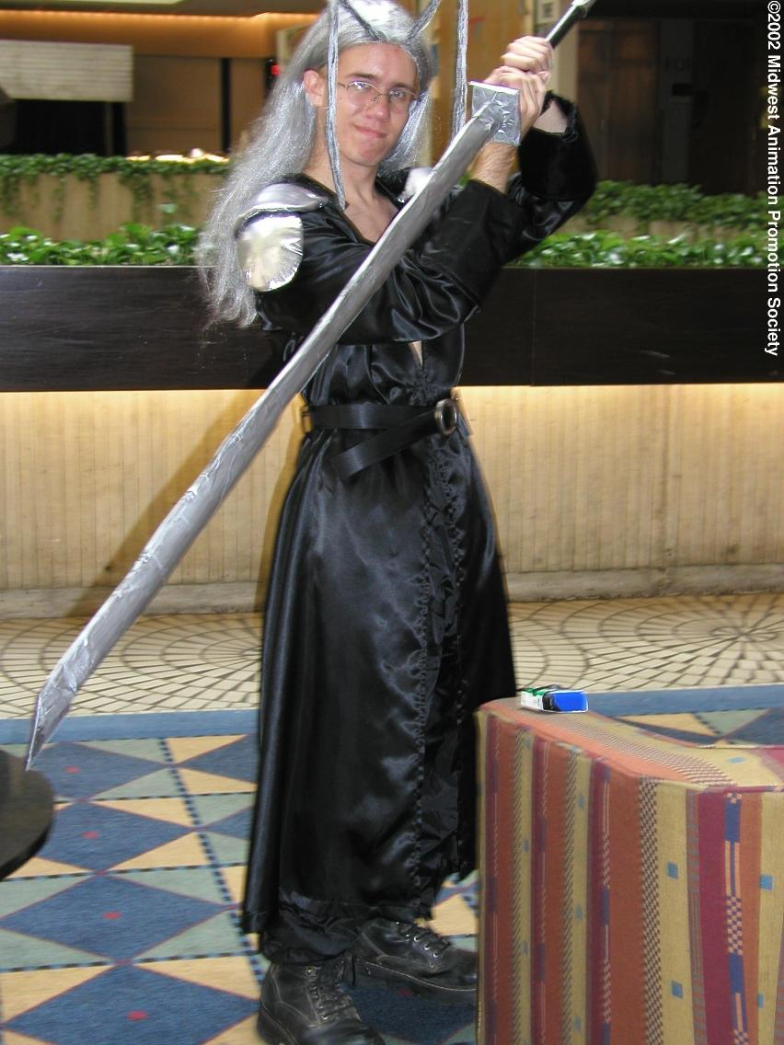
Black holes do exist, and so do other universes, I intend to one day, travel to another universe.

My contact info

By the way, I want you to decode this message, if you can then I will make out with you remember I love a person with a black hole as there face…….

