Months of the Year
Lunary Winter
Merry Brea Spring
Harch Spring
Pril Low Summer
Way May Low Summer
Lune Low Summer
Lullay High Summer
Caesar High Summer
Amber High Summer
Tember Autumn
Tober Autumn
Cymber Winter

Days of the Week
Moonday The Moon’s Day
Duesday Market Day
Wotansday W’ansday
Thunorsday Thunor’s Day
Freyasday Freya’s Day
Reapsday Hela’s Day
Sunday The Sun’s Day

Time
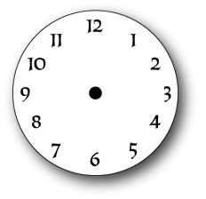

Days of the Month
1 | 2 | 3 | 4 | 5 | 6 | 7
8 | 9 | 10 | 11 | 12 | 13 | 14
15 | 16 | 17 | 18 | 19 | 20 | 21
22 | 23 | 24 | 25 | 26 | 27 | 28

Festival Days
1 | 2 | 3 | 4 | 5 | 6 | 7

Notes

Pulses

