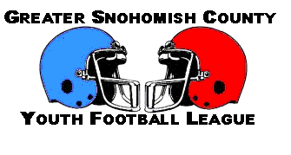

Association: ______________________________________________________________
2006 Midget Teams

Team Name | Head Coach | Phone | Colors
Team Name | Head Coach | Phone | Jersey | Pants | Helmet

2006 Junior Teams
Team Name | Head Coach | Phone | Colors
Team Name | Head Coach | Phone | Jersey | Pants | Helmet

