INTRODUCTION
Past and Present of Civil Engineering Practice in Nepal
Gyaneswor Pokharel, Dr. Eng.
JSTC Domestic Research Fellow
Public Works Research Institute, Ministry of Constructions, Tsukuba, Japan

ABSTRACT: This paper introduces the current state of civil engineering practice in Nepal and future prospectus. The historical perspective of civil engineering is briefly outlined. Then, the modernization plans of the civil engineering based infrastructures and the currently faced problems are explained. From the ongoing natural and manmade disasters, the major losses in human lives and property loss is primarily attributed to the water induced disaster, especially, flash flood, surface erosion, debris flow and landslides, etc. The tectonic movements, and excessive deforestation to fulfill the fuel demand and the increasing population have accelerated these processes. While the problems along major highways and reservoirs, are attributed to the insufficient site investigations during project design as well as the construction of less efficient substructures. The aging of the existing structures without proper regular maintenance is also considered another problem arising largely because of the lack of fund. On the other hand, the large hydropower and tourism potentials of the country are slowly attracting foreign investments. This perspective of civil engineering based infrastructures if utilized effectively; the other problems can be solved as the economic condition gradually moves ahead. Overall, Nepal remains very much challenging place to advanced civil engineering projects and construction technologies.

In Nepal, the developments in the practice of civil engineering continue to be influenced by the unique combination of extremities comprising its geographical location, topography, geotectonic, climate and cultural diversity (Fig. 1~4). Nepal is situated between 26° 22' and 30° 27' north latitude and 80° 04' to 88° 12' east longitude and is sandwiched between two giant countries, with Peoples Republic of China to the north and Indian to the east, west and south (Fig. 1). It is one of the few landlocked countries of the world and the nearest seacoast is 1,127 km away. Nepal is well known as a mountainous country (Fig. 2), where the mountains and hills occupy about 83% of the total land area. There is a narrow flat area close to the border with India and stretching the length of the country, which is locally known as the Terai. Perhaps most unique feature of Nepal is the variation in altitude across the breadth of the country, with a low of about 60m at Jhapa in the southeast to the tall Himalayan range in the north, where the 8848m high Mt. Everest is located. It may be interesting to note that the word ‘Himalaya’ means ‘the Abode (alaya) of the snows (Him)’ in Nepali language.

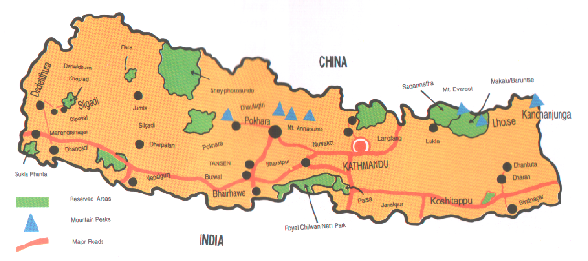

Figure 1: Map of Nepal
The length of the country (east-west) is about 800km and the width (north-south) is about 190km, with the total land area of 147,181 sq km. The temperature variation from north to south is accordingly quite drastic and the annual precipitation varies from less than 300mm to more than 5,500 mm with an average of about 1,500mm. Monsoon entering from the southeast causes heavy rain from early June to the end of September. 80% of the annual rainfall and 85% of the annual run off from all the rivers and rivulets occur during this period, during which the steep slopes are vulnerable to landslide and erosion.

Contact Address: E-mail: webmaster@CivilEngOnLine.com URL: http://www.CivilEngOnLine.com/
Topographically, the landforms is roughly divided into three regions (Fig. 2), each comprising distinctive features in terms of environment, peoples, economy, customs, and culture. The contrast in the landforms from the high Himalayas in the north to the low plain area in the south is the result of the continental tectonic phenomenon resulting from the collision of Indian plate with the Eurasian plate (Upreti & Dhital, 1996). As a result, Nepal is one of the seismically active regions of the world. It is also clearly evidenced by the occurrence of destructive earthquakes periodically.

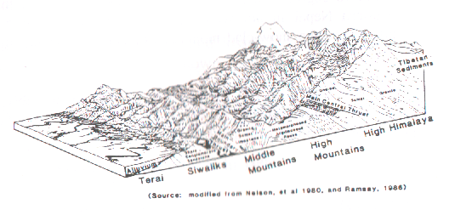

Figure 2: Physiographic regions of Nepal (DPTC, 1994)

The heritage in relation with civil engineering
Historically Nepal was represented by Kathmandu valley alone in both name and fact until the country assumed its present form in the 18th century. From the beginning the valley has been the center of urban civilization. The valley’s traditional prosperity came from its fertile soil and its strategic location on the trans-Himalayan trade route between India and Tibet. Traders, scholars, monks, pilgrims, and envoys from many countries journeyed through the valley and left a legacy of diverse ideas and influences. History is encoded in the valley’s traditional art and architecture and lives in legends, festivals, and customs, some over 1,500 years old (Moran, 1991) that act as direct links to the past. The existence of Buddhist and Hindu architecture within close neighborhood (Fig. 3) in the valley clearly indicates the peaceful development of two distinct cultures.
Kathmandu offers superbly arranged and skillfully built temples, cities, buildings, and palaces and clearly proves the finest artistic achievement in the past. From the ordinary house to the multistoried temple their buildings are masterpiece of design decorated with exquisite detail. Communities centered about palace squares organize Cities. More shrines sprang up in the public squares in front of the palaces, creating a virtual forest of pagodas, pillars, and temples (Moran, 1991). These large-scale construction works were constructed under royal interest and financial support. The classic Pagoda styled Hindu temples (e.g. Fig. 3) were built on the geometric design of a Mandala, with the four directions symmetrically balanced. A school of thought believes that the architecture was first developed in Nepal and then spread into China and beyond (Moran, 1991). The equivalent Buddhist shrine is the Stupa, a solid hemispherical dome.
Besides these temples, palaces, and housing, the water supply (public sunken fountains and water taps) and drainage system of the old age Nepal is also notably well established. Some of these public utilities are still working well.

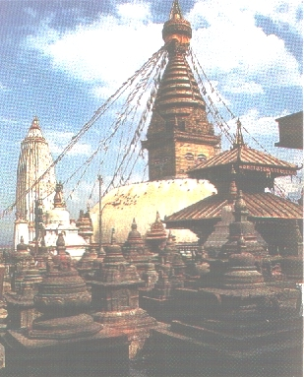

Figure 3. Sisterly development of Hindu Pagoda architecture and Buddhist Stupa (Tourism Board of Nepal)

Civil engineering in the early part of this century
Integration of Nepal beyond the current size was ceased in 19th century. The written history of Nepal outside Kathmandu valley began parallel with the integration work in 18th century. Until this time, the civil engineering and architectural work outside valley does not noticeably exist except a few places e.g. the Lumbini (the birth place of Lord Buddha), Janaki Mandir and few royal palaces. In the early part of 20th century, the construction of modern buildings were started under the guidance of foreign architect e.g. Singha Durbar by French architect. The Singha Durbar was considered as one of the largest buildings in Asia. The building was destroyed by fire in 70s and the remaining part still accommodates major government offices and Ministries at the heart of the Kathmandu valley. In addition to this big government office building, there were many European styled building constructed during the Rana regime as ruling families’ residential building/palaces and many government offices now occupy these buildings. Even though, the country did not have a single university graduated architect or civil engineer, the European consulting architects and engineers were hired in those constructions and the building remained in tact in regions’ most deadly Earthquakes e.g. The Great 1934 EQ. This can be attributed to the thick masonry wall and heavy foundation work. They used brick masonry and timber for flooring and roof girders. In this period, there was not any notable construction of public utilities in and outside the Kathmandu valley.

Civil engineering in modern Nepal
Nepal was opened to the outside world after the Rana regime transferred government to publics in 1950. Many foreign countries established their embassies and Nepal became a member of UN, too. The poverty in the country due to lack of infrastructure such as technology, education, hospital and transportation system still became a setback in industrializing the country. Foreign educated civil engineers and architects started introducing their own development plans. In these 50years since the end of the Rana regime, more than 10,000 kilometers of roads were constructed. Because of lack natural resources and technical know how, most of the national roads were constructed either by foreign aid or long-term loan. The east-west national highway that connects east and west borders was completed in the beginning of ‘90s. The national highways to connect major towns in mountains still remained a major problem especially due to the heavy cutting of steep slopes. Besides the infrastructures related to transportation, there has been significant progress in the construction of water supply systems, irrigation canals, local government buildings, schools, hospitals, and similar infrastructures. Due to the lack of regular maintenance and renovations, the aged infrastructures are now either crumbling or became inefficient. This can be attributed to the lack of enough funds as well as the poor management system.
In 1990, multiparty system was restored in Nepal and public elected government took hold over the government again and investment from the private sector was promoted to take leading roles in the inefficient government owned industries. The domestic private companies are now involved in various large-scale construction works partly funded by government or fully funded by themselves with partial loan from national and multinational banks. Many construction projects with new/different technologies are emerging near or around the religious places (e.g. recently completed Cable car attracts domestic tourists) and the places that attract overseas tourists (Figure 4). His Majesty's Government of Nepal has introduced a new Tourism Policy in1995 to promote tourism sector. Major existing facilities are being upgraded. The tourism industry is growing very rapidly. In 1995 around 363,400 overseas tourists visited Nepal. Considering the projected arrivals (1 million/year by 2005) and the existing hotels, there will be a big shortage of world-class hotels in important tourist destinations like Kathmandu and Pokhara.
The construction and operation of hotels and resorts offer very promising prospects for profitable investment. Similarly, foreign investment in popular tourist activities and recreations seems moving in positive direction, especially in capital-intensive tourism industries such as hotels, resorts and in areas that transfer modern technology and skills.

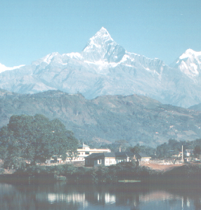

Figure 4. Fishtail mountain makes Pokhara as one of the best tourist place in the world (Photograph courtesy of http://www.pokhara.com/).

Abundance of water as a natural resource: multipurpose hydropower projects
Theoretical hydropower potential of Nepal's rivers, based on average flows has been estimated to 83 million kilowatts (Economically Feasible Capacity is 44000 MW), which is one of' the largest potential in the World. Despite the enormous hydropower potential, till now Nepal has been able to generate only 0.3% of its total hydropower potential. Demand for power is growing at about 10 percent annually. At present electric power supply is available to only 14 percent of the population, thus, the peoples are still using the conventional fuel wood. It is enunciated that the country's power demand will grow to 1,640 MW by the year 2015. A large amount of power produced in Nepal can be easily exported to neighbouring countries. Small sized hydropower projects are being privatized and it is taking somewhat a positive speed.
Major multipurpose hydropower projects e.g. Karnali Chisapani Projects (10,800MW, project cost: about US$5 billion) that involve multination, especially India and Bangladesh. Such large scaled multipurpose projects require detailed studies and equal share of project costs with respect to direct or indirect benefits e.g. downstream advantages. Down-stream advantages especially refer to the control of flood in India and Bangladesh and it is becoming difficult to estimate such benefits. The developed countries e.g. Japan and USA had difficulty in joining the free market opened by Nepal, perhaps because of the differences in construction method, cost, market and policies. Nepal Electricity Act of 1993 was introduced to provide access for the sale of its power to other countries as well as to invite investments from large sized international companies e.g. Enron Int’l. Nepal and India entered into a Power Trade Agreement that allows independent mutual power deals on government, semi government and private sector levels between the two countries.
Table 1: Hydropower Potential in Nepal
Average annual flow (cubic meters) 225 Billion
Theoretical Generation capacity 83000 MW
Economically Feasible Capacity 44000 MW
Existing Hydropower generation 253 MW
Demand by 2005 610 MW

Table 2: Major Hydropower Projects in Nepal
Name of | Installed | Average | Cost
The Project | Capacity | Annual | Million
 | (MW) | Energy | US$(GWH)
Arun III | 402 | 2891 | 852.6
Karnali (Chisapani) | 10,800 | 20842 | 4812
Upper Arun | 335 | 2050 | 500.8
Pancheshwor | 6,480 | 10671 | 2980
Lower Arun | 308 | 2275 | 481.1
Kali Gandaki-2 | 660 | 2660 | 772.0
Burhi Gandaki | 600 | 2495 | 774.0
Upper Karnali | 240 | 1665 | 365.0

Nepal introduced, the Income Tax Incentives for Hydropower Projects, e.g. 5 years tax waives for the Generation of electricity and similarly in investments on Transmission work has 10 years tax waives. The multinational business firms from overseas could utilize the local cheap labor force, construction material, and technical employees; the investments in hydropower business are promising and it opened big room for foreign investors to exploit the multipurpose hydropower business potential in Nepal. It will open further industrializing the country in broader term and overall economic development of the country.

WATER INDuced natural disasters
As mentioned in the introduction, more than 80% of the average annual rainfall precipitates in just 3-4months (June-September) and 85% of the annual run off from all the rivers occur during this period. This intense rain and high amount of surface flow makes this period vulnerable for slope failures. Upreti & Dhital (1996) write that the damage caused by landslides and slope failures in the Himalayan region was estimated to cost more than US$1billion in economic losses, causing more than 200 deaths every year, which is about 30percent of the total of such losses worldwide. Rapidly increasing construction of infrastructure, such as roads, irrigation canals, and dams; without enough Geotechnical investigations, is contributing considerably to triggering the landslides. Such infrastructures are also often severely damaged by mass movements. For example, the heavy rain in July 19-21, 1993 and resulting flood caused severe damages to major national highways, and Kulekhani hydropower station. The damage confined to gullies, steep soil slopes, and slopes with highly weathered rock. Debris and mudflows, rockslide, soil and/or rock slope failures, and riverbank scouring were most common. The landslide near Jogimara and the wash out of the Malekhu Bridge along Prithivi national highway (Pokharel et al, 1997) closed the route for months. Similarly, there were more than 2,000 landslides along another national highway (Tribhuvan Highway) and adjacent areas (Upreti & Dhital, 1996). JICA funded DPTC and ICIMOD have carried out detailed studies and summarized the major water-induced landslides occurred recently and in the past.
Beside the immediate effect of the rain, the high altitude valleys in Himalayan mountain also suffers from accumulation of excessive snow in ice form, called glacier lakes and there is always risk of Glacial Lake Outburst Floods (GLOF). There had been losses of human lives and property due to the GLOF on the downstream villages.
Mitigation of Water induced Slope Failures
In the early days of large-scale infrastructure developments, e.g. roads, importance of Geotechnical engineering (e.g. the site investigation works) works was not recognized properly, especially, because of lack of geotechnical professionals. Thus, the possibility of the post construction Geotechnical hazard was never quantified, neither were there any hazard maps prepared. Upreti & Dhital (1996) writes that different approaches to mitigate the water induced landslide and slope failures have been developed recently. Deoja (1991) introduced a hazard mapping method suitable to domestic use that deals with geotechnical engineering concerns such as slope as well as hydrological and geological features. Such maps can show not only the hazard level, but also, also the main type of failure, extent, and direction of movement in case of failure.
Upreti & Dhital (1996) points out that the slope stabilization work has a very recent history in Nepal. Such work is mainly confined to important road constructions. Construction of retaining walls, modification of slope gradients and improvement of drainage condition are the most commonly employed methods. Currently, the Department of soil conservation, HMG Nepal, is trying to motivate local peoples through various training programs to control and stabilize the landslide and slope failures by using low-cost methods such as tree-planting, check-dams, and use of local materials. Similarly, the government has recently introduced some trial projects to siphon the water from GLOF and reduce the water level on the GLOF.
Some slopes that are still in the risk of further movements & failures are monitored (e.g. DPTC, 1994). In some cases, bioengineering techniques especially the local natural fibers are also used to stabilize the slopes. Normally such stabilization works are undertaken on landslides of moderate or small size. Photograph (Fig.5) shows a slope stabilization site that has a unique combination of retaining wall; rock anchoring, surface and subsurface drains as well as bioengineering works. The soil-nailing system that is most successful in Japan may be applied with slight improvements by attaching anchor plates at the end of soil nails (Fig. 6). In Nepal, this method may prove to be an economical and a light slope stabilization system to moderate to small sized slopes. The solution to the heavy cutting of steep slopes is only the costly tunneling work that is almost impossible under current economic situation of the country.

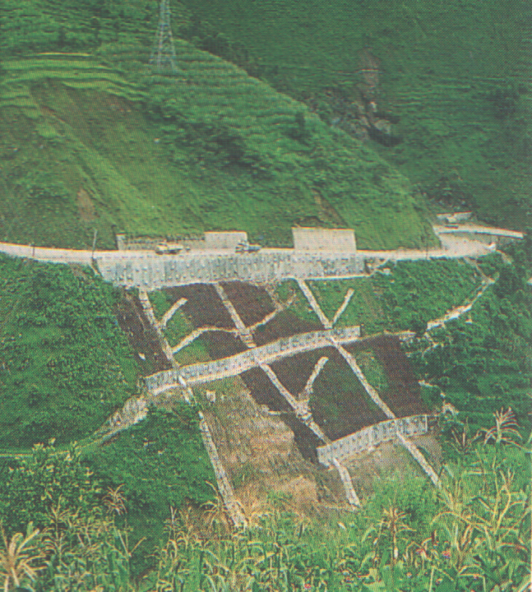

Figure 5. A typical slope stabilization work
(Photograph after ICIMOD, 1996)

Concluding remarks
As Nepal moves to the 21st century, she has opened a large room for civil engineering projects related to infrastructure developments as well as business oriented multipurpose hydroelectric projects. Even though the land-to-sea route will remain always unpredictable, the air route to east and west will play vital role in the tourism and recreational sectors. Multinational companies will exploit the advantage of two giant neighbors and the huge water resources in Nepal. With the passes of time and economic growth, the technology in infrastructure developments to natural disaster mitigation will advance accordingly. Overall, the infrastructure developments and the practice of civil engineering in Nepal will remain unique and a challenging job to the Civil Engineering profession because of the unique combination of extremities comprising its geographical location, topography, geotectonic, climate and cultural diversity.

Acknowledgements: The author is grateful to Mr. A.S. Dhakal for the reading materials and Prof. M.B. Karkee for his advice in the course of preparation of this manuscript. I am also grateful to Nepal Tourism Board for providing the various bulletin and CD ROM.

references
Deoja B.B., M. Dhital, B. Thapa, A. Wagner (editors) (1991): Mountain risk engineering handbook, ICIMOD, Kathmandu
DPTC Annual Disaster Review, 1994, JICA/Nepal
Moran (1991): Nepal Handbook, Moon Publications, USA
Nepal Tourism Board Bulletin: Recent Publications
Nepal Tourism Board CD ROM on Nepal (1999): Investment opportunities in Nepal for Multinational Companies, Feasible Project Areas.
Pokharel, Dhakal and Bhattarai (1997): Rainfall Induced Disaster and Landslides of 1993 in Nepal in Geotechnical Engineering Perspective, 14th ICSMGE, Sept. 1997, Hamburg.
Upreti & Dhital (1996): Landslide studies and management in Nepal, ICIMOD, Kathmandu.

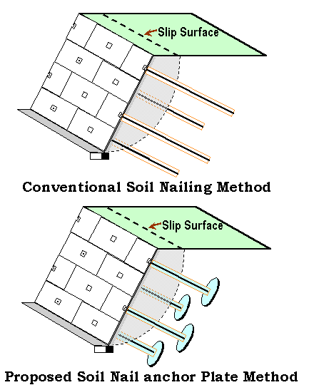

Figure 6. Proposed soil nailing method with and without
anchor plate attachments

