AREAS & VOLUMES OF REVOLUTION
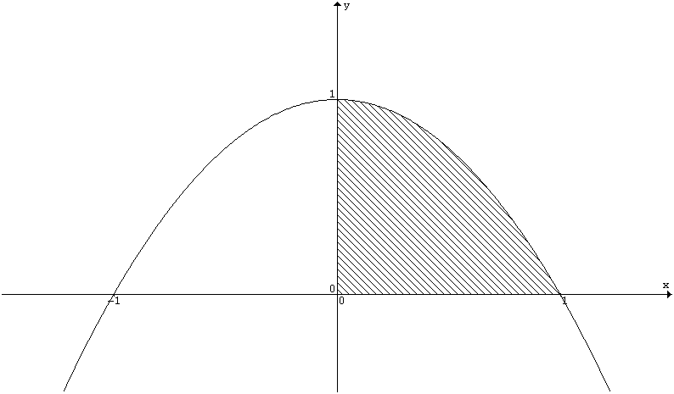 | y = 1 – x²  Area = ∫ y dx = ∫ 1 – x² dx  Volume of revolution about x–axis  = π∫ y² dx = π∫(1 – x²)² dx  Volume of revolution about y–axis  = π∫ x² dy = π∫1 – y dy
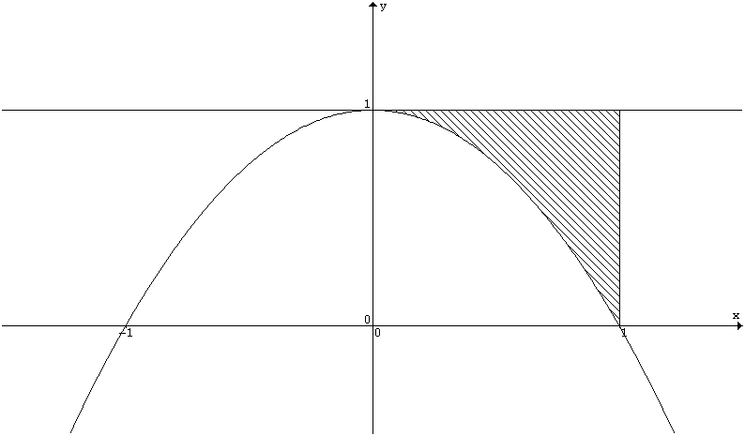 | y = 1 – x²  Area = ∫ 1 – y dx = ∫1 – (1 – x²) dx  Volume of revolution about x–axis  = πr²h – π∫ y²dx = π1²1 – π∫(1 – x²)² dx  Volume of revolution about y–axis  = πr²h – π∫ x² dy = π1²1 – π∫1 – y dy
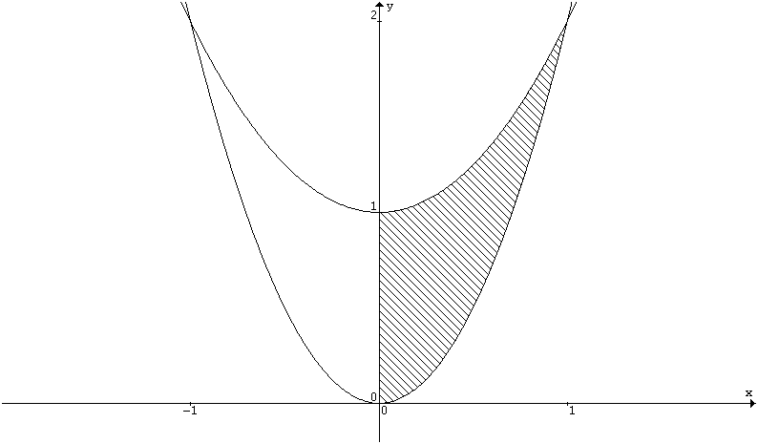  f(x) = x² + 1  g(x) = 2x² | f(x) = x² + 1, g(x) = 2x²  Area = ∫ f(x) – g(x) dx = ∫(x² + 1) – 2x² dx  Volume of revolution about x–axis  = π∫ [f(x)]² dx – π∫ [g(x)]² dx  = π∫(x² + 1)² dx – π∫ (2x²)² dx  Volume of revolution about y–axis  = π∫ (g^{–1}(y))² dy – π∫ (f^{–1}(y))² dy  = π∫ dy – π∫ y – 1 dy
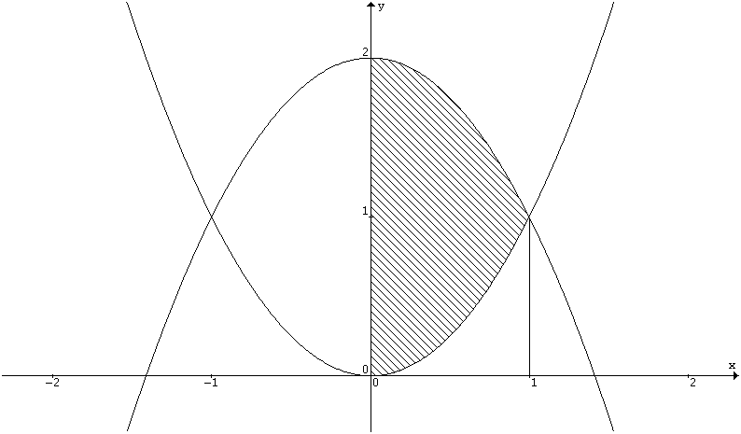  f(x) = 2 – x²  g(x) = x² | f(x) = 2 – x², g(x) = x²  Area = ∫ f(x) – g(x) dx = ∫(2 – x²) – x² dx  Volume of revolution about x–axis  = π∫ [f(x)]² dx – π∫ [g(x)]² dx  = π∫(2 – x²)² – (x²)² dx  Volume of revolution about y–axis  = π∫ [g^{–1}(y)]² dy + π∫ [f^{–1}(y)]² dy  = π∫ y dy + π∫ 2 – y dy
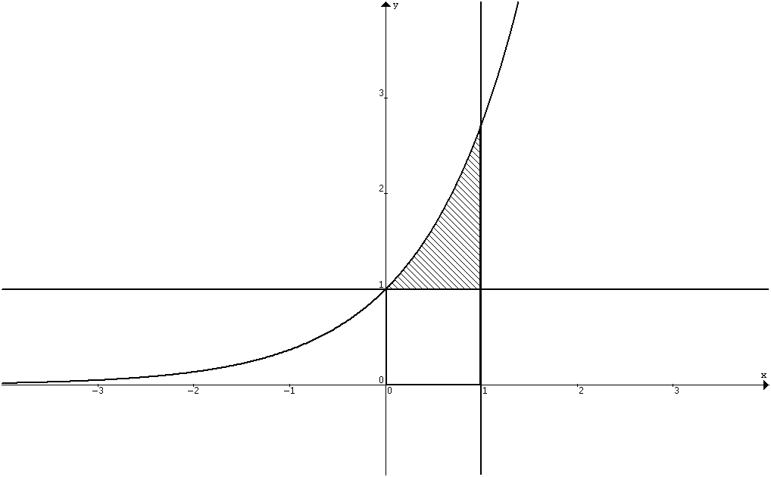 | y = e^{x}  Area = ∫ y – 1 dx = ∫e^{x} – 1 dx  Volume of revolution about x–axis  = π∫ y² dx – πr²h = π∫(e^{x})²dx – π1² 1  Volume of revolution about the line y = 1  = π∫ (y – 1)² dx = π∫ (e^{x} – 1)² dx  Volume of revolution about the line x = 1  = π∫(ln y – 1)² dy i.e. rotate y = e^{x+1}

