Summary of Complex Numbers
Modulus and Argument
arg (1 + i) = tan^{–1} = arg(1 – i) = – tan^{–1} = –
arg(–1 + i) = π – tan^{–1} = arg(–1 – i) = – (π – tan^{–1} ) = –
If z = , then | z | = =
and arg z = arg(–1 + i) – arg(–1 – i) = – (– ) = = – 2π = –
If z = 1 + i, then | z¹⁰ | = | z |¹⁰ = ¹⁰ = 32 and arg (z¹⁰) = 10 arg z = 10 ( ) = = – 2π =
=
= – – i
Let (x + iy)² = –1 + 2i  x² – y² + 2ixy = –1 + 2i  x² – y² = –1 ––– (1)  2xy = 2 ––– (2)  Substitute y = into (1): x² – = –1  x⁴ – x² – 2 = 0  x² =  x² = 2, –1 (rej.)  x = , –  y = 1, –1  ∴x + iy = 1 + i, –1 – i. | ∴the square roots of 3 + 4i are ±(2 + i).
If a polynomial with real coefficients has complex roots, they occur in conjugate pairs.
Loci
Conjugate  z  z* | Multiplication by i and –i  z  iz  –z  –iz | Parallelogram Law  z  w  z + w
| z – (1 + i) | = 2  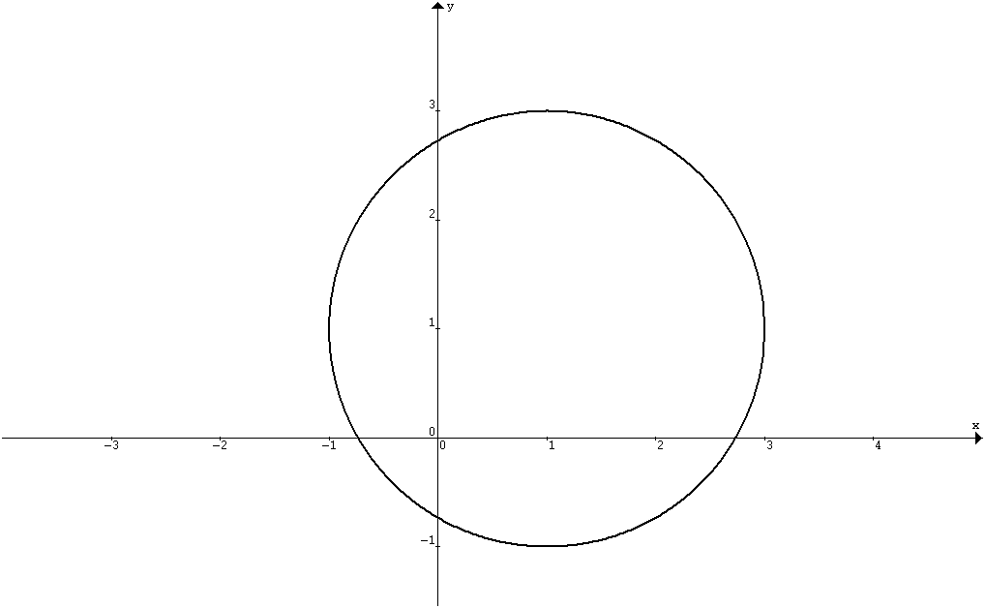  Circle with centre at (1, 1) and radius 2. | | z – 2 | = | z – i |  Perpendicular bisector of line joining (2, 0) and (0, 1). | arg (z – (1 + i) ) =  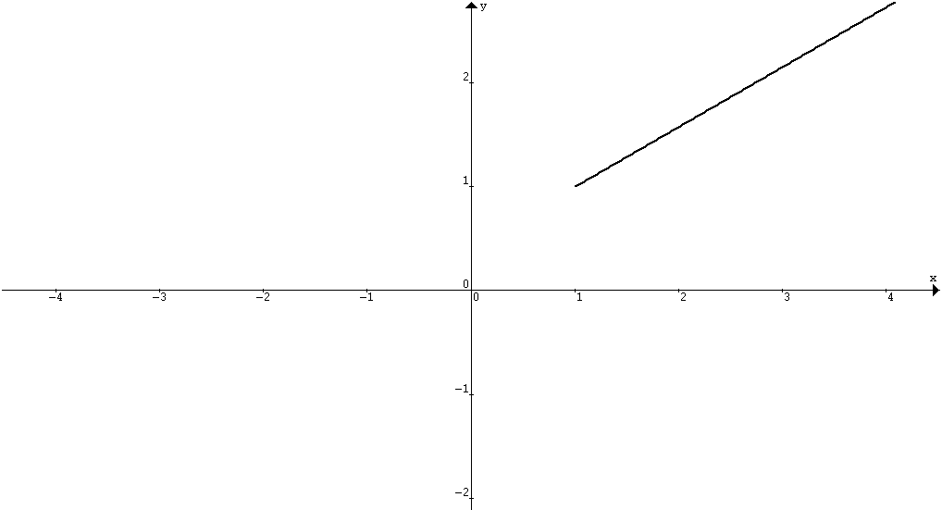  Half line from A(1, 1) (excluding the point A) making an angle π/6 with the positive x –axis.
| z – (1 + i) | ≤ 2  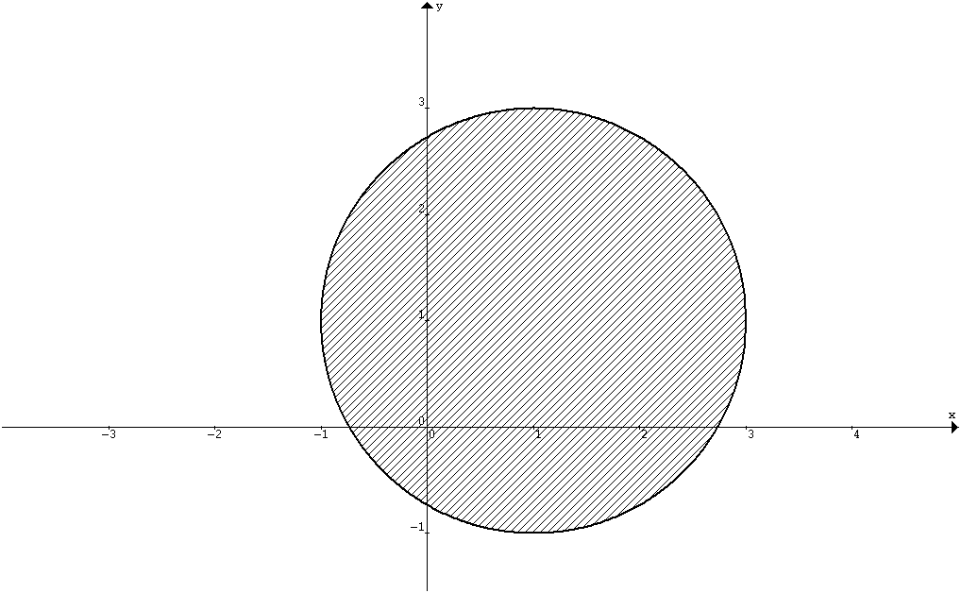 | | z – 2 | ≤ | z – i | | 0 ≤ arg (z – (1 + i) ) ≤
| z – (1 + i) | ≤ 2  =  Max | z – 4 | = + 2  Min | z – 4 | = – 2 | | z – (1 + i) | ≤ 2  =  Max arg(z+3)= tan^{–1}+sin^{–1}  Min arg(z+3)= tan^{–1}– sin^{–1} | | z – (1 + i) | = 2  Intersections of the loci | z – (1 + i) | = 2 and | z – 1 | = | z – i |  are 1 + + (1 + )i  and 1 – + (1 – )i.
Modulus–Argument Form and Exponential Form
Euler’s Formula: cos θ + i sin θ = e^{iθ}
De Moivre’s Theorem: (cos θ + i sin θ)^{n} = cos nθ + i sin nθ
e^{i(θ+2nπ)} = e^{iθ} cos θ = ( e^{iθ} + e^{–iθ} ) sin θ = ( e^{iθ} – e^{–iθ} )
1 = e^{i0} = e^{i2nπ} i = e^{iπ/2} –1 = e^{iπ} –i = e^{–iπ/2}
1 + i = 2(cos + i sin ) = 2 e^{iπ/3} 1 – i = 2(cos – i sin ) = 2 e^{–iπ/3}
–1 + i = 2(cos + i sin ) = 2 e^{i2π/3} –1 – i = 2(cos – i sin ) = 2 e^{–i2π/3}
E.g. If z = cos θ + i sin θ, then
= =
= = = = i cot
Eg. z⁵ = 1 = e^{i2nπ}
z = e ^{i2nπ/5} , n = –2, –1, 0, 1, 2
= e^{– i4π/5}, e^{– i2π/5}, 1, e ^{i2π/5}, e ^{i4π/5}
Eg. z⁵ = 1 + i = 2e^{iπ/3} = 2e^{i(2nπ+π/3)}
z = 2^{1/5}e , n = –2, –1, 0, 1, 2
= e^{– i11π/15}, e^{– iπ/3}, e ^{iπ/15}, e ^{i7π/15}, e ^{i13π/15}
Eg. z¹⁰ – 2z⁵ + 4 = 0
⇒ z⁵ = = 1 ± i = 2e^{±iπ/3} = 2e^{i(2nπ±π/3)}
z = 2^{1/5}e , n = –2, –1, 0, 1, 2
= e^{– i13π/15}, e^{– i11π/15}, e^{– 7iπ/15}, e^{– iπ/3}, e ^{–iπ/15}, e ^{iπ/15}, e ^{iπ/3}, e ^{i7π/15}, e ^{i11π/15}, e ^{i13π/15}

