Summary of Rational Functions
 |  | Numerator
Denominator | constant c | linear (cx – d) | quadratic cx² + dx + e
linear (x – a)  1 vertical asymptote  x = a | 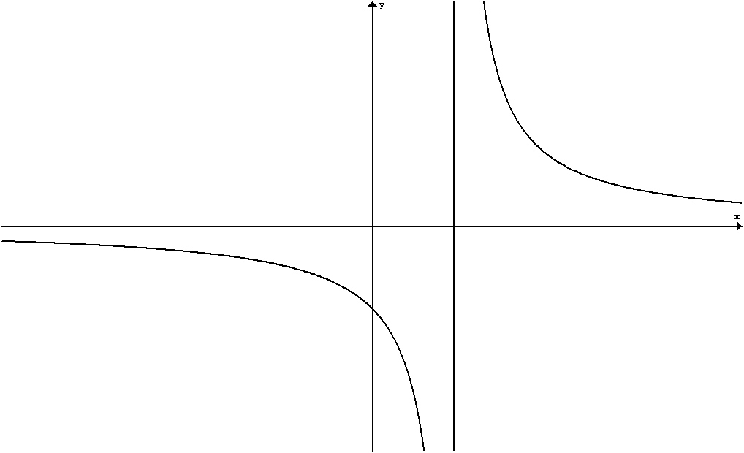  Horizontal asymptote  y = 0 | 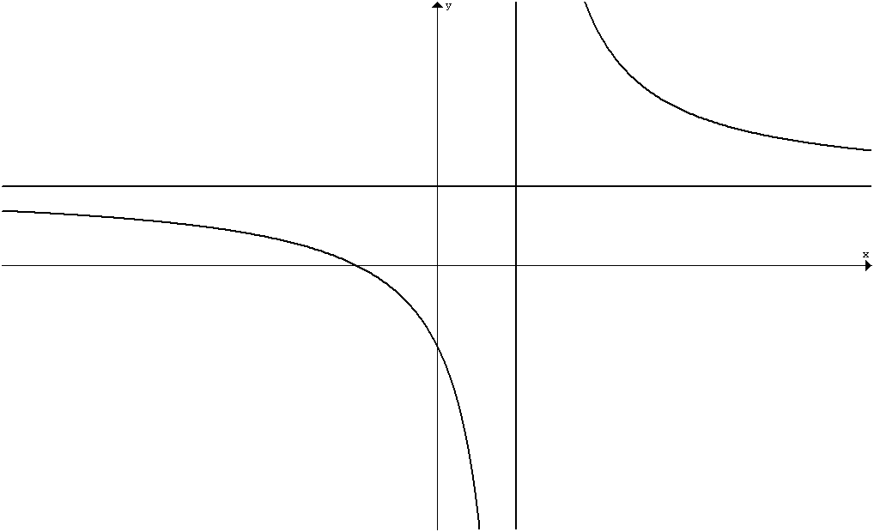  Horizontal asymptote y = c | 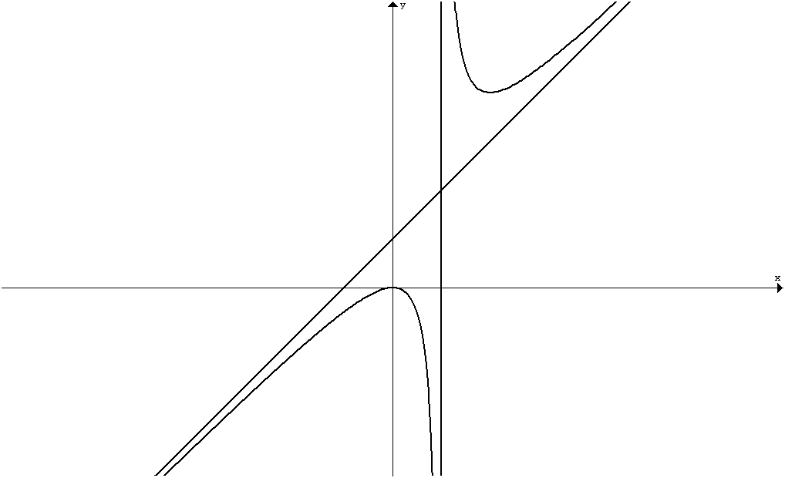 or 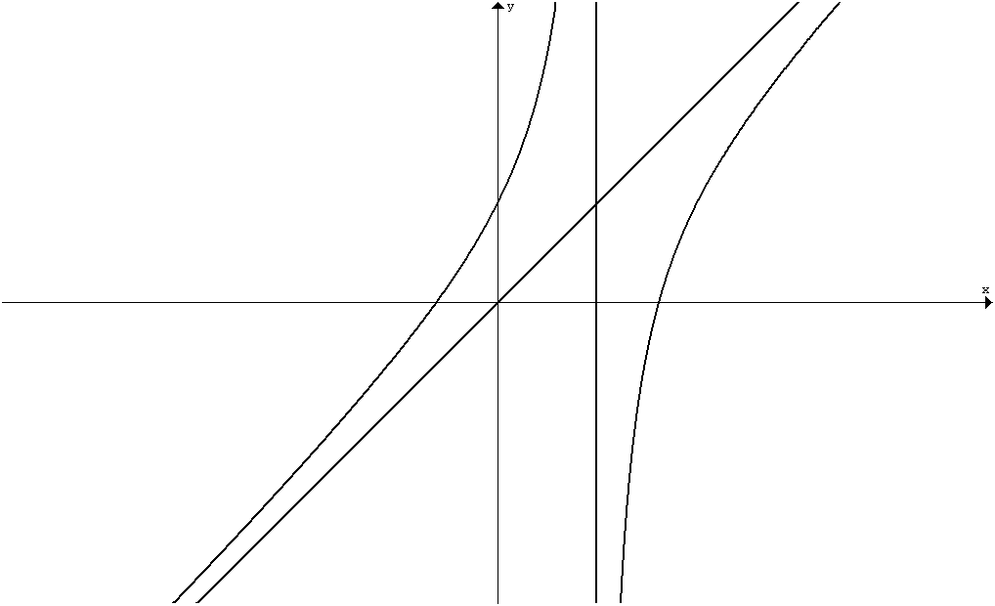  1 oblique asymptote
(x – a)(x – b)  2 vertical asymptotes  x = a & x = b | 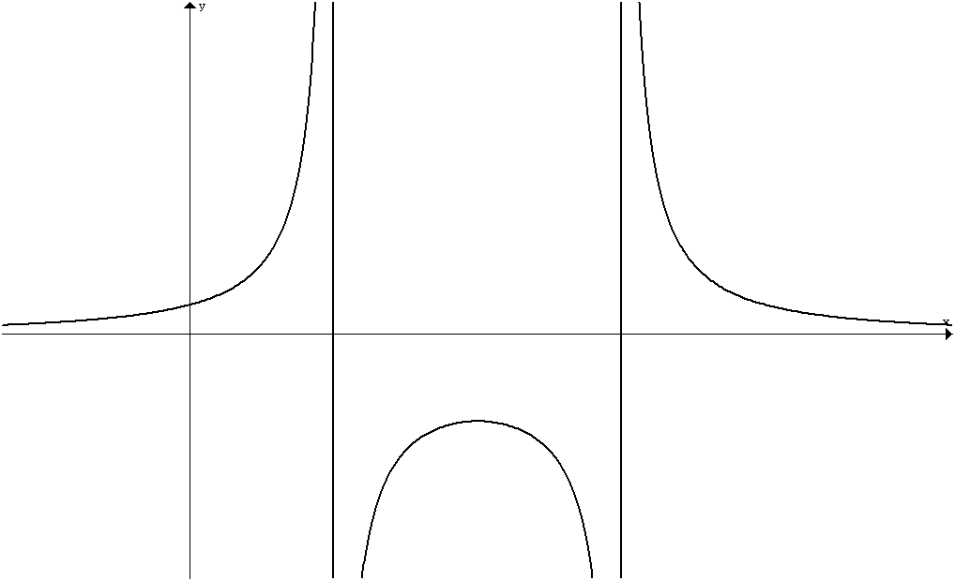  Horizontal asymptote  y = 0 | 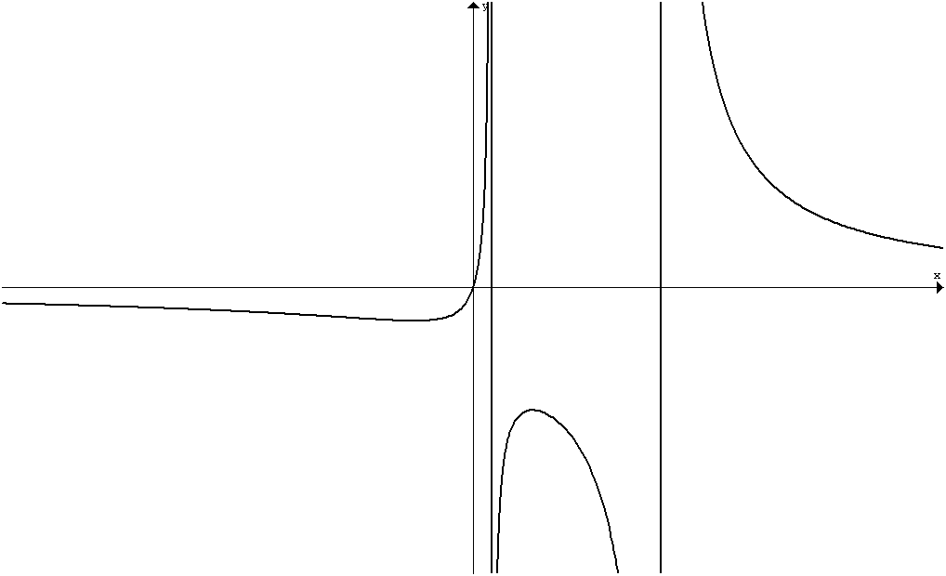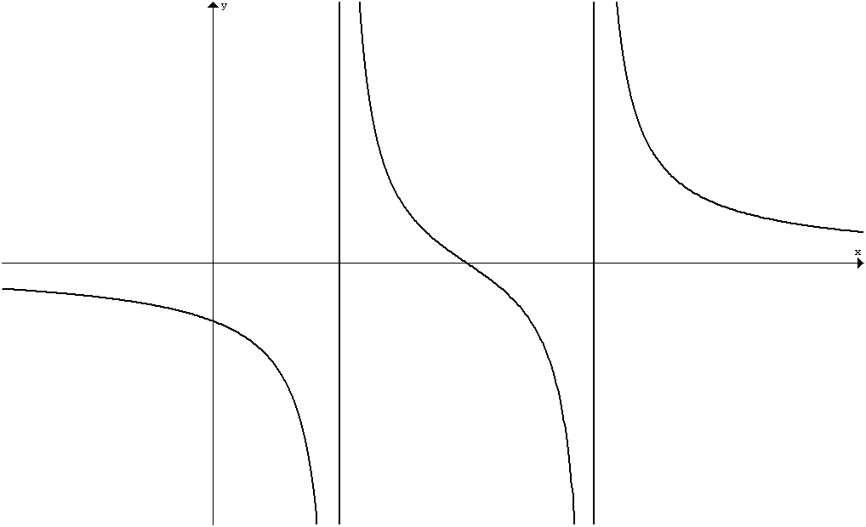  Horizontal asymptote y = 0 | 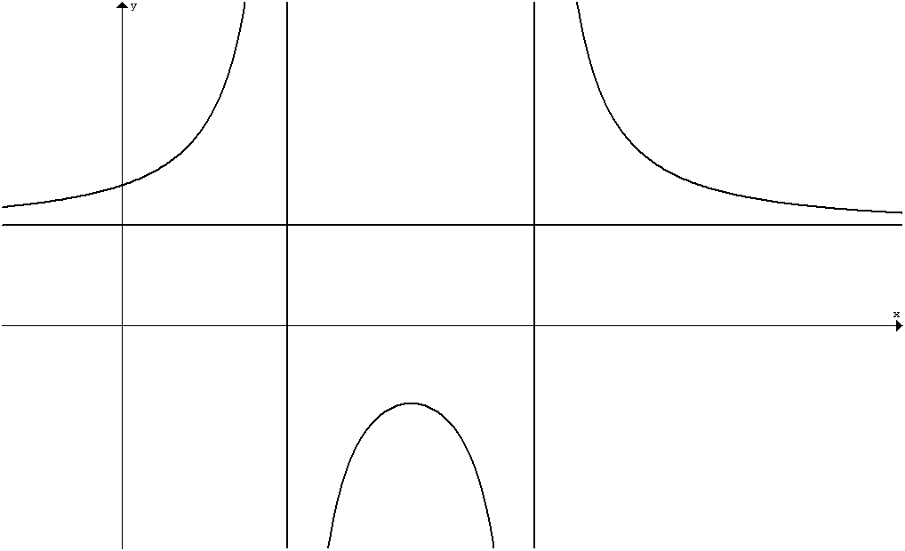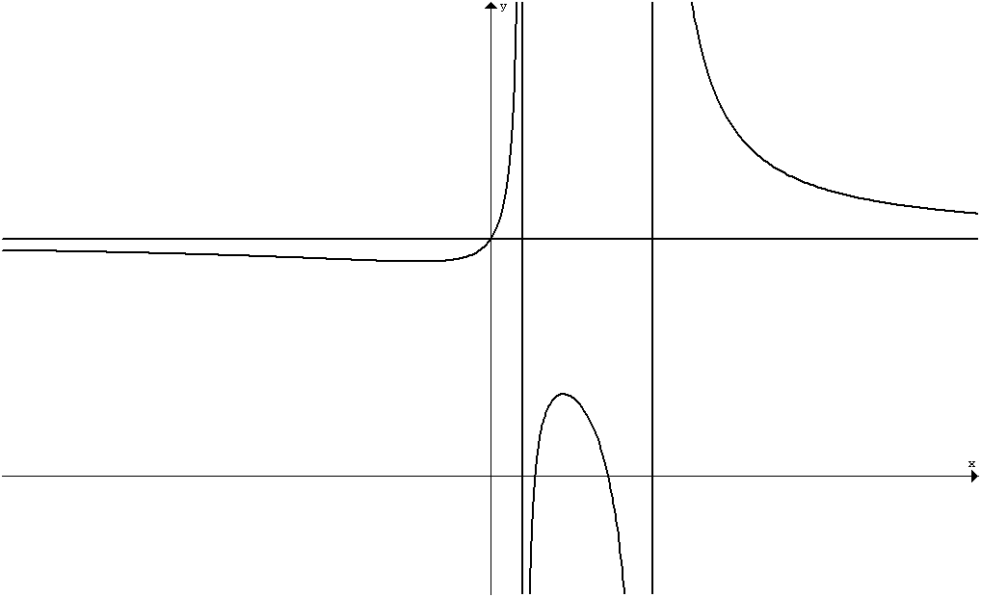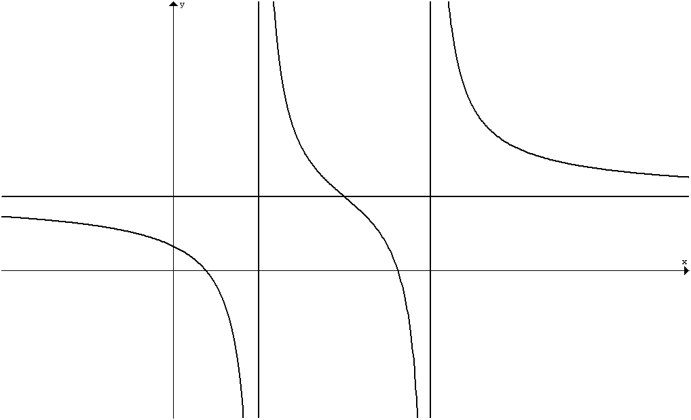  Horizontal asymptote y = c
(x – a)²  1 vertical asymptote  x = a | 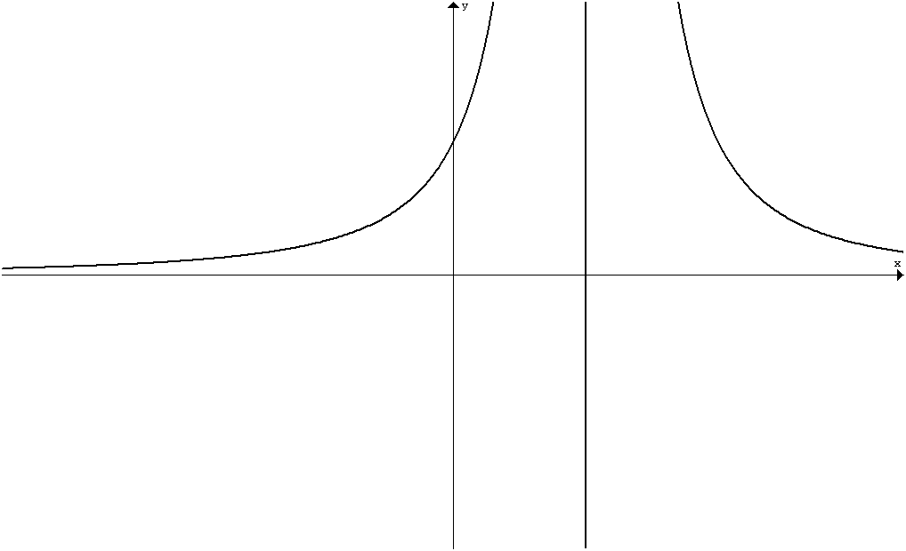  Horizontal asymptote  y = 0 | 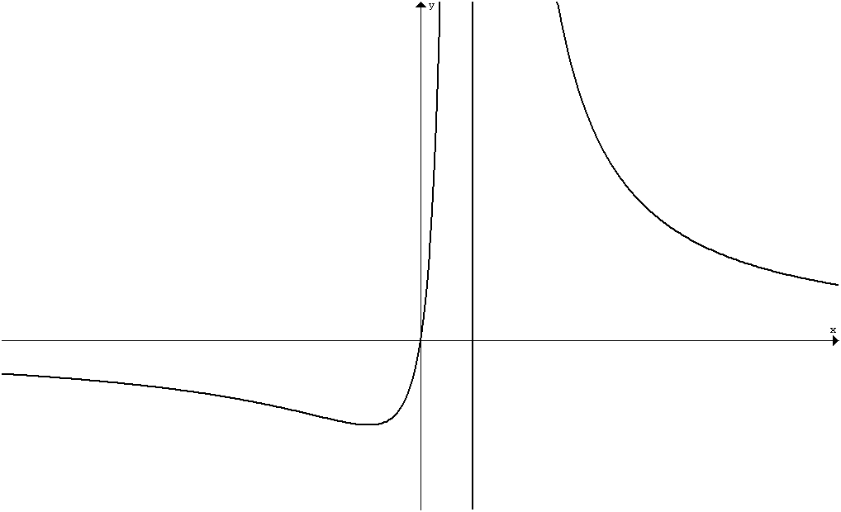  Horizontal asymptote y = 0 | 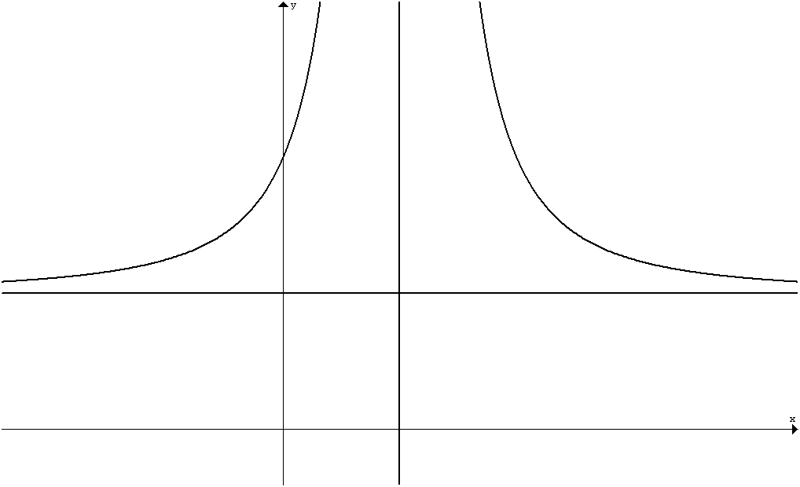 or 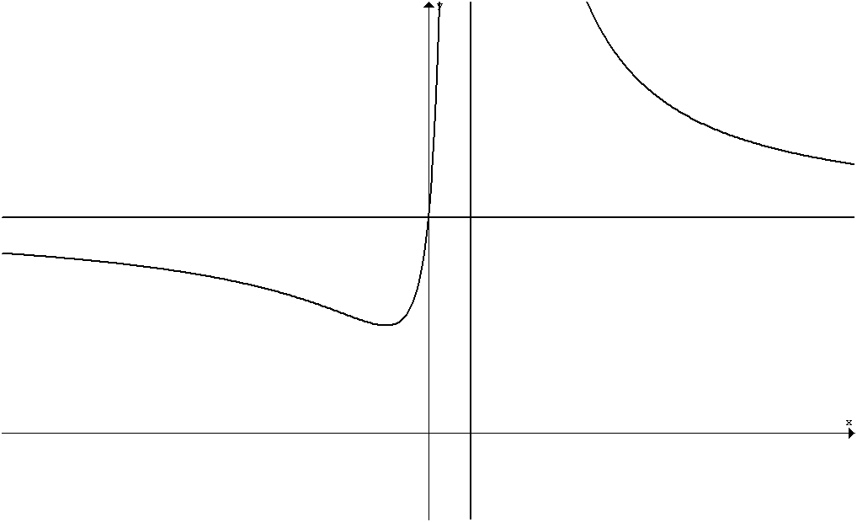  Horizontal asymptote y = c
irreducible  quadratic  No vertical asymptote | 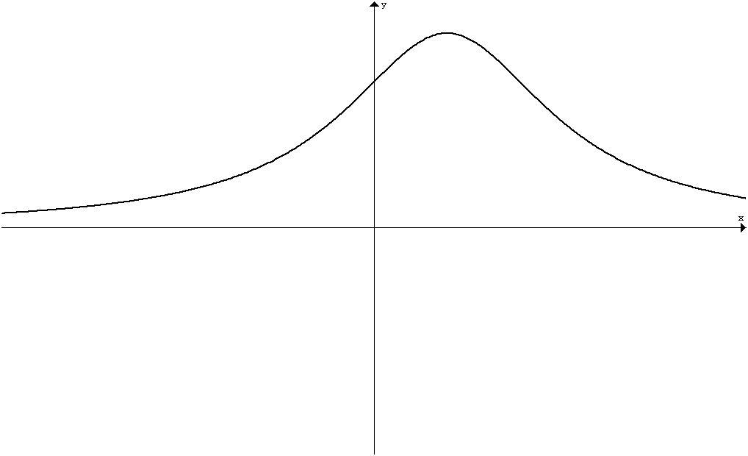  Horizontal asymptote  y = 0 | 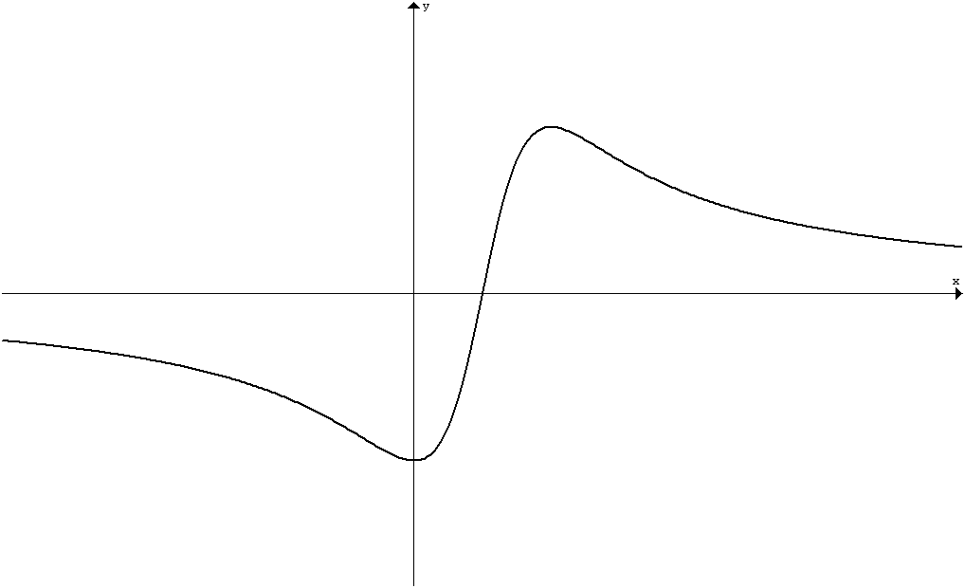  Horizontal asymptote y = 0 | 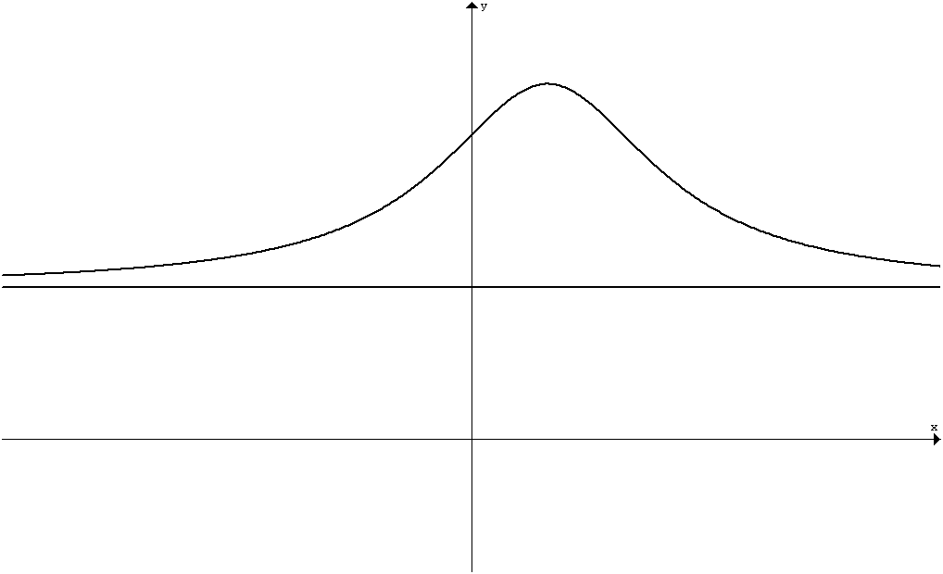 or 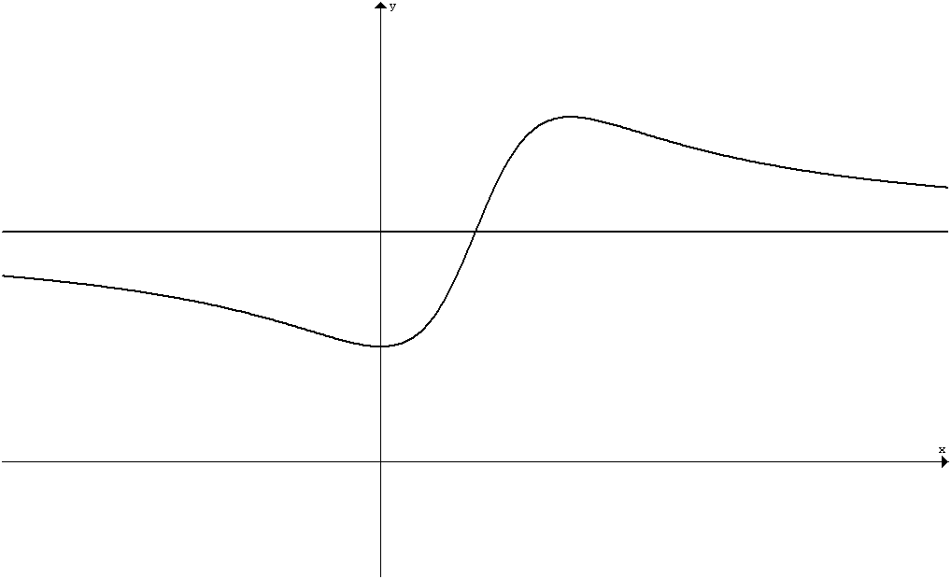  Horizontal asymptote

