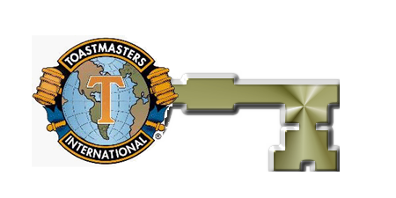

啟發溝通智慧
勇闖事業顛峰

Toastmasters: Your Key to Success is a seminar organized by Toastmasters International Hong Kong Division to help you unlock some very powerful COMMUNICATION skills. You’ll discover the proven secrets of effective communications (in English) from some of our most experienced members. This 3 hour seminar will help you improve the skills of Better Listening, Better Thinking and Better Speaking: the techniques and strategies that will put your career on the fast track! Be part of this highly interactive session that includes lots of audience participation.

How to Register
Please contact our Registration Office for details. Enquiries are also welcome.

Registration Office
(Open 9am to 7pm, Monday to Saturday)

Telephone: 31905812
Fax: 31908513
e-mail: lpkw @ pacific.net.hk

VENUE:
Great Eagle Hotel, Tsim Sha Tsui
TIME & DATE:
2 to 5 pm, 15th December 2001.
COST:
$200 per person $150 for Students
Special Discount if book in bulk

Toastmasters International is a non-profit making organization founded in the USA in 1924. Its mission is to enhance the Communication and Leadership skills of members through the practice of Public Speaking. The oldest Toastmasters Club in Hong Kong has a history of over 47 years.
This seminar is about:
Effective communication @ work
- English made easy
- Interviewing techniques
- Impactful business presentation
- Effective use of A/V aid
Effective public speaking @ ease
- Think on your feet
- 6 "S" in convincing your audience
- Practice & receive feedback from Toastmasters
- Enhancing your charm as a speaker
- enhancing your charm as a speaker

The Seminar Website & On-line Registration Office is at:
http://hk.geocities.com/tms_reg
The Website for Toastmasters International is at:
www.toastmasters.org

