Magic
Shows

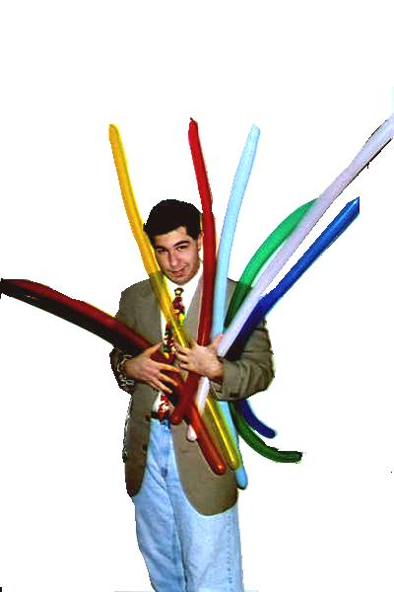

You’ve seen Al Hastings in Schools, Parties, and other Local Functions all over Pittsburgh, Now you can have him appear at your party. You’ll get a guaranteed GREAT magic show, Laughter, and the COOLEST balloon animals you have ever seen! Al’s schedule fills quick, so tear off a number and call today! You’ll Love it! Fun for the whole Family of all ages.

