Handbook for Boy Scouts and Parents of Troop 125

TABLE of CONTENTS

INTRODUCTION…………………………………1

THE TROOP............................................................1

WHAT THE TROOP EXPECTS………………….1

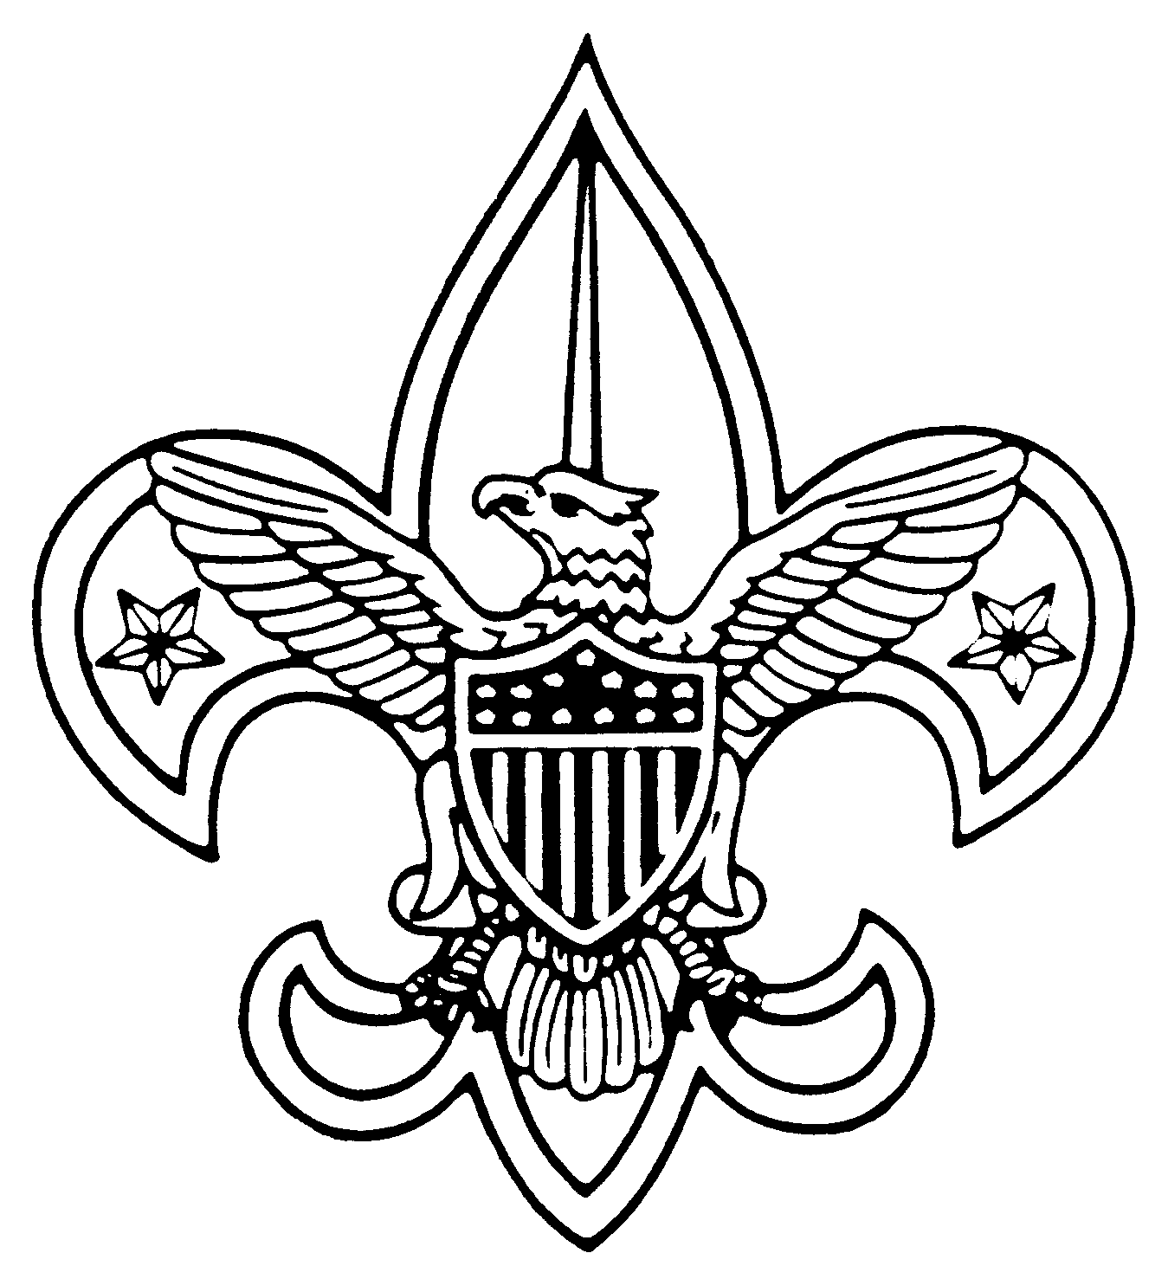GETTING STARTED..............................................2

UNIFORM................................................................3

EQUIPMENT...........................................................2

HOW THE TROOP OPERATES......................…...4

TROOP MEETINGS................................................3

DUES / FUNDRAISERS..........................................3

ADVANCEMENT………………………………..3

CAMPING / WORSHIP...........................................4

LEADERSHIP ........................................................5

SERVICE TO OTHERS .........................................5

REGISTRATION.....................................................5

APPENDIX.............................................................5

Introduction:
This Handbook has been prepared to assist New Scouts and their parents to become, well-oriented, active members of Boy Scout Troop 125. We realize that not everyone comes to the Troop with a background in Scouting; therefore, we have tried to provide you with a statement of our Troop’s philosophy and history, as well as to provide answers to the most-often asked questions regarding the operation and life of our Troop. We hope new Scouts and parents will read these TOGETHER and discuss, as necessary, the various topics. Your specific questions, comments, and suggestions are welcomed by the Troop Leadership.

The Troop:
Although the charter is very recent, September 1, 1996, Troop 125 has quite a bit of history with the Scouting program. During mid 1970 and early 1980, Woodlawn United Methodist Church was the proud sponsor of Boy Scout Troop 522. After being dissolved Troop 522 later re chartered in 1995 at the Dotsonville Community Center. During mid 1990, Troop 125 was chartered with the North Stewart Elementary School in Stewart County. While only together for a few years Troop 125 was re organized and brought to Woodlawn at the Woodlawn United Methodist Church with six, veteran Boy Scouts with experience coming from Troops 517, 540, 514, and 522. These boys were Chris Browning, Eric Hersh, Lee Hersh, John Brinkman, Jeremy Brinkman, and Dan Moelter. The Troop was first chartered by the Woodlawn United Methodist Church with the Institutional Head being Reverend Kathy Paisley and the Chartering Organizational Representative, James Buchanon. The remainder of the adult leadership was Dennis Singer (chairman),Mary Gulin, Sherry Hersh, Nancy Brinkman, Julie Singer, members of the committee, and Rob Hersh Scoutmaster. As 1 January 2002, Troop 125 is now sponsored by the WK & T Chapter of the 101st airborne Association. As you can see this troop is a melting pot of boys and leaders with excellent sponsorship and strong traditions for over twenty years.
Troop 125 is part of the Cogioba (Indian for black dirt) District of the Middle Tennessee Council, located in Nashville, Tennessee: 1-800-899-6622-7268.

What the Troop Expects:
Troop 125 strives to maintain a group of “Active Scouts.” A boy cannot derive the full benefit of the Scouting program if he only attends to do “Fun” things. He may soon be left behind by his rapidly advancing, more skilled and knowledgeable peers who attend regularly. We realize that the demands of family, church, school, and extracurricular activities can take its toll on a scouting program. Experience dictates that boys who have good parental guidance and who learn to budget their time, DO have time to be active, to attend camp outs and to advance within the Scouting program. Each boy has an integral part of the Patrol, that he is assigned to, along with the functions of the Troop. Realistically it is not fair for the other boys who take a regular part in the planning of the “Fun Stuff” to have a patrol member show up only to participate in the “Fun Stuff.” Scouting is not for every boy. If boys discover that our Scouting program is just not their piece of cake, they are encouraged to find other ways to pursue their interests and goals. No boy should be MADE to participate in Scouting. We consider Scouting as the best program available for turning real boys into real men, during their most vulnerable stage of life. In Scouting a boy never loses, every aspect of the program is a positive influence for growth in stature and wisdom.

Getting Started:
We welcome young men of Scout age who are, or can become, vitally interested in the Scouting program. Eligibility rules are occasionally modified by the Boy Scouts of America, but generally, boys can participate in Boy Scouting from age 11 until their 18th birthday.
All boys regularly participating in the activities of the troop must be registered as a Boy Scout. The current total troop registration fee is discussed under the Registration portion of this hand book.
Troop 125 re-charters each year in December for the new upcoming year. The troop will maintain 100% subscription for Boys Life magazine. This will insure that the troop will receive free rank through out the year. This is a considerable savings for the troop. Further, reading Boys Life magazine provides an excellent opportunity for boys to find out what other Boy Scout organizations are doing across the country.
The first item a new Scout needs is an official Boy Scout Handbook Attached in the front of the handbook is A Parent Guide, which you and your son are to read and discuss. This exercise is one of the joining requirements for your son. A Scout will use His handbook continuously through out his Scouting adventure. His advancements will be recorded in His handbook as he progresses. It is each Scout’s responsibility to maintain all of His advancement records from Tenderfoot to Eagle. He must not rely on someone else to do it for him. While an individual Scout’s advancement records are maintained by our local troop, each Scout is expected to carefully retain all of his rank, merit badge cards, and emblems. It is also each Scout’s responsibility to take his hand book to the Troop advancement chair person each time a new requirement is signed off so the troop records can be kept
up to date. The Handbook can be purchased locally at the Grandpa’s store on highway 41-A. Be sure to put the Scout’s name in His book.
Parents or guardians are requested to sign and return the troop medical release form that is attached at the end of this book. This will be kept on file at the troop and be taken to all Scouting activities.

Uniform:
The Boy Scouts of troop 125 will wear their Class “A” uniform correctly at the following times:

Weekly meetings
Scoutmaster Conferences
Boards of Review
Courts of Honors
Traveling to Summer Camp
At all long term camps
Special Scouting functions To Be Announced

The Boy Scout Official uniform includes; Class “A” khaki Scout shirt with all appropriate patches and insignias, olive green shorts or olive green trousers, Boy Scout socks, belt, neckerchief, and the Boy Scout hat. The cost of these items can be astronomical to be purchased all at once. Boy Scout Troop 125 requires that the Class “A” shirt be the official uniform of our troop. By the time a Scout reaches His 1st class rank Scoutmaster’s conference, he will have added to his uniform, the merit badge sash and all merit badges he has earned. When a Scout reaches his Life Rank Scoutmaster’s Conference, The Scout will have the complete Boy Scout Official Uniform. This will prepare the Scout for His Eagle Board of Review. The merit badge sash will be worn to all courts of honors. When a Boy Scout wears his uniform he indicates his allegiance and dedication to the ideals of Scouting; Duty to God and Country, Duty to other people, and Duty to his self. Parents it is your responsibility to strongly encourage your Boy Scout to proudly wear his complete uniform. Please check him prior to his departure for any and all Scouting activities.

Equipment:
In addition to a uniform, and a handbook, a Scout needs a modest amount of camping and accessory equipment. Few can afford to buy or obtain all the items a boy MIGHT need initially. However, a Scout needs the following: tent / rain gear / sleeping bag / pocket knife / canteen / drinking cup / eating utensils / mess kit. There are older boys in the troop who have out grown some of their initial equipment, and could be purchased at quite a savings. These items will get the boy started. A check list of the items a boy may need for various outdoor experiences is included in the Appendix.

How the Troop Operates:
Troop 125 is a boy led and boy run program. The Senior Patrol Leader runs the troop with the Patrol Leaders running each Patrol at the guidance of a qualified Adult Leader. Other duty positions include Assistant Senior Patrol Leader, Junior Assistant Scoutmaster, Troop Guide, Den Chief, Instructor, Assistant Patrol Leader, Troop and Patrol Scribe, Quartermaster, Historian/Librarian, Chaplain Aid. All positions are either elected or appointed by the Scouts and the Scoutmaster. The Troop elections are held as soon as possible after the first of the year, and then again after return from Summer Camp in July.
The Patrol Leader’s Council, (PLC) is led by the Senior Patrol Leader, and consists of the
following positions: Assistant Senior Patrol Leader, Patrol Leader of each Patrol, Troop Guide of the
New Scout Patrol, and Troop Scribe. Any other duty position can sit in on the PLC at the S.P.L. discretion. The PLC meets the first Saturday of every other month at 1:00 PM. The PLC, with the guidance of the Scoutmaster and Assistants, plans all up-coming events three months in advance. At the next Committee meeting the up-coming events will be addressed to the Committee for approval.

Troop Meetings:
Regular Troop meetings begin at 7:00 PM every Thursday, unless otherwise indicated. Scouts should try to have their parents arrive prior to 7:00 PM. The troop meeting will be for one and one half (1-1/2 hours). Please do not allow your Scout to leave the Scout meeting without the knowledge of the Scoutmaster or Assistants.
Every Troop requires many Scoutmasters and a strong Troop Committee in order to be successful. Troop 125 has a very active Committee led by experienced adults. EVERY parent is considered to be a member of the troop and is expected to give his/her time and talents to the program of his/her son/sons. All adults are encouraged to stay at each Troop meeting and participate at any and all activities, whether there is a camp out, fund raiser, hike, Courts of Honor, or just any thing.
Dues / Fund Raisers:
Troop 125 has established a working budget for the well being of the program. Dues are $5.00 per month, paid January through October at the first meeting of the month, for the following purpose:
A - Registration for the next year.
B - Boys Life subscription for the next year.
C - Merit Badge Library and Office requirements.
D - Advancement.
E - Christmas Angel Tree .
F – Troop Junior Leadership Training.
G -.Eagle Scout Recognition.
A Camp Savings Plan has been established to help offset the cost of Summer Camp and other local campouts. The Troop Treasurer and Scoutmaster monitors this program.

Each Fund Raiser has a purpose to build the troop with the following:
A - Adult Camping
B - Adult Registration
C - Adult Training
D - Troop Equipment
E - Trailer
F - Reserve Fund

Advancement:
Advancement is the art of meeting a challenge, learning by doing, while being taught by his peers and trained adults. Scouting is designed to be fun. but to get the full benefit of the Scouting program, your boy must advance. The climb up the Eagle ladder is designed to broaden your son’s outdoor skills and his awareness of his duties as an American citizen, in addition to exposing him to a, wide, variety of potential career ideas. You should take His Boy Scout Handbook, read and study the ascending requirements, which permit him to progress through the ranks. Each rank demands more of him as he builds on His scouting skills. Discuss your son’s progress and urge him on, regularly. He will thank you many times in the future. Those who drop by the wayside universally regret it usually the day they turn eighteen years of age.
Troop 125 maintains high standards of achievements. Beginning with the Tenderfoot rank and extending through Eagle, each Scout who has satisfactorily completed the requirements for his next rank and who has had a “Scoutmaster’s Conference”, must participate at a “Board of Review”. The Scout must be in Class “A” uniform and have his “Boy Scout Handbook” to confer with the Scoutmaster and to be reviewed by the board. The only exception for the Class “A” uniform is while at a local camp out. Boards of Review for all ranks, except Eagle, will consist of, at leas, three, but, no more than six “Registered” adults leaders from Troop 125. Boards of Review are serious business and Scouts learn early to expect the review to challenge his attitudes, citizenship, and personal goals at the level of his peers. Boards of review will be held for one week after the Scout notifies the “Advancement Chairman” that He is ready for a review. This will be directed by the Scoutmaster after completion of the “Scoutmaster’s Conference”. Scoutmaster Conferences will be conducted the first two meetings of the month, starting at 6:00 PM, prior to the regular meeting. This will alleviate any interruptions that could happen during the normal meeting. The Scoutmaster will explain this to your boy as he prepares for a conference and a review.
The Ranks of Tenderfoot, Second Class, and First Class a Scout will learn primarily “Basic Scouting Skills” by participating at regular weekly Troop meetings and local camp outs. A Scout can not advance if he does not participate. Each camp out for a Patrol is designed to advance a scout for a particular skill, or requirement.
Merit Badges are a way a Boy Scout expands his knowledge of many hobbies and career fields available to him. Each month Troop 125 will work on a theme with an activity that each Scout will have the opportunity to work on a Merit Badge. Individual Merit Badge training and study pamphlets are always necessary. The Troop has a library with these study pamphlets available for check out, from the “Troop Librarian.” Merit Badge information is addressed in the Troop Operating Proceadures.

Camping:
Troop 125 strives to keep the “OUTING” in Scouting, by camping a least twenty days per year, which includes a “Long Term” Summer Camp. Most “Short Term” camp outs, (week end), are located near the Woodlawn area. Camp Wapalani, located near the horse stables at Fort Campbell, Kyle Lake located at the west end of Ft. Campbell training area, and L.B.L. near Dover Tennessee. Normally the troop will load all necessary troop gear during the meetings. with the guidance of the Troop and Patrol Quartermaster,s and depart from a Woodlawn area, on a Friday evening, and returning Sunday around 12:00 - 1:00 PM. Each Scout normally bring his “Happy Meal” for that Friday evening. Transportation to and from the camp out will be provided by the parents. Boy Scouts who are planning these activities will occasionally ask if you can drive. Meals are cooked by Patrols and Patrols will do a duty roster and do their own grocery shopping prior to the camp out. The Boy Scouts and Adults eat very good while on camp outs. We have determined that a normal week end camp out will cost a boy approximately $10.00 for food. If the camp out is longer than two nights, the boys and the parents will be notified of the difference. All camp outs and grocery shopping cost must be paid for in advance. We will do our best to get the boys to plan, far enough ahead, so the cost can be paid for over a period of time. Each Patrol will plan their menu and develop a method to secure the ingredients for their camp out. Food from home will be limited. Soda drinks will not be allowed on a camp out. The Scoutmaster’s are authorized to do a “Shake Down” of personal gear, to identify, not only non wanted items, but to insure that needed items are being brought to the activity.
Summer Camp is spent each year at Boxwell Reservation, located at Gallitan, Tennessee, during camp week #4, (first week of July) at site #6, (Sleep Hollow), at Camp Stahlman, located at Gallitan, Tennessee. Each year, in January, Adult members attend a Camp Promotion Seminar. Parents and Scouts will be notified sometime in the month of January about Summer Camp in more detail. Sunday Worship is scheduled every Sunday morning while at a camping activity. The Troop / Patrol Chaplain Aids will help with this endeavor along with the guidance of the adults.

Leadership:
Both Boy Scouts and Adults have the opportunity to enhance their leadership skills on a formal basis. Troop 125 conducts, annually, Troop Junior Leader Training, (J.L.T.), to help Scouts recognize the three steps in problem solving. There is also a Cogioba District Training Seminar, Red Wolf, and an annual Council Leadership Training Summer Camp, Brownsea, available to Scouts who are fourteen years of age and have attained the rank of First Class. Adults can participate in Council Area training, Basic Leader Training, (B.L.T.), Wood Badge Training. and High Adventure Training. Occasionally a Leader will be selected by the Middle Tennessee Council to participate in a Training Seminar at the Phillmont High Adventure Base, Cimaron New Mexico. Troop 125 has set up a savings plan to offset the cost of these training seminars for Boys and Adults. All adults are highly encouraged to attend adult training seminars to better the quality of the troop. If you are interested see the Scoutmaster.

Service to Others:
A major aspect of the Scouting program is service. In order to advance in rank a Scout must participate in a number of Service Projects. Service projects are ongoing at all times of the year. At times, your son will be asked to participate in a worthwhile service project. This is just a stepping stone to the Eagle rank Service Project that your boy will be planning in the future.

Registration:
The current total troop annual, twelve month, registration fee is $17.00, per Scout, $7.00 goes to National headquarters for the purpose of registration, $1.00 for insurance, and $9.00 for Boys Life magazine (one per family). There is a $1.00 fee for transfer from a previous Boy Scout or Cub Scout unit. Any new Scout crossing over from Cub Scouts will have an additional $4.00 cost that will take care of the transfer fee, from Cub Scouts to Boy Scouts, and will cover the Scouts’ Troop 125 Numeral, Red Shoulder Tabs, Patrol patch, Scout Rank with holder, and mother’s pin . The Scout will receive these items at the Cross-Over, and within the first or second month into the troop. All other Scouts will pay the same fee. Troop 125 re-charters every year at the end of December. Based on the amount of dues that are paid through out the year, each boy will have paid for his own re-charter for the next year.

Appendix:

A-1 Purpose of The Boy Scouts of America
A-2 The Aims and Methods of the Boy Scouts of America
A-3 Camping Equipment Checklist
A-4 Personal Equipment Checklist
A-5 Troop Junior Leader Duty Positions

