The Monkey Fist
http://huizen.dds.nl/~erpprs/kne/faqknot.htm

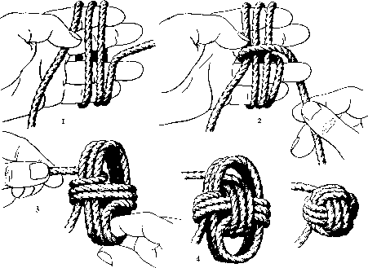 |  |  | The Monkey Fist is used as an end knot for a heaving line. A heaving line is a line used for throwing from one location to another. This enables a larger line that could not be thrown over the distance to be pulled over. The most common use of a heaving line is at sea, to pull a cable to shore from a ship. A cable is not easily thrown over a distance of 10m [ ft]or more, so instead one throws a heaving line. The line is tied to the cable and when it has been received the cable can then be pulled over. To make it easier to throw one needs to connect a weight on the end of the line - usually a stone, lead-ball or a small bag of sand is connected to the end. Better still a small rope ball is tied on the end. It is neat, it will endure many tosses last long and it is easily thrown. That is what the monkey fist is was originally used for. Now it is also used as fancy knot for key-rings, necklaces and so on. The knot can be done with or without a central core (i.e. a round stone or ball bearing) to add extra weight but it is recommended to use extra loops depending on the size of the object.
 | 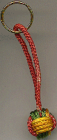 | The Monkey's Fist - A Mariner's Knot  The Monkey's Fist is used every day by ships, tugs and boats to carry a messenger line to a distant wharf or dock. A larger line is bent (sailing term for tie) on to the messenger line and hauled in. With one line secure the captain can complete the maneuver in control. The knot was tied to the end of large ropes on the ship, and the balled-end of the knot made it easy to throw to the docks for mooring.

http://131.230.57.1/knots/m_fista.htm
http://www.learntosail.net/fists.html
http://huizen.dds.nl/~erpprs/kne/faqknot.htm

To tie a Monkey's Fist:

Begin with three LOOSE parallel loops around the spread fingers of your left hand, Leave about 18 inches hanging at the beginning. We will call this set of loops "A loops." Start a fourth loop, only this time, come between your little and ring fingers. Now, work the end of the line back between the little and ring fingers close to your palm to "capture" the A loops. Also keep these loops loose. Next, pass the line over, between your ring and middle fingers, and come back through these same fingers. Repeat this process going between your middle and index fingers. We will call this second set of loops the
"B loops."

We are now looking down at your "fingers" -- the circles.

- Begin a second loop between your middle and index finger. This time, however, pass the line down along the back side of your index finger INSIDE of the A loops. (Remember I said to keep the loops loose.)
- Next, bring the line back up (hand to finger tip) along the back side of your little finger, again going INSIDE of the A loops. You should begin to be "capturing" the B loops. These are the "C loops."
- Now, come over the top and run the line down along the PALM SIDE of your index finger, again "capturing" the B loops but going inside the A loops. Repeat number 2, only going on the palm side of the little finger.
- At this point you should be able to pull your fingers out, and with a LITTLE tightening of these first C loops start to form a ball.
- You can now make a third C loops, paralleling the second.
- Start a forth loop going back down parallel to the third loop to finish the knot tying part.
- Next, insert your weighted core into the center and start working the loops to tighten the knot. The Monkey's fist is traditionally finished by splicing the two ends and seizing with small line (multiple wraps.)
- You can also tie a bowline in the longer end and seize the shorter end to the bowline end in at least two places -- close to the knot and close to the bowline.

GOOD LUCK

