SPEECH PROCESSINIG AND ANALYSIS

Prepared by
Hemakumar.B

Index

- Introduction 1
- Speech processing 2
- The Speech signal 3
  - Production of speech 3
  - Classification of speech signals 4
  - Characteristic Parameters of speech 4
  - Phonemes and Dipones 5
  - Digitization of Speech 5
- Speech Analysis 6
  - Short-time Fourier analysis 6
  - Cepstral analysis 8
  - Linear Prediction analysis 9
5. References 11

SPEECH PROCESSINIG AND ANALYSIS

1. INTRODUCTION:

From times immemorial, man has strived to flash “news and views” to fellow beings. Primitive man interacted through inarticulate utterances, mimics and gestures. Then evolved, quite naturally, the faculties of speech and languages. God’s priceless boons to mankind facilitating the expression of thoughts and emotions. The inherent superiority of speech over other modes of communication and its seamless integration with other services makes it the favorite choice for providing easy to use, efficient and affordable linkage medium between man and machine.

The unique features offered by digital technology have made it attractive for speech signal processing. The fusion of digital methods with human voice, one of the most complicated analog signals, has posed good challenges. These complexities notwithstanding, progress in speech signal has taken place in several directions and at a very rapid pace. Communication is the focal point of all these activities, whether it is person to person, machine to person or person to machine communication. The communication between human beings embraces the subject of coding and decoding of speech for its storage and efficient transmission. The communication from machine to person gives the machine a “mouth” with which it can deliver information to humans. In the same way, the communication from person to machine gives the machine an “ear” through which it can listen to instructions from humans, and carry out the necessary action.

Impetus to speech processing research has been provided by the overall amelioration in computing facilities.

2. SPEECH PROCESSING:

There are three main areas in speech processing,
- Speech Synthesis
- Speech Recognition
- Speech Coding
- Speech Analysis
- Speech Enhancement

In speech synthesis a machine is developed, which can accept as input a piece of English text and convert it to natural sounding speech. Applications of speech synthesis include speech output from computers, interrogating database from any ordinary telephone, permitting a doctor in remote location to access medical records stored in a central computer and reading machine for blind.

In speech recognition a system is produced which can recognize a speech from any speaker of a given language. The main application areas for speech recognition is telephone banking, direct control of machines by human voice, quality control, voice input to computer for document creation.

Speech coding is concerned with the development of techniques, which exploit the redundancy in the speech signal, in order to reduce the number of bits required to present it. The main application areas for speech coding are voice mail systems, cordless telephone channel, narrow band circular radio, military communications and secret missions.

Speech Analysis is concerned with study of its spectrum and extraction of time varying parameters from the signal for producing speech. The main application areas for speech analysis are automatic intercept systems for telecommunications and voice alarms.

Speech Enhancement is concerned with minimization of the derogatory effects of noise on performance of speech communication systems. The main application areas for speech enhancement are improving the performance of equipments working in the noisy environment, correcting for reverberation effects, pathological speech problems.

3. THE SPEECH SIGNAL:

3.1 Production of speech

The vocal tract, approximately 17cm long in an average adult male, begins at opening between vocal cords, or glottis and end at the lips. The cross sectional area of the vocal tract can be varies from zero (compete closure) to about 20cm² by controlling the position of lips, tongue, jaw and velum and ends at nostrils. When the velum is lowered, the nasal tract is acoustically coupled to the vocal tract to produce nasal sounds of speech. For sounds, which are nasalised, sound emanates from both the lips and the nostrils.
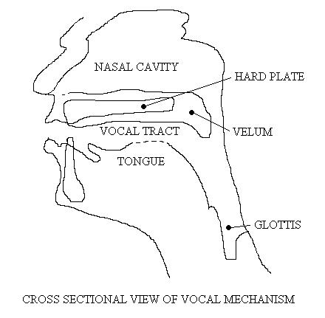

In speaking, the lungs are filled with air. The vocal cords constrict the flow of air from the lungs to the vocal tract. Due to this, the pressure in the lung increases. As lung pressure is increased, air flows out of lungs and through the opening between the vocal cords. This flow of air is the source of energy for speech generation.

3.2 Classification of speech signals

Speech signals can be classified into three distinct classes according to their mode of excitation.

Voice sounds are produced when the vocal cords vibrate in a relaxation mode. The oscillations can be obtained by forcing air through the glottis and adjusting the tension of the vocal cords; thereby producing quasi-periodic pulses of air, which excite the vocal tract.

Fricative or unvoiced sounds are generated by forming a constriction at some point in the vocal tract and, as air is forced past it, turbulence occurs which causes a random noise excitation.

For plosive sounds, the vocal tract is closed at some point; the air pressure is allowed to build up and then suddenly released. The rapid release of this provides a transient excitation of the vocal tract.

3.3 Characteristic Parameters of speech

Human sounds can be characterized in terms of three vital parameters, namely, Pitch related to the frequency of sound (in Hz), Loudness, the physiological perception of the intensity of sound (in dB), and Quality (timbre), a property possessed by sound by virtue of its harmonic content.

Vowels having the same pitch and loudness differ in their quality. A vowel contains several pitches simultaneously, which imparts to it an “overtone structure”. These pitches include the one pitch at which the vowel is spoken and many other pitches which also occur. The different characteristic pitches that are discernible, are called Formants. Consonants are conditioned according to the vowel preceding or following them.

3.4 Phonemes and Dipones

The smallest units of sound, which can be recognized by contrast with their environment, are termed Phonemes. They form the basic units of speech. Stop consonants like lbl, lgl, lkl, lpl, ltl, etc., are phonemes. Dipones are sounds stretching from the middle of one phoneme to the center of the next, thereby spanning the transition region

3.5 Digitization of Speech.

The acoustic energy of the speech is converted into electrical energy by a suitable electro acoustic transducer like a moving coil, electrostatic or piezoelectric microphone. In preparation for performing signal processing operations on the speech signal, the speech waveform is passed through a low pass filter restraining the components below a frequency W Hz. It is then sampled at a rate >2W, the Nyquist rate, quantised and converted into binary digits. Although the frequency W is determined by the intended application, it usually lies between 3 and 5 kHz. Straightforward application of sampling theorem shows that a sampling rate ≥ 8000 samples per second is adequate for digital representation of telephone bandwidth ~ 4kHz speech signals. An encoding rate of 16 bits per second is followed.

The digitized signal is now ready for processing and various operations can be carried out on this digitized signal, as demanded by the problem at hand.

4. SPEECH ANALYSIS:

There are several methods for analysis of speech. But the following methods are commonly used.
- Short-time Fourier analysis.
- Cepstral analysis (or) Homomorphic filtering.
- Linear prediction analysis.

Of these the first two methods involve Fourier transform computation and use of fast algorithms while the method applies efficient algorithms for inverting a correlation or covariance matrix. Linear Prediction offers the advantage of a parametric model but lacks in flexibility.

4.1 Short-time Fourier analysis

A segment of speech signal is resolved into its spectrum with the help of Fourier transform. Since the spectrum is changed by the variations in excitation and vocal tract shape for producing different sounds, a short time Fourier transform altering with time can give a spectral representation of speech.

The short-time Fourier transform of a signal. X_{n}(e^{jω}), is
X_{n} (e^{jω}) = ∑ x (m) h (n-k) e^{-jωk}
Where X_{n} (e^{jω}) is a low pass representation of the signal in band centered at ω and h (n) is an analysis window, which determines the portion of the portion of the input signal that receives emphasis at time index n.

There are two common methods of implementing a short time spectral analysis. The first is by means of a filter bank. Which may be either implemented directly on fast Fourier algorithm may be used. In this method the reconstructed signal is formed as

y(n) = ∑ X_{n} (e^{jω}) e^{jω}

In the second method, called the overlap addition method

y(n) = ∑ N⁻¹ ∑ Y_{r}(e^{jω}) e^{jωn}

Where Y_{r} (e^{jω}) = X_{rR} (e^{jω}); i.e., windowed segments spaced by R samples in time and overlapped and added to produce the reconstructed signal. . Figure below shows the illustration of short time Fourier analysis.

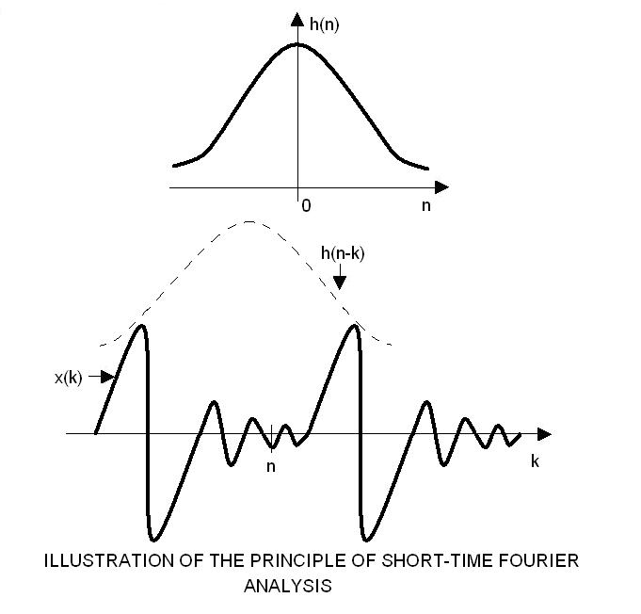

4.2 Cepstral analysis (or) Homomorphic filtering

Let x (n) is the voiced speech signal, e (n) is the excitation function and h (n) is the vocal tract impulse response. Then, the excitation function and the vocal tract impulse response are convolved to produce speech signal, i.e.,

x (n) = e (n) ∗ h (n)

The general non-linear filtering technique referred to as Homomorphic filtering carries out deconvolution of speech. In this method, the convolution operation is converted into addition giving the output known as complex cepstrum.

Figure below shows the class Homomorphic system for Deconvolution. The system H∗ is defined by the property that

X (z) = log X (z)

Where X (z) and X (z) is the Z transforms of x (n) and x (n) respectively.

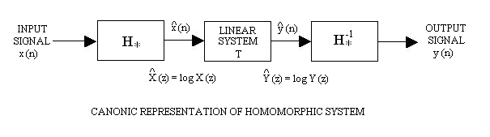

The system T is linear and the system H∗⁻¹ is the inverse of the system H∗.

If x (n) = x₁ (n) ∗ x₂ (n) then X (z) = X₁ (z) X₂ (z)

Taking logarithms on both sides we get

log X (z) = log X₁ (z) + log X₂ (z)

X (z) = X₁ (z) + X₂ (z)

Consequently

x (n) = x₁ (n) + x₂ (n)

Therefore, the convolution of components transferred to sum. The output of the system H∗, referred to as complex cepstrum.

4.3 Linear Prediction analysis

It is a very important and powerful speech processing technique. The basic idea behind he method is that sample values of speech, x (n), can be approximated as a linear combination of the past p samples.

Mathematically the predicated value of speech signal can be approximated by the equation

x (n) = a₁ x (n-1) + a₂ x (n-2) + a₃ x (n-3) + …..a_{p} x (n-p)

= ∑ a_{k} x (n-p) n > 0

Where a₁, a₂, …. a_{p} are the predictor coefficients.

The difference between the actual samples and predicted sample is known as prediction error e (n) given by

e (n) = x (n) – x (n) n > 0
= x (n) - ∑ a_{k} x (n-k) n > 0

The total mean squared error is expressed as

E_{p} = ∑ e² (n) = ∑ [ x (n) - ∑ a_{k} x (n-k) ]²

The parameters { a_{k} } that minimize the E_{p} can be determined by partially derivating E with respect to each coefficient a_{i} i = 1, 2 …. p and equating to zero, that is

= -2 ∑ x (n-i) [ x (n) - ∑ a_{k} x (n-k) ] = 0

Therefore

∑ a_{k} ∑ x (n-i) x (n-k) = ∑ x (n) x (n-i) i = 1, 2 …. p

∑ a ϕ_{ik} = ϕ_{io} i = 1, 2 …. p

where
ϕ_{ik} = ∑ x (n-i) x (n-k)
and
ϕ_{io} = ∑ x (n) x (n-i)

5. REFERENCES:

[1]. Ramesh Babu.P, “DIGITAL SIGNAL PROCESSING”, Scitech Publications India Pvt. Ltd., 2001.
[2]. Khanna.V.K., “DIGITAL SIGNAL PROCESSING, TELECOMMUNICATION AND MULTIMEDIA TECHNOLOGY”, S.Chand and company Ltd., 2003.

