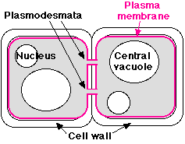
Intercellular Junctions:
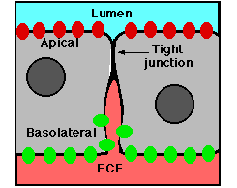
Cells are held together by adhesive forces of the Tight Junction
cellular membrane molecules acting as a weak cellular “glue.” The purpose of these junctions are to promote tight cellular adhesion and communication. Also the junctions serve to seal areas of tissue to provent substances from freely flowing between the intercellular space.

Epithelial cells- cells that from sheets to provide interfaces between masses of cells and a cavity.

Tight Junctions (zona occludens):
Two Primary Functions:
- Prevent the passage of molecules and ions
through the space between a series of cells (known as the lumen) and other tissue. The tight junctions thus makes any materials travel through the cells themselves in order to pass through the tissue.
- Block the movement of integral membrane proteins between the apical surface (portion of cell
expose to the lumen) and the basolateral surface (portion of cell not exposed to lumen). This preserves endocytosis at the at the apical surface and exocytosis at the basolateral surface.
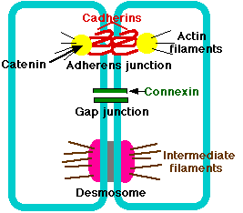
Adherens Junction (zona adherens):
Provide strong mechanical attachments between adjacent cells such as in:
Holding together cardiac muscles as the heart
expands and contracts.
They hold epithelial cells together.
Formed by cadherins: transmembrane proteins that bind to each other extracellularly and bing to catenins intracellularly. Catenins are actin microfilaments found in the cell.

Gap Junctions

