AP Calculus
Unit 4 – Applications of Differentiation
This unit includes the following:
- Related Rates
- Intervals of Increase/Decrease; Concavity
- Relative Extrema; First and Second Derivative Test
- Using the derivative to graph polynomial functions
- Graphing functions with vertical tangents and cusps
- Minimum and maximum of a function; Applications of min/max
- Rolle’s Theorem; Mean-Value Theorem
- Rectilinear Motion

Homework Assignments/ Schedule
Date | Assn. # | Assignment
Monday, 10/20 | #4.1 | Pg 239/#9,13,17,23,27,30  Due 10/27
Tuesday, 10/21 | #4.2a | Pg. 248/#3,7,13,17,21  Due 10/27
Wednesday, 10/22 | #4.2b | Pg 249/#27, 31, 35, 39  Due 10/27
Friday, 10/24 | #4.3 | Pg 255/#5,13,17,25,31,35  Due 10/27
Monday, 10/27 | None | Answer homework questions
Tuesday, 10/28 | #4.6 | Pg 278/#5,11,19,25,35  Due 11/3
Wednesday, 10/29 | #4.7 | Pg 288/#5,11,15,19  Due 11/3  (Quiz today!! Sections 4.1, 4.2, 4.3)
Friday, 10/31 | #4.8 | Pg 296/#3,5,7,9,15  Due 11/3
Monday, 11/3 | Portfolio | Answer Homework Questions
Wednesday, 11/5  (Block Day) | None | Group Quiz (Sections 4.1 – 4.3, 4.6 – 4.8)  General Review
Thursday, 11/6  (Regular Day) | None | Test on Units 3(all) and 4 (sec. 1-3, 6-8) Today!!  Calculator Part
Friday, 11/9 | None | Test on Units 3(all) and 4 (sec. 1-3, 6-8) Today!!  No Calculator Part
Monday, 11/10 | #4.10 | Pg. 308/#1,3,5,9  Due 11/17
Tuesday, 11/11 | None | Veterans Day Holiday
Wednesday, 11/12 | #4.11 | Pg 315/#3,7,13, 15, 21, 23  Due 11/17
Friday, 11/14 | #4.VEL | Handout – Applications of Velocity  Due 11/17
Portfolio Assignment (due on 11/17/08)
(but I recommend doing some of the questions before the test)
The portfolio assignment is meant to capture a Big Picture idea for the unit and also highlight some ideas that are critical for the AP Exam for Calculus AB. This is to be kept along with all of your Portfolio assignments for the year in your folder.

Big Picture Questions: Calculus I (AB): Applications of Derivatives
1. Clark W. Griswold, the protagonist of the National Lampoon Vacation films, is attempting to decorate his home festively for the holidays. This year, he has decided to add a live nativity scene, starring various children from the neighborhood. Unfortunately, it has begun to rain very heavily, and he needs to decide how long it's safe to leave the live baby Jesus in and when he needs to go with a stunt doll stand-in.
The 4-foot-long manger has a cross section which is an equilateral triangle with side length 18 inches. If rain is accumulating in the manger at the rate of 250 cubic inches/hour, how fast is the water level rising when it is 10 inches deep? | 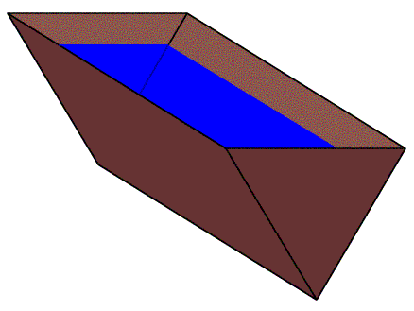
2. The set of graphs below are f(x), f '(x), and f "(x), but not necessarily in that order.
(a) Determine which graph represents which function. Justify your answer.
(b) Describe and draw possible graphs of f '''(x) and f⁽⁴⁾(x), the third and fourth derivatives.
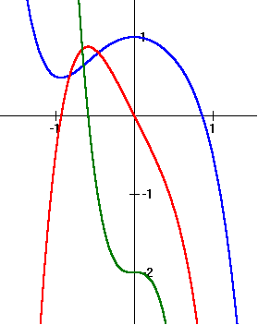
Optimizing Farmland

3. Farmer Steve plans to fence a rectangular pasture adjacent to a river. The pasture must contain 180,000 square meters in order to provide enough grass for the herd.

What dimensions would require the least amount of fencing if no fencing is needed along the river?

AP Exam Focus areas (taken from the Topic Outline for AP Calculus AB)

Second Derivatives
- Corresponding characteristics of the graphs of
- Relationship between the concavity of and the sign of
- Points of inflection as places where concavity changes

Questions: Page 248/ #1-4 Page 255/#18 Page 264/#18

Applications of Derivatives
- Optimization, both absolute (global) and relative (local) extrema
- Modeling rates of change, including related rates problems.
- Analysis of curves using

Questions: Page 269/ #10, Page 296/#5

