AP Calculus
Unit 8 – Differential Equations/Slope Fields/Inverse Trig Functions
This unit includes the following:
- Solving Differential Equations
- Slope Fields
- Derivatives and Integrals of Inverse Trig Functions

Homework Assignments/ Schedule
Date | Assn. # | Assignment
Friday, 3/6 | #7.7a | (Sec. 7.7) P. 514/ #1, 3, 5, 13, 15, 17  Due 3/16
Monday, 3/9 | Portfolio | Group Quiz (Unit 7)  (Efram gone)
Tuesday, 3/10 | #7.7b | (Sec. 7.7) P. 514/ #2, 4, 6, 14, 16  Due 3/16
Block, 3/11 | #Apps1 | (Sec. 7.7) Handout – Applications of Differential Equations  Due 3/16
Friday, 3/13 | #Apps2 | (Sec. 7.7) Handout – Applications of Differential Equations  Due 3/16
Monday, 3/16 | None | Answer Homework Questions
Tuesday, 3/17 | #Slope1 | (Slope Fields) Handout – Analyzing Slope Fields  Due 3/23
Block, 3/18 | #Slope2 | (Slope Fields) Handout – Analyzing Slope Fields  Due 3/23  Quiz today!! (Solving Differential Equations)
Friday, 3/20 | #8.2 | (Sec. 8.2) P. 539/#3, 7, 9, 13, 17, 21, 27, 31, 41  Due 3/23
Monday, 3/23 | None | Answer Homework Questions
Tuesday, 3/24 | #Trap1 | Handout – Midpoint Approximations of Integrals  Due 3/27
Block, 3/25 | #Trap2 | Handout – Trapezoidal Approximations of Integrals  Due 3/27
Friday, 3/27 | None | Answer Homework Questions
3/30 – 4/10 | Review | Review for AP Exam (AP Exam May 6th)
4/13 – 4/17 |  | Spring Break!!!
4/20 – 4/28 | Review | Review for AP Exam (AP Exam May 6th)
4/29 |  | Final Exam!!!
5/7 – Date TBD | Project | Final AP Calculus Project  Math Steeplechase for Junior High Students

Calculus Lunch @ Location TBD will be after the AP Exam, Wednesday, May 20th

Unit 8 Portfolio

Problem #1 – No Calculator
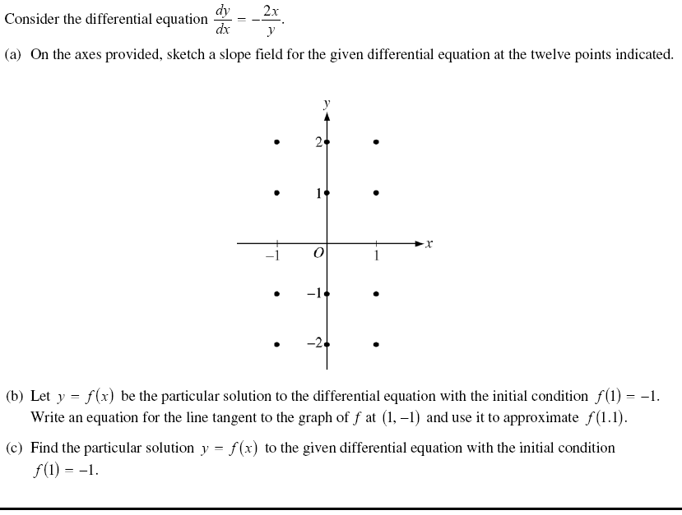
Problem #2 – Calculator Allowed
