Word | Definition | Picture | “My Own Words” | Truth Box
Inverse
Variation
Constant
Of
Variation
Ch 11.1 Inverse Variation (Please have a calculator)

Note! THE GRAPH OF AN INVERSE VARIATION
WILL BE A _________________________________________________

Ex. Suppose Nemo wants to replace his broken iPod. A new one costs $400 and he will have to work to earn the money to buy it.

Table Graph Equation

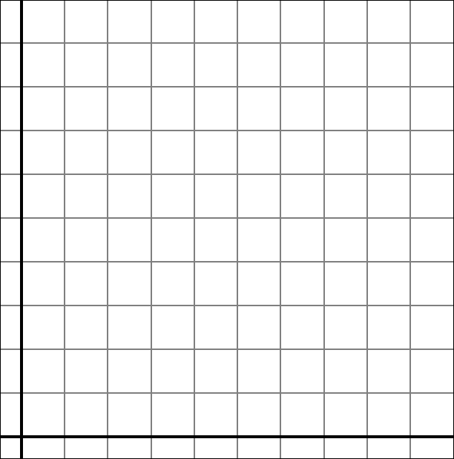
X Hourly Wage | Y  # of hours of work
5
10
20
50
100

Comparing Direct and Inverse Variation
Direct variation Inverse Variation

20
5
12
3
4
1
X·Y
Y
X
3
6
4.5
4
18
1
X·Y
Y
X
For each table, tell whether y varies inversely
with x. If it does, write a function rule for the relationship shown by the data.

Each pair of points is from an Inverse Variation.
Find the missing value.

Remember: With Inverse Variation, the product (xy) is always constant.

Your Turn!
Decide if each is an Inverse Variation, Direct Variation, or neither

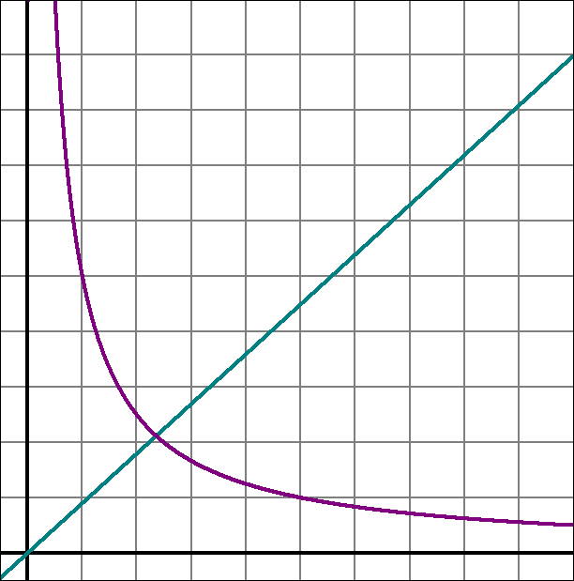 | 2  18  6  6  12  3  Y  X

Sentence Frames:

The graph of an Inverse Variation will always be
a ______________.

The _____ represents the Constant of Variation in
the equation y = k/x.

The _____________ of the x and y values of an inverse variation is a constant.
function.

