Word | Definition | Picture | “My Own Words” | Truth Box
Rational Functions
Asymptotes
Ch 11.2 Graphing Rational Functions

Asymptotes
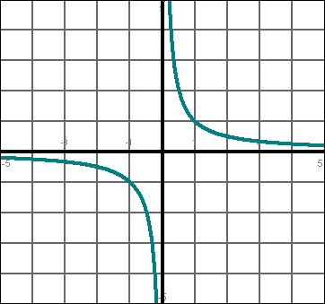
- Draw in the asymptotes for the following rational function.

- What is the equation of the vertical asymptote? Draw a line to it.

- What is the equation of the horizontal asymptote? Draw a line to it.


Evaluate each rational function for x = -3.
Evaluating a rational function

Find the vertical asymptote for each rational function.

What are the 3 steps to graphing a rational function?

1.

2.
3.
Graphing Rational Functions Examples
Graph the function | 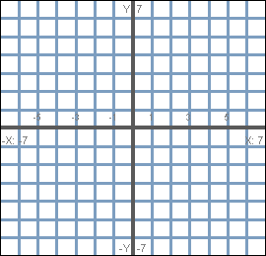
Graph the function

Your Turn!
Evaluate the rational function for x = -2

Graph the following function

Sentence Frames:

- A rational function is a ______________ over another

_______________.

- To find a vertical asymptote, I need to_________________

________________________________________________.

