Ch 7-3 Exploring Quadratic Functions of the form ax²+bx+c

VOCABULARY
Word | Definition | Picture | “My Own Words” | Truth Box

Axis of Symmetry
Vertex

The axis of symmetry is a _____________ line.

To find the x-coordinate of the vertex:________________

To find the y-coordinate of the vertex:________________

In a quadratic function, when b≠0, the parabola
shifts _________ and __________.


Find the Axis of Symmetry and the coordinates of the
vertex for the following Quadratic Functions.

Axis of Symmetry:  Vertex: | Axis of Symmetry:  Vertex:
Finding a suitable domain for a quadratic equation.

x | y

Find a suitable domain for the given quadratic function.
List the vertex and axis of symmetry. Then graph the
quadratic function.

Axis of Symmetry:  Vertex: | 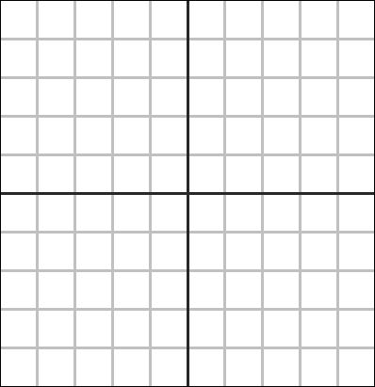
  X | y

Axis of Symmetry:

Vertex:

X | y
Your Turn!
Axis of Symmetry:

Vertex:

X | y

Sentence Frames
- I find the y-coordinate of the vertex by … __________ ____________________________________________

- I find a reasonable domain for the quadratic by … ___________________________________________
___________________________________________

3. The variable b in a quadratic equation moves a parabola ___________ and ___________.

