Word | Definition | Picture | “My Own Words” | Truth Box
Quadratic Inequality
Solution to a Quadratic Inequality
Ch 7.3b Solving Quadratic Inequalities by Graphing

Steps to Solve Quadratic Inequalities by Graphing
1. ____________________________________________________________
_______________________________________________________________

2. __________________________________________________________________
________________________________________________________________

3. ____________________________________________________________
_______________________________________________________________

Example:
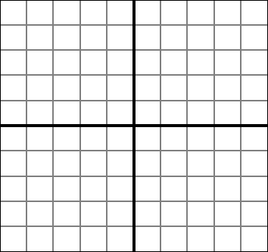

Example:
Your Turn!

Start your assignment right now!!
(Page 331 / # 31, 33, 35, 37)

Sentence Frames
- When graphing an inequality, you shade the region where ______________________________________
- There are ____ regions formed when you graph a quadratic inequality.

