Word | Definition | Picture | “My Own Words” | Truth Box
Discriminant
Ch 7.7 Using the Discriminant

The Discriminant tells us…

Discriminant | Number of Solutions

The link between solutions of ax2+bx+c=0 and x-intercepts

__________________________________________________________________________________________________________________________________________________________________________________________________________________

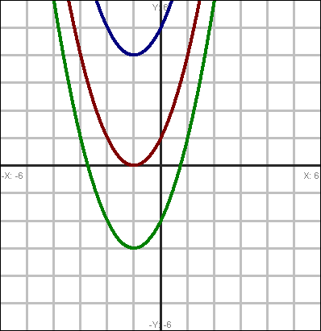
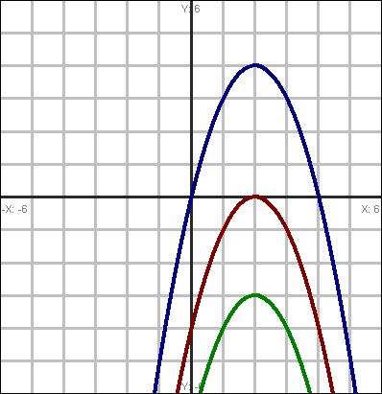

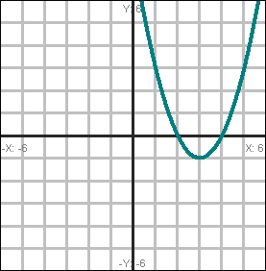
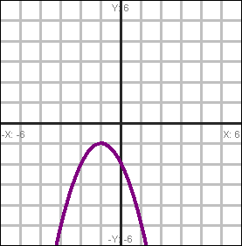
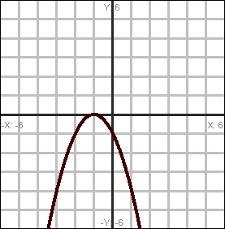

Your turn!!!
Find the number of solutions to each equation.

Sentence Frames

1.Describe how to use the discriminant to find when there are 0, 1, or 2 solutions to a quadratic equation. ____________________________________________________________________________________________________________________________________________________________________________________________________________________________

2.
Does the direction a graph opens affect the number of solutions found by using the discriminant? Why or why not? ______________________________________________________________________________________________________________

