Ch 9.3a The Trigonometric Ratios

VOCABULARY Definitions of the day
Word | Definition | Picture | “My Own Words” | Truth Box
Ratio

Angle

This angle measures 30º | 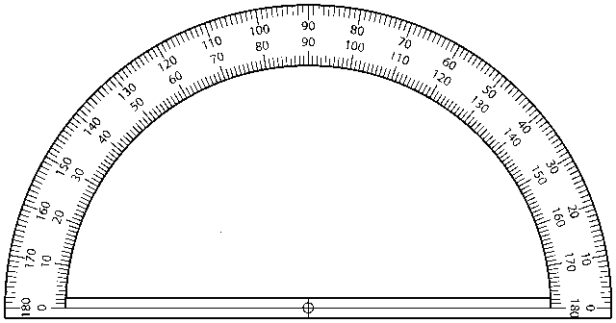
This angle measures 72º
This angle measures 90º

Labeling the angles of a triangle

The Trigonometric Ratios (using the above triangle)

A way to remember this!!
Example
1. Find the 3 trigonometric ratios for angle R  2. Find the 3 trigonometric ratios for angle S | 9 cm  12 cm  15 cm  R  S  T

Example
3. Find  sinA =  cosA =  tanA = | 12  b  13  A  B  C

Sentence Frames

The sine of an angle is the ratio of the _____________ leg and the ______________.

The cosine of an angle is the ratio of the ___________ leg and the _______________.

3. The tangent of an angle is the ratio of the __________ leg and the _____________ leg.

