Ch 9.7 Graphing Square Root Functions

VOCABULARY Definitions of the day
Word | Definition | Picture | “My Own Words” | Truth Box
Square Root Function

Domain (review)

What can you say about the expression under a square root sign?

Find the domain of the following square root functions.

Find the domain of the following functions and then graph them.
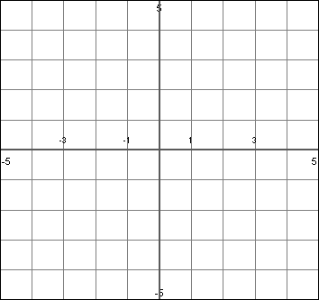  Domain? | Domain?
  x | y
  x | y

Your Turn!
Graph

Domain?
x | y

Sentence Frames
- The expression under a radical sign must not be __________________. So the expression under

a radical sign must be ___________________________.

