Barb Netteler
Game Proposal

Coding: Pink Elephant
Game Story
History and (revealed) Information
The year is around 912 A.E (After Eerschwits, which is about 500-700 years from now). The world is severely overpopulated with humans and just about every other animal is either extinct or endangered. Because of this, couples that choose to have children can only have two: one boy and one girl. However, despite many advances in medical technology, doctors are unable to prevent the occurrence of twins, which for the time is extremely rare in the eyes of the public. The current propaganda says that scientists have the ability to genetically alter one of the embryos to ensure the one boy, one girl balance. Of course, they can't do this. If a regular pregnancy breaks the boy/girl balance, it is terminated. In the case a twins, a few things can happen. If it actually is a boy/girl combination and the family doesn't already have children, the doctors do nothing. Malzeltov. But if it's not, or the family already has one child (of the opposite sex as the fetus. If it's the same, the pregnancy is determined to be a 'miscarriage.'), there are a few different choices. One, the infant is sent to a different part of the country to either replace a stillborn or given to a couple that is unable to have children. Two, it is sent to a rearing facility for processing. Or three, the infant is terminated if there is no immediate need for one. Because of this system, mothers are only told the gender and number of children if it keeps the balance. A person pregnant with an 'extra' is only told of the one, and since they are unconscious for child birth, they do not know of the 'extra' child.
In the case your character (a young male named, according to the hospital wristband, Lambda 13), you were sent to a rearing facility. There you went to school and were taught the basics of education, interaction, and-- most important-- history. (the major focus on the pseudo-government group lead by a man known by Eerschwits, who were responsible for 'advancing and saving the human race') Once you reach the appropriate age, you are put through a series of tests. These tests will then determine what place the person will occupy. This includes mundane/menial/dangerous/undesired jobs, scientific/medical research (even rats are an endangered species, so why not use the over abundant humans?) , expendable military (infantry, pilots, just about anything that would be below a captain's duties), or, if the test results were bad or there was no need at the time, termination. In your case, the only viable option was medical research.
This is where you actually get into the game. You are sent to a facility called the Eerschwits Medical Research Center, which doubles as a research lab and hospital, for processing. The 'process' is were scientists put you through a two-stage chemical coma in order to make you a perfect drone for your niche in life. (if you're bound for toxic waste cleanup, all you know is toxic waster clean up. All you can fathom is toxic waster cleanup. It's your life, the topic of conversations, subject of your dreams. You are made to be physically unable to consider anything that is not toxic waster clean up and the basics of interaction-- just because you're a drone doesn't mean you have to be a rude drone) Your character completes the first stage of the process, which alters the brain chemistry and perception to allow for the reprogramming that comes with the second stage. But before you can be given the drugs to start the second stage, something happens-- the Officials (the equivalent of a government run police/security force) are tipped off about a foreign spy that has snuck into the hospital. The staff is detained, for a relatively short period of time, while the area is swept. For you, this completely throws off your processing. While the hospital staff was detained, the sedatives keeping you unconscious wear off. You wake up confused, with only a vague feeling of who you are.
In-game Storyline
Confused and wondering why you're in a hospital, you set out to figure out what's going on. Depending on your first actions, you quickly dive into a hallucination where a horde of doctors descend on you with medical saws. Just as suddenly the images are gone, leaving you alone in the corridor. Now you really want to know what's going on. From here on out, there are various ways for you to make your way through the game. You can go it solo (taking aid when you need it but never partnering up) to take on the quest of regaining your sanity, feeding your most likely formed addictions, exposing the system, take the system down, or all and any combination of the above. You can also do all those with help (from your twin, the foreign spy, or other characters you meet depending on which path you take. all of which makes certain goals easier or harder), or you can escape from the government with your twin to simply deal with your delusions in solitude.
(current)List of Characters
• Lambda 13: Escapee of the drone process, the character you play. 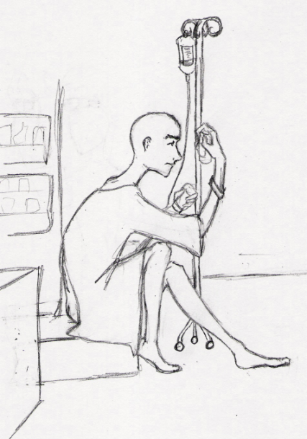 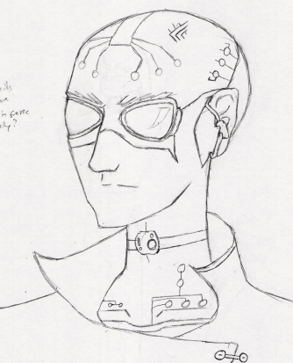
• Rook: Foreign espionage drone, thinks you are a fellow spy and his contact at the hospital (nothing you say or do with convince him otherwise). Because of this, he gives you information, helps if you get stuck, and gives you supplies. Some of the things he gives you include vials of illegal chemicals to 'keep the Officials off your back,' smoke grenades if you need a quick but incredibly attention grabbing exit, small hand held weapons (guns, knives-- excluding the surgical kind), and a portable radio 'liberated' from the Officials. Note: if Rook dies for some reason (you kill him, Officials kill him, etc) he is dead. He is not coming back.
• Dr. Bastian Kinney: Your twin, works at EMRC.
• Officials: Cop drones sent to EMRC to either capture you or kill you, depending on you respond their efforts. They are after you and only you, so for the most part they will leave others alone or try to keep their interference to a minimum. (if you take someone as a human shield they'll most likely not shoot, but only if you're still considered a low enough threat. too big a threat and a few casualties along the way can be over looked) But become too bold in guerilla tactics against them, or get to a point in the game were you 'know too much,' and they will shoot through whatever’s in their way to get to you. If they see incriminating interaction between Lambda and another other (Bastian, Rook, etc) that person could also become a target.
• Captain Libiermann: Officials' Officer called in to coordinate the cop drones in pursuit of you. Depending on which path you take, he can be a bored officer on a trivial case, your worst enemy, or a hidden ally.
• AI Staff: People in various locations have their own personalities based on how you treat(ed) others. Good source of information, but quality differs depending on who you ask and how much they like you. Take into account that gossip, no matter how wide spread, isn't always true or accurate. (this is also true when it comes to information passed on about you, too)
• Ingroup: Collective name for a group of 20 (or so) of the world's top administrators and corporate presidents. They run the world as they see fit, all the while making the various nations and people think they run themselves.
• St. Eershwits XXIV: Current leader of the Ingroup, running things in the name of the eternal Eershwits. (the original is long dead, he's just a clone)
Art Style
The art style is a 3D, pseudo-realistic look done in cell-shading. (think Advent Children, but less movie and more like an extremely well done/rendered animation) Lines are sharp and colors are saturated without being bright and overly 'colorful.' In-game architecture and design themes would have an art nouveau influence. Medical facilities would have an atmosphere that gave a sterile, cold, clean mood. Other facilities would also be 'clean,' but not overly-cold and sterile. Lived in, old but not rundown. (unless it was an abandoned/derelict location)
Music Style
(The recommended listening experience is surround sound in stereo) Music would be subtle, but not understated. A classical electric, if that makes sense. The common theme through out all music would be a beating bass line that reflects on Lambda's heart rate. Onscreen action becomes hectic (conflict, running/hiding from trouble, bad drug interaction, etc) causing Lambda's heart rate to increase; the music's tempo increases and becomes more active, and the 'heartbeat' becomes more noticeable, louder (like a pounding in your ears). When the action calms down so does the music, but the 'heartbeat' is the last to slow to normal levels.
Sound Effects and Hallucinations
Sound effects are in (if available) surround sound. If someone behind Lambda shoots a gun, you hear that sound behind you. The volume of speakers, radios, and stereos in game depends on how close you are to them and where you're standing. (standing by a speaker facing toward you would be louder than standing next to a speaker facing away from you) All the sound effects and background noise one would hear in real life would be portrayed. At times, the chaos of noise around you can even eclipse the music itself. During these times, the noise Lambda makes is harder (if not impossible) to detect, but the same holds true for all individual characters. (basically, they can't hear you but you can't hear them either)
During a hallucination, there often will be sound effects generated with no known/seeable source. Ghost footsteps, disembodied voices, etc. Plus music/announcements/orders over radios. (even your own, if you have one) Hallucinations may be the only time you hear ragtime music, gambling scores, or gospel broadcasts pouring out of a radio, so these little things are good to take notice of.
During a hallucination music can be one of two ways: the same as in normal perception or twisted. Twisted hallucination music would have the same 'heartbeat' as normal. However, notes could be disordered or with just enough lack of harmony to be vaguely uncomfortable. A Theremin and instruments with resounding/echoing qualities could also make an appearance.
Mechanics
The view of the game is from the third person perspective with the default camera position being behind and just about the character. The character can freely move around in a limited radius before the camera angle would pan to keep the character in focus. (think Zelda: OoT)
The screen itself will be relatively empty of status information, except for a small heart rate bar on the lower left corner. Instead of measuring health in individual points, it's done in beats. The average, safe range of 'health' is 70-90 bpi. Anything lower or higher signifies a health crisis-- either from bad drug reactions that need to be remedied or physical damage from enemies.
Controller Setup
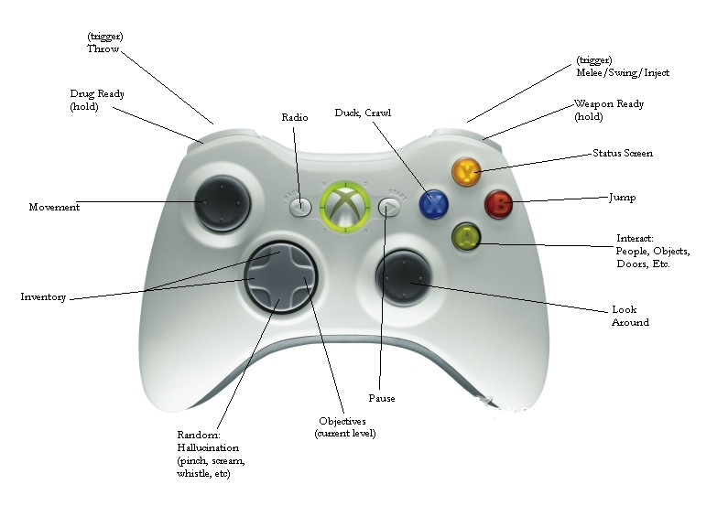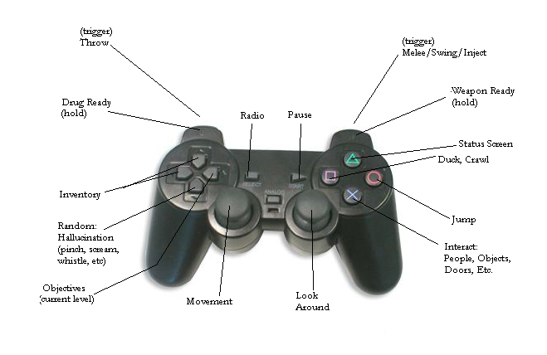
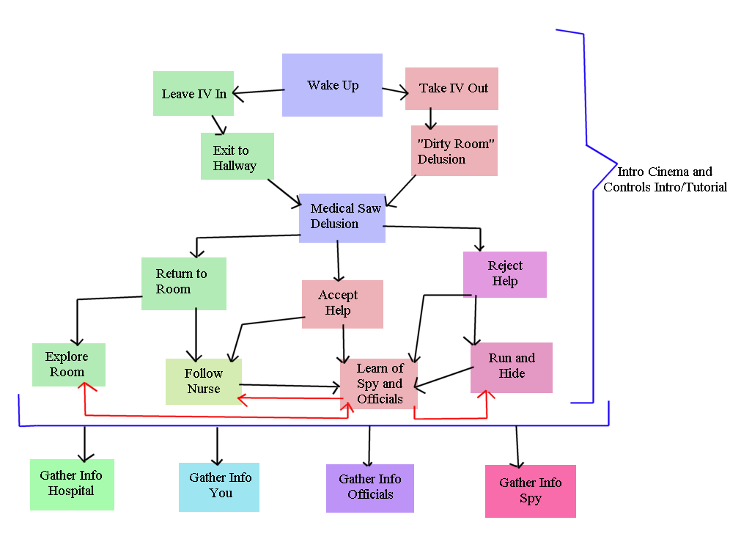

Hallucination
Hallucinations are a major factor in the game. It can be controlled with various drugs, but even on the medication delusions are possible. At the start of the game, hallucinations are easy to recognize and break. As the game progresses, the delusions start resembling reality more and more. And it is even harder to break the hallucination. This can cause problems because in the hallucination you it is possible to learn information that is not real-- in a sense sending you on a wild goose chase.
There is no screen change or any other outside warning of when a hallucination occurs (unless it is an obvious hallucination) The player has to be able to figure out whether what they are seeing is real or fake. There are various clues during hallucinations that can tip off the player, but in order to notice these, you have to be aware of what's actually in the real game world.
While in a hallucination, there are two possible states that Lambda's physical body can be in: action or comatose. While in an action state, Lambda will physically move around will in the hallucination. This is dangerous because while it may seem that you're walking down an empty corridor, you could be in reality walking into a lounge full of Officials. The only way to tell if you've had an action hallucination is when the delusion is broken and you're suddenly in a very different spot. A comatose hallucination is just as bad. While 'comatose' Lambda simply stands or lays there, unmoving, unresponsive to outside stimuli. A lamb for the slaughter for any Officials that may stumble upon you or concerned staff. During this kind of delusion, it is possible to wake up in a different location-- a hospital room-- because that is where staff would put you.
Drugs and Items
Drugs are a key feature in this game. Not only are they used to control your hallucinations, they are also used as cure items and even weapons at times.
• Paccerebilliquidus: Used during processing to keep the brain 'neutral.' You can find IV bags of the stuff at various places in the hospital, but it wasn't meant for long term usage. As the game progresses, you start to develop an immunity to it. There are other drugs which you can use with Paccerebilliquidus to increase its potency.
• Remeoxemplarmentis: Used to reverse processing and return your mind to its original state.
• Pain Killers/Opiates/Anesthetic: Opoid- Morphine, Codeine, Oxycontin, Hydrocodone, Fentanyl, Methadone. Muscle relaxants- Atracurium, Gallamine, Vecuronium. Inhaled anesthetics- Nitrous Oxide, Xenon. General IV/Sedative- Diazepam, Methohexital, Ketamine. Used to numb pain or cause unconsciousness. Pain slows your character and makes it harder to move silently. Pain can present through physical trauma and psychosomatic problems (because of hallucinations. it is possible to think you are seriously injured in a hallucination and have the pain still be around when the hallucination is gone) Highly addictive. The more you take, more often, the less the drug works so the more you have to take.
• Anticoagulant/Coagulant: Drugs that prevent or encourage the clotting of blood.
• Lorazepam: Ativan, Temesta, Tavor. To augment the action of the primary anesthetic drugs. Treat anxiety, insomnia, anticonvulsant. Psychological and/or physical dependence possible. Withdrawal symptoms similar in character to those of alcohol and barbiturates have been observed after abrupt discontinuation, therefore, a gradual taper is recommended over a period of time.
• Paccerebilliquidus enhancers: Magivoximens and Voximperitims. Drugs used to enhance the effects of Paccerebilliquidus. Magivoximens is the least powerful of the two, but can be safely used in larger doses than the other and with fewer side effects. Voximperitims is more powerful and a single dose lasts longer, but you can't take it in large doses and has more side effects. Side effects of the enhancers’ nausea (which can reduce speed and prevent you from moving in stealth), seizures.
• Supplies: Generic supplies like gauze, scissors, scalpels, clamps, sponges, stethoscope, IV tubing, needles, syringes, masks, scrubs, etc. Can be used to treat wounds, as weapons, aids in stealth/disguise, etc.
• Officials' radio: Radio given to you by Rook that is tuned to the Officials' tactic channels. The radio lets you listen in on the Officials and their movements, but it does have a down side. They can figure out that you have a radio and, if they do, use it to set up traps.
• Guns: Rook and other characters/places can give you access to small handguns. However ammo is very limited. The Officials use larger, more powerful guns that you are unable to use. (you're weak and skinny, so when you try to use them you get blasted back on your butt. might make for an interesting cut scene)
• Knives: Combat and other types of knives, generally supplied by Rook. They are larger and more durable than any scalpel you could pick up, but they are not as sharp.
• Bone Saw: Picked up from the hospital morgue and only the hospital morgue. Very strong, very sharp, very durable, and very loud.
Stealth and Fighting
For the most part it will be a stealth type game. The forces out to get you have better numbers and fire power, so you are better off not getting caught. You can sneak around in various ways. Avoidance- ducking down empty corridors, moving through air vents, etc. Disguise- take on surgical masks, scrubs, lab coats, average clothes, etc. to make yourself harder to recognize. Disturbance- cause a distraction in one area to make it easier to get through another. Smoke bombs to cover the direction and speed of your escape.
But there will be a few out-right conflicts, though most of those will occur during hallucinations. When it comes to actual fighting, your opponents are quite ranged. Your main concerns are with the Officials, the people that are sent to the hospital to capture and/or kill you. But, depending on how you interact with the hospital staff, they too can given cause to attack you, pursue you, or rat you out to the Officials. The hallucinations are the fun fights, in my opinion. Your opponents can range from regular people (staff, Officials, mailmen) to zombies, chickens, and elder gods. In any case, the approach to fighting depends on a few things. If your opponent doesn't know you're there and you have a small hand-held weapon, you can sneak up to them and do a 'backstab.' (the technique itself depends on the angle and weapon used) At a distance, you can throw your weapon or opt to go in close to try melee. (you can pistol whip someone when out of bullets) Just take into consideration that all the weapons you have are weaker, slower, and/or less durable than that of the Officials.
Available weapons are quite ranged. You have the more common knives, guns, scalpels, bone saw, etc. There are also the various drugs through out the game that you can use to 'spike' or poison your enemies. You can also used objects through out the environment-- IV stands, chairs, pillows, etc.

