Group 24

System Design Report

Specifications for Project

Ms. Terrie Taylor

Table of Contents

Executive Summary 3

Introduction 4

Part I: Problem Definition 5

Part II: Proposed System Requirements 9

Part III: Alternatives, Evaluation and recommendation 11

Part IV: Proposed System Design 16

Part V: Remaining work required 29

Appendix A: Statement of Work 31

Executive Summary

Problem: An under-performing inventory system, currently in use, that does not fill the needs of our client, namely Ms. Terrie Taylor of the University of Oklahoma’s Athletic Department. This inventory system is supposed to keeps track of all computer equipment and accessories for her department. The current inventory system, Track-It!© does not fulfill the goal of this department.

Solution: Contained in this report is a complete outline of the current situation and a proposed system built by this team that will meet all of the client’s specifications for fulfilling her goal of efficiently keeping track of all inventory in her realm of responsibility, including:

Maintaining an “active” database of all products currenty in use by faculty or staff.

Maintaining a “history” file of all products, their past, and any and all history pertaining to a particular piece of equipment

Maintaining a warning system to warn our client of active leases that are preparing to expire

Plan for the next stage: Completion of design phase and another client meeting to approve this phase of design. Complete design and

Introduction

The purpose of this system design report is to further clarify any and all questions relating to the problems, requirements and alternatives of the proposed system. Further, this report will show a complete proposed system with procurement specifications and remaining work required to complete this system.

Current Situation
Project Statement
The project will focus on creating an inventory system that will help the IS Department of the University of Oklahoma track its laptops.
Strategic Analysis
The system will be made for the University of Oklahoma's Athletic Department. Currently the school has 18 sports that both men and women compete. The project will specifically be designed for the IS Department of the organization. The IS group focuses on maintaining support for all athletes at the university. It operates and maintains the infrastructure of all computing needs for the entire staff of the department. It is also responsible for operating the computer labs available to student athletes.
The mission of the University of Oklahoma is to provide the best possible educational experience for students through excellence in teaching, research and creative activity, and service to the state and society. The mission of the Athletic Department is to provide the opportunity for all students to develop to the fullest degree all desirable abilities and skills. It shall be the mission of the Athletic Department to provide the opportunity for each student to attain proficiency in athletic endeavors. Athletics is not an end in itself, but merely one of the contributing factors in the total education of the student. It also wants student athletes to enhance their learning experiences by utilizing the tools and technologies available to them. Performance is measured internally for the department by continually focusing on meeting the needs of all users within the department.
The proposed inventory system will improve the performance of the organization by minimizing the amount of time needed to track and report information pertaining to desktops, laptops, and other equipment available to users. These machines and equipment are used by students and staff and our currently leased by outside companies. The new system will be used by relatively few, but will track a significant amount of information about the desktops, laptops, and other equipment. The goal of the new system will be to cut down on the amount of time currently needed to track information about these items.
Success will be measured by the amount of time saved with a new tracking system. For the system to meet our client's expectations a significant advantage over the current system must be met.

Current Situation Operations
The OU Athletics Department currently has an inventory management system in place called Track-It!©. The current system also has some unnecessary information concerning purchasing of the computer system and equipment. Track-It!© does not adequately notify the user of upcoming lease dates. The client would like to be notified six months in advance by a printable report that can be physically filed. The client would also like to weed out any unnecessary information and add a password for security. Track-It!© does not unpopulated records. If someone returns a system and then checks out another, the system shows the user with two computer systems. The client has expressed interest in having a completely new system that addresses the problems Track-It!© has.
Track-It!© has inventory entered into the computer. Inventory is computer systems consisting of both desktop and laptop computers. The system also keeps track of vendor information and which vendor supplies which equipment and when it was supplied. The system also tracks which faculty member is using which system and the time frame in which they have used the system.
The new system will keep track of the same things as the old system. In addition the new system will give warnings to the user when equipment is due. Physical reports will be produced for filing. The new system will also produce an active list that shows all equipment being used by faculty and an inactive list that shows all inventory not being used.

Infrastructure
The client currently uses a help desk database called Track-It!© to keep track of inventory. The inventory consists of all the computers and laptops used by the Athletic Department of The University of Oklahoma. The database is stored on a server that is currently located in the stadium. The server may temporarily be moved to Carson due to construction on the stadium. The database is only accessible from the workstations in the information systems office.
The new system will be stored the same way and will have the same users as the current system, except more focus will be placed on lease dates and information concerning vendors and end users will be eliminated. The client does not need the system to be web enabled. The system should have password protection to ensure only certain people will have access.

Problem Analysis
The current system Track-It!© does not adequately track equipment. It does not warn the user when there is either overdue equipment or when leases are running out. The system also has too much information. The user is bogged down in miscellaneous data about purchasing.
Proposed System Goals
The client wants a new system that will keep better track of inventory. The system should unpopulate an inventory item after it is removed. A warning that the lease on equipment is due should be provided two to six months in advance. The client wants to be able to print a warning report to be filed physically. The system should have a user-friendly interface. The user should be able to enter new inventory and update current inventory with ease. The system only needs to store relevant information on inventory. The client does not want to deal with excessive information.

Constraints
The budget limit is $0.00. Microsoft Access© and Visual Basic© will be used to develop the system and are available at zero cost. The new system will be stored in the existing infrastructure that the current system uses. Time is a possible constraint in developing the ideal system for the client.

II. Proposed System Requirement

At first, the new system that we are going to design will eliminate unnecessary information on the current system. Unnecessary information includes: vendor information, faculty information, and purchasing information. Next, it must be password protected in order to ensure only authorized personnel have access.
The new system will concentrate solely on tracking equipment. It will keep track on where is the equipment be located, how long has it been there and when is the lease up.
Besides that, the system will allow user to enter new inventory and update current inventory with ease. It also should unpopulate an inventory item after it is removed. The most important feature that the system will provide is giving a 2 – 6 months in advance lease expiration warning. The warning message will list up the equipments information that will be expired within 2 months or within 6 months.
Since the client’s budget limit is $0.00, so Microsoft Access and Visual Basic will be used to develop the new system and are available at zero cost.
To use Microsoft Access 2000, the client needs:

* PC with a Pentium 75 MHz or higher processor

* Microsoft Windows 95 or later operating system, or Microsoft Windows NT
Workstation operating system version 4.0 Service Pack or later

* For Windows 95 or Windows 98:
16 MB of RAM for the operating system, plus an additional 8 MB of RAM
for Access

* For Windows NT Workstation version 4.0 Service Pack 3 or later:
32 MB of RAM for the operating system, plus an additional 8 MB of RAM
for Access

* Available hard-disk space for Access 2000 (Hard-disk usage will vary
depending on configuration. Choices made during Custom installation might
require more or less hard-disk space):
Typical installation: 161 MB

Under the new system, the Access data files would be stored on a network drive offered by the client. The network drive should have 100 megabytes space to store thousand of records.
Since the new system would be a user-friendly application, we just need to provide a little training to the client.
Alternatives

The team has three alternatives. They are to 1) buy an updated version of Blue Ocean’s Track-It!© software 2) build a completely new system or 3) outsource the system to a consulting company. Because the team cannot edit the current system, the group will not use the option anymore.
Buy Updated Version of Track-It!©
The first alternative the group has is to buy an updated version of the software. Because of today’s fast changes in technology, companies are always offering new versions of their software. Blue Ocean also, currently has a new version of its software. The name of this new version is called Track-It!© Version 4.0. “Track-It!© is a fully scalable and web-enabled PC management system with tightly integrated modules for Help Desk, Inventory, Auditing, Purchasing, Training, Reporting, and more (www.blueocean.com). Some of the features that it provides is increased efficiency in managing the many work orders, track warranties, service contract expirations, who has equipment checked out on loan, and how much has been purchased from vendors.
One of the major strengths that this new version of software offers is that the client would already be somewhat familiar with the software. It also lets the client know when work orders become overdue. The weaknesses of this software are that it fails to meet some of the critical features the client desires. Although this software says it helps track service contract expiration, it doesn’t go into detail on how this is done. The client also wants the system to be password protected and to be able to prints reports, which are not included in the newer version of the software. Major corporations like Kraft, Nabisco, FedEx, Arthur Anderson, GE, and many other companies also use this software. The Athletic department is not a huge corporation, though. Only one other user, besides the client, will be using this software, so it provides more than the client needs.

Build New System
Another alternative the client has is to build a completely new system. A completely new system would contain all of the features desired by the client. It would be a small access database stored on a current network drive offered by the client. It would be accessible by multiple computers in the client’s office. Information on about 1000 items would be stored, using only 100 megabytes of estimated space. This alternative would require little changes except for some basic training to the client. The training would be real basic since the client would only have to have some Access experience.
This alternative offers more strengths than weaknesses to the client and is the best choice out of the three alternatives. This new system would be user-friendly, password protected, track inventory better, and most importantly it would have the lease expiration warnings. These strengths meet all of the clients needs, and because the system would be relatively simple, it would require little training and time to build it. The installation time would also be short and there would be little disruption to the client. Also, the cost to the client would basically be zero dollars because a group of students would build it.

Outsource the Current System to a Consulting Company
The last alternative the client has is to outsource the current system to a consulting company. An outsourced system would basically offer everything like an updated version of the current software. Although it does offer more of the client’s needs, an outsourced system does have limitations. The client’s and their assistant’s jobs would change and loss of control would occur.
The strengths of outsourcing the current system are that it would allow the client to focus on other job related activities and most of the client’s needs would be meet. But the weaknesses of outsourcing the current system outweigh its strengths. Cost is the biggest weakness. This is not a one-time cost like buying an updated version of the software, but an on-going cost that the client would have to incur. Because contracts are formed, the client will not be able to break the contract if their needs are not met. Also reports that the client may want will cost extra. Compared to other outsourced systems, this system is relatively small, so it may be less important to the outsourcing company. There may also be companies that don’t outsource such small systems and response time will be greater for any requests that the client may have.

Evaluation Table
 | Stores only relevant information | User friendly | Able to print reports | Cheap costs | Little training | Shows lease expiration warnings | Password protected | Little disruption in work
1) Buy updated version | No | No | No | No $695 | Yes | Yes | No | No
2) Build new system | Yes | Yes | Yes | Yes | Yes | Yes | Yes | Yes
3) Outsource system | N/A | No | N/A | No  $695+ | Yes | N/A | N/A | No

Recommendation

The project team recommends building the system for the OU Athletics Department. After evaluating all possible alternatives and consulting with the client during meetings and the presentation it is clear that the team is capable of putting in a system for the client. The main reason for selecting the build alternative is based on costs.
Leaving the system the same would not benefit the Athletics Department because the current system does not satisfy requirements needed by the client. Another option the team explored was to modify the current system. Although this would be a relatively cheap alternative, the current Track-It!© system doesn't solve current problems. Our client has made it clear that Track-It!© is extremely non-user friendly and does not want it or an updated version. Outsourcing is not a feasible alternative because of limited funds within the Athletic Department and the high price tag that accompanies this alternative. It's extremely hard for our client to receive funds for smaller projects in the IS Department and for this small of a problem it's not expected that management would change its stance on funding allocation. Another reason not to outsource is the simplicity of the requested system.
Since the group is working at no costs it will be extremely inexpensive for the client to implement the system. It's also clear that the specific system requested by the client is relatively simple and will be a reasonable project for the team. Selecting the build option will be the cheapest, fastest, and easiest for all parties involved.
Proposed System Design

Proposed Design Specifications

The new system will be built in Microsoft Access 2000. It will require no programming, just a working knowledge of Access. There will be three tables in the database: 1) Equipment, 2) Order, and 3) History. The Data Schema section describes these tables and their contents. These three tables with keep track of active and inactive equipment as well as what equipment has been received from OU and what equipment has not. There will be some data entry for the client. She/He will have to enter in new equipment in both the Equipment and History tables. When the database is opened it will automatically search for the following: 1) Overdue Equipment, 2) Equipment due within 2 and 6 months, and 3) Waiting Orders. These searches will be conducted and then reports will be generated for the client to print out.
The interface will consist of several options: 1) Enter a New Order, 2) Enter New Equipment, 3) Return Equipment to OU, 4) Return Equipment to Client, and 5) Print Reports. Option one and two are self explanatory. Option 3, Return Equipment to OU, will be used when equipments lease runs out and the computer has to be returned. The client will enter a return date and the equipment record will be moved to the history table. Option 4, Return Equipment to Client, will be used when an end user no longer needs the equipment, but the lease data is not yet up. The client may return the equipment to OU or she/he may assign it to another user. Option 5, Print Reports, will take the client to a Reports Menu. The reports menu will display several reports: 1) Equipment In Use, 2) Equipment Not In Use, 3) Equipment History, 4) Equipment Due Report. The Equipment In Use report will show all the equipment that is checked out by end users. The Equipment Not In Use report will show all equipment that has been returned to the client, but not to OU. The Equipment History report will show all equipment that has every been through the clients office. It will show what piece of equipment has been where at what time and when it was returned both to the client and to OU. The Equipment Due Report is the report generated by the initial searches for overdue and upcoming lease expirations. This report will show all equipment that is either past due or is going to be due in the next 2 and 6 months.
The system contains four processes (See the Process Model below). None of these processes trigger another process. They are stand alone. Each process is triggered by outside actions. For example, equipment arriving from OU or equipment being returned to the client. A function hierarchy diagram is not needed because these processes are independent.

Proposed System Narrative
The new system will eliminate unnecessary information. Unnecessary information includes: vendor information, faculty information, and purchasing information. The new system will concentrate solely on tracking equipment. It will answer the questions: Where is the equipment? How long has it been there? When is the lease up? The new system will not change the current infrastructure. It will be installed and run on the same medium as the old system. It will however be password protected in order to ensure only authorized personnel have access.
Input/Output Specifications

External – Client
Input – Order

When faculty/staff request equipment a new order is placed. The client or data entry
clerk enters in the order and it is written out to the order data store.
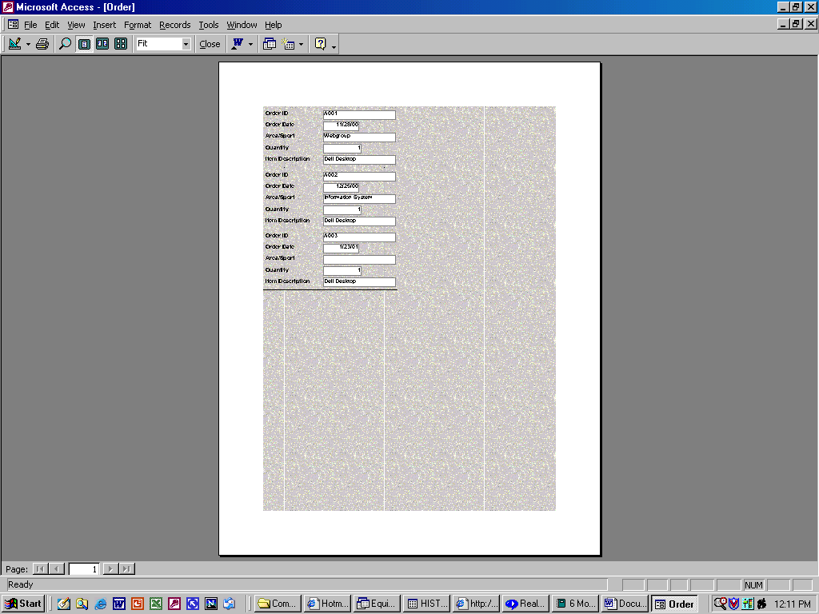

Order ID | Order Date | Area/Sport | Quantity | Item Description
A001 | 11/28/00 | Webgroup | 1 | Dell Desktop
A002 | 12/25/00 | Information System | 1 | Dell Desktop
A003 | 1/23/01 |  | 1 | Dell Desktop

Input – New Equipment

New equipment arrives from OU and the external client or data entry clerk enters in
the pertinent information. The information is written out to the equipment data store.

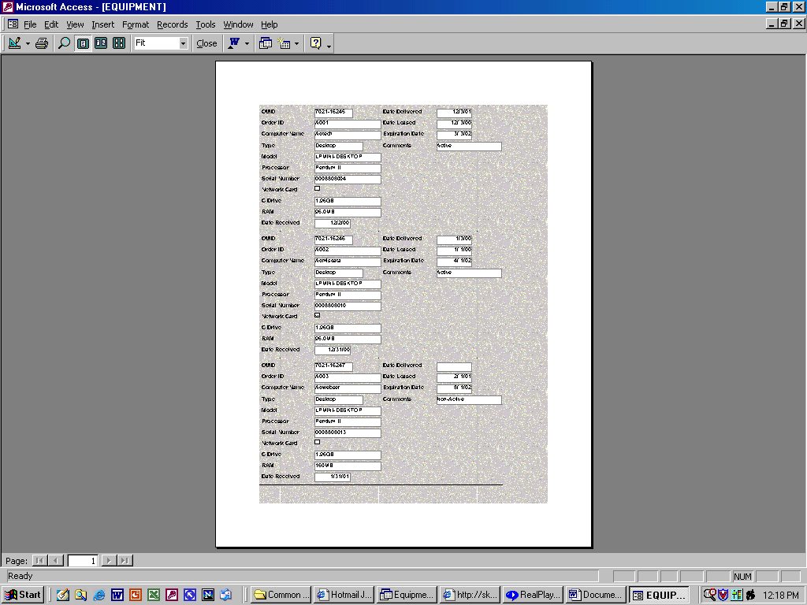

OUID | Order ID | Computer Name | Type | Model | Processor | Serial Number | Network Card
7021-16245 | A001 | Adtech | Desktop | LPMINI-DESKTOP | Pentium II | 0008808004 | No
7021-16246 | A002 | Admisdata | Desktop | LPMINI-DESKTOP | Pentium II | 0008808010 | Yes
7021-16247 | A003 | Adwebser | Desktop | LPMINI-DESKTOP | Pentium II | 0008808013 | No

C Drive | RAM | Date Received | Date Delivered | Date Leased | Expiration Date | Comments
1.96GB | 96.0MB | 12/2/00 | 12/3/01 | 12/ 3/00 | 3/ 3/02 | Active
1.96GB | 96.0MB | 12/31/00 | 1/3/00 | 1/ 1/00 | 4/ 1/02 | Active
1.96GB | 160MB | 1/31/01 |  | 2/ 1/01 | 8/ 1/02 | Non-Active

Output – Order Report

The order record data flow is read in from the order data store after accepting the new equipment data flow from the client external. Then the order report data flow is generated out to the client external.

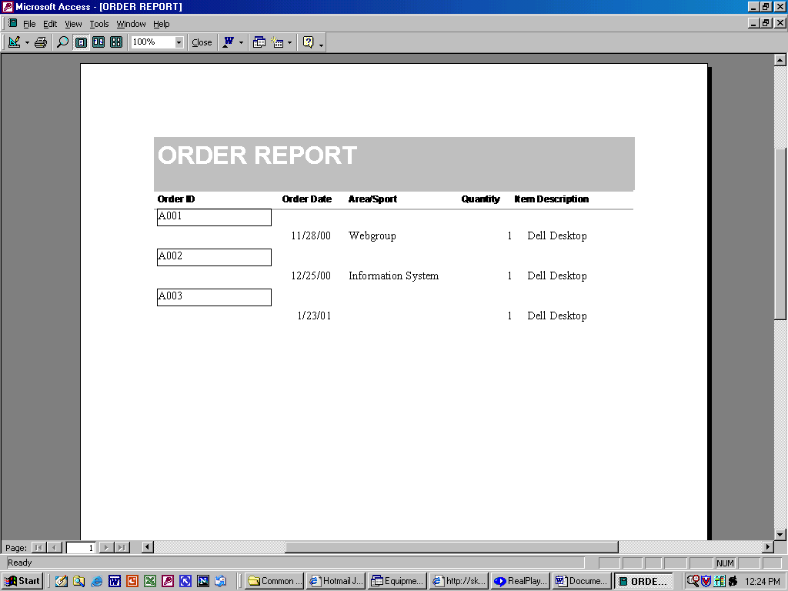

External – Client
Input – time
Output – 2-Month Report
6-Month Report

Reports are time triggered. Every month the equipment data store is searched
and two reports are generated, the six month report and two month report.
The two month report contains information on equipment that the lease
expires within the next two months. The six-month report is the same
except the lease expires within the next six months.

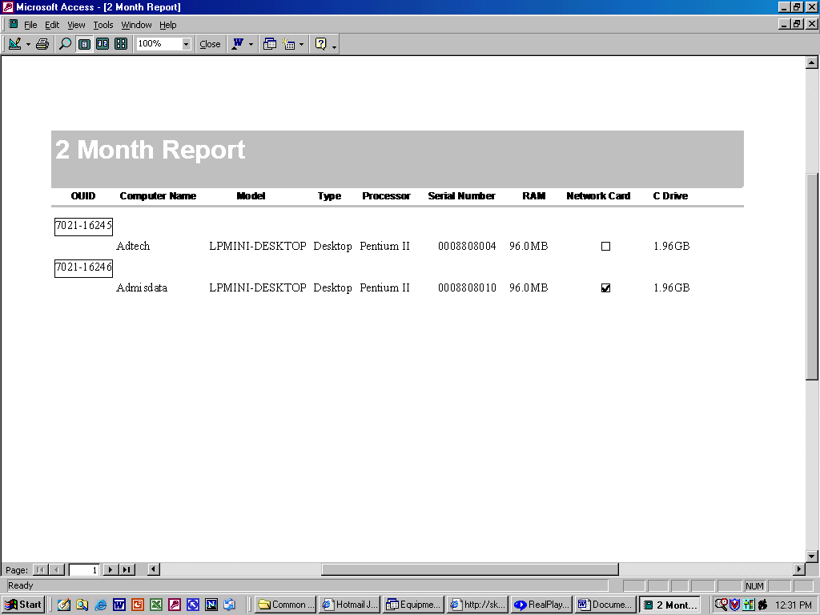
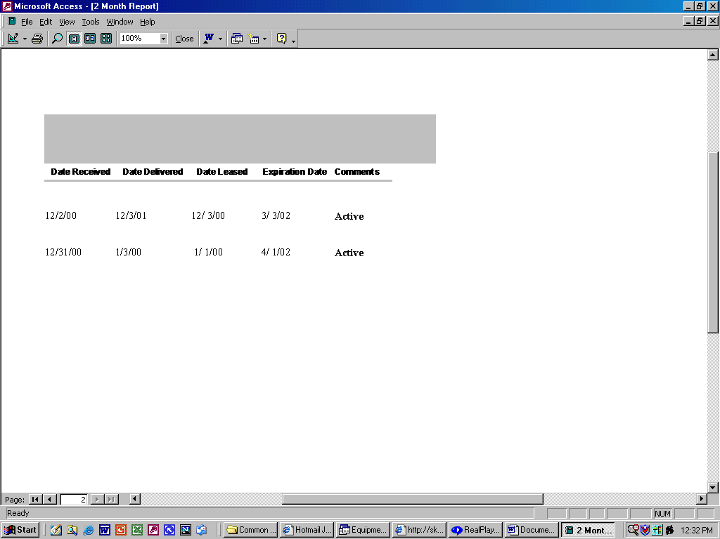

External – Management
Input – Return Date

When equipment is returned the client enters in the return date and the information is recorded in the equipment data store. The equipment record is then deleted and created in the history data store.

Data Schema

Entities
Order – The order data store contains information about requested equipment.
Equipment – The equipment data store contains information about equipment currently in
use.
History – The history data store contains information about equipment that is not in use.

Order
Attribute | Description
Order Date | Date the system was ordered
Area/Sport | The Sport department that needs the system
Quantity | The number of systems requested
Item Description | The description of the system, such as hard drive size and speed.
Equipment
Attribute | Description
OU ID | The ID number assigned to each system by the university
Order Date | Date the system was ordered
Computer Name | The name given to the computer on the network.
Type | Type is either Desktop, Laptop, or Other.
Model | The model number assigned by the vendor to each system.
Processor | The speed and type of processor.
Serial # | A unique number assigned to each piece of equipment.
Network Card | The speed and type of network card.
RAM | The amount of RAM.
C Drive | The size of the hard drive.
Date Received | The date the client receives the system from OU.
Date Delivered | The date the client delivers the system to the end user.
Date Leased | The date the system is leased from the vendor.
Expiration Date | The date the system is due back to the vendor.
Comments | A blank field that will hold any comments the client chooses to enter about the system.
History
Attribute | Description
OU ID | The ID number assigned to each system by the university
Computer Name | The name given to the computer on the network.
Type | Type is either Desktop, Laptop, or Other.
Model | The model number assigned by the vendor to each system.
Processor | The speed and type of processor.
Serial # | A unique number assigned to each piece of equipment.
Network Card | The speed and type of network card.
RAM | The amount of RAM.
C Drive | The size of the hard drive.
Date Received | The date the client receives the system from OU.
Date Delivered | The date the client delivers the system to the end user.
Date Leased | The date the system is leased from the vendor.
Expiration Date | The date the system is due back to the vendor.
Return Date | The date the end user returns the system to the client.
Comments | A blank field that will hold any comments the client chooses to enter about the system.

Process Model

Metadata

Externals
Client – Terrie Taylor, Information Technology Specialist of the OU Athletics
Department.

Data Flows
Order – Order Date, Area/Sport, Quantity, Item Description
Order Record – Order Date, Area/Sport, Quantity, Item Description
New Equipment – OU ID, Computer Name, Model, Type, Processor, Serial #,
RAM, Network Card, C Drive, Date Received, Date Delivered, Date Leased,
Expiration Date, Comments
Equipment Record – OU ID, Computer Name, Model, Type, Processor, Serial #,
RAM, Network Card, C Drive, Date Received, Date Delivered, Date Leased,
Expiration Date, Comments
Order Report – Order Date, Area/Sport, Quantity, Item Description
6 Mo. Report – OU ID, Computer Name, Model, Type, Processor, Serial #, RAM,
Network Card, C Drive, Date Received, Date Delivered, Date Leased,
Expiration Date, Comments
2 Mo. Report - OU ID, Computer Name, Model, Type, Processor, Serial #, RAM,
Network Card, C Drive, Date Received, Date Delivered, Date Leased,
Expiration Date, Comments
Return Date – OU ID, Return Date
History Record – OU ID, Computer Name, Model, Type, Processor, Serial #, RAM,
Network Card, C Drive, Date Received, Date Delivered, Date Leased,
Expiration Date, Return Date, Comments

Data Stores – refer to the Data Schema section for contents of data stores.
Order – The order data store contains information about requested equipment.
Equipment – The equipment data store contains information about equipment currently in
use.
History – The history data store contains information about equipment that is not in use.
Processes

All processes will be implemented in Microsoft Access 2000. It does not require any programming, but working knowledge of Access.

- Order – When faculty/staff request equipment a new order is placed. The client or data entry clerk enters in the order and it is written out to the order data store. There are only 2 data flows connected to this process, the order which comes from the external client and the order record which is sent to the order data store.
- New Equipment – New equipment arrives from OU and the client or data entry clerk enters in the pertinent information. The information is written out to the equipment data store. The order data store is read and looks for equipment that has not been received and generates a report of equipment. The order record data flow is read in from the order data store after accepting the new equipment data flow from the client external. Then the order report data flow is generated out to the client external. Then the equipment record data flow is written out to the equipment data store.
- Reports – Reports are time triggered. Every month the equipment data store is searched and two reports are generated, the six-month report and the two-month report. The two-month report contains information on equipment that the lease expires within the next two months. The six-month report is the same except the lease expires within the next six months. The equipment record data flow is read into the system from the equipment data store. Then both the 2 mo. Report and 6 mo. Report data flows are written out to the client external.
- Returning Equipment – When equipment is returned the client enters in the return date and the information is recorded in the equipment data store. The equipment record is then deleted and created in the history data store. The return date data flow is accepted from the client external. Then the equipment record data flow is read in from the equipment data store and when the correct record is found the system sends the delete equipment data flow to the equipment data store. Then the history record data flow is sent to the history data store.

Remaining Work Required

Prototype for Client
The team will build a prototype of the inventory database to present to the client to make sure that the database provides everything that the client wants. The prototype will also be used in the Proposed Design Presentation to the team manager.
Proposed Design Presentation
The team will present the system design models and components to the team manager and demonstrate how they fit together. The team will also demonstrate the connection of the design to the prototype. The team and manager will check for consistency with the models and prototype.
Final System
After presenting the prototype to the client and team manager, the team will make corrections and produce a final system.
Final Report
The final report will sum up the whole project. This report will include title page, table of contents, executive summary, introduction, problem definition, proposed system requirements, alternatives, evaluation, recommendation, proposed system design specifications, implementing and testing, statement of work, and any supplemental material.

Final Presentation
The team will give the final presentation to the client and the team manager. This presentation will sell the final system and show everything that was accomplished during the project.
Training
The team will train the client and any users to use the system.
User Manual
The team will write a user manual to give to the users. The manual will explain how to use the system and document any useful information about the system.

Appendix A-Statement of Work

Overview. The project will focus on creating an inventory system that will help the IS Department of the University of Oklahoma’s Athletic Department track its laptops. The purpose is to create a system that is user friendly, easy to track inventory, password protected and able to give warning of a product’s lease expiration within six months of expiration. The new system will allow for information to be more easily audited.

Scope. Team 24 will propose a system that is currently better at tracking inventory for leased equipment, especially year- end inventory. The new system will focus more on lease dates and focus will be taken away from vendor and the end user. The user interface will be user friendly to the extent that it allows information to be easily entered into inventory and allows minimal data entry errors. The new system will also allow for information to be updated. Unnecessary information will not be stored in inventory. The system will be ran on a server and a hard copy of lease expirations for laptops will be available. Security for the system will be password protection.

Possible Alternatives. The team will investigate four alternative solutions to the current system and propose only those alternatives that have the potential to solve the client’s problem. The alternatives will be to buy an updated version of Blue Ocean software, outsource to a consulting company, edit the current system and build a new system.

Deliverables. The project will include a project definition report due on February 18, 2002, a proposed system report on February 25, 2002, a system design report and presentation on March 4, 2002, a data flow diagram, a context level diagram and entity relationship diagram. All diagrams will be included in each report and/or presentation. The purpose of these reports and presentation is to confer with the client as to how the system is to be built and the steps to take to achieve the desired system. The final presentation, date still tentative, will implement the desired system of the client.

Client Resources. The storage space will be on a network drive. Other resources will be listed further into the project.

Development Plan. (Gantt Chart)
The project includes a mixture of reports and presentations that will lead to a final deliverable that satisfies the client’s needs. The deliverables will either be presented to the client and team manager or, in some cases, only to the team manager. These deliverables will offer possible solutions and how the solution will benefit the client. A recommendation to the client will be in the form of a proposed system report. This report will decide the solution in which the team will pursue under the client’s requirements. This solution will be studied more and a deliverable, system design report, will be generated. The purpose of this report is to account for the steps taken to build or acquire the solution. The solution will then be processed into a working prototype and then be used in the final report and presentation. The client will receive the statement of work, appendix-A of the project definition report, and the final report.

