Chapter 1 - Problem Description
Introduction
In this coursework, I will use Macromedia Dreamweaver MX to make an E-book, and the topic is “Tigers”.
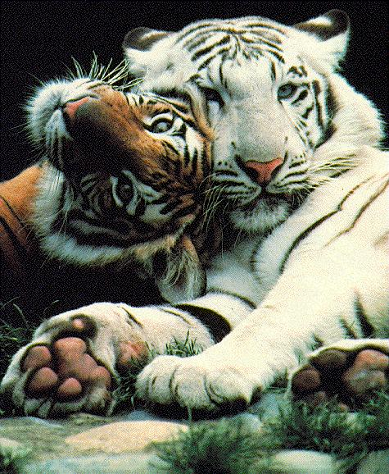
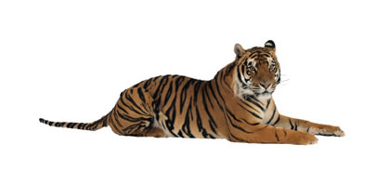
Tiger is very famous among many kinds of animal. Even a two-year old child knows what a tiger is. The problem is, not many people in Hong Kong know deeply about tigers, especially the younger ones, who are between ten and fourteen years old, this may be due to the living style and lack of wild animals in Hong Kong. Many of them only know that tigers are animals with four legs, with orange and black stripes and eat meat. Instead, people don’t know that tigers can be categorized into different types. If the younger generation wants to know more about tigers, the most effective ways will be reading reference books and searching information on the internet. However, these learning ways are a bit boring in these days, because the learning trend nowadays emphasizes more on interactive and enjoyment. Assimilating knowledge from books or from the internet are really monotonous tasks.
This is why I chose “Tigers” as the educational topic for my coursework; I hope young people will know more about the nature, especially about dying out animals. An E-book about tigers would be a good idea; readers can get started on tigers and then move on to other wild animals after they have developed an interest and desire to find out more about other wild animals.

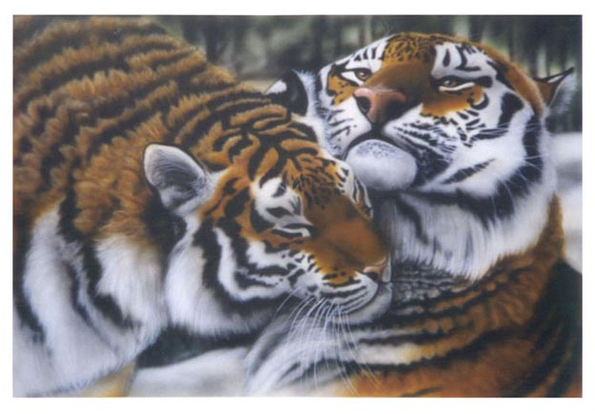
Different kinds of tigers will be included in the E-book, and the description will be written in simple English with as little difficult words as possible. Therefore, the E-book will be easy to understand and suitable for young people of ten years old and above, who are in the best age group to assimilate such knowledge. The E-book will also be user-friendly. The first page can be linked to different pages which talk about different kinds of tigers, users can choose the kind they want and start reading within a single click. Everyone will know how to use it; special computer knowledge is not required since different buttons will be inserted in every page with different functions. Sound effects will also be added where possible. As a result, readers can learn a lot about tigers through this riveting learning method, and develop an interest in wild animals, which is the aim of the E-book.

Problems Facing
Different problems may be face during making the E-book, including:
- Although information about tigers is easy to obtain, it is difficult to sift through a variety of information in order to winnow out the most suitable ones.
- Sound effects such as roaring sounds of tigers are difficult to obtain since sound clips are rarely found on the internet.
- There will be some biological words included in the E-book; it may be difficult to express them with simple English words.
- Since Macromedia Flash may not be use in making the E-book, motion effects are not sufficient; more GIF may be used instead.


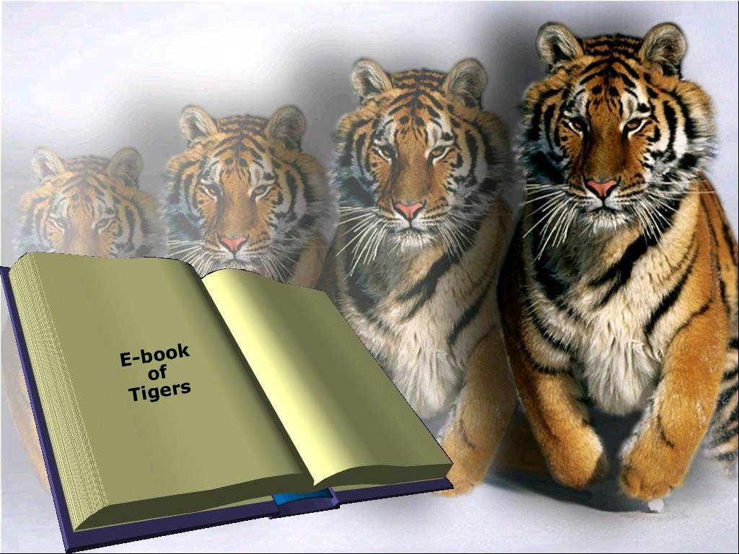
Chapter 2 - Investigation and Analysis of Problem
Introduction
The aim of the coursework is to make an E-book about ‘Tigers’. As mentioned in Chapter 1, the E-book will be most suitable for students between ten and fourteen years old, it will provide them a new learning method with more interacting activities and enjoyment. Therefore, the E-book should be attractive and user-friendly in order to gain and hold attention of students, also providing an easier way to learn. In this case, making the E-book by using web page format will be a good solution. Therefore, we have to choose a web authoring tool to complete this task.
Since there are many kinds of web authoring tool, we have to compare their requirements and functions, in order to find out the most suitable one for designing the E-book. And now we are going to make comparisons between Macromedia Dreamweaver MX, Microsoft FrontPage, Netscape Composer and Microsoft Notepad.

Integrated web authoring tools
This included both Macromedia Dreamweaver and Microsoft FrontPage.

Macromedia Dreamweaver

Macromedia Dreamweaver is a very popular web authoring software which has strong support creating dynamic websites with its relatively optimized HTML codes. The advantages and disadvantages of Dreamweaver MX are as follows:

Advantages | Disadvantage
It is a What You See Is What You Get (WYSIWYG) Editor. | It dose not include the On-the-fly spell check, nor retain formatting function, which were included in Microsoft FrontPage.
It can draw tables, create links by dragging and dropping and create layers; it can also perform site map navigation, direct editing of HTML and direct uploading. | It has a more complicated user interface compared to Microsoft FrontPage, since it comes with many functions.
It is compatible with other Macromedia products, such as Flash or Fireworks.

Microsoft FrontPage

In Microsoft FrontPage, features are presented in a graphical way; users can compose web pages readily as if using a word processor. It also provides different kinds of wizards in order to simplify the process of creating websites. It is a web authoring software similar to Dreamweaver. These are the advantages and disadvantages of FrontPage:
Advantages | Disadvantages
It is a What You See Is What You Get (WYSIWYG) Editor. | It does not support the creation of layers, so the web page may be less attractive.
Advantages | Disadvantages
It can draw tables; it can also perform on-the-fly spell checking, retain formatting, site map navigation, direct editing of HTML and direct uploading. | It is not compatible with other Macromedia products, which makes it more difficult to make special effects.
Its user interface looks similar to MS Word, that makes it easier to be use since most of the users are familiar with MS Word.

Basic authoring tools
This included Netscape Composer.

Netscape Composer
Netscape Composer is a very simple web authoring tool. Simple websites with a few pages can be composed easily by Netscape Composer, with some basic web page formatting features. The advantages and disadvantage of Netscape Composer are as follows:
Advantages | Disadvantage
It is very simple to use as it does not have many complicate functions, web pages can be build easily. | It is only suitable for building simple websites with just a few pages, complicated page structures such as frames are not supported and dynamic websites cannot be built by using Netscape Composer.
No HTML knowledge is necessary; web pages can be setup by typing words and pressing the buttons.
Text editor
This included Microsoft Notepad.
Microsoft Notepad

Microsoft Notepad comes with Microsoft Windows; users can simply type in the HTML codes, in order to build the website. The followings are the advantages and disadvantages of Notepad.
Advantages | Disadvantages
It is cost effective, since it comes with MS Windows, users need not to buy any software nor download them from the internet. | Users using different Operating Systems other than MS Windows may not use this software, since it only comes with MS Windows.
If users have deep knowledge of HTML, they can build dynamic and complicated websites by typing in the HTML codes. | HTML knowledge is necessary for users using Notepad, if they do not have enough knowledge about HTML, they cannot build websites by Notepad.

Summarization
Summarizing the above comparisons, we have concluded that using Macromedia Dreamweaver as the software for creating the E-book will be the most suitable for the following reasons:
Knowledge required | Not much knowledge about HTML is necessary for building the E-book in web page format. Therefore, an integrated web authoring tool is most suitable.

More Supportive | Macromedia Dreamweaver supports more dynamic features than Microsoft FrontPage; drag and drop creation of links and creation of layers were also supported by Dreamweaver but not by FrontPage.
More Compatible | Macromedia Dreamweaver is compatible with other Macromedia products; this provides more ways to design the E-book with more interacting activities and enjoyment.
Cost Effective | A free trial version of Dreamweaver can be downloading from the website of Macromedia. However, FrontPage must obtain from Microsoft Office, so it is more costly.

Necessary Hardware
Lastly, we’ll briefly talk about the hardware which will be used in producing the E-book. First of all, photos will be chosen for the gallery of the E-book from different reference books, in order to insert these photos, a scanner will be needed to scan the photos. However, in some cases, photos may not be scanned easily. Therefore, a digital camera will also be needed, which will be used for capturing photos from reference books. Besides, in order to test the compatibility of the product, a simple will be test in different computers, as a result, a CD-R/RW writer or a floppy disc drive will be needed to store it in different storage media.

Chapter 3 - Design of the Solution
Introduction
As mentioned in Chapter 2, an educational E-book about tigers in web page format will be produced by using Macromedia Dreamweaver. The major of the Design of the solution is to introduce the contents and layout of the E-book, as well as the special features of the E-book, which will make it different from other ordinary text books. First, I’ll briefly explain the steps of producing the E-book.

Procedure
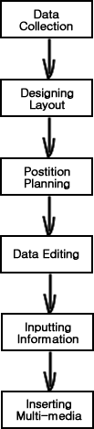 | 1. Collect data and resources which will be useful in the coursework, these mainly include description and photos of different kinds of tiger.  2. Design a simple and easy-understanding, but attractive and animated layout for the E-book.  3. Have the position of the menu bar, buttons, graphics and text well planned, making a user-friendly interface.  4. Edit the data collected, delete some useless information, and make some improvements of the paragraphs, in order to make the contents of the E-book more comprehensive and interesting.  5. Input the edited information; make it become a readable E-book.  6. Insert the multi-media elements, such as animations, sound clips and other dynamic features, a pictorial E-book will then be produced.
Contents of E-book

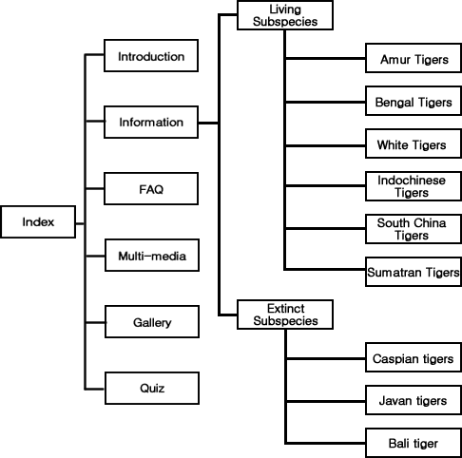
The above diagram describes the structure of the E-book; the contents are displaying in the way of a flow chart. The opening page of the E-book will be the index page with the Introduction showing in the main frame. The followings are some brief description about each link.

Introduction |  | In the introduction page, there will be brief explanations of the E-book. The explanations will include short paragraphs about tigers and the main contents of each link. This is for the user to familiarize with the E-book.
Information | This is the main page of the E-book, the information about tigers will be found in this page. The page will be divided into two sections: Living Subspecies and Extinct Subspecies, the former will have information about Amur tigers, Bengal tigers, White tigers, Indochinese tigers, South China tigers and Sumatran tigers; while the later will have information about Caspian tigers, Javan tigers and Bali tigers.
FAQ | In the FAQ section, additional information about tigers which were not include in the Information page will be put here in the form of question and answer.
Multi-media | In this page, some audio clips will be available for users. Some video clips will also be added if appropriate.
Gallery | In the Gallery page, about 20 photos of different kinds of tiger will be posted on the page.
Quiz | Users can take a simple quiz about tigers here, the quiz will consist of about 15 to 20 multiple choice questions.

Layout of E-book
The layout of the E-book will be like the figure on the next page. In the E-book, fewer frames are preferred since too many frames will reduce the displaying spaces. Therefore, only two frames will appear in the E-book, a top frame and a main frame; the top frame will be used for the menu bar and a GIF banner while the main frame will be used for displaying the contents.
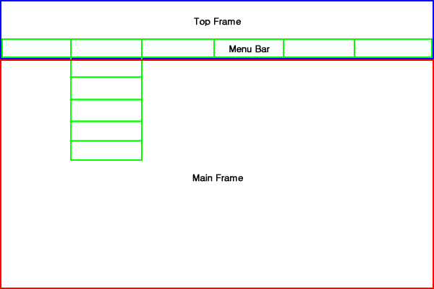
The upper part of the top frame will consist of a GIF banner, which keeps flickering all the time while the user is running the E-book; the lower part of the top frame will consist of a menu bar, which provides six buttons for users to browse the E-book. And for the ‘Information’ Button, there will be a sub-menu popup when the cursor accesses the area of the button. The popup sub-menu will consist of both living and extinct tiger subspecies.

Features of E-book
This E-book will have many special features which ordinary text books do not have, since the aim of producing the E-book is to replace ordinary educational text books. The followings are the special features which will be found in the E-book.

Well organized | The contents of the E-book will be well organized; each page will provide different links to different pages. Users can access the pages they want to view simply by a single click on the provided links.
Animations | There will be few GIF animations and movies in the E-book, users will not feel boring when they are reading the E-book. In fact, these animations can raise their interest in reading the E-book.
Sound clips | As mentioned before, the E-book will include some sound clips. This will be a very useful feature, since ordinary text books cannot provide sound effects.
Interactive | The quiz in the E-book will run in a form of interactive. When users answer the questions, the answers will popup immediately after they clicked on the chosen answers.
Gallery | In ordinary text books, not many photos were used, since the page area is limited, and most of them are not very big in size. But in a web browser, more photos than text books can be displayed in the E-book, and they can be larger in size.

E-book Format Selection
As mentioned in Chapter 2, the E-book will produce in the form of web page by using Macromedia Dreamweaver. Here, I’ll make some further indications about the formats which will be used for animations, graphics and sound clips.
Animations | Among many kinds of graphics format, GIF format will be the best for animations as it supports motion effects. Even though GIF format is quite big in file size compared to JPEG format, it is the only format which is suitable for making animations.
Graphics | A lot of graphics will be used in the E-book; the browser may have to load more than ten graphics at a time in some pages, photos in the gallery will also be large in size. Therefore, smaller graphics file size are preferred, JPEG will be the best choice, since it provides the highest compression rate among all the bitmap graphics formats, which can able the browser to read the file faster.
Sound Clips | Nowadays, most music files downloadable from the Internet are using MP3 audio format, this is because MP3 format supports high compression rate with lowering just a bit of the quality, and it also supports streaming technology. Therefore, it is very suitable for the sound clips use in the E-book, in that case, users will not have to download the whole file before they could start hearing.

Chapter 4 - Implementation of the Solution
The following screenshots were captured from the finished E-book.

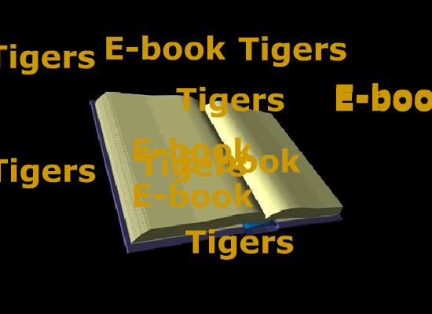
Introduction Movie



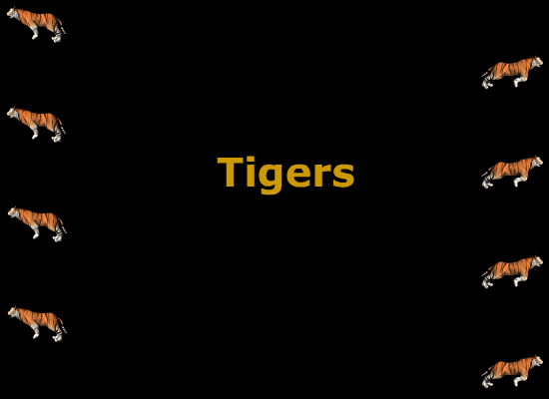

Buttons
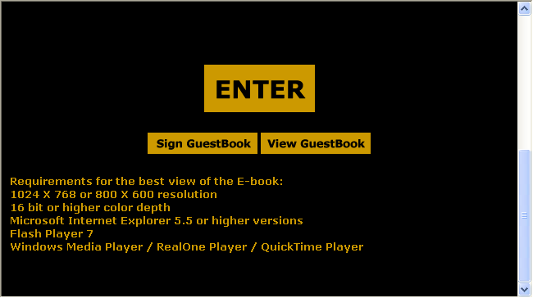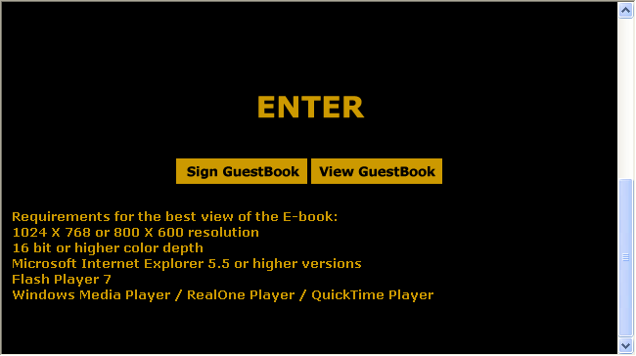
Main buttons in the E-book will be displayed with orange rectangles and black words (Left figure). When cursor moves over the buttons, they will be high-lighted. The rectangle will change into black and the words will change into orange (Right figure).

Banner
The banner will change when cursor moves over different menu options.

When cursor moves out of the menu bar area, the banner will display the words “TIGERS The E-book” as shown above. However, when cursor moves to different menu options, tigers with different appearance with jump out as shown below.

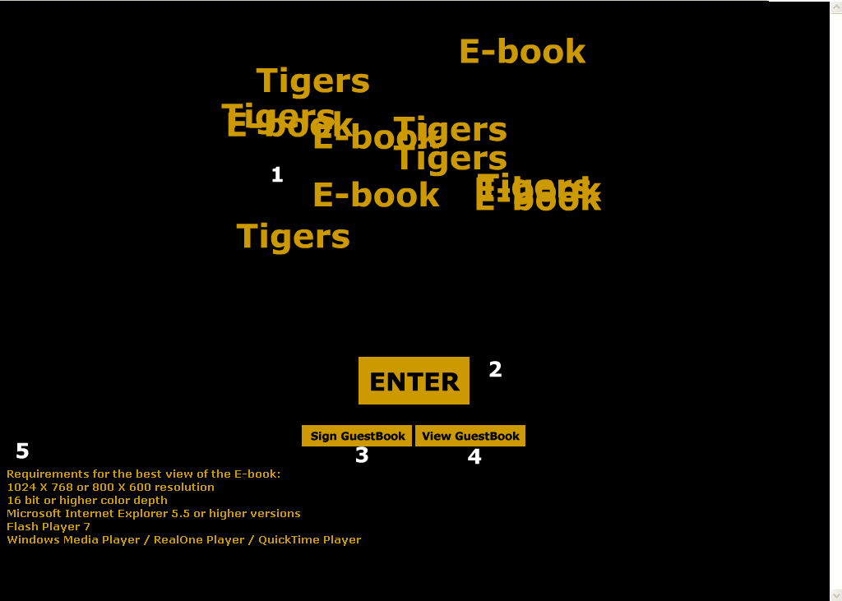 | Index page  - Introduction movie  - Enter button  - Sign GuestBook button  - View GuestBook button  - Requirements for the best view of the E-book
Introduction  - Top banner and navigation bar  - Introduction  - Credits  - Sign GuestBook  - View GuestBook | 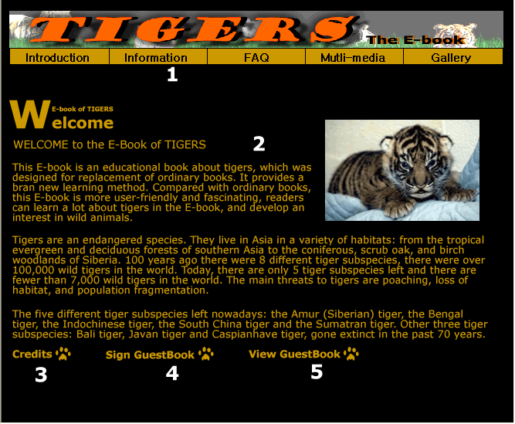
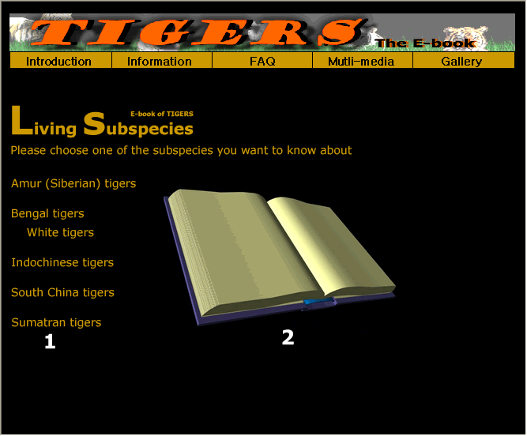 | Living Subspecies page  - Subspecies selection  - Photo display area, change when cursor point on different subspecies
Tiger Information Pages  - Profile  - Description  - Next / Back button | 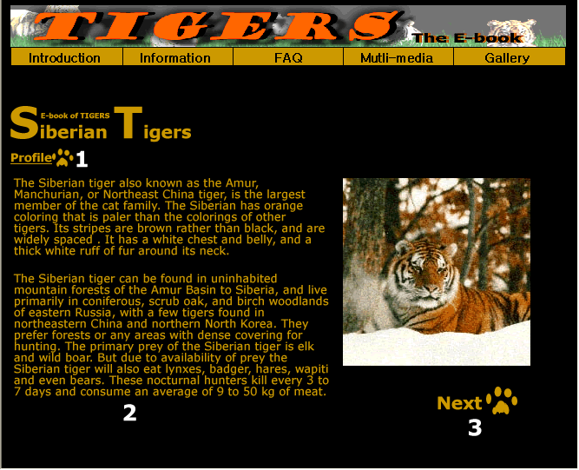
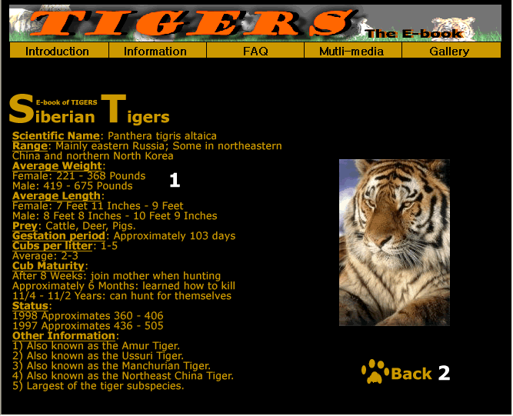 | Tiger Profile Pages  - Profile  - Back button (Back to Information page of that sub specie)
Extinct Subspecies page  - Description of extinct tigers  - Profile of Caspian Tiger  - Profile of Javan Tiger  - Profile of Bali Tiger | 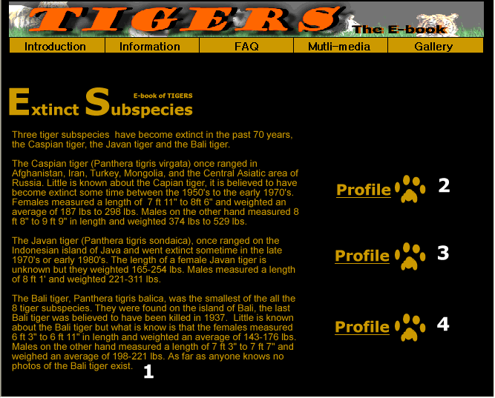
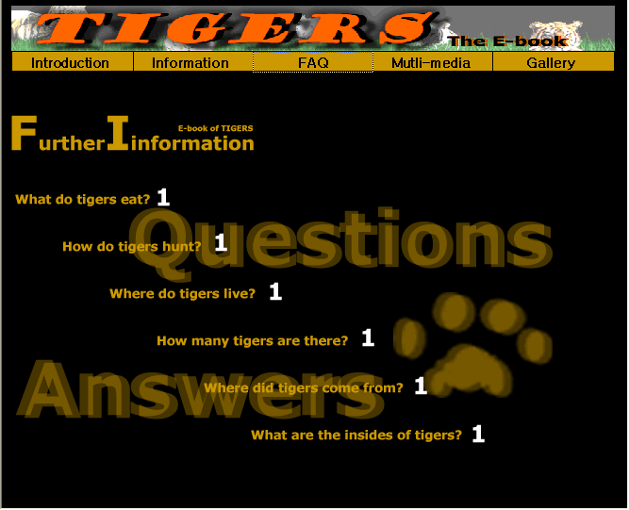 | FAQ page  - Different questions about tigers
Question and Answer Pages  - Selective links  - Other Questions button (Back to FAQ page) | 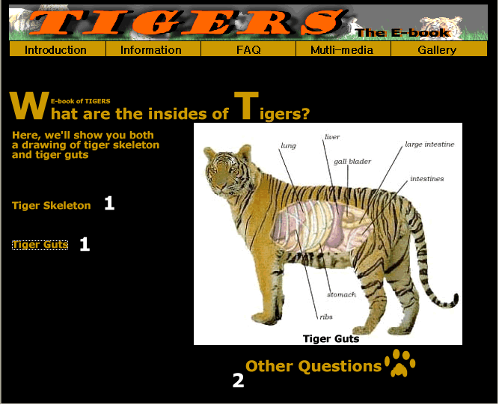
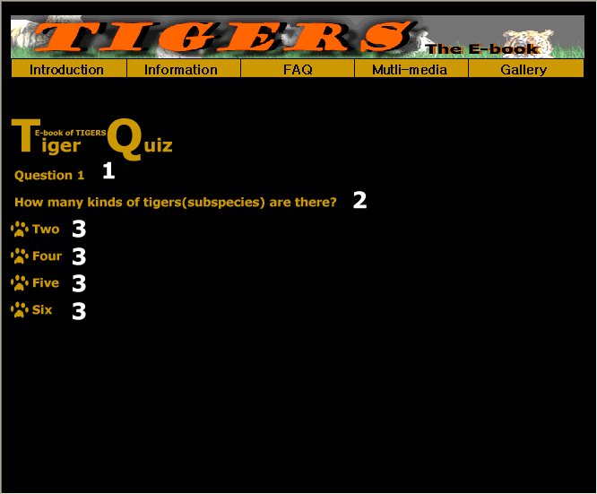 | Quiz Pages  - Question number  - Question  - Multiple choice answers
Sound Clips page  - Description of sound clip  - Play button | 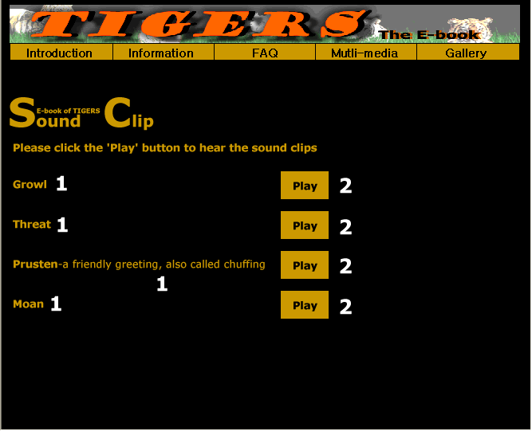
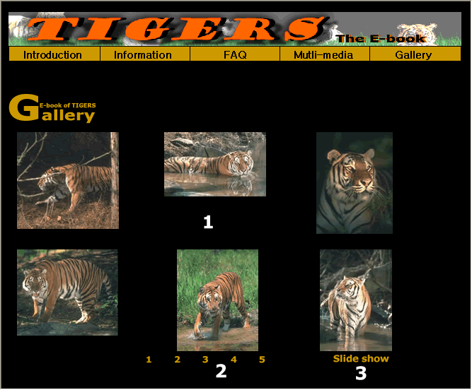 | Gallery page  - Overall preview display area  - Page selection  - Slide Show preview
Slide Show preview page  - Photo display area  - Previous button  - Next button  - Specific photo preview (Input the number from 1 to 30 in the box)  - Play button (Photos will change one by one automatically, each photo will stop for 3 seconds) | 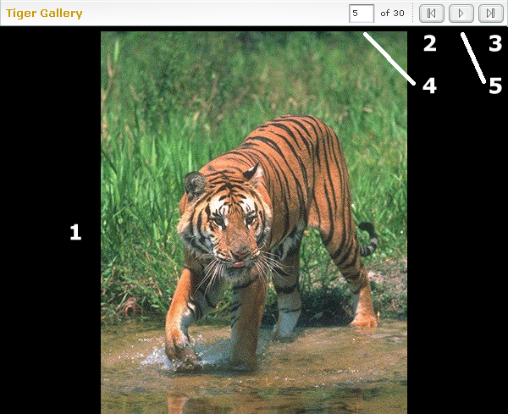

Chapter 5 - Testing and Evaluation
Testing Plan
After finishing the E-book, testing is needed to find out errors. The followings are different testing target and method.

- Testing target 1: Dead links
Testing will be carried out to find out dead links, the simplest testing method of this error is to click on every possible links. If the expected webpage does not show, dead links can be found.

- Testing target 2: Non-displayable images
Testing will be carried out to find out if there is any non-displayable images exist in the E-book. If the image URL was typed wrongly, the image will not display in the E-book properly, a cross sign will be displayed instead. Therefore, wrongly linked images can be found easily.

- Testing target 3: Displaying problems
The E-book will be executed in different computers to ensure that it can be read in different circumstances, e.g. in different resolutions, without any displaying problems such as confusion in position of text or images.

- Testing target 4: Non-playable sounds
Testing is needed to ensure that all the sound clips can be played. Since different users of the E-book use different versions of software, the sound clips should also be tested in different computers.



Testing Results
After completing the above testing plan, the following results were obtained.

- Testing result 1: Dead links
The links in the main contents of the E-book were correct. However, the links of both signing and viewing the GuestBook were incorrect. The E-book uses the guestbook service of Yahoo! Geocities, when users click on either the signing or viewing button of the GuestBook, the browser will automatically connect to Yahoo! Guestbook. In the testing, the browser failed to connect to the Yahoo! Guestbook page. Instead, it connected to a page showing “Sorry, the page you requested was not found.” As shown below.
After checking the html codes, the URLs of the dead links were wrong, “/gb” was missed. This was the problem leading the above error.

- Testing result 2: Non-displayable images
All the images, excepting the Slide Show preview page of the Gallery, were displaying properly in the testing. The Slide Show preview page was produced using a function called Image Viewer in Dreamweaver MX 2004, which will add a Flash element to the webpage. All the URLs of the images were typed correctly and they were all in the same format (JPEG), but still some of the images could not display properly, the displaying area was leaved blank.
After browsing the official site of Macromedia (Print screen shown on next page), it was found that "Progressive" JPEG images—those that appear gradually as the image is being downloaded cannot be displayed in the Image Viewer Flash element. This is a known limitation of the Flash player.
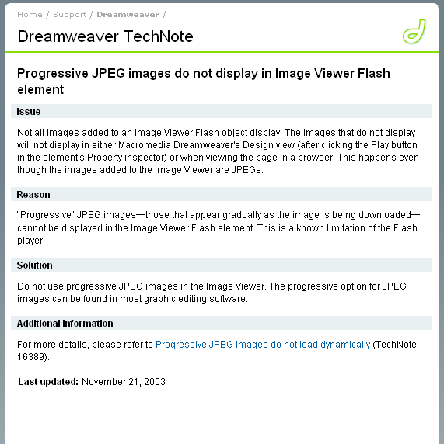

- Testing result 3: Displaying problems
The E-book was tested under both 800 X 600 and 1024 x 768 resolutions, it was also tested by 4 computers, two were running Windows XP Professional Edition, one was running Windows XP Home Edition and the last one was running Windows 98 Second Edition. The results showed that the E-book can be read in different computers with either 800 X 600 or 1024 x 768 resolutions without any displaying problem (Print screen shown on next page).
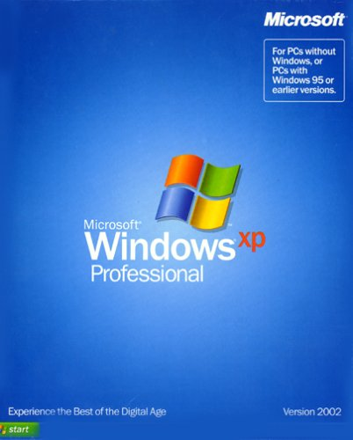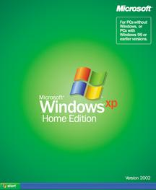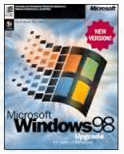
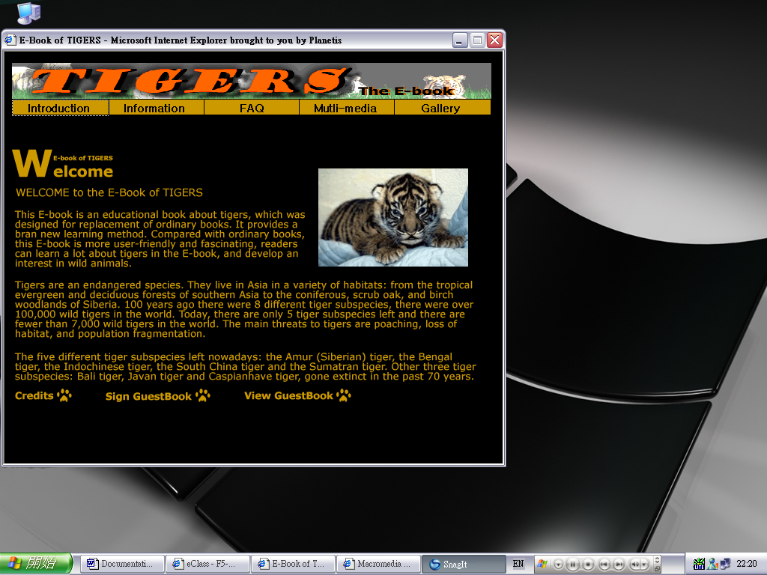
^ 1024 X 768 resolutions ^
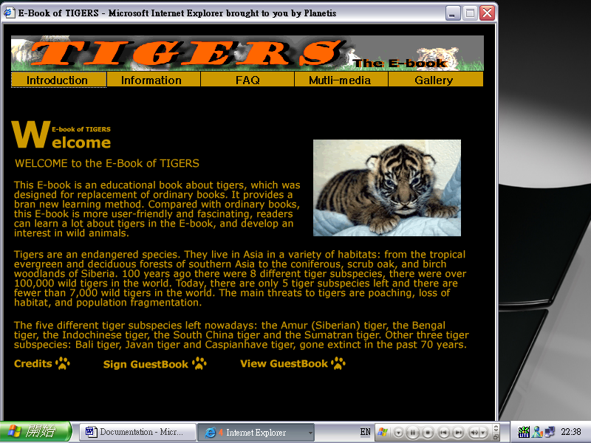
^ 800 X 600 resolutions ^
- Testing result 4: Non-playable sounds
At the beginning of design, the sound clips were planed to be played by pressing the buttons of a media control panel fixed in the webpage (As shown below). However, due to insufficient skills, this could not be done. The new plan was to open the media player and play the sounds automatically by clicking a button. The new plan was successfully achieved and was played successfully in different computers.

Correction of errors
After finding out the errors, it’s time to correct them. The following corrections were made.

- Correction 1: Dead links
The URLs of the signing and viewing GuestBook pages were corrected using Microsoft Notepad. The missing words “/gb” were added and the GuestBook page showed as expected. Users can type their comments in the space provided and their comments can be viewed by others since they’ll be stored in the Yahoo! Geocities server.
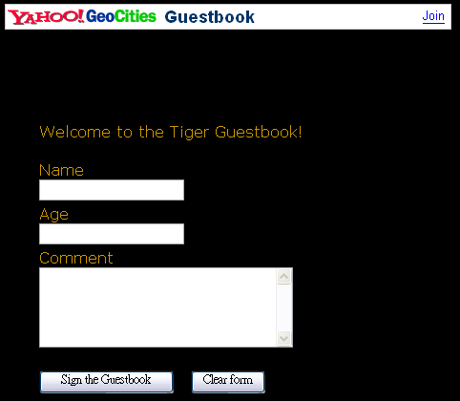
- Correction 2: Non-displayable images
Following the guidelines given by the official site of Macromedia, all the images displayed in the Slide Show preview page were converted to “Non- progressive” JPEG images. After that, all images displayed properly when they were tested for the second time.
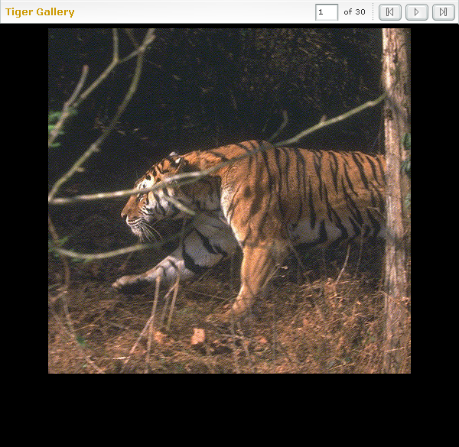
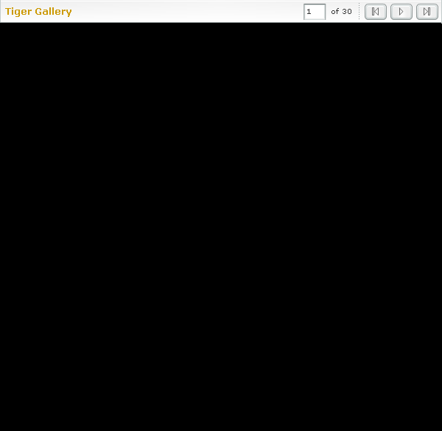
- Correction 3: Non-playable sounds
As mentioned above, the sound clips could not be play with the use of a fixed media control panel. Play buttons (As shown below) were made instead, to run the media player and play the sounds automatically.


Chapter 6 - Conclusion and Discussion
Conclusion
E-book may be the most popular method of learning in the near future. Besides of purposes of ordinary books, E-books can perform extra tasks, such as playing audios and videos, viewing animations and performing interaction.
The E-book of Tigers achieves the above objectives. Therefore, it can teach student in a better way.
The E-book of Tigers aims to help those younger generations develop an interest in the nature. This can be done by starting with tigers, a well known animal. Readers will start to find out more about the nature when they realize that learning about such knowledge is entertaining and benefiting. While the younger generations knows more about this, more people will see through the importance of protecting the nature, both human beings and animals will then benefit from that.

Further Improvements
It was suggested that some improvements should be made in the E-book.

- Improvement 1: Adding more Flash elements
Due to insufficient knowledge in Flash, not many Flash elements were added in the E-book. However, in order to gain readers attention, more Flash elements should be added, since it is more attractive and gorgeous. Therefore, knowledge of Flash should be learnt and make uses in designing the E-book.

- Improvement 2: Using texts
To ensure fixed positions of words and images, all the pages, including texts were displayed in the form of images. Therefore, it is complicated for the readers who need to copy information from the E-book since texts words cannot be select by using the cursor as usual.

- Improvement 3: Adding score calculating system for the quiz
There were totally 15 questions in the quiz; users can take part in it simply by clicking their selected answer and they will know whether they were right or wrong immediately. However, when they finish the quiz, they will have no idea on how many marks they got; this is a disadvantage of the E-book. Since limited knowledge was available, a score calculating system could not be achieved. If the system could be added, the quiz will be more satisfactory.
E-book Designer’s words
I was quite enjoying in designing this E-book. Although tiger this topic is nothing special for me, but the both designing and debugging process made me fascinated, the successful achievements also made me felt contented. Since I have rich experience in designing webpage with HTML, there were not many difficulties came across when I was structuring the E-book. However, my knowledge and skills of Flash were insufficient; this hindered me from building a dynamic E-book. I spent a lot of time in thinking ideas which could make the E-book more attractive. Lots of fantastic ideas reached my mind, but I regret that not many of these ideas came true because of this problem. I was depressed when I saw others, who were skillful in using Flash and had the same ideas as mine’s, achieved their targets. Actually, there are quite a lot of differences between the finished E-book and the design in my mind. I hope I can have more chances to do this kind of coursework in the future and I am sure that I will do better than this time.

References

