Fig. 13.07additional TextFieldTest2.java Explanation

(0) Desired Outcome

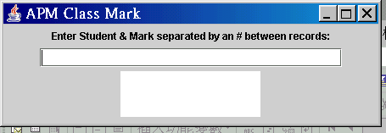

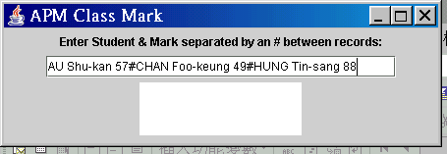

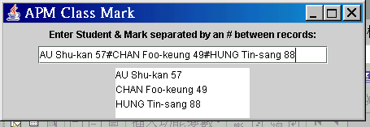

/*-----------------------------------------------------
Programe Name : TextFieldTest2.java

Purpose : This program simulates your class
mark record.
It allows user (the teacher) to enter
the student name along with one's
mark, and use a $ sign to separate
between records, in the text field
at the top of the content pane.
The marks are then displayed in the
text area at the bottom.

Source : Fig. 13. 7 (pp. 620-5) of Deitel
& Dietel: JAVA - Prentice Hall

Tester : Dr. Charles Tang
peacemaker@charlestang.org
charlestang.org

Test Date : 2003.9.15
Version : 1.0
Organization : VTC-IVE(KC)CP
----------------------------------------------------*/

// Import declaration
import java.awt.*;
import java.awt.event.*;
import java.util.*;
import javax.swing.*;
// Begin class TextFieldTest2 which inherits existing
// members of the superclass JFrame that provides
// a window
public class TextFieldTest2 extends JFrame
{
private JLabel prompt;
private JTextField markData;
private JTextArea markOut;

// (A) Set up GUI constructor TextFieldTest2
public TextFieldTest2()
{
// super to call superclass JFrame's
// constructor
// i.e. (1) Set title bar string
super( "APM Class Mark" );

// Prompt at top of content pane to input 2 fields
prompt = new JLabel
( "Enter Student & Mark separated by a $ between records:" );

// Input data in a line after the prompt line
markData = new JTextField( 32 );

// Output mark info each line per record
markOut = new JTextArea( 3, 15 );

markData.addActionListener
(
new ActionListener()
{
public void actionPerformed
( ActionEvent e )
{
String inputString =
markData.getText();
StringTokenizer markString =
new StringTokenizer
( inputString, "$" );
StringBuffer buffer =
new StringBuffer();

while ( markString.hasMoreTokens() )
{
buffer.append
( markString.nextToken() + "\n");
}

markOut.setText
( buffer.toString() );
} // End-method actionPerformed
} // End-new ActionListener
); // End-addActionListener

Container container = getContentPane();
container.setLayout( new FlowLayout() );
container.add( prompt );
container.add( markData );
container.add( markOut );
setSize( 450, 150 );
setVisible(true);
} // End-GUI constructor TextFieldTest2

// (B) Create main method object to begin
// execution
public static void main( String[] args )
{
TextFieldTest2 application =
new TextFieldTest2();
application.setDefaultCloseOperation
( JFrame.EXIT_ON_CLOSE );
} // End-main method
} // End-class TextFieldTest2

