BIT- B5 Educational Software
Appendix 6

- Brief Introduction of this educational software:
This is called “Phonics 2”, an educational CD-ROM program and music CD. It teaches kids about English Phonic knowledge, such as blends, diagraphs, rhyming, reading and spelling. It is suitable for 5-9, which is equivalent to P.1-P.4. Students from these levels are thus suitable for usage while they learn English.

Here are some pictures with brief explanations, showing how to use this educational software- Phonics 2.

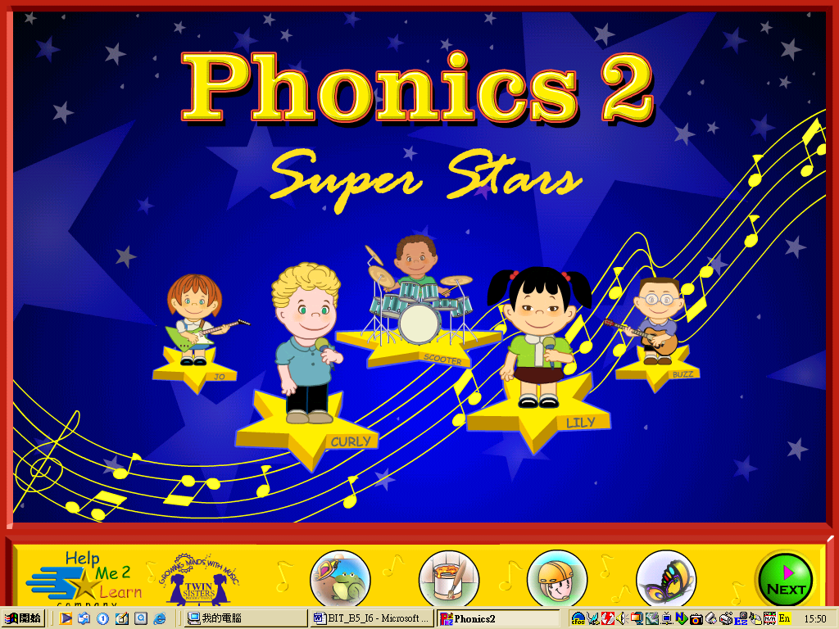
This is the main page of “Phonics 2”

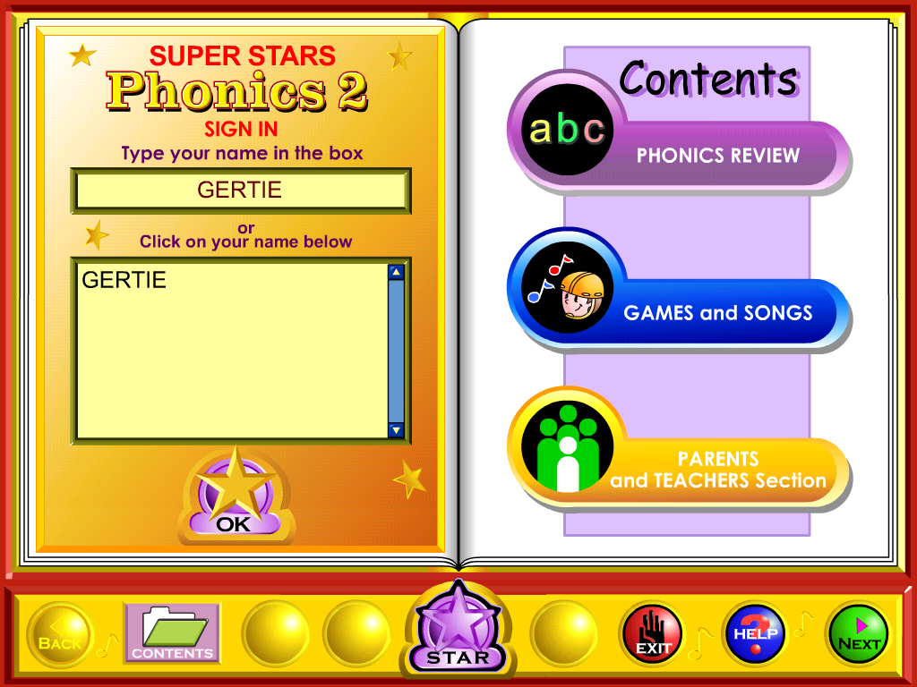
After signing in your name, you can click “Contents” and enter specific fields: Phonics Review, Games and Songs and Parents and Teachers Section

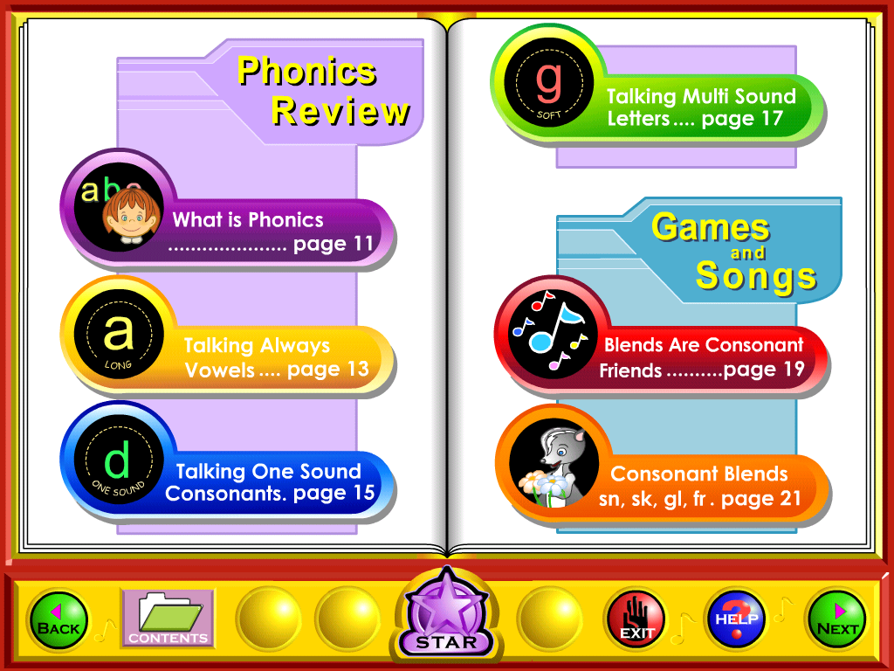
After clicking “Phonics Review”, teachers can choose a specific topic for teaching or let students to have self-revision.
Next, teachers can introduce “Games and Songs” to students.

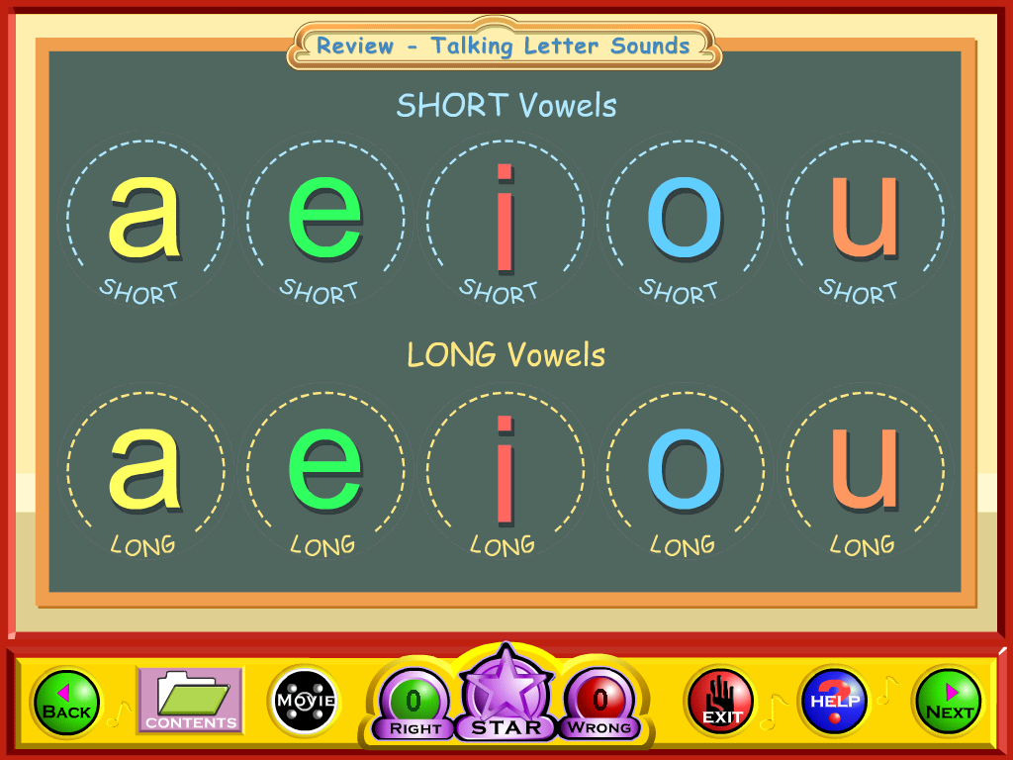
Teachers can press a specific letter and let students to hear the sound(s).
Teachers can also let them to press the letter and ask them to make the letter’s sound(s).
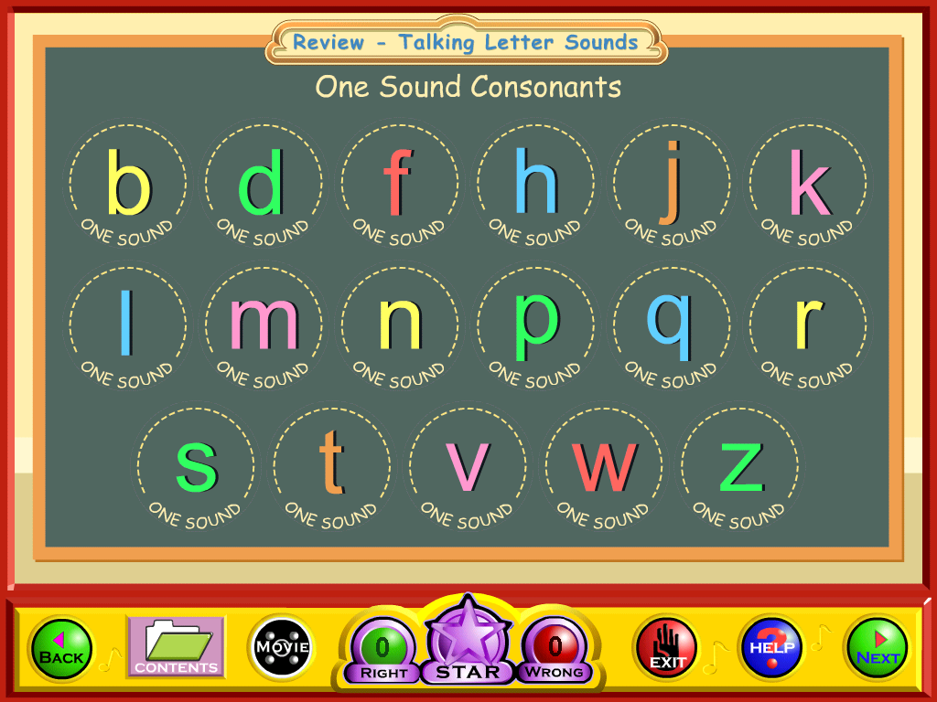

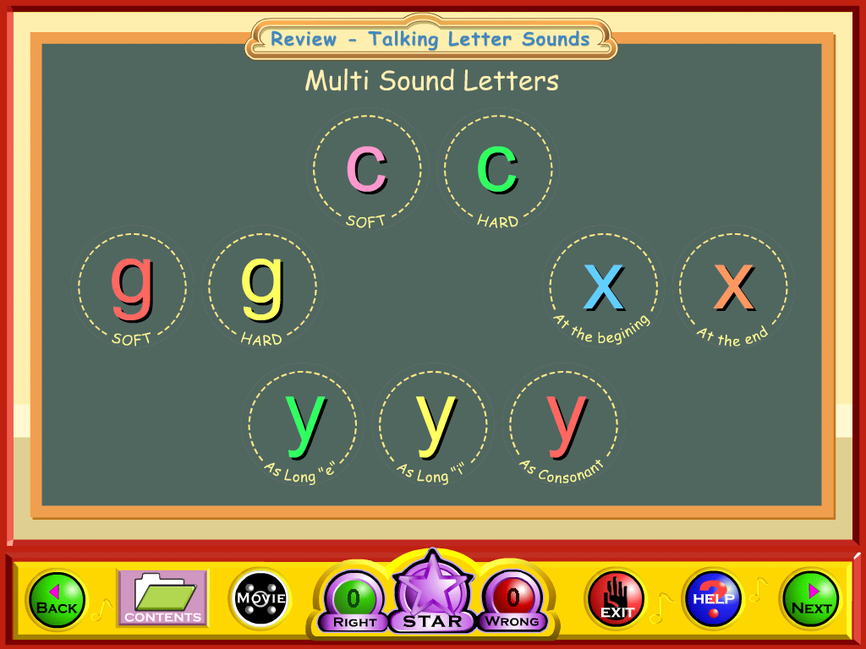

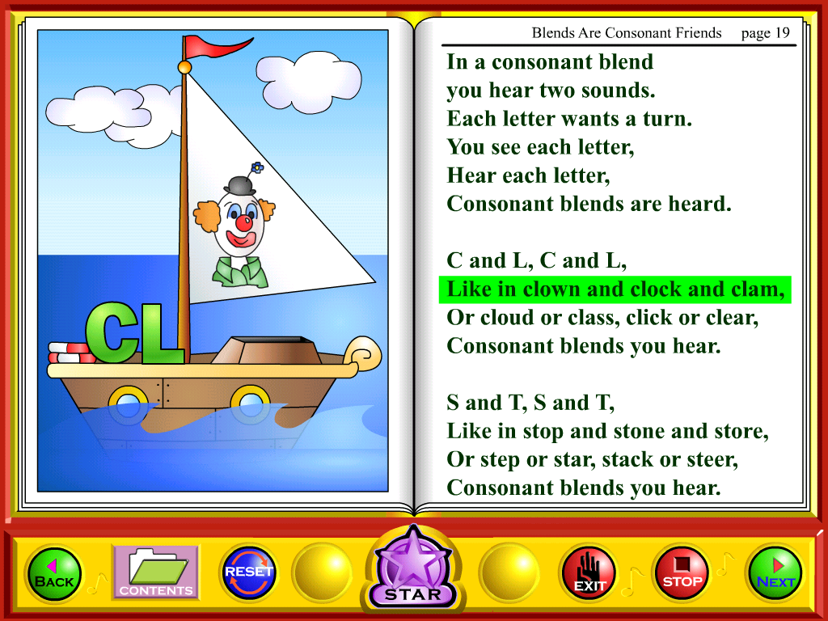
This is Song Section. Students can follow the rhythm and begin to sing. Actually, the lyrics of the song are some phonic rules.

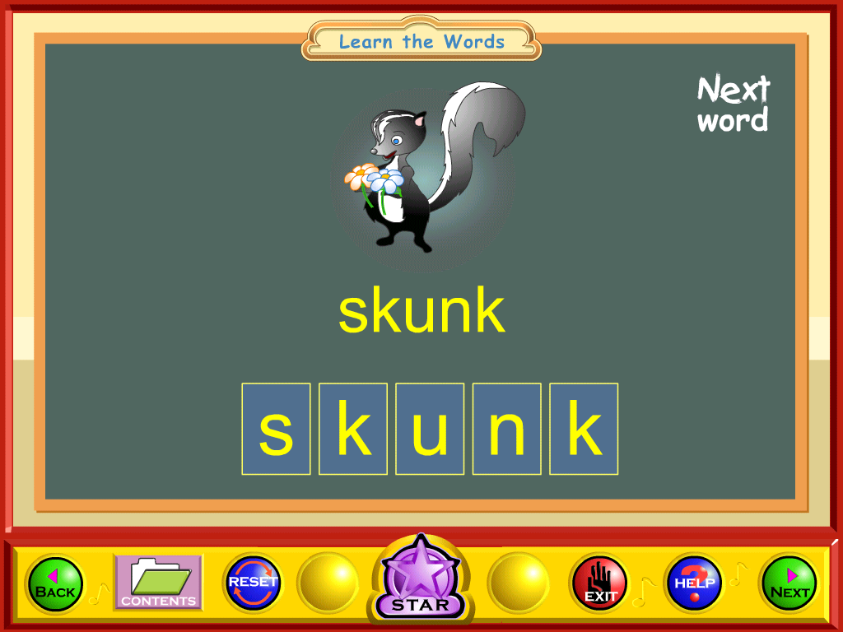
This shows how to blend a word, “skunk”.

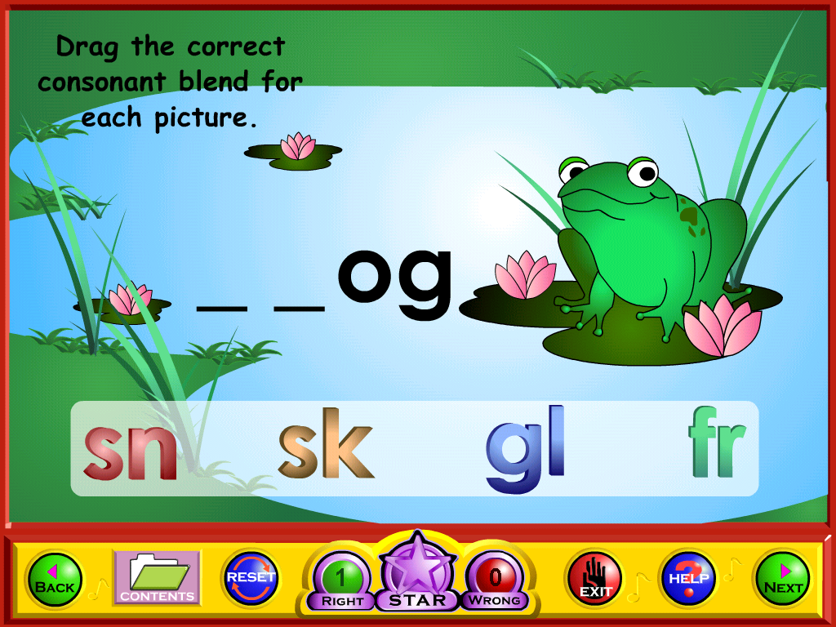
This game asks students to drag the correct consonant blend for the picture.

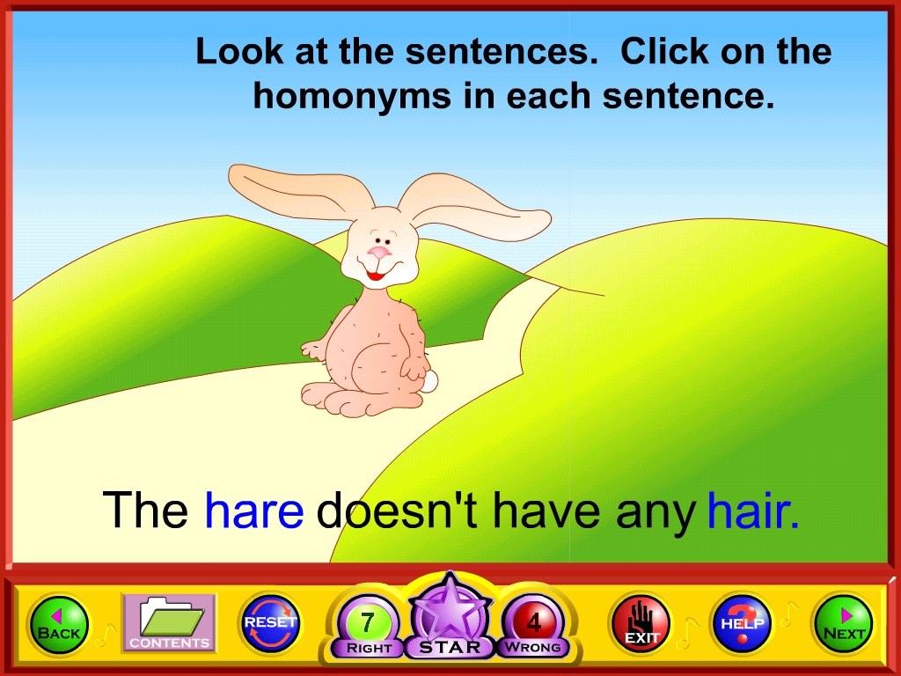
These 2 pictures are another games for revisions and entertainment.
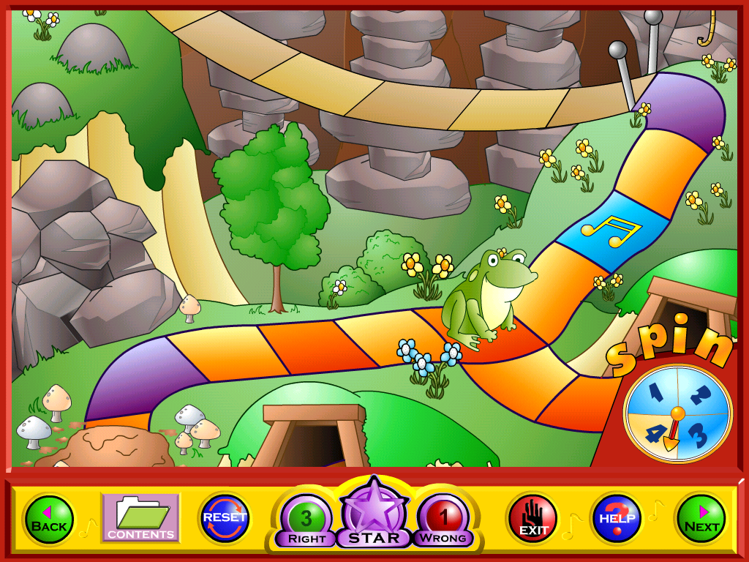

- Merits and Shortcomings of the use of educational software on learning and teaching

 | Merits | Shortcomings
Learning | - Colorful animations, interesting songs and games can arouse students’ interest in learning  - Student can use the software by themselves as clear instructions are provided in the disc  - It allows students have self-pacing. | - Though instructions are given, students may find it difficult to follow the instructions. E.g. Students may not understand a specific word when the medium of instruction is English.  - Even though most of the families in HK can afford having computers and other IT facilities, some do not have them. This proscribes students to use the software to acquire knowledge.
Teaching | - Teachers can get students’ involvement as students often prefer lessons that are fun and full of various activities.  - By using educational software in classroom, communicative approach is facilitated as there are frequent communication between teachers and students | - Some schools may not have enough IT facilities in each normal classroom. Teachers may have to bring students to Computer Room.  - Some schools may have a tough teaching schedule. Thus, teacher may not have time to use educational software to deliver their lessons even they want to.

  - As stated in the previous paragraph, it is suitable for teachers to use “Phonics 2” while they teach phonic skills to P.1-P.4 students in English lessons. Take an example, teacher can introduce some basic phonic knowledge (letter and sound relationship) to P.1 student and then let them recognize the similarities and differences. After that, teacher can sing the song and let them play the game section.

  - Reference:

Help Me 2 Learn Company and Twin Sisters Productions. (2001). Phonics 2 [electronic resource]: Intermediate Level. Santa Ana, Calif.: Help Me 2 Learn Company.

