1. Introduction
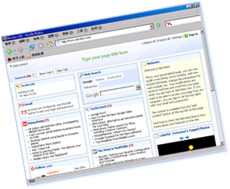
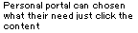
What is personal portal? According to Brain Candy in (http://home.neo.rr.com/catbar/brain_candy/) said: "They are web sites which are lists of your favorite links that you build for yourself to make navigating the Web easier and more organized. Often, search sites offer to build these for you, if you just answer some questions about what you want to see. It's convenient, but by answering those questions, you're giving them some really important information. “But since the source is 1999, in 2006, personal portals, it is more interacting, not only provide lists of the link, but also the user can design their owner styles personal portal.
2. Project Schedule
3. Study of Personal Portals
3.1 Finding
To finish the task 1(i) which is to discuss the feature about two existing personal portal publishers, first, I go to Google to search the key word “personal portal”, but after I take a look, I discover it costs a very long time to check does the web site is a personal portal publisher or not, so later, I search the key word “free personal portal –meaning” in Google, luckily, after doing that, I can chosen two representative publishers which are the
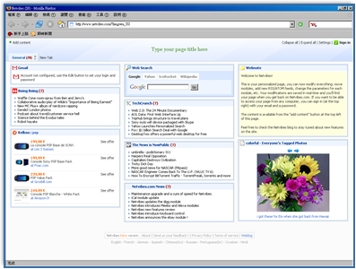  ( http://www.netvibes.com/) | 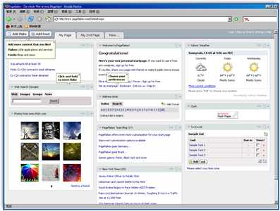  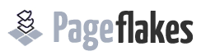  (http://www.pageflakes.com/ ).
3.2 Study of two Existing Personal Portals
After finding these two publishers which are provided personal portal for users, i started to study them and to consider what the features should contain in the web site. Later, i take my research down below.
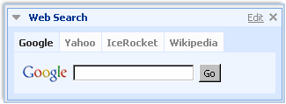 | Its can search Google, Yahoo, MSN as well as the WikiPedia.
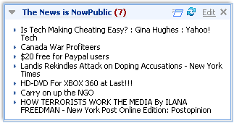 | Its support the News column which will update the News everyday. It’s a great habit for student to read News everyday.
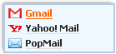 | It’s provided Gmail, yahoo mail and pop-mail. It allow user to demonstrate the mail and the abstract.
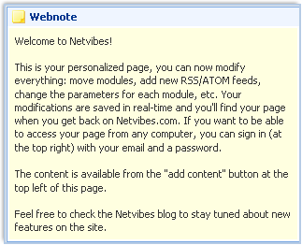 | Its act the notebook, allow user to mark the important thing down in order to recommend their self.
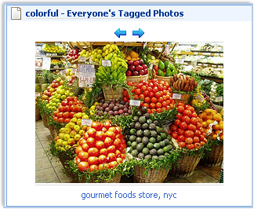 | Photos: Its act the photo album, allow user to share their photo to their friend or family.
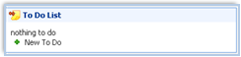 | To do list support for reordering user tasks the way you want. You can rename them by doing a single click on the text, and quickly add a new task without having to go to the edit menu.Student can be take their homework list on that too.
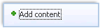  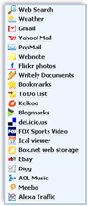 | It provided add content which allow the user to choose what the item they need.

Also, I take another research on pageflakes too.
  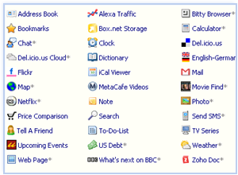 | This item can let the user add a module (feed or flake) simply click on it and it will appear on your site up to 89 flakes.
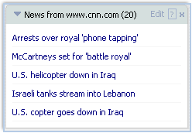 | News: Its provide the news from cnn.com everyday.
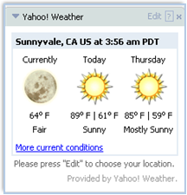 | It support weather forecast, it is nice design for user to see what the weather today.
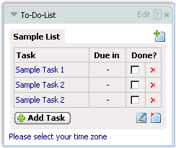 | To Do List in pageflakes can list the task that the user must not forgive it. Also, it provides more than 1task which can be expand.
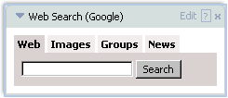 | It provide search bar that can search from Google by different kind of information, such as web, images, group etc.
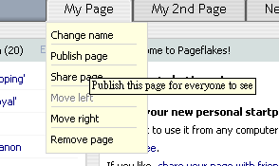 | It supports the pages that other user can not see unless the users share the page, it can be kept secret.
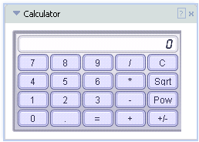 | The function of this item is to judge the number or amount of something by using the information that user already have, and adding, multiplying, subtracting or dividing numbers. It is good for student to using it when they need to do homework.
Later, I also take note about what the technologies between two personal portals. But, the technology that the two personal portals web site has 2 same technologies but Pageflakes has another technology.
Same:
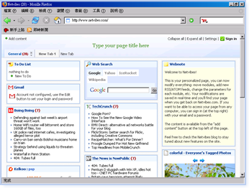 | Ajax technologies  Based on Wikipedia.org., the advantage of using it is can load quickly since the payload coming down is much smaller in size. For example, a table control and related TD and TR tags can be produced locally in the browser. If the user clicks other pages, only the data is brought down, and populated into the HTML generated in the browser.
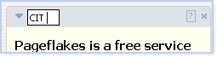  An example of changing item name under DTML | Dynamic HTML  By Wikipedia.org said, “It is used together to create interactive and animated web sites by using a combination of static markup language (such as HTML),etc. It is accessible, standards-compliant way.
Different:
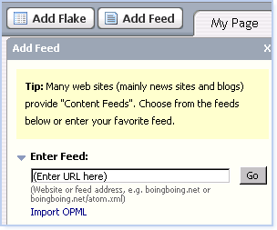 | RSS technologies  In PageFlaskes.com, user can put the RSS news easily. First, click the “Add feed”, then, enter the RSS web site, finally, click go. After RSS apply, web site will become more interacting, take PageFlaskes.com as an example, after apply RSS in this web site, user can become a master, user can order what he/she need to see or the information in order to get the first sense when the web make change.
  - Evaluation of the portals
In my opinion, I think a good personal portal should contain a to-do list which can remind me to do the homework, weather which can let me know will the weather be rain or sunny, photos which can allow my classmate to access my web page in order3 to know more me, search bar which can easily to find information for doing homework, e.g. project, Tag which can easily to link my favor web site, E-mail which can let me to check the email more convenient as I do not need to open the Microsoft Outlook, Chat which can allow my friend can chat to me can my personal portal.

  - Conclusion of the study
In conclusion, i find that personal portal provided by personal portal publisher in the web site yet is already satisfy for everyone, for examples, they provided photo for youth, provided to-list for student…
But, although they allow too many item for user e.g. their target may be youth, older or student, the items may be let the user difficult to make choice what they need. So, in my opinion, the publisher can ask the user what their ages and occupation in order to detect the useless item and can more quickly to make the decision.

