Assignment4
Name: Chan Kai Chi
Class: S.6B
Class no.: 8
Date: November 11,2003
Output devices
Output devices present information in a form that can be understood by us. There are three forms of computer output: soft copy, hard copy and audio output. Soft copy output is information presented as a displayed form on the screen. Hard copy output is information that is printed onto paper. Audio output is information presented in sound form. The corresponding output devices discussed in this section are visual display units, printers/plotters and audio-output devices.

OUTPUT DEVICES
Soft copy
Visual display units
Hard copy
Printers
Plotters
Audio output
Sound synthesizers
Display card

Soft copy
Visual display units (VDU)
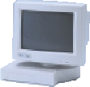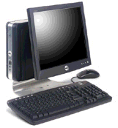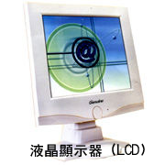
cathode ray tube monitor flat screen liquid crystal display
In the main they are CRT (Cathode Ray Tubes) the same as is found in most home televisions. Technology is developing the flat screen and has been reasonably successful in improving LCD (Liquid Crystal Display).
VDU are described by their colour capability and resolution. Resolution is determined by the number of pixels (or dots) on a screen. The higher the number of pixels on the screen, the better the resolution and sharpness of the picture. A typical screen has over a million pixels.
Early computers used monochrome monitors which can only display text in one colour on a dark background. Monochrome monitors are still used by people that only need monitors to display text and numbers. For example, travel agents, stockbrokers and retailers.
CRT emit considerable radiation. The display has evolved from the earliest 4 colour low resolution CGA to 16 colour EGA to 256 colour VGA and recently the enhanced Super VGA with 16million colours and a resolution of 1284 x 968 pixels resolution and higher over twice the detail of the earlier types. The standard screen size is being 14 inch.

Display card
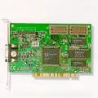
This is a card which is installed inside your PC which translates data into a form which can be sent to the monitor.

Hard copy
Printers
Since the display on a monitor is only temporary, information on the screen disappears once the power is switched off. We often need a hard copy (printed form) of the output information. For example, a term paper or a school report. Hard copies are produced by printers.
Printers can be divided into two types: impact printers and non-impact printers. Impact printers physically strike the page to create text or image while non-impact printers do not.

Dot matrix printer
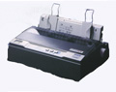
Dot matrix printer are impact printers. They use a matrix of pins contained in the print head to strike a printer ribbon against the paper in order to create an image. Characters are formed by dots as the printer head moves horizontally across the page. The number of pins in the print head determines the quality of the output. A 24-pin dot matrix printer can produce letter-quality printing, as if produced by an office typewriter. Different typefaces are also available.
Dot matrix printers are inexpensive. They are useful when multiple copies of a document is required. For example, a retail company many need to print 3-ply invoices. Dot matrix printers are used for tasks where high- quality print-out is not essential. However, one disadvantage of this type of printer is the noise that is makes.

Ink-jet printer
Ink-jet printers are non-impact printers that spray ink onto a page. Electrically-charged ink droplets are formed by a spray nozzle. They are then deflected into their proper positions as they pass through an electric field.
The ink-jet printer can produce high-quality coloured printouts. As its cost continues to decrease, ink-jet printers have become the most popular printer for home users.

Laser printer
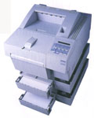
Laser printers are also non-impact printers. They use a laser beam to create images onto a drum. The images are electronically charged to attract toner, which is then transferred from the drum onto paper. A heating process follows which fixes the images onto the paper. This technology is similar to that used in a photo-copying machine.
The laser printer produces the best quality printouts among the three printer technology mentioned. It is widely used for business printing where high-quality output is required. Colour laser printers are also available for desktop publishing and for use by graphic artists.
Table of comparison between different types of printers
 | Dot-matrix | Ink-jet | Laser
Cost | Low | Medium | High
Speed | Slow | Fast | Very fast
Quality | Good | Very good | Excellent
Popularity | Low | High | medium

Plotters
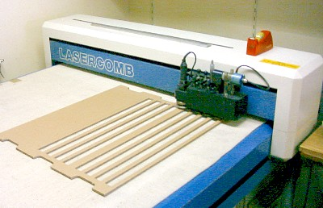
Printers are capable of producing graphic output but are usually limited by size and quality. Pen plotters, however, can convert computer-generated graphics into high-precision, hard copy outputs. The pen of the plotter (which allows for ink colour changes) moves back and forth across the page while the paper is moved up and down by a roller. By combining the movements of the pen and paper, straightlines and curves can be drawn anywhere on the paper.

Audio output
Audio output devices enables output to be heard. Modern computers equipped with a sound card and a set of speakers can reproduce recorded sounds and music.
Speech synthesizer
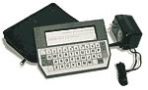
Speech synthesizers create speech output. It is similar to a speech recognition device, only in reverse. The computer takes a word or a sentence and converts it into the equivalent speech sound for us to listen.
Applications of this technology include telephone directory enquiry service, phone banking systems and computer assisted learning tools for learning a foreign language. In addition, this technology is of great use of people who are able to write but cannot speak.

