Hong Kong Institute of Vocational Education (Tsing Yi)
Department of Information and Communications Technology

HDCSA (45300) & HDSE (45303)
CMM3332 Object-Oriented Technology
(2002/2003)

Laboratory Exercise 5A
Suggested Answer

1.
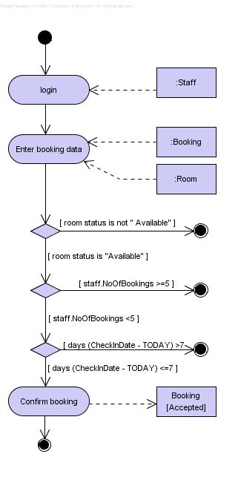
2.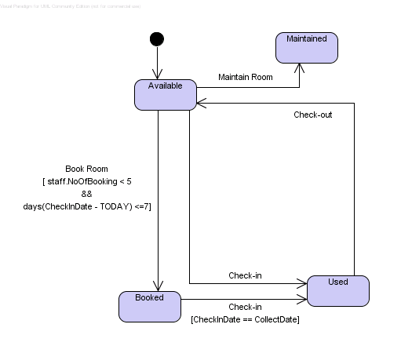

3. 