Definition and Basic Properties of Tangents to a Circle

- Definition:
A straight line, which touches a circle at only one point is called a tangent to the circle. The point at which the line touches the circle is called the point of contact.

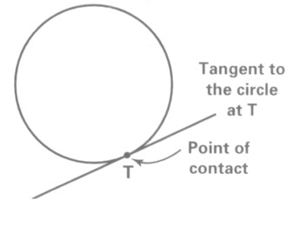

- Basic properties:

Figure | Theorem
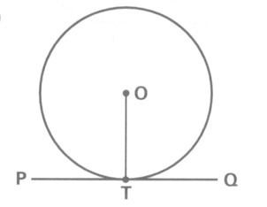 | If PQ is the tangent to the circle at T, then $\text{PQ}⊥\text{OT}$.  tangent radus
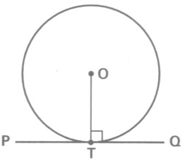 | If $\text{PTQ}⊥\text{OT}$, then PTQ is the tangent to the circle at T.  converse of tangent radus

Tangents to a Circle from an External Point

Figure | Theorem
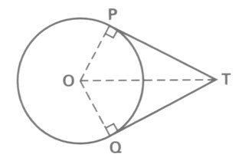 | If TP and TQ are two tangents to circle O, then  TP = TQ  ∠TOP = ∠TOQ  ∠OTP = ∠OTQ  tangent properties

Angle in the Alternate Segment

Figure | Theorem
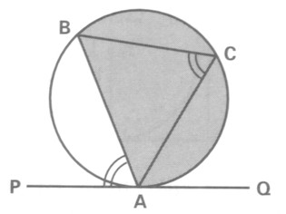 | If PQ is the tangent to the circle at A, then ∠BAP = ∠BCA.  ∠ in alt. segment
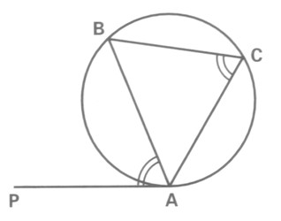 | If ∠BAP = ∠BCA, then PA is the tangent to the circle at A.  converse of ∠ in alt. segment

