Market Entry Strategies: Pioneers Versus Late Arrivals
By Gurumurthy Kalyanaram and Ragu Gurumurthy
What is the best way to move into a new market? If you do not have a first-in advantage, attack the one who does.
Want to be King of the Mountain in a new marketplace? Here is some advice: be first, or a close second, and do not pause for breath. Others want to be King of the Mountain too. Even though you have a huge advantage in being first, you can lose it in the blink of an eye over pricing or service or lagging technology. Aggressive competitors have a vast array of weapons to knock you down.
Today's strategic planners, having created as much value as they could by cutting costs, are looking now to grow domestic markets, as well as build new markets and revenues in such countries as Brazil, China, India, Malaysia and Mexico. Before striking out, though, they need the answers to some crucial questions:
Does it pay to be first with a product or service? Is being an innovator worth the risk? Is it better to wait and learn from the experiences of the first entrant to the market? What is the proper balance between the risks and rewards? If you are a pioneer, what can you do to prevent share erosion when a new player enters the market? If you are a late entrant, what strategies should you adopt to make your entry successful?
Studies show that in most cases, being first to the market provides a significant and sustained market-share advantage over later entrants. Still, later entrants can succeed by adopting distinctive positioning and marketing strategies. Pioneers in most industries, once they have reached the status of incumbent, are powerful. Sometimes, however, they get complacent or are not in a position to cater to the growing or shifting demands of the marketplace. New entrants can take advantage of gaps in the offerings of these aging pioneers, or find innovative ways to market their product or service.
Pioneers with a distinctive presence in the marketplace need to be in a position to react, or even better, anticipate potential entrants and increase the barriers to their entry. For example, a pioneer may be in a position to reduce its price and decrease the value of the business for a new entrant, or it can block entrance entirely by controlling key distribution channels.
Whether a late entrant or a pioneer seeking to foil newcomers, it helps to have a thorough understanding of the entry and defensive strategies available, a good sense of timing and a game plan for decision-making.
BASIC STRATEGIC PLANNING
Competitive strategies typically depend on the market environment and the positioning and product portfolio of the existing players. These are the basics:
Reduce price to penetrate an existing market. By introducing a product at a lower price than the pioneer's, a latecomer can attract new customers who would not have otherwise purchased such a product in effect expanding the total market. Reduced price can also induce the pioneer's current customers to switch. Still, this strategy is likely to result in reduced margins for the new entrant compared with other players in the market, unless the new entrant's cost of production is relatively cheaper. This can be adopted by both the incumbents and pioneers.
Improve a product or service, with focus on a niche market. Companies can compete by being innovative in the marketplace. The innovation may be radical or incremental. One example of incremental innovation is an enhanced version of an existing product. The enhanced product can compete directly with existing products, or it can be positioned to attract a smaller segment of the existing market. In addition, the improved product or service can sometimes attract new customers that are not the current target for the existing product or service. For example: potential satellite-based wireless service providers are currently offering a new feature called global coverage. This service could both complement and replace options available to current customers but most of the potential players in the marketplace are targeting either traveling professionals who need to be in constant touch or the rural market, in which the cost-to-provision telecommunications infrastructure is very high and satellite-based options help governments offer ubiquitous telecommunications services. In both cases the telecommunications market is expanded, generating additional revenue.
Target new geographic markets for existing products. As markets mature in the home base, companies traditionally look outside to more lucrative markets. Most consumer goods companies, for instance, are setting their sights on China. Many heavy equipment manufacturers are targeting newly emerging markets that will need tractors and cranes for building. Faced with intense competition and maturation in the local markets in the United States, regional Bell operating companies such as BellSouth are expanding into emerging markets such as Brazil.
Develop new channels of distribution to access new markets or better penetrate existing ones. Going global is not the only solution. Sometimes the risk and the investment required to penetrate international markets may not be worth the return. Focusing on existing markets, where your company has a good understanding of the environment, can prove less risky and bring quicker successes. This can be accomplished by repositioning the product or service through marketing, advertising, packaging and so on. For instance, Dell Computer went after the mass market by having customers place their orders directly with Dell by phone, fax or computer. This direct channel revolutionized the method of selling computers to the end users, including corporate clients.
In addition to choosing the appropriate marketing strategy, it is crucial to determine the timing of the introduction of any new product. This is especially true in high-tech industries, in which product life cycles are short and it is difficult for late entrants to catch up and extract reasonable returns. In most cases, if you are entering second or later in such a market, you should do so immediately after the pioneer.
PIONEERING ADVANTAGE:
FICTION OR REALITY?
Put simply, it costs the most to be the first, for two reasons:
1) the product innovation requires a higher investment in research and development than does product imitation, and
2) the necessary marketplace education and testing forces the pioneer to spend heavily on advertising and promotion. A second entrant enjoys the fruits of the pioneer's labor.
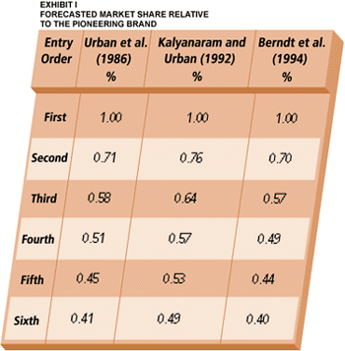
Are there higher returns on market share and investments to offset the pioneer's increased costs and relatively higher risks? Companies such as the Hewlett-Packard Company and the 3M Company, which generate growth through innovation, garner more than 60 percent of their revenues from products introduced over the most recent three-year period. Obviously, these companies have succeeded in pioneering at a very high level.
Does this occur in other industries and in countries other than the United States? In fact, numerous studies have found that later entrants in a market achieve a lower market share than earlier entrants and that this holds true in a variety of product categories and industries, such as consumer packaged goods, industrial goods and pharmaceuticals. Even when a company's tangible (e.g., financial) and intangible (e.g., brand equity) resources and business skills are considered, early entrants continue to hold market-share advantage.
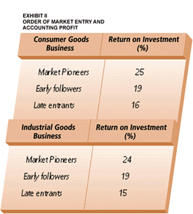
What is the magnitude of market-share penalty for later entrants? A 1995 study by Gurumurthy Kalyanaram and others in Marketing Science suggests that the new entrant's forecasted market share divided by the first entrant's market share equals, very roughly, one divided by the square root of order of entry of the new entrant. (See Exhibit I.) Therefore, if there are two players in the market, the first entrant will have a market share of 59 percent and the second entrant will have a market share of 41 percent (which is 70 percent of 59 percent). This is validated in the cellular industry in several countries in Europe in which the average market share of the first entrant in Belgium, France, Germany, Italy, the Netherlands and Spain is 58.5 percent and the second entrant is 41.5 percent. The figures are consistent with the results in Exhibit I since the second entrant has about 70 percent of the pioneer's market share. (See Exhibit III.)
Why do early entrants so frequently enjoy a higher market share? First, consumers in general are risk averse. If a product or service provides enough satisfaction, consumers do not want to risk switching to a new product. Second, the pioneer becomes the prototype for the product category. Later entrants are compared to the pioneer, and always somewhat unfavorably. Whenever consumers think of photocopying for example, Xerox is the name that jumps to mind. Third, consumers learn best the attributes of early entrants. More knowledge translates into more strongly held beliefs and great confidence in choice. And lastly, early entrants are able to secure the best positioning in the marketplace.
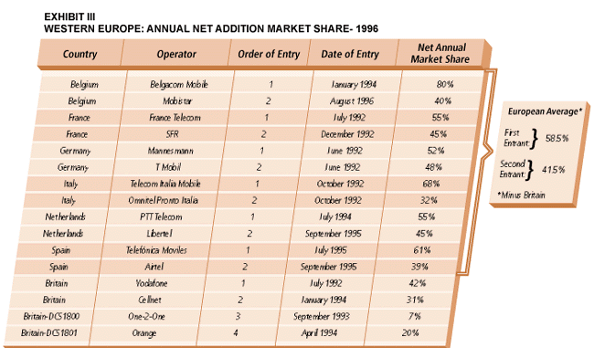
Does the pioneering advantage manifest itself in return-on-investment metrics apart from market share? Yes, after substantial research and development investments, being early in the market is rewarding. Research shows that the pioneers enjoy a higher return on investment in both consumer and industrial goods. (See Exhibit II.) This research and development investment and continuous new product launch is also used as an entry barrier by several pioneers.
A recent analysis of the evolution of wireless markets in Europe indicates that first entrants are also market leaders in most countries. (See Exhibit III.) Pioneers in cellular service establish a presence in the marketplace, build brand equity and create an excellent distribution network. Also, a peculiarity of this industry is that the quality of service is primarily determined by coverage. Having evolved over time, the first entrant's network usually has much better coverage. The customers become used to enhanced coverage over time. So new entrants have to invest significantly to achieve this same coverage -- an effort that is capital intensive and time consuming. All new networks have initial bugs that take time to fix. Subscribers are just not willing to go through another learning curve, when there is already a robust supplier of service. Another frequent constraint is access to property to build the towers, since the first entrants have already seized the ideal sites for coverage. This, in turn, may require the later entrant to invest larger amounts in network infrastructure to gain similar coverage. Given these hurdles, it can take two to three years before a challenger achieves coverage competitive with the incumbent's.
In addition to coverage and related quality of service, another huge barrier to entry for new entrants is the issue of number portability. Customers would have to get a new cellular number when they switch carriers since they cannot take the same phone number with them as is done in land line networks. In general customers do not like to change their phone number, especially in Europe, where customers receive calls in their mobile phones. Thus, we see the inherent advantages to being first in the market in the wireless industry: control of ideal sites; freedom to evolve and fine-tune network coverage; building of brand loyalty by offering superior customer service; locking in customers by subsidizing equipment for an extended period under fixed-service contracts, and gaining control of key channels of distribution.
AGILITY NEEDED
FOR LATE ENTRANTS
The picture, however, is not always so rosy for pioneers and bleak for late entrants. In some industries and some geographic areas, pioneers have lost market-share advantage relatively quickly. This can happen for any of several reasons:
1) An entrenched pioneer may not be offering a superior level of customer service.
2) A new technology may have changed the cost equation, so that a new entrant can offer similar or better service at a lower cost.
3) The new entrant may have developed a new way to access the market, with an innovative distribution strategy.
4) The latecomer may simply be pricing aggressively, targeting selected segments by taking advantage of the incumbent's tendency to average pricing across all segments.
In what situations is the pioneering market-share advantage muted? For a start, when consumer learning is limited, the pioneering advantage is likewise bound to be limited. Consumer learning becomes very difficult if the product becomes complex and technical. For example, when picture phones were introduced in the late 1970's, the market did not respond because consumers could not find occasions to use the product.
The pioneering advantage is also limited in a cluttered market: If there are many available brands, consumers react by becoming confused.
Moving beyond such issues, what can later entrants do to overcome any inherent market-share disadvantage? First, the later entrant should differentiate itself substantially in the minds of the consumers. Such positioning can be accomplished through substantial changes in either the product or promotion strategies. For example, the Chrysler Corporation redefined perceptions of its minivans by introducing Caravan, a two-door van. The Ford Corporation's Windstar, expected to be a marquee van, substantially lost its glamour to the Caravan. When the General Motors Corporation decided to reposition its Oldsmobile, it changed not only its product but also its advertising copy. The new copy appealed to consumers over 30 years old, projecting the image of a younger professional woman via this voice-over: "This car is not only for your father's generation, but it's for you too."
A second route for later entrants is to discover creative ways to increase product trial. At best, one study has found that the market-share advantage for the early entrants comes from higher trial penetration. If the later entrant can generate greater trial market share, then its disadvantage can be overcome. Sample-product trial is an appropriate mechanism. For example, in consumer goods, consumers can be supplied with a sample product for trial. In non-consumer goods, other creative mechanisms must be designed. Limited demonstration of usage or prototypes is possible in software products, and test usage is possible in automobiles. Also, distributing the product through new channels such as direct marketing (think of the Lands' End catalogue or the Mary Kay cosmetics parties) or a home-shopping-network channel would place the product in the hands of more consumers.
The later entrant can also segment the market, focusing on a particular target. By providing appropriate value, the later entrant can extract additional rents. A good example of this is the competition among the International Business Machines Corporation, Compaq Computer and Dell Computer in the personal-computer market. Finally, later entrants can position themselves as variety enhancers, rather than as replacements or substitutes for the pioneers.
An example is Orange, the late-entry cellular service provider in Britain, which successfully nudged aside the pioneers. Orange entered the market almost 30 months after the first entrant, Vodafone, and nine months after One-2-One, and with technology similar to One-2-One's. Orange, however, has followed a very aggressive entry strategy. It has not only invested heavily in the network over the first two years of introduction, but also developed aggressive pricing strategies. Orange seized a third of Britain's total market's first quarter 1996 growth by offering about a 30 percent savings to end users, compared with Vodafone and Cellnet. The pricing strategy was effective enough to compensate for Orange's relatively poor network coverage. (This rapid increase in penetration of new subscribers decreased in the second quarter, after Vodafone and Cellnet lowered the price differentials in key segments.) Thus, aggressive pricing tactics, investment in network infrastructure and innovative marketing tactics such as aggressive advertising and creative service bundling have made Orange a credible player.
Different markets require different strategies. What worked for Orange in Britain, for example, will not work for new entrants in Scandinavia. There, the incumbent's monopolies are not driven by profits from the wireless industries, and thus they price their wireless services below the average price for the rest of Europe. This is a significant barrier to entry for new players, especially since entering the industry requires a high capital investment. So the key source of differentiation for new entrants in such situations is going to be creative marketing, innovative advertising, new service packages and superior customer service. This is especially true since the incumbents offer a relatively poor level of customer service, a concern to end users.
Later entrants can also succeed by attacking high-growth markets particularly when there is a significant shift in the industry. Such shifts can be due to changes in regulation, or technological breakthroughs that improve the product, or breakthroughs that improve the process of manufacturing and delivering the product. The classic example is MCI's success in penetrating the long-distance market and winning a regulatory battle with the AT&T Corporation.
Another strategic option for the later entrant is micro-segmenting the customer base -- that is, targeting high-value customers who are able and willing to pay a higher price for the product or service relative to the cost incurred in catering to that segment. For example, the competitive-access providers (now Competitive Local Exchange Carriers, or CLECS), in order to provide local telecommunications services, basically skimmed the best customers of the regional Bell operating companies by offering a lower price. This was possible because the regional companies had adopted an average price scheme partly dictated by the Federal Communications Commission.
Innovators have also been successful in entering markets with a significantly better technology. Usually, however, technological innovation gives a company an edge for only a time, since incumbents catch on fairly quickly. Given that this is the case, new entrants should support their innovations with effective positioning, appropriate pricing and aggressive advertising. For example, I.B.M., a later entrant to the personal computer market, captured the lead in the 1980's by developing the technology and using its powerful marketing engine. Later, Compaq and Dell fundamentally redefined the business. Compaq reduced the cost by changing the manufacturing process and having superior logistics. Dell, in addition to using an efficient manufacturing process and superb logistics, invented the mail-order or direct channel to access end users, who by now were comfortable with personal computer technology. I.B.M. was not able to react to these changes fast enough and lost its lead in the 1990's.
DEFENSE STRATEGIES
FOR PIONEERS
Even as new entrants attempt to redefine the business or formulate niche strategies to attack profitable industries and market segments, pioneers can fight back to retain their competitive advantage. The major strategies for the pioneers:
1) increase the barriers to entry for later entrants,
2) innovate faster than the latecomers, and
3) build a market-responsive and flexible organization.
In most markets both pioneers and later entrants operate with incomplete information. Pioneers can take advantage of this by using effective signaling mechanisms as a deterrent. For example, pioneers can cut price, signaling to potential new entrants that it is a low-cost industry and it will be difficult for them to survive. Pricing below variable cost, however, is illegal in most countries. On the other hand, new entrants traditionally focus on a few key segments of the market typically those that are subsidizing the cost to serve other segments of the incumbents. So, it is important for pioneers to understand their end-user segments and to adopt a differential pricing scheme to extract optimal rent from each of the segments.
Pioneers can also attempt to lock up the key channels of distribution, making it difficult for new entrants to get access to the market. In several industries and countries, however, it is not possible to get exclusive distribution rights. Pioneers can also offer special types of enhanced customer service packages or reward programs to make it harder for key customers to switch.
Another route, especially in the high-tech industries, is for a pioneer to remain innovative and launch the next generation of products or at least announce the next generation of products, thus deterring the entry of competition. The Intel Corporation's strategy in this regard is an example.
Finally, a responsive and flexible organization may be the most productive route, especially when the structure of an industry changes drastically or there is a seismic shift in the regulatory environment. In the telecommunications industry, for instance, the 1996 Telecommunications Act has fundamentally changed the rules of the game, leaving almost all the markets open for competition. This has forced both the regional Bell operating companies and the long-distance carriers such as AT&T and MCI to revise their strategies. Aging pioneers in other industries have also followed the strategy of attack as best defense, targeting potential new entrants' home bases -- be it geographic or product markets. As Fuji penetrated the photographic film market in the United States, for example, the Eastman Kodak Company's strategy was to attack Fuji in its home market. This strategy met with mixed results, due to the tight controls in the Japanese market.
The underlying parameters for all these strategies are that companies should be aware of the market dynamics and have an organization that is flexible with the right culture to adapt, not only reacting to potential competition but also proactively developing their strategies. It is easier to lose a market-share point than it is to gain one.
An example of a good blocking strategy is Vodafone's decision to lower its prices in key market segments to match those of its new competitor, Orange, thereby reducing the price differential between the two companies. While doing this, Vodafone kept its average price in the market constant and extracted more rent from customers who were not targeted by the competition.
Managers should have a feel for the marketplace, to correctly estimate the switching barriers for customers and set the price differential accordingly.
Another example in the wireless industry is the case of cellular companies in the United States. These companies have undertaken a suite of counterattacks, including innovative service packages and special deals on the equipment for one-year contracts, thereby increasing the switching barriers for the customers. This has also slowed the penetration of personal -communications-services (P.C.S.) players among the cellular customer base. But as these companies, which offer a service similar to cellular but based on a different technology, build their networks and offer enhanced services, they will inevitably begin to attract cellular customers unless cellular companies can offer similar features in the long run. Meanwhile, both the P.C.S. companies and the cellular companies have launched aggressive advertising campaigns.
KEY SOURCES OF DIFFERENTIATION
It is important to note that in the case of the telecommunications industry, pioneering advantage can be sustained only through continuous investment in building network infrastructure and the offering of superior customer service the two key sources of differentiation. In the wireless industry, customers are repeat purchasers, since their contract terms typically last for only one year and the cost of handsets is dropping rapidly. This situation could enable a late entrant to compete effectively by developing a good network infrastructure and by gaining access to good distribution networks. This is evident from the fact that the incumbents in several countries have not been able to sustain their lead and the differences between early entrants and second entrants are decreasing rapidly. For example, in Britain, Vodafone had an 18-month advantage over its prime competitor, Cellnet, with similar technology. Three years after the launch of Cellnet, however, the difference in market share in annual net additions between Vodafone and Cellnet is only 11 percent. Vodafone has been able to retain its lead in the recent past only by fighting back efficiently on the customer-service dimension and by developing creative service-bundling strategies.
MARKETING-STRATEGY
FRAMEWORK
Having thoroughly analyzed the various strategies adopted by successful pioneers and later entrants, we have developed a framework both can employ to formulate strategies for growth, penetration or share retention, as the case may be.
The first component in our framework involves developing an understanding of the dynamics of the market. The critical areas to be analyzed are:
1) those fundamental drivers of technology that may cause a significant shift in the market;
2) changes in governance, such as any shifts in regulatory policies that might have a marked impact on the industry structure;
3) the size and growth of the potential market, and
4) the competitive profile.
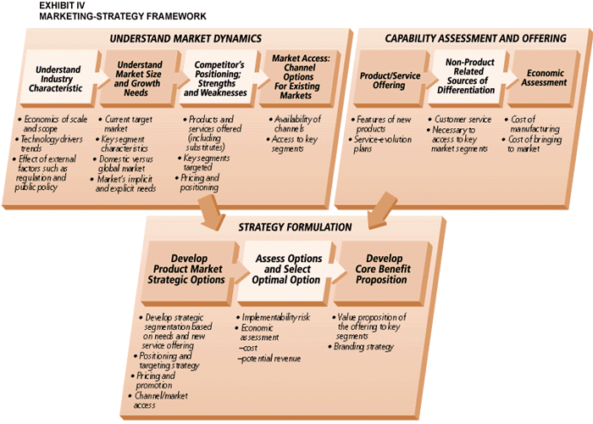
Several qualitative and quantitative tools are available to assist in evaluating these critical issues. For instance, the model developed by F.M. Bass, the Bass model (1969, 1987), and the Booz-Allen & Hamilton model (1997) are highly useful for forecasting market size and growth. Competitive assessment on the other hand, is primarily done by conducting extensive secondary research on the key players. Our experience indicates that more than 60 percent of relevant information can be found in public sources and that the challenge lies in the gathering and synthesis of this information.
The second component of the framework involves conducting an internal assessment of your company's capabilities and product offerings. Product or service development is an iterative process between developers and researchers, one involving marketplace feedback. Once a product is defined and the positioning determined, it is important to understand the economics of manufacturing. In a competitive environment in which a technology edge is short-lived, try to think beyond simply making a good product in an economical way. Companies need to evaluate and develop non-product-related sources of differentiation, such as customer service, innovative ways to access end-users, creative marketing partnerships with other services such as frequent flyer programs, and so on.
At the completion of external and internal assessment, a company is ready for the final component of the framework: the actual development of the product strategy. Strategic elements here include segmentation, positioning and decisions on marketing instruments.
One of the most important strategic elements is the timing of product entry. Should the company be the first to enter the market or a later entrant? Just what are the risks and rewards? Again, there are some important tools available to facilitate scenario planning and decision making. These include the formulation suggested by Dr. Kalyanaram in the journal Marketing Science (1995) and market share models by Dr. Kalyanaram and Glen L. Urban (1992) and by Dr. Urban and others (1986), again in Marketing Science. Other useful approaches for product strategy are the lead-user technology proposed by Eric Von Hippel, and the "wargaming" simulation analysis methodology developed by Booz-Allen. Thus, based on the market, internal and product strategic assessments, an optimal strategy can be formulated.

