Name:  Section:  Instructor: | shing nga hin  Listening + Conversations > Understanding > Pronunciation: Vowels and Consonants > How to Practise > Strategies + Materials: F+T+G > Plan  Sa,uel Cole | Instructor’s Comments
Diary number:  #1 Emphasis on Focused Practice  #2 Emphasis on Transfer Practice  #3 Emphasis on General Practice | 1 2 3 (please circle)  This diary covers my learning for two weeks, from:  ___12__/___11___2006 to ___21__/__11___2006
Objective:  1.What do you plan to achieve within this two week period?  2.Be specific about your goal for this time period. For example, how many pronunciation exercises do you plan to do? How much time will you spend listening? Speaking? | Objective  To improve the Pronunciation of the Vowels and Consonants in Conversations.  To improve my Listening.
Time Allocation:  1.Show the time you Indicated on your VELA Plan that you would spend each week on your language learning.  2.How does the time you actually spent compare with what you intended to do?  3.If there is a difference between what you planned to do and what you actually did, comment on why this happened. | Indicate the time you allocated on your VELA Plan:  Record the time you actually spent:  Week 1:  (record the number of hours each day you spent on your plan)  Week 2:  (record the number of hours each day you spent on your plan)  Comment on the time you spent:
  Mon | Tues | Wed | Thurs | Fri | Sat | Sun
   |  |  |  |  |  | 1h
  Mon | Tues | Wed | Thurs | Fri | Sat | Sun
   |  |  |  |  | 1h
  Mon | Tues | Wed | Thurs | Fri | Sat | Sun
   |  |  |  |  |  | 1h
Focused Practice:  Strategies and Materials  1.What strategies did you choose to help you with your focused practice?  2.What type of materials are you using? Provide details such as titles and page numbers etc. | Focused Practice – Strategies & Materials  Focused practice is when you teach yourself something specific about a language such as linking or weak forms. It is divided into 2 parts:  - The strategies and materials you used, and  - Assessing your progress.  List all the specific listening or pronunciation learning that you have done.  - I choose Discovering how vowel and consonant sounds are pronounced, identifying which ones are problematic and doing exercises to help my focused practice.  - I once used the dictionary and have do some practices
Focused Practice:  Assessing your Progress  1.What did you like or dislike about this practice?  2.What did you learn?  3.Why did you choose these materials?  4.What successes or problems did you have? | Focused Practice – Assessing your progress  In this section you should review and reflect on your progress, identify any problems or successes you have had, and think about why you have been successful or unsuccessful.  - I like this form extremely. It extremely simple, easy to understand.  - I have learned more English pronunciation  - This is because i want learn more English pronunciation.  - No problem.
Transfer Practice:  Strategies and Materials  1.What listening or speaking practice did you do during this period?  2.Where you able to recognize or understand any of the words or phrases from your focused practice?  3.What did you do if you came across words or phrases that you didn’t understand? | Transfer Practice – Strategies & Materials  Transfer practice is when you make an effort to use what you have learned during focused practice. It is divided into 2 parts:  The strategies and materials you used, and  Assessing your progress  List all the listening and pronunciation practice you have done here.  1. I have listened the Freshman Days.  2. I can find “+ pronunciation” to help me understand this across words or phrases  3. When I meet not not clearly, I can ask the friend of mine and use dictionary
Transfer Practice:  Assessing your Progress  1.Why did you choose the listening/pronunciation practice that you did?  2.How do you think you are progressing so far?  3.What successes or problems have you had?  4.Why do you think you were successful or unsuccessful? | Transfer Practice – Assessing your Progress  In this section you should review and reflect on your progress, identify any problems or successes you have had, and think about why you have been successful or unsuccessful.  - This is because it can improve my listening skill, and I learn more speaking skill in conversation practice, so I choose this practice  - I think I can learn more listen and speak skill.  - I sometime have not understand some English words.  - I think so successful, this is because I know more English words.
What do you plan to do next?  Why?  Do you need to modify your plan or any aspect of it (objective, time, materials, strategies)? | What Next and Why?  - I plan to use Speaking + conversation as my next plan.  This is because i want improve my speaking skill.  2. Yes ,this is because I don’t what to do.

Focused Practice

http://lc.ust.hk/~sac/advice/english/pronunciation/P5.htm
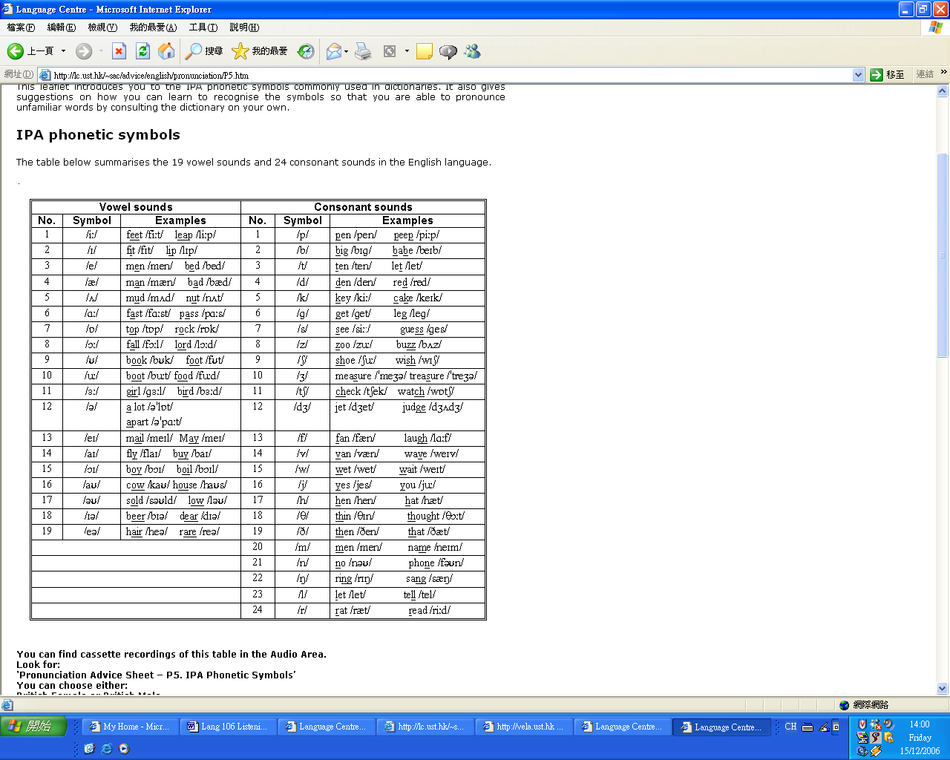

Transfer Practice
Freshman Days
By Dino Mahoney

Episode 3: Walls Have Ears

Jerry | Hey, it was great! You should have come!
Wilson | I didn’t feel like it.
Jerry | Hey, you should have seen all the food! Pork chops, chicken wings, chicken legs, sausages, hamburgers … everything! Hey, I brought you something to drink.
Wilson | No thanks.
Jerry | Well, have you eaten?
Wilson | I had some biscuits.
Jerry | Biscuits?! Is that all?! Hey, do you want to go out and see if we can find you something to eat somewhere?
Wilson | No.
Jerry | Hey, know that O Camp pal of yours, Millie? She kept asking about you.
Wilson | I think I’ll turn in.
Jerry | (Imitates Millie’s voice) “Where’s Wilson? Is he alright? Is he … ill?”
Wilson | Could you please turn your lights off?
Jerry | She’s not bad looking.
Wilson | Good night.
Jerry | How can you sleep? Come on, let’s go out, explore. Hey, have you ever done this before? (Picks up a glass, puts it against the wall and puts his ear to the glass)
Wilson | What are you doing?
Jerry | Shhhh.
Wilson | Jerry!
Jerry | Look, how can I listen to what they’re saying with you making all that noise?
Wilson | You shouldn’t be listening to other people’s conversations!
Jerry | Quiet!
Annette | He’s kind of good-looking, I suppose.
Millie | Jerry?
Annette | Don’t you think?
Millie | But who cares … he’s so … immature … He bounces around as if he were a puppy … I feel like he’s my kid brother.
Annette | I know what you mean – he’s sort of eighteen going on twelve.
Millie | And all that ‘neighbour’ stuff.
Annette | I know.
Millie | Nauseating! I hope he’s not going to start pestering us.
Annette | You don’t think he got the message?
Millie | I hope so … but I doubt it. That kind of guy is too full of himself.
Annette | We did manage to slip away.
Millie | What a relief that was.
Jerry | Hey Wilson … are you sure you don’t want a drink?
Wilson | I want to go to sleep.
Jerry | Puppy? Kid brother? Me?
Wilson | We’ve got classes in the morning … get some sleep.
Jerry | Hey Wilson … are you glad we’re sharing? (No response) Well, say something.
Wilson | Turn off the light.
Jerry | Let’s go for a walk.
Annette | So you met Wilson at O Camp?
Millie | Yep.
Annette | I couldn’t make O Camp – was it good?
Millie | It was fun. We did all kinds of things … you know, played games, got to know each other.
Annette | Got to know Wilson?
Millie | Tried to. He’s very shy.
Annette | Do you think that’s why he didn’t come to the barbie tonight?
Millie | Not sure. I like shy guys.
Annette | Do you?
Millie | Yeah, they make me feel safe – especially if they wear glasses … you can trust a man with glasses.
Annette | My boyfriend’s shy.
Millie | You’ve got a boyfriend?
Annette | Back in Australia.
Millie | Do you have a photo of him?
Annette | That’s him.
Millie | Let’s see. He looks nice.
Annette | He is.
Millie | What’s his name?
Annette | Michael.
Millie | You’re going to miss him.
Annette | I’ll see him at Christmas … he’s coming over. You can meet him.
Millie | Great.
Annette | Have you got a boyfriend?
Millie | Me? Huh! Fat chance! Too busy studying. You know what it’s like in Hong Kong – one exam after another – no time for real life.
Annette | Well you’ll be spoilt for choice here – there are guys everywhere. The place is crawling with engineers.
Millie | Like Jerry.
Annette | And Wilson.
Millie | I hope he’s OK.
Annette | (A knock on the door) Who’s that?
Millie | Yes?
Jerry | … You didn’t mean it, did you?
Millie | Mean what?
Jerry | I mean … I’m not really … you know … am I?
Millie | I have no idea what you are talking about.
Jerry | Really? Well, I was just wondering if you two would … you know, like to go for a walk.
Millie | A walk?
Annette | We’re just about to turn in, Jerry, we’re pooped.
Jerry | Oh.
Millie | How’s Wilson?
Jerry | Asleep, I think. Anyway … it was just a thought.
Millie | OK.
Jerry | Puppy? (Millie closes the door)
Millie | He’s mad!
Millie | Completely mad.

