控制處理流程—4
1. cells(列號 ,欄號)
cells()和range 的比較:

cells(1,1) ===range(“a1”)
cells(1,2)=== range(“b1”)
cells(1,3)===range(“c1”)
cells(2,1)===range(“a2”)
cells(3,1)===range(“a3”)

例如:
Sub c1()

With Worksheets("sheet1")
.Range("a1") = "A1"
.Range("a2") = "A2"
.Range("a3") = "A3"
.Range("b1") = "B1"
.Range("b2") = "B2"
.Range("b3") = "B3"

End With

With Worksheets("sheet2")
.Cells(1, 1) = "A1"
.Cells(2, 1) = "A2"
.Cells(3, 1) = "A3"
.Cells(1, 2) = "B1"
.Cells(2, 2) = "B2"
.Cells(3, 2) = "B3"
End With

End Sub

執行後, 結果一样:
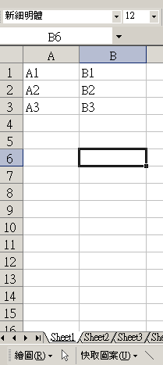
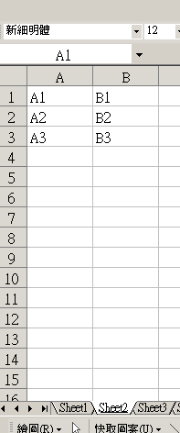

例子:
Sub c2()
rowpos = 2
colpos = 2
Cells(rowpos, colpos) = "XXX"
End Sub

B2 儲存格顯示”XXXX”
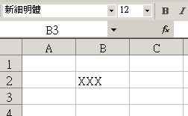

2. Do …loop while 迴圈陳述式
語句格式:
Do
……………
…………..
loop while 重複迴圈條件

do…….loop 之間是要重複執行語句,
while之後是終止重複迴圈條件語句.

Sub ex1()

num = 1
Do

Cells(num, 1) = "xxxx"

num = num + 1

Loop While num <= 10

End Sub

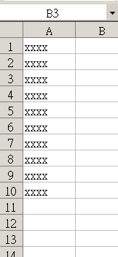

do…loop 之間重複執行了
Cells(num, 1) = "xxxx"
num = num + 1
語句

while之後終止重複迴圈條件語句是
num <= 10
.當num 超出 10 時迴圈終止.

3.Exit do 陳述式:
語句強制終止 do…loop陳述式, 不會顧及while之後的終止條件.

例子:
ub ex2()

num = 1
Do

Cells(num, 1) = "xxxx"

num = num + 1

If num > 5 Then

Exit Do
End If

Loop While num <= 10

End Sub

結果:
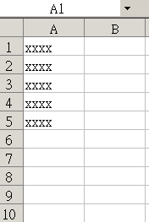

如果 num > 5

就執行語句exit do
強制終止 do…loop陳述.

4. 例子:

