- Steven is an IT coordinator in a school. He considers using the following two methods to filter
improper contents on the World Wide Web (WWW).

♦ Method A: Block access to a list of domains and IP addresses.
♦ Method B: Allow access only to a list of domains and IP addresses.

Suppose the lists of domains and IP addresses for the two methods are set as follows:

Method A | Method B
yousex.com  mypornography.com  tooviolence.com | education.com  gospel.com news.com  news.com  202.40.218.20  202.40.218.23

(a) According to the setting of Method A, will the following URLs be blocked? Justify your answers.

(i) ‘http://gallery.mypornography.com/~john/index.html’

(ii) ‘http://www2.tooviolence.com’

(iii) ‘http://www.yousex.com.jp’
(3 marks)

The following diagram shows the flow of the filtering of Steven’s design:

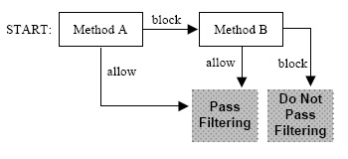

(b) (i) According to Steven’s design, will the web site with URL ‘http://education.yousex.com’
be blocked? Justify your answer.

(ii) Steven discovers that the domain ‘tooviolence.com’, which contains improper contents,
can still pass through the filtering. Give one possible reason.
(3 marks)

