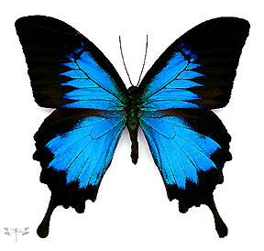

This butterfly just happened to be flying around. I looked at it and right away thought of my daughter, Diana. I thought, “If it’s you, Diana, come down and tell me.” And it did!

Immediately, the butterfly landed on my finger! It walked up and down on my finger, then onto my hand, back and forth. I could even see its little feelers moving. I couldn’t believe it! My wife sort of looked at me – I think she knew what I was thinking.

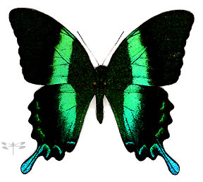
As we’re all aware, even on the most overcast day, the sun is still shining brightly behind the dark clouds. But when we’re feeling sadness, it’s important to remember that a sparkling rainbow may be up there too, perhaps right above our head!

Mandy is a postal clerk in Wisconsin. Her daughter, Kimberly, died of sudden infant death syndrome when she was 7 months old: Before Kimberly was born; we painted a huge mural of a rainbow and sunshine on her wall. Her whole bedroom was decorated with rainbows. And a lot of the gifts she received had rainbows on them. Kimberly was our rainbow kid!


Ever since she died, on her death date and on her birth date, there are rainbows here. It’s sunny, it rains, the sun comes back out, and then there’s a big rainbow in the sky! That’s Kimberly’s way of coming to us and reassuring us that there’s life after death. Last year on her death date, we went to her grave. As we were leaving the cemetery, a big rainbow appeared in the sky in the east. It gave us shivers and chills and brought tears to our eyes – and smiles too!The rainbow is one of mankind’s oldest symbols of hope and eternal life. It’s no surprise, therefore, that many bereaved people report seeing a magnificent rainbow on various anniversary dates following their loved one’s death.

