Activity 4 (d)
- Start Word to create a page.
- Insert a two-column table.
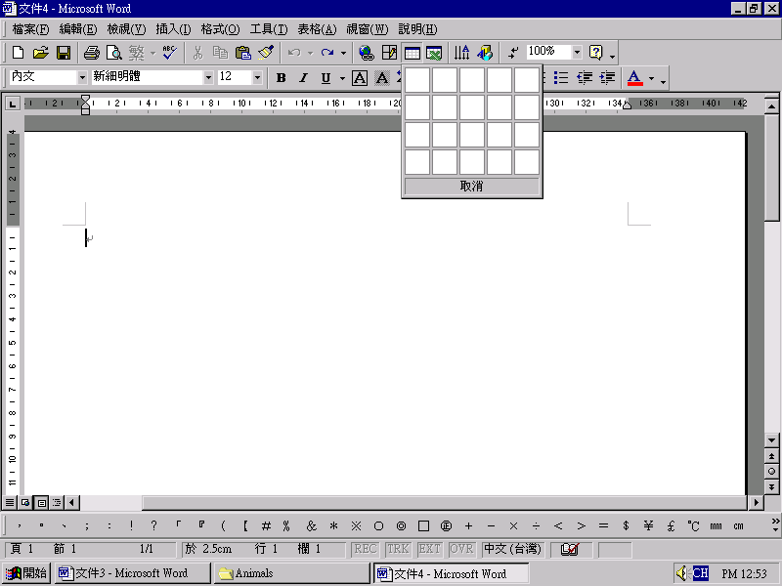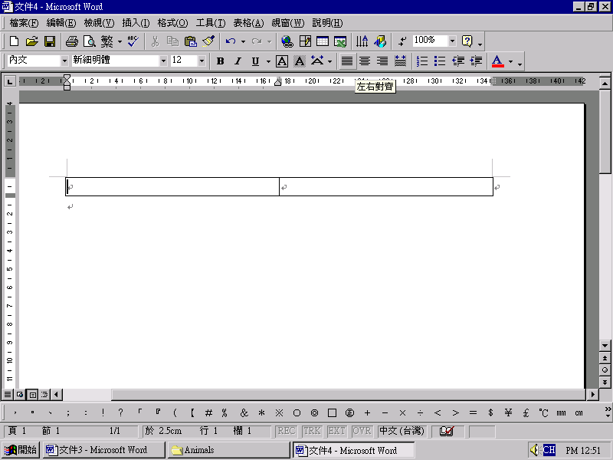
- In one column, type in the paragraph about the animal.
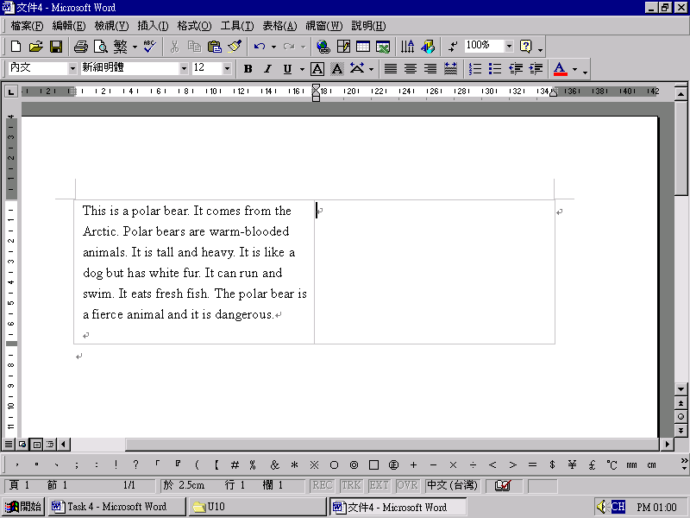
- In the other column, add clip art- Insert, Clip Art, Select a picture, press OK.
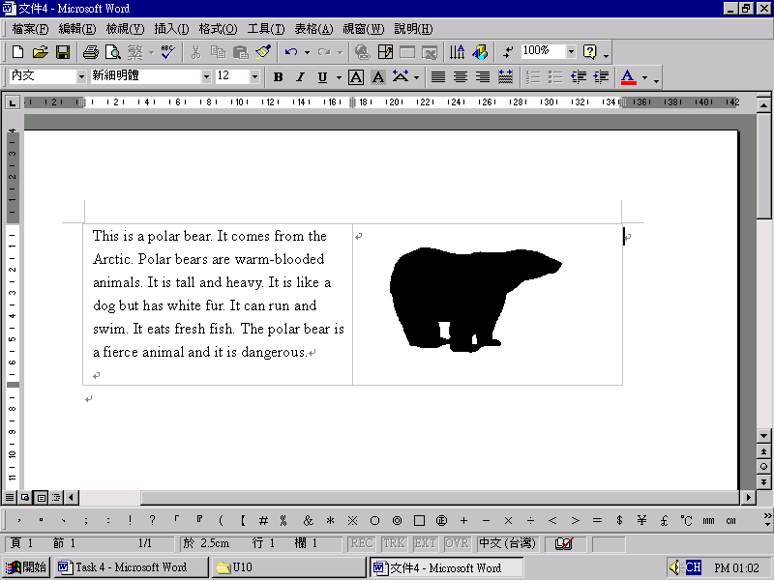
- Modify fonts - type/size/colour.
- Save file - file name "class-number" (e.g. 1a-01)
Click and view the two samples.

 | 
Polar Bear | Study Pack | Chimpanzee

