Suggested Answers to Revision Exercises 12 of Textbook

Multiple-choice Questions
Question | 1 | 2 | 3 | 4 | 5 | 6 | 7
Answer | C | B | C | C | D | B | B

Structured Questions
1. (a) No. (1 mark)
It is doubtful whether water charges will be lower. Most likely, residents
have to pay more. (2 marks)
Residents have to pay more rates. (2 marks)
(b) Yes, it is a monopoly. (1 mark)
. It is the only seller of water for home, industrial and commercial use in
Hong Kong. (2 marks)
. The industry is under government ownership. No private finns can enter the
industry. (2 marks)
. It is extremely costly to own and build the reservoirs, pipes and catchment
areas. No private finns can afford the expenses. (2 marks)
. Even if the problem of financing is solved, new finns will suffer from a
cost disadvantage, whilst the existing supplier (the Water Supplies
Department) enjoys economies of scale. (2 marks)

(c) The cost of supplying water has risen because there is an extra cost of
purifying the polluted water. (1 mark)
The supply of water decreases. (1 mark)
The demand for water increases because of population growth and greater
consumption. (1 mark)
Water charges will be higher. (1 mark)

Water
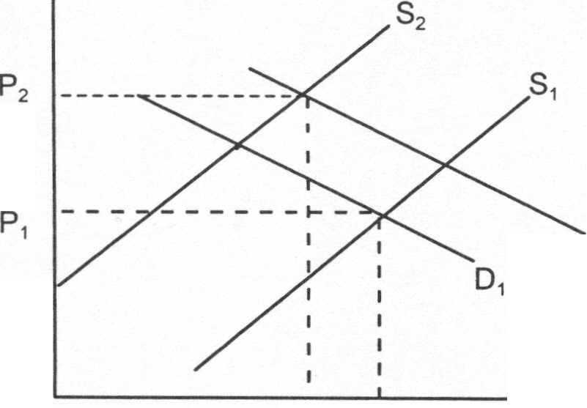
Price ($)

(2 marks)

Quantity/period
Q2 Q1
0

2. (a) It belongs to monopolistic competition. (1 mark)
This is because it fulfills the conditions of such competition: . There are many stationery stores in Hong Kong.
. Stationery in different stores are differentiated.
. There is free entry and exit.
. Infonnation is imperfect.
(Any 3 points,) mark each, maximum: 3 marks)
(b) They are price searchers (1 mark)
because products are differentiated, (1 mark)
and shop locations are different. (1 mark)
The shop owners thus have a better control ofthe market prices. (1 mark)
Even if the shop owners charge higher prices, customers may accept them. (1 mark)
(c) Their products are differentiated. Customers have a lot of choices. (1 mark)
Shops are usually conveniently located. (1 mark)
Shopkeepers are often polite and helpful. (1 mark)

3. Electricity supply is a huge capital investment. Kowloon does not have enough
customers to support two suppliers of electricity. (2 marks)
There will be duplication of work and waste of resources ifthere is more than one
supplier. (2 marks)

4. (a) It is oligopoly. (2 marks)
(b) A few banks dominate the market. (2 marks)
Banks provide similar but differentiated services of personal loans.(2 marks)

