Lemon is acidic or alkaline?
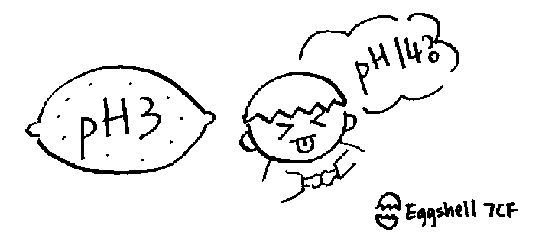

There has a great difference in the answer if we consider the

question under views of chemistry or nutritional science. So, lemon is

acidic or alkaline? It commonly believes that lemon is acidic because

it's sour in taste. However, in the view of nutritional science, lemon

is an alkaline food.

Why? The answer is simple as when we take in the food, it will

become alkaline. That's why we classify it as an alkaline food. For

example, when we take in lemon juice (wow.. so sour! :P), It'll be

oxidize to form water, carbon dioxide and an inorganic compound. The

alkaline or acidic nature of the inorganic compound formed determines

whether the food is an alkaline or acidic.

If it contains more sodium, potassium or calcium, it'll become

an alkaline food. Because when sodium compounds dissolve in water, it

forms an alkaline solution.

Na₂CO₃ + H₂O ---> 2NaHCO₃
HCO₃⁻ + H₂O ---> H₂CO₃ + OH⁻
2(Na+)₂O₂²⁻ + 2H₂O ---> 4Na⁺OH⁻ + O₂

You may doubt, where comes the NaCO₃ & 2(Na+)₂O₂²⁻?.. ha ha.. :-)

Ok, just recall your memories with Junior forms biology. The food you

ingest, no matter that's chickren leg or french fries. It burns!!!

Of coz a fire won't be set, instead, a series of complex chemical

oxidation process will take place. It's similar to an simple experiment

by,

1. heating the food to burn out all of the organic matters.

2. dissolving the ash

3. test it with limus.

In contract, if it contains more sulphur, phosphate or chloride,

it forms an acid food.

So, what is the answer to the question? From the action of

turning red in the experiment when we put lemon juice on blue litmus

paper, we know that lemon juice is indeed acidic.

With different point of view, we may have different result to

determine whether the chemical is acidic or alkaline. So, please take

care of it. ;-)

reference :

物質與化學(時代生活知識文庫)

物理與化學趣談(世茂出版社)

Modern Inorganic Chemistry(ELBS) by G.F.Liptrot

檸檬是酸性還是鹼性

由化學或食品學的觀點來看食品是酸性或鹼性時, 可能會有很大的分別。

檸檬是酸性的還是鹼性的呢? 大多數人都會覺得有酸味者都是酸性的。 但由食

品學的角度來看, 檸檬是鹼性食品。

為何呢? 食品在進入人體後就會變成鹼性,所以我們將它們歸類為鹼性

食品。 例如檸檬汁進入人體內,便會氧化燃燒成二氧化碳和水,其餘的部分則變無

機質。 我們看它的無機質有什麼東西,便可決定它是鹼性食品或酸性食品了。

如果鈉、鉀、鈣等的含量較多,便會成為鹼性食品。因為鈉等化合物溶化在

水中就會變成了鹼性物質。

Na₂CO₃ + H₂O ---> 2NaHCO₃
HCO₃⁻ + H₂O ---> H₂CO₃ + OH⁻
2(Na+)₂O₂²⁻ + 2H₂O ---> 4Na⁺OH⁻ + O₂

噫.... 何來碳酸鈉和過氧化鈉? 初中時唸的營養生物學告訴我們食品會

被燃燒(消化) -- 一個複雜的氧化作用。 化學家將食品作模擬消化, 從而決定

食品的酸鹼度。

1. 將食品燒成灰燼

2. 利用溶劑溶解灰燼

3. 測試灰燼溶液的酸鹼值

相反, 如果磷、硫磺、氯等的含量較多,則會成為酸性食品。

那麼正確的答案是甚麼呢? 從將檸檬汁塗在石蕊試紙上會呈現紅色, 就

可知道檸檬確實是酸性的。 隨著觀點不同, 要知道一種物質是酸性或是鹼性

時, 結果亦會不一樣, 大家可要小心啊!

參考 :

物質與化學(時代生活知識文庫)

物理與化學趣談(世茂出版社)

Modern Inorganic Chemistry(ELBS) by G.F.Liptrot

