Writing Neuron C Source Code
You will develop applications with the NodeBuilder tool using the Neuron C programming language.

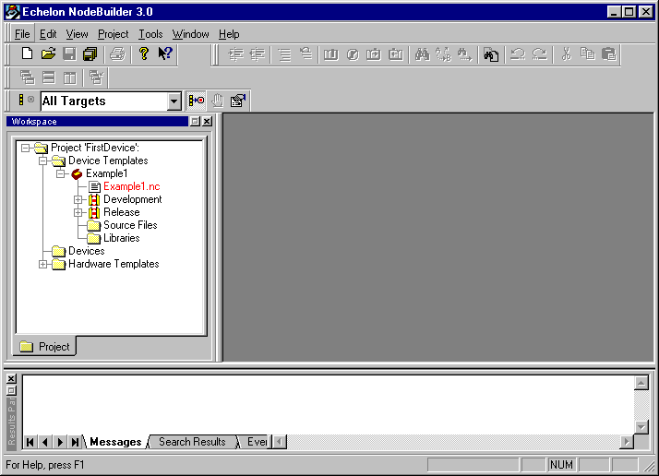

Double click the “Example1.nc” on the left pane to create a new source file.

Paste the following program to the Nodebuilder.
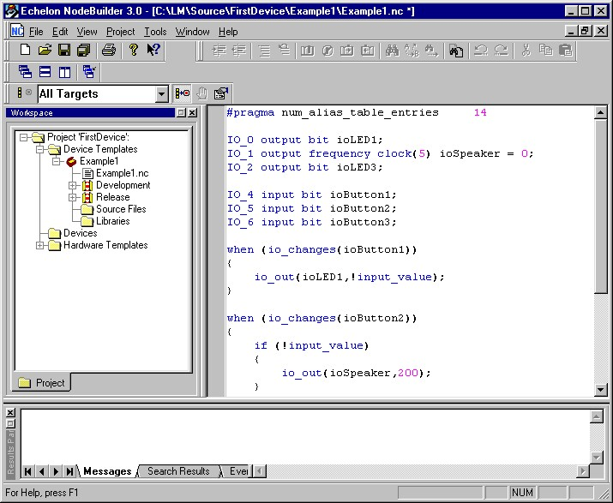

#pragma num_alias_table_entries 14

IO_0 output bit ioLED1;
IO_1 output frequency clock(5) ioSpeaker = 0;
IO_2 output bit ioLED3;

IO_4 input bit ioButton1;
IO_5 input bit ioButton2;
IO_6 input bit ioButton3;

when (io_changes(ioButton1))
{
io_out(ioLED1,!input_value);
}

when (io_changes(ioButton2))
{
if (!input_value)
{
io_out(ioSpeaker,200);
}
else
{
io_out(ioSpeaker,0);
}
}

when (io_changes(ioButton3))
{
io_out(ioLED3,!input_value);
}

Open the File menu then click Save All to save all your changes to the source files.

Program explanation

#pragma num_alias_table_entries 14
Use to control the number of alias table entries. Normally set to 14.

IO_0 output bit ioLED1;
IO_1 output frequency clock(5) ioSpeaker = 0;
IO_2 output bit ioLED3;

IO_4 input bit ioButton1;
IO_5 input bit ioButton2;
IO_6 input bit ioButton3;
Use to define the function of IO pins of the device.
You can refer to Chapter “I/O objects” (page 191) of Neuron C Reference manual. There are more than 30 I/O type for neuron chip, which is very useful.
We have used:
Bit Input/Output object (p.193 of NC Ref.) for LED and Button.
Frequency Output object (page 205 of NC Ref.) for the speacker.

when (io_changes(ioButton1))
{
io_out(ioLED1,!input_value);
}
This procedure will be executed when the input “ioButton1” change to 0 or 1.
The “io_out” function will send the data to the “ioLED1” to control the LED on or off. “input_value” is the current value of the “ioButton1”. The “!” at the beginning means NOT. You can try to delete the “!” later to see what happen.

when (io_changes(ioButton2))
{
if (!input_value)
{
io_out(ioSpeaker,200);
}
else
{
io_out(ioSpeaker,0);
}
}
This procedure will generate the frequency to the speaker. You can refer to the Frequency Output object (page 205 of NC Ref.) for detail.
io_out(ioSpeaker,200); will generate a signal with period of 200*12.8us = 2.56ms. You can find the table in the NC Ref. for the clock is 5.
io_out(ioSpeaker,0); will stop to generate a frequency.

