Hong Kong Examinations
and Assessment Authority
2007 HKASL
Computer Applications

Individual Project
Topic︰

School ︰HKTA Yuen Yuen No.1 Secondary School
Name ：Wong Mei Wah
Class ：7A
Class No ：29

Content

- Introduction 3
Comparison between before and after introducing POS 4

- Objective and Analysis 6
Hardware (Peripheral device) 7
Software 10
A Virtual Private Network 14

- Design & Implementation 16
Business administration 16
Inventory control……………………………………..…………………..17
Financial control 21
Membership administration 24

- Testing & Evaluation 28
Testing 1 28
Evaluation 28
Testing 2 29
Evaluation 29

- Conclusion & Discussion 30
Strength………………..…………………………………………………30
Weakness………………………………...……………………………….30
Feedback………………………………………………………………….31

- Documentation………………………………………………………..……...32

Introduction

With the increasing business volume, I found that traditional cash register and transaction done by man can no longer support the business volume. Besides, traditional cash register can only do simple things, like colleting money, printing an invoice and counting the cost, etc. Thus, it only get a little and limited management information such as the total sales or different department basic sales statistics. Information of basic running like gross profit analysis, inventory, the fast-selling and slow-selling products, etc, can hardly collect or even cannot obtain from it.

Besides, in order to facilitate sales, such as business administration, membership administration, inventory control and financial control, I would like to adopt a system to help business.

After several researches, we would like to introduce a popular system, Point of Sales system (POS).

POS means with the use of front stage registering equipment and system, each transaction information can be recorded and transmitted to the back stage computer and server and help business for later sales analysis.

In the following table, it shows the difference of before using POS and after using POS.

Comparison between before and after introducing POS
 | Before | After
Business administration | - Products are numerous and jumbled, it is hard to handle  - Settle bills by checker is outdated and easily makes mistakes  - It is time- consuming and troublesome when there is sale promotion  - Immediate sales condition can not be known | - Use bar-code for classification, handling become easy  - Bar-code reader is introduced, mistakes and time is greatly reduced and shorted respectively  - Variety discount is recognized by the computer automatically, time is saved  - Immediate sales condition can be know at any moment and in details way.
Financial control | - Predict products’ selling state just by intuition  - Only daily business volume can be obtain  - Sale promotions like discount and big sale’s effects can not obtain  - Sales transaction or commissions are recorded by manpower | - Products’ selling state are ranked for further analyze  - Computer will analyze statistic automatically, sales situation can be obtain immediately  - The amount of consumers and transaction in particular period can be recorded  - Sales transaction amount or commissions are recorded by computer
Inventory Control | - No sale record, inventory amount is hard to handle  - Inventory lost can not be digitized  - Dull sales, overstock or run out of stock is hard to discover | - Connect to the front stage, inventory amount will be automatically decreased  - Inventory difference can be analyzed and traced  - POS record the inventory which avoid overstock
Membership administration | - Members data and shopping are hard to manage  - Consumers’ purchase motion and shopping habit can be hardly obtained | - Detail membership administration, (member discount, redeeming rewards…)  - Consumers’ purchase motion and shopping habit can be easily obtained

In the following, I would use a bedding chain store as an example to show how POS facilitate sales, including business administration, membership administration, inventory control and financial control. Besides, I will analyze the Point of Sale system and the feasibility of implanting the proposed system. I will also describe and justify the underlying database design for the system.

Objective and Analysis
- Obtaining sales information:
By using POS, computer automatically gather statistics and analyze a product, departments, sales period, business volume, interests (rate), business transactions, etc, which can let the operator know each product’s selling situation, customer’s shopping style, sales promotion activities results and so no, in order to help the operator for operating the business and making sales decision.

- Reducing running cost and increasing the efficiency:
By adopting bar code management system together with bar code reader in dealing the bill, personal mistakes can be greatly reduced. Also, man-power cost and bill-paying time can be lowered and shorten respectively. Hence, the enterprise’s competitiveness and its image can be increased.
- Help inventory control:
Stock up, sale, inventory done by computer are clear. Safety stock can be established to provide stock up advice, to check the fast-selling and slow-selling products, to control the inventory condition and to prevent man-made abuse.

- Assist membership administration:
Collect customers’ or members’ transaction information in the front stage and send them to the back stage for analysis in order to know customers’ shopping attitude, habit and model.

Hardware (Peripheral device)
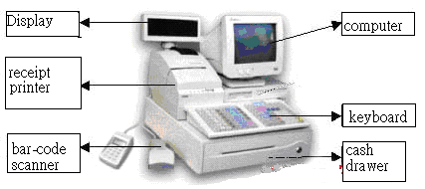

From the above diagram, front stage hardware include a computer, a keyboard, a cash drawer, a receipt printer, a bar-code scanner, a customer display and a credit card reader(or magnetic stripe reader).

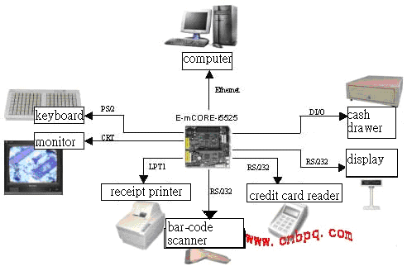

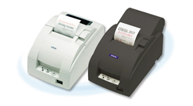

Receipt printer: A receipt printer is connected to the computer which will print the receipt when a transaction is made. There are two types of receipt printers, dot matrix and thermal receipt printer.


Barcode scanner: A barcode scanner is used to scan the product’s barcode accurately and input the data to the computer. There are different types of barcode scanners, CCD, laser, hand held, and desktop barcode scanner.

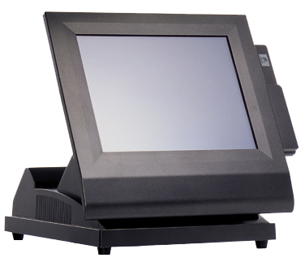

Monitor: A monitor is usually a touch screen monitor in LCD or CRT form. It replaces the use of a mouse. It is user friendly, so it shortens the training time but increases the efficiency.

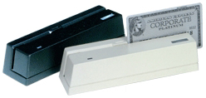
Magnetic stripe / credit card reader: It is used to read data inside the credit card or magnetic card. Data will be input to the computer. It provides another paying method out of cash, and it is more convenient to the customer.

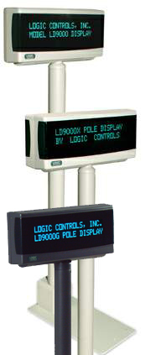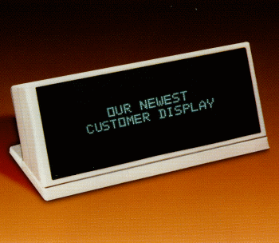

Customer display: It is used to output the total amount and the price of each item which brought by customer. There are two types of customer displays, pole and desktop customer displays.

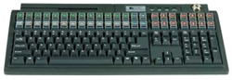
Keyboard: It provides more than a hundred key settings. Operator can enter data very quickly.

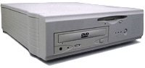
PC station: It connects to the computer and stores all the record, such as products’ data, members’ data, and staff’s data, etc.

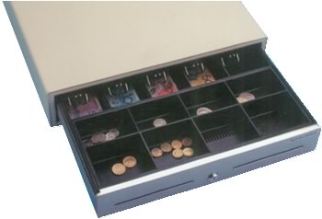 Cash drawer: It is connected to the computer. It will be opened when the computer send a signal out.

Software
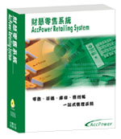 | AccPower Retailing System comprises Sales Memo Entry, Sales Memo Payment, Purchases, Account Payable and Inventory Control in one package. The System automatically generates the accurate financial information once a voucher or an invoice entered. All information is definitely important for financial analysis and management decision to compete with comprehensive business environment.

System Features
Easy to use
User friendly interface design is to minimize user's learning time. Users can input the information in a familiar background just like an actual voucher or invoice. Quick Access Area can give the user access to the primary functions quickly. Quick Access Area is represented by buttons in the center of the windows.
Multi Language Interface
The default languages include English, Traditional Chinese (BIG 5) and Simplified Chinese (GB). Users can change the language when they want. The reports will be displayed in the corresponding language. Familiar language environment makes you easy to work with AccPower Retailing System.
Multi Company Control
Users can handle more than one account of different companies and different financial years by AccPower Retailing System.
Multi Currency
Users can use foreign currency to handle the transactions in Sales Memo Entry, Sales Memo Payment, Purchase Order, Vendor Invoice, Purchase Return Entry and Account Payable Payment. The System automatically calculates the exchange difference.
Multi Level Chart of Accounts
AccPower Retailing System supports 6 levels of chart of accounts. Users can generate reports at designated level.
Send Reports via E-mail
Users can send all reports to the designated person via e-mail. The receiver can be called from address book of e-mail program or clients/vendors in AccPower Retailing System.
Export Data
AccPower Retailing System allows users to export all data to many general formats. For example, Text File, HTML File, MS Excel File, MS Word File, Symbolic Link File, DIF File, Lotus 1-2-3 File, QuattroPro File, SQL File, XML File, MS Access Database File, DBF Database File, Rich Text File, SPSS File, PDF File and LDAP File.
System Functions
Sales Memo Entry
-user friendly interface
-user can use different currency and set exchange rate to every transaction
-allow to input the information about date/time, salesman, payment methods, and credit card, etc
-support multi payment methods: cash, credit card or others
-support partial payment
-support shift duty
-user can pre-set the decimal points of total amount, e.g. cents or dollars
-auto link with inventory control to create stock sales records
-support Receipt Printer, Cash Drawer, Customer Display (Pole Display), Barcode Reader and Programmable Keyboard

Purchases Control

-user can use different currency and set exchange rate to every transaction.
-support service items and remark sales
-allow to input salesman, payment terms, payment methods, ship via, order number, freight charge and other costs, etc
-up to 3 level accumulated discounts
-user can search vendor or stock easily by code, name or even telephone number
-last transaction price for each vendor will be recorded and be automatically used in next transaction
-link with account payable to create transaction Journals
-pre-set 3 types invoice formats which can be modified by user

Vendor

-record vendor contact information, including content and time
-independent A/P account for different vendor
-pre-set currency, class, credit limit, credit status, payment terms, payment method, delivery method and district, etc
-generate and print mailing labels

Stock Control

-support different selling prices and cost management: standard price, retailing price, wholesale price, promotion price, maximum price, minimum price, last purchase price, average cost price and standard cost price
-up to 4 levels accumulated discounts for each stock. For example, 2% off for over 10 pieces, 5% off for over 20 pieces, 10% off for over 50 pieces and 15% off for over 100 pieces
-support up to 30 characters for stock code
-support many kinds of barcode format
-support stock image and different graphic formats
-independent interface for stock adjustment entry

Report Designer

-user can modify all reports by own self
-all reports can be exported to the formats of Excel, RTF, TXT, BMP, JPG, TIF, PDF (English only) and XHTML, etc

User Security Control

-each function can be set for each user to browse, add, edit and delete

Sales Tax Control

-support VAT tax for mainland China
-support sales tax for many countries

System Requirements

-Intel Pentium II 450Mhz or above compatible computer
-64MB RAM or above
-60MB Hard Disk Space
-800x600 resolutions
-MS Windows 98SE/Me/NT/2000/XP or 100% compatible Operating System
-CD-ROM
-one USB port

A Virtual Private Network
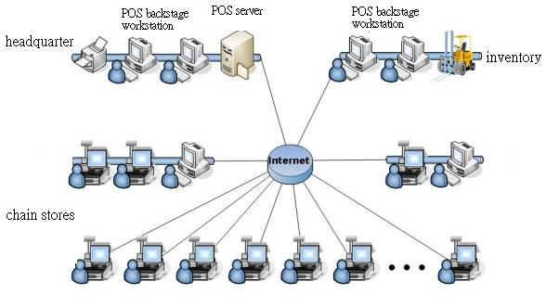
A Virtual Private Network (VPN) establishes protected communications links across a public network. The end-points of a VPN establish an encrypted link across the network. This allows organizations to safely exchange information over the Internet rather than relying on expensive dedicated private lines.
VPNs may be either:
- Firewall to Firewall, or
- Firewall to Remote Computer
Firewall to Remote Computer VPNs are useful for establishing secure communications between a central office and individual remote users. This can be used to allow employees who are traveling or telecommuting to securely communicate with the home office.
Community Internet helps ensure that information in your business flows freely but securely by delivering tailored VPN solutions that meet your particular needs.

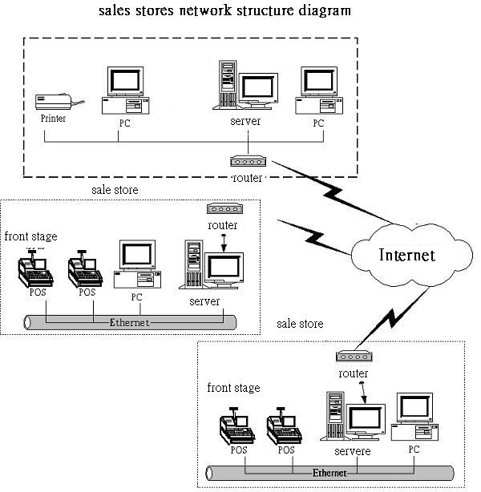

Design & Implementation

Business administration
Sale proposal
Besides, the sale amounts can be used to do a sale proposal for future planning.
For example, we can find out which product sells like hot cakes and which product is unmarketable by a linear graph. Besides, it shows the changes in different period, for example, down quilts selling fast in December and January, but sell slowly in the May. Then we can set some sale promotion like discount or “buy three get one free” to attract more customers. Also, we can increase the amount of the fast-selling products in particular period but decrease in the slow-selling month.
Thus, we can use the collected data to predict and find out future selling curve line which help the company’s to organize and plan for the future development.
Inventory control
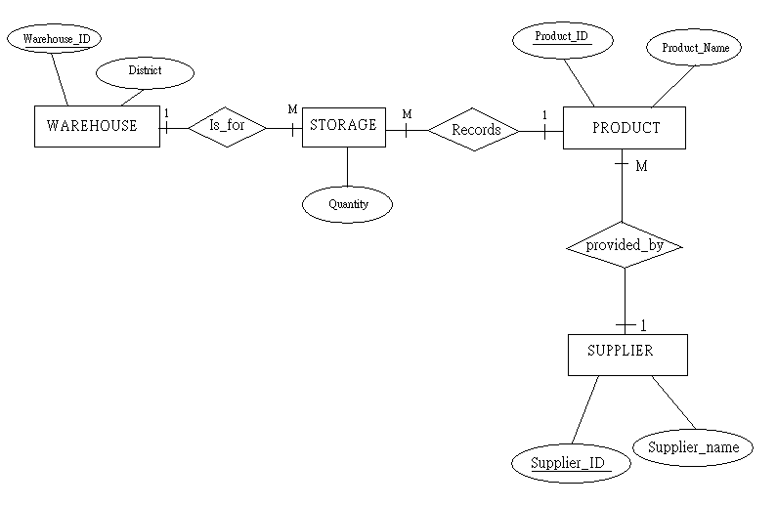
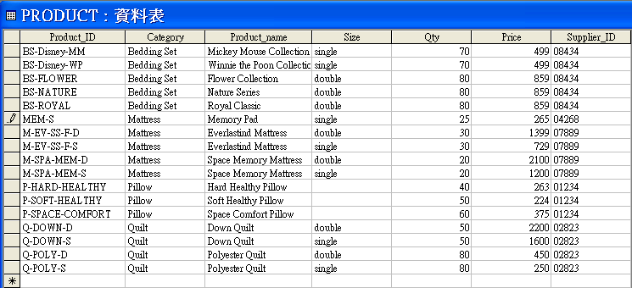

- Check inventory

In the above line graph, we can see the selling trend of different products. For example, pillows sell quickly in January, August, November and December. That means the products run out sharply in these months. Thus, we need to check the inventory and order goods before products run out.

To check the inventory, we may enter a SQL:
SELECT Product_name, Qty
FROM PRODUCT; 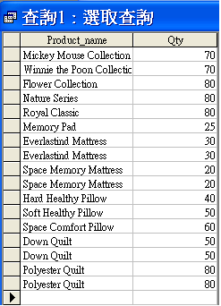

- Order goods

Assume that products should not less than 50 in the inventory, if not, order should be made to the supplier as soon as possible. We can use SQL to show the supplier phone numbers and the products which are not sufficient. Hence, we can use the phone numbers to order specific products from supplier.

SQL:
SELECT distinct P.Product_ID, P.Product_mame, P.Qty, S.Phone_no
FROM PRODUCT as P, SUPPLIER as S
where P.Supplier_ID=S.Supplier_ID
and Qty<=50;

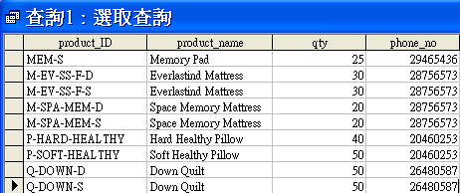

- Allocate goods from others sale store

- Chain stores can check the amount of required products in particular sales store or warehouse for products amount adjustment’s reference.

- A sales store can adjustment list directly and immediately if it needs to allocate or transfer products from other sales store, and the asked sales store and headquarter can check print the list synchronously.

- Then, if the answer is yes, the system will confirm the list and automatically adjust the inventory.

- If the answer is no, the system will state the reasons and send a message back to the sales store who asks for help.

- After the goods are received, the sales store who asks for help will confirm the allocation and the system will renew the inventory.

- It will then finish after both sides finish checking.
- Both of the sales stores can check the allocation condition in more detail anytime.

Financial control
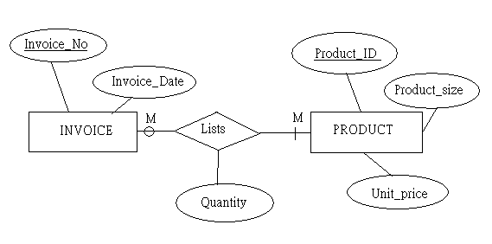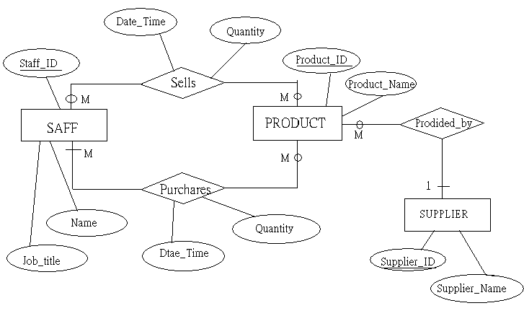
With POS, financial control becomes easy to manage, to analyze and to plan the future sale proposal.

Salary calculation

POS system collects information of sale and records them in the computer and server. Salaries can be calculate though POS which simplifies the process and save time for calculation by man. Also, by using POS, it can record who deal with that particular transactions. Then we can calculate the commissions (sale amount ╳ 5%) by using the data saved in the computer. Hence, commissions will be added in the monthly salaries. This not only helps for account, but also increase staff’s morale and encourages them to work even harder.

For example, we use database and SQL to find out staff Ng Siu Fong’s total salaries.

- Transactions done by Ng

SQL:
SELECT S.Staff_Name, P.Product_name, P.Price
FROM PRODUCT AS P, STAFFREC AS S, INVOICE AS I
WHERE (((S.Staff_Name)="Ng Siu Fong")
AND ((I.Product_ID)=[P].[product_ID]) AND ((S.Staff_ID)=[I].[staff_ID]))
ORDER BY P.Product_ID;

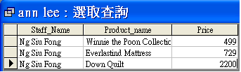

- Commissions

Commission=(sale amount ╳ 5%)

SQL:
SELECT SUM(P.Price)*0.05 AS Commissiom
FROM PRODUCT AS P, STAFFREC AS S, INVOICE AS I
WHERE (((S.Staff_Name)="Ng Siu Fong") AND ((I.Product_ID)=[P].[product_ID]) AND ((S.Staff_ID)=[I].[staff_ID]))

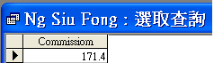

Thus, we find out Ng’s commission is $171.4.

- Total salary

Total salary=Monthly salary + Commission

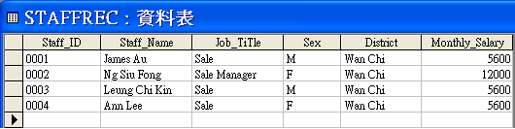

Ng’s total salary= $171.4 + $12000
=$12171.4

Membership administration
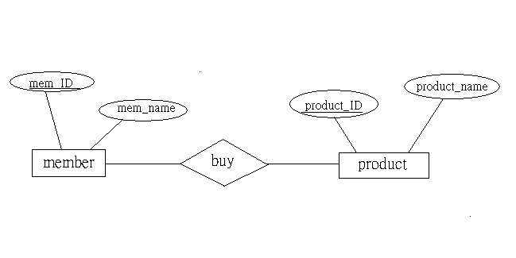
With the help of POS, data are easily being collected and store in the data base file. In the data file, we can do research promptly.

- Arrange the member card
In our company, member card is divided into three types: Platinum member card, Gold member card and Classic member card which are according to members’ points as the following table.

Card type | Points
Platinum member card | >=500
Gold member card | 200-499
Classic member card | 0-199

The member card will be renewed annually if points are change.
In the following table, it shows the record of last year.
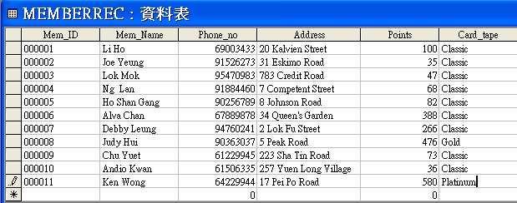

Now, we are going to update these records.
First, we need to export the data to MS Excel.
Secondly, we can use a formula (F3=vlookup(E2,b25:c18,1) to update the data. 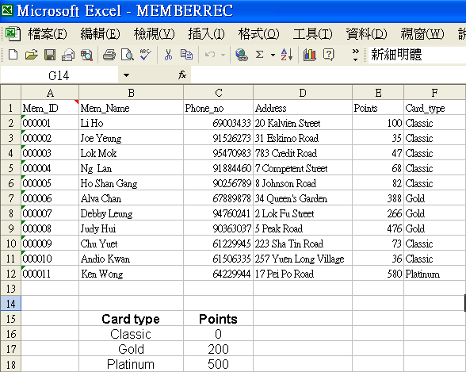
- Send gifts
Members will be received a gift if they meet the follow requirement.

Point | Gift
>=500 | $200 coupon
>=300 and <500 | $100 coupon

- First, we need to find out who will receive a $200 coupon by entering a SQL : SELECT mem_name, address, points
FROM memberrec
WHERE points>=500
ORDER BY points;
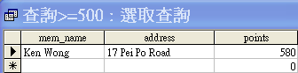
Then we can find out that Ken Wong’s point is greater than 500. We will send the $200 coupon according to his address.

- Next, we need to find out who will receive a $100 coupon by entering a SQL: SELECT mem_name, address, points
FROM memberrec
WHERE points>=300 and points<500
ORDER BY points;
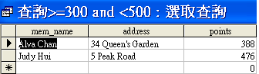
Then we can find out that Alva Chan and Judy Hui’s points are between 300 and 500. We will send the $100 coupon according to their address.

Testing & Evaluation
Testing 1:
Date: 16 Jan 2007
Location: Wan Chai branch store
Business hours: 10:00 a.m. ~ 10:p.m.
Staff Ann Lee arrives at Wan Chai branch store at 9:50 a.m. and uses the staff card to touch the access control machine. The access control machine (RFID) will then transfer the staff ID number to the computer. The computer will then record down the staff ID number, date and time in the data base. People who are late will be mark as “LATE”. As the computer is linked with POS, we can also find out who is late thought POS.
At 12:15, a customer buys product down quilt by cash. Sales will use barcode scanner to scan the barcode. Then, product name, size and price, etc will be shown on the monitor. Then, the customer takes out the member card. Sales will then enter the member number to the computer to make a discount and record points. The discounted new price will be shown on the customer display. After paying money, a receipt will be printed out with date, time, sales name, product ID, product name, size, quantity, original price, discount (%), amount, total amount, change and payment method. by the same time, as product is sold out, inventory will minus one automatically.

Evaluation:
When every thing is okay, the system runs stably. It makes transactions efficiently and effectively. Data are transmitted for later use.
Testing 2:
Date: 2 Feb 2007
Location: Wan Chai branch store
Business hours: 10:00 a.m. ~ 10:p.m.
Staff Ng Siu Fong reaches store at 9:45 a.m. and uses the staff card to touch the access control machine. As there are new product arrived on yesterday, Ng Siu Fong wants to check the product amount with the record in the POS. Unexpectedly, the computer work failure. Nothing shows out. It seems attacked by virus or Trojans. Technicians are coming after 3 hours. Transaction can only done by hand. Transaction can only in cash, no EPS or credit cards. Also, member card cannot be use within this period.

Evaluation:
When computer or network is failed, the whole system down. First, access control records can not transmit to the computer. Transactions are also affected as barcode cannot transmit information to the computer.
Besides, a store can do nothing if the computer or network fails. It cannot ask another sale store to send product as temporary use through VPN if the product sold out.
It will also create big trouble to those use credits card payment.

Conclusion & Discussion
Strength:
- Computerizing management enhance company’s image;
- Sales’ records and inventory can be updated immediately;
- Improving the efficiency of chain store and productivity;
- Each record is managed in a systematical way, which greatly reduces mistakes or cheating by man;
- More efficient and effective in allocating human resources;
- Increase the information exchange inside the company and among branch stores;

Weakness:
- It is costly to buy and update computer hardware and software;
- It is time consuming to enter products’ information and to keep updating the data;
- It needs money and time training staff to operate the system;
- It has not have e-commerce or cover with online shopping. This will be a general direction and a trend for future development. Hence, POS should develop and improve in this way.
- Also, this POS system has a big loophole. The system is weak to face failure of computer or failure of network. It will make the useful system into useless. So backup and anti-virus should be strong enough.

Feedback:
Certainly, this is an interesting project which I can use the knowledge in real life situation. As a student, I think we seldom think how chain store operate even we shop many times. We never think how transactions are done and what the steps behind are. This project is really an opportunity for me to know how much I learnt can be applied on real life situation and to know more about the society. And make me think this subject is really “Computer Application”.
However, undoubtedly, I face lots of difficulties in doing the project. With absent mind and no idea with commercial knowledge, it makes me even harder in designing the project structure. Luckily, my classmates and the advanced technology really help me a lot. It makes me to have some basic idea to do this project. This may not be a good proposal, but I really try my best.
Documentation

Thanks the following web sites for providing relative and useful resources for this project.

- Tatung Company
http://si.tatung.com.tw/index.htm

- ComLogic
http://www.comlogic.com.hk/htcdoc/eu/mp/00/mp.html

- Asia Solution Corporation Limited
http://www.asc.com.hk/hk/products_internet.asp

- CNPOS
http://www.tkpos.com.tw/fyi/front/bin/cglist.phtml?Category=106563

- Sony Corporation of Hong Kong Ltd
http://www.so-net.com.hk/download/category/office/office104.php

- SonicWALL
http://www.vpn-technology.com/ssl-vpn.htm

- TRICAN CONSULTANT LTD.
http://www.trican.com.hk/

- POS World
http://www.posworld.com/barcodereaders.html

